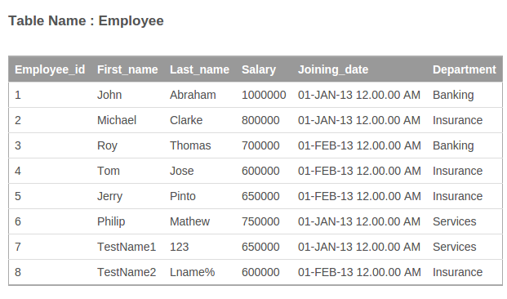
1. Create a table called Employee with schema as above. Please add EmployeeId as primary key, use appropriate data types to store data and add other constraints as required.

2. Insert records into the Employee table with records as shown above.
insert into employee values(2,'Gur','Deep','Hyd','Insurance');
3. Fetch all employees with all information.

4. Get firstName and last name of all employees.

5. Get firstName of all employees in upper case.

6. Print out all departments in table but each should be printed only once.

7. Select all employees belonging to Insurance department.

8. Select employee name who have salary more than 700000

9. Select employee firstname,lastname who have Date of Joining between 15-Jan-2013 till 15-Feb-2013. (Date comparison to be format to be checked)

10. Find all employees who have firstname or last name starting with the letter 'T'.

11. List all employees sorted by their salary in ascending order.

12. List all employees sorted by their salary in descending order.

13. Now add a new column called Date of Birth in table.

14. Update Date of Birth for each employee. Note DOB should be different for each employee.

15. Add an bonus of 10000 USD to all employees belonging to the Insurance department. It seems insurance department is doing very well !!

16. Delete only the last 2 records where first name starts with 'Test'

17. Now create new table called department with the following columns :
DepartmentId
DepartmentName
Make DepartmentId as a primary key.

18. Insert 3 records for Banking,Insurance and Services in the department table.

19. Remove the column department Name in the Employee table and add a new column called Department Id. Make this as a foreign key referring to the department id in the department table. (This will not work in SQLLite. But get an idea on how it should be done)

20. Update the DepartmentId in Employee table so that they point to the appropriate department in department table.

Using the w3school Database, please fetch the following data using SQL.

1. Find all customers belonging to the USA.
2. Find total number of customers categorized by the country.
3. Find the top 3 countries from which maximum orders are coming in. The output should have country name and total orders for the entire year of 1996.
4. Find the least selling items. The business development team would want to review these items.
5. Find the total orders shipped by each shipper.
6. Fetch the best selling product in each category (Beverage,condiments,confections etc)

