|  |  |
| --- | --- |
| Name | Student ID |
| Alec Kurkdjian | 40056402 |
| Cong-Vinh Vu | 40061685 |
| Irfan Ahmed | 40056645 |
| Shadi Makdissi | 40060588 |
| Ogo-Oluwa Jesutomi Olasubulumi | 40055693 |

**Product Backlog**

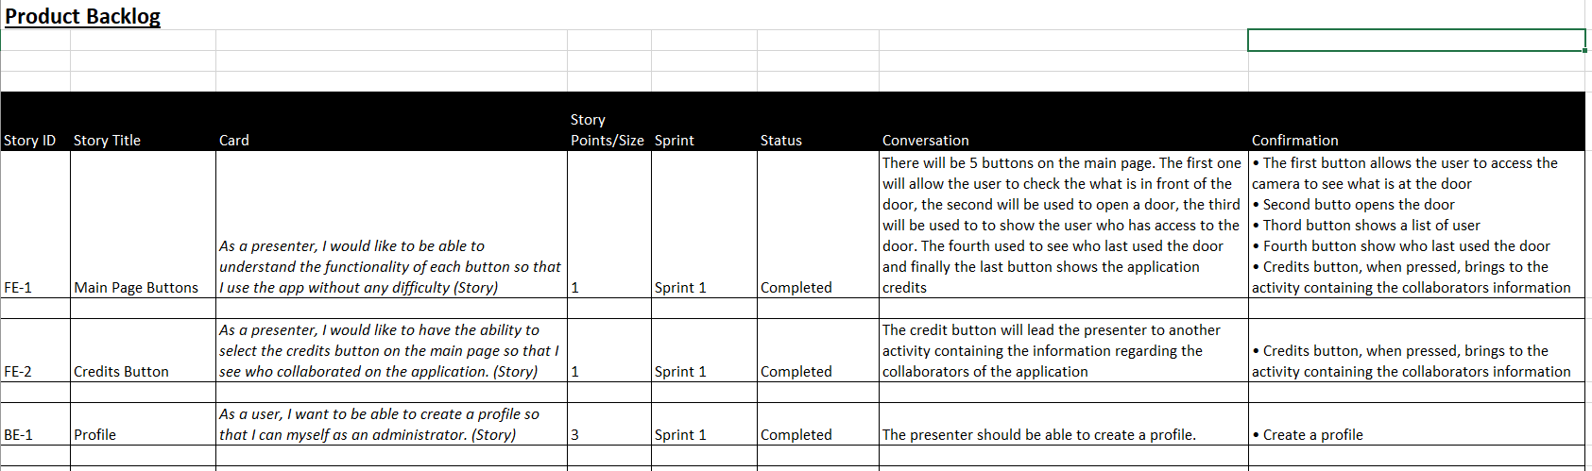

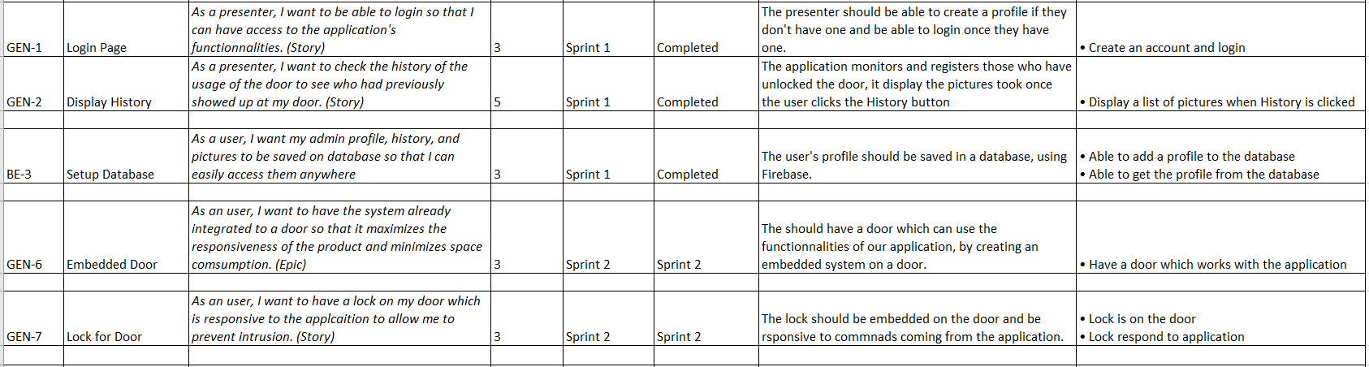

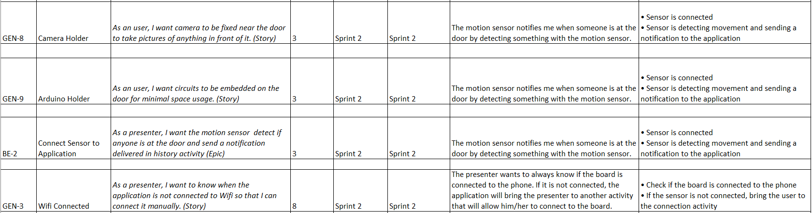

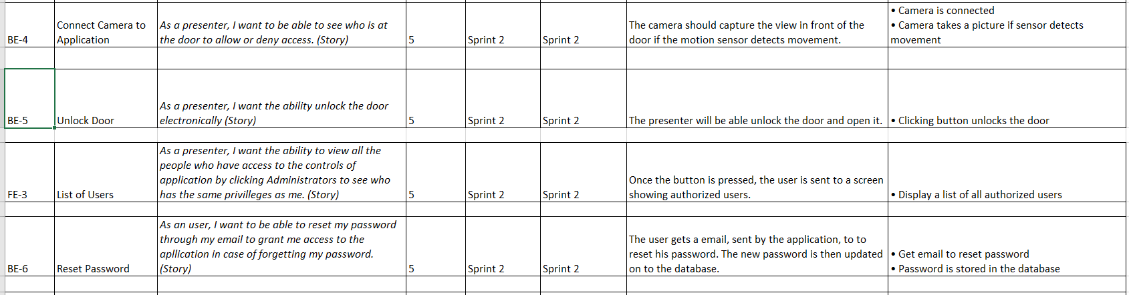

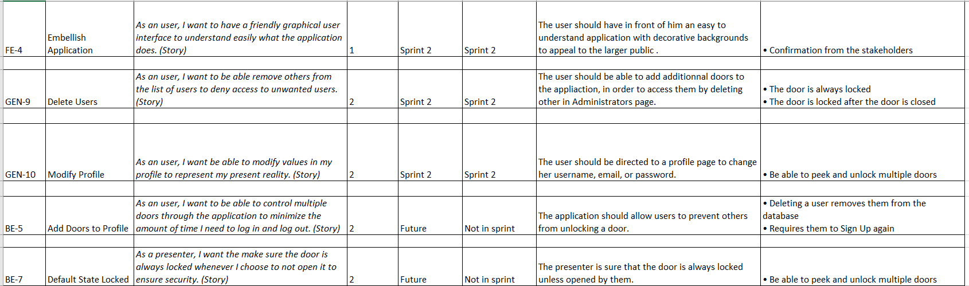

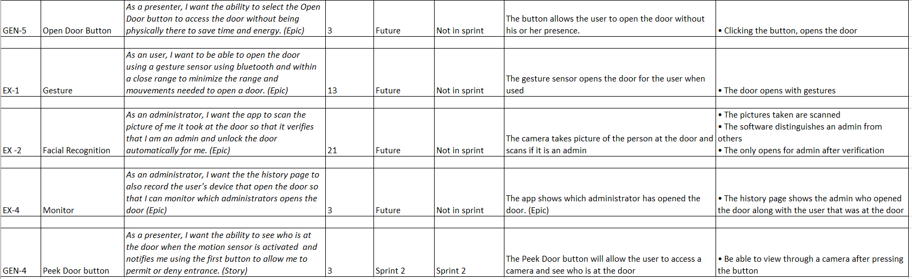

**Sprint 1 and Definition of Done (DoD)**

