Documentation and Programming Guidelines

Before doing ANYTHING (documentation and programming), 3 steps MUST BE PERFORMED

1. Check out the targeted branch (branch made for a task)
2. Fetch on the targeted branch to view any updates on its’ contents
3. Pull on that branch if local branch is not up to date

The **only person** allowed to **create a branch** is the **technical lead**, before any task is given or started, the technical lead will create the required branches.

The **only person** allowed to do **any merge** from a pull request is the **technical lead**. Any merge from a pull request must be **approved by the technical lead**.

Before deleting any branches, you must first get the **approval of the technical lead**.

It is **prohibited to commit directly into the master branch** for any reason.

Commit messages must follow template below:

Title

-Followed by brief description of commit starting with character -

-Example below:

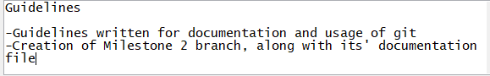

**Documentation**

* Every Milestone will have its’ documentation branch, only documentation will be committed inside that branch
* Word documentation from milestone k MUST be written in its; respective file (Milestone-k) with being an integer. Any other file aid to milestone documentation is also allowed, but should not contain full sentences
* Word files should be formatted using front: Arial or New Times Roman with size 12 for standard wording.

**Programming**

* Any styling should be done in the style.xml file