**Point-Source Angular Tracker**
In some applications, it is necessary to determine the direction of a point source that stands out against its background, such as an aircraft engine or a laser designator spot against a landscape.
An **azimuth tracker** can be constructed using two detectors with orthogonal fields of view (90° apart). A slanted optical baffle is placed in front of each detector, with the baffles tilted in different directions. The relative measurements from the two detectors can then be used to estimate the azimuth angle.
Similarly, the **polar angle** can be determined using a second pair of detectors whose baffles are oriented perpendicular to those of the first pair. Together, the two detector pairs provide the information needed to estimate the source direction in three-dimensional space.
During initial acquisition, wide-field-of-view optics can be used to locate the target. Once the sensor is pointed toward the source, the field of view can be progressively narrowed. This reduces background stray light while maximizing the relative contribution of the target signal.
In principle, the concept is not limited to visible light. By selecting suitable optics and detectors, the approach could potentially be adapted to wavelengths ranging from ultraviolet through the long-wave infrared and, with a substantially different implementation, even to radio frequencies.
The concept combines angular sensing, optical filtering, and field-of-view control in a potentially compact point-source tracking architecture.
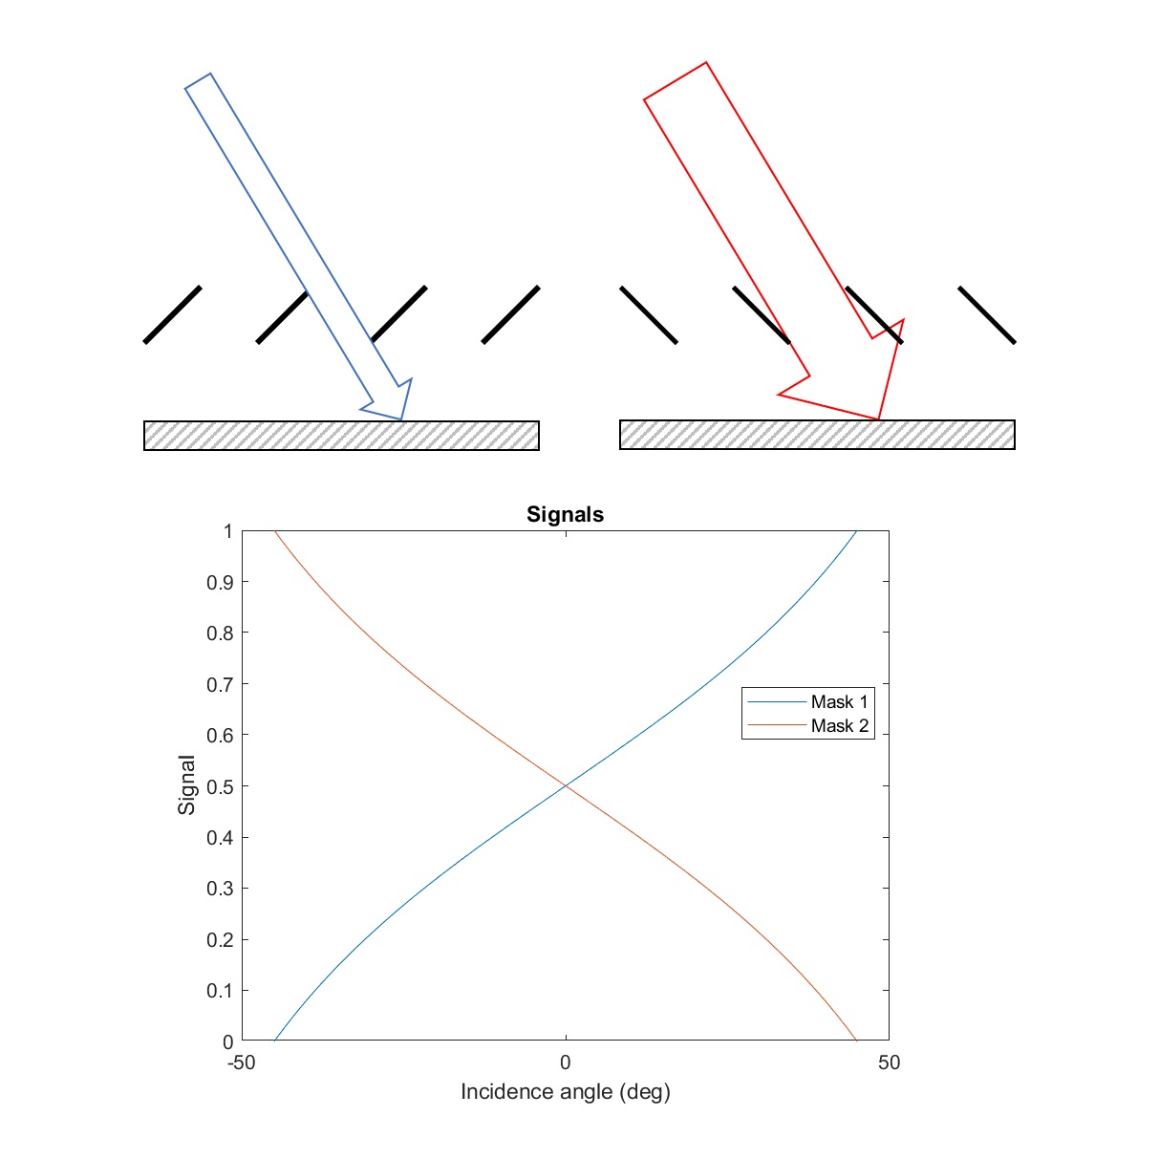
#OpticalEngineering #ElectroOptics #InfraredSensing #OpticalTracking #SensorTechnology #Photonics #LaserDetection #SignalProcessing #RemoteSensing #EngineeringInnovation

