Final Project

course name: Principles and application of Database system

Student: Tomiris Arman

2019

**Introduction**

The project is about General Motors automobile company. It provides three types of interfaces: dealer, customer and marketing department. All of them are related to each other.

  

**Manufacturer Dealer Customer**

Let us consider the abovementioned scheme. Our company has several manufacturing plants and factories all over the world. **Dealer** is the person who will be responsible for making deals with customer. A dealer will take cars from **manufacturer** and add it to his inventory. He will offer them to his potential clients, so that any **customer** can choose the car he wants to buy. **Marketing department** will be keeping track of sales and transactions between different dealers and customers.

**Database design**

|  |  |
| --- | --- |
| vehicles (VIN, ModelID, Color, MID)  models (ModelID, BrandID, ModelName, Body)  brands (BrandID, BrandName…)  manufacturers (MID, MName, Location) | dealers (DID, DName, Address)  inventories (InvID, DID, VIN, Price)  customers (CID, CName, Address, Phone, Gender)  sales (InvID, CID, Date) |

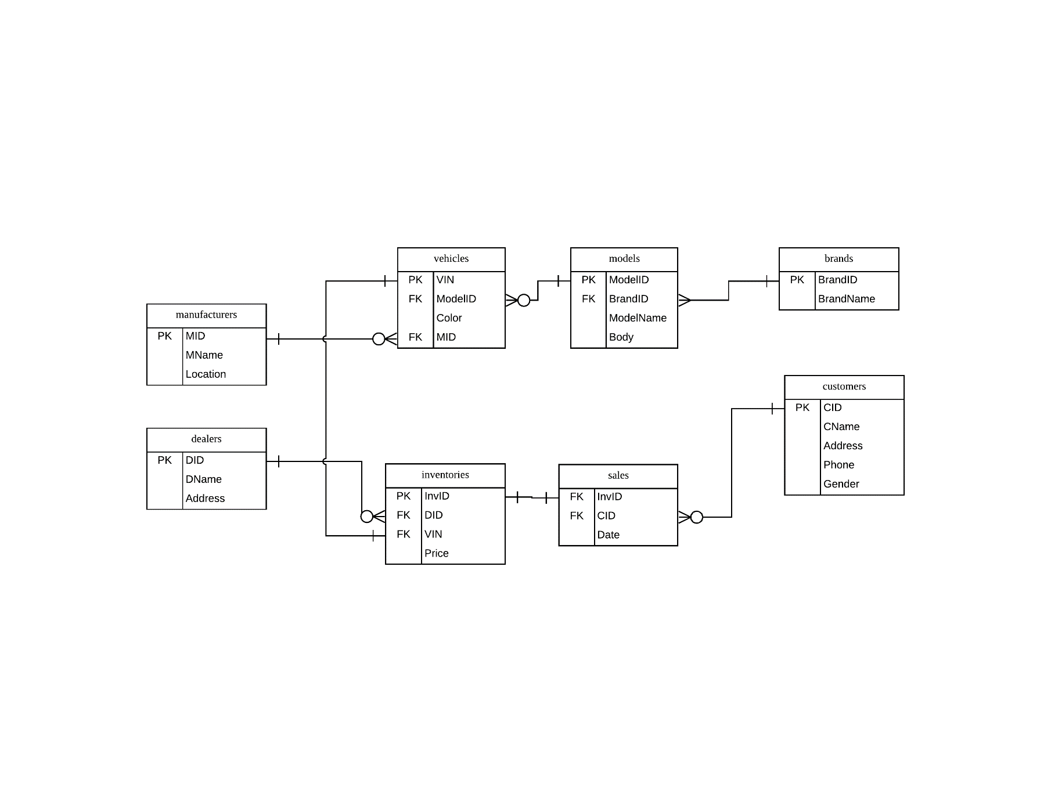

“Vehicles” table includes all information about every existing car. Dealers will choose cars from “vehicles” table, add it to “inventories” and assign a price for each vehicle. Also dealer have to be sure that the car he wants to add is not in the inventory of other dealer, in other words, the VIN of this car must not appear in “inventories” table. Customers will choose cars from “inventories”. The same model of car can have different dealer, manufacturer and price, so a customer has many options. When a customer has chosen a car he likes, it will be added to “sales” table. Also we should check whether this car is already purchased or not, in other words, it must not appear in “sales” table.

**The program structure**

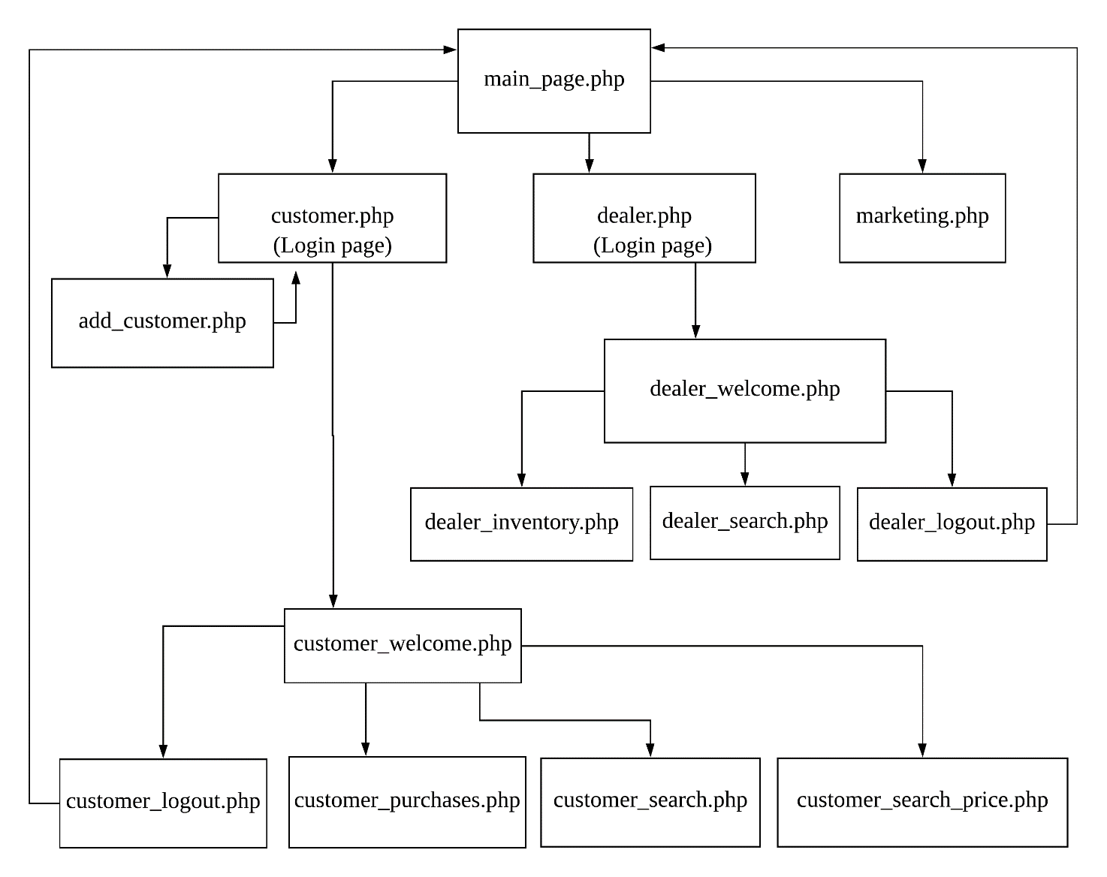

**Queries**

**customer_welcome.php**

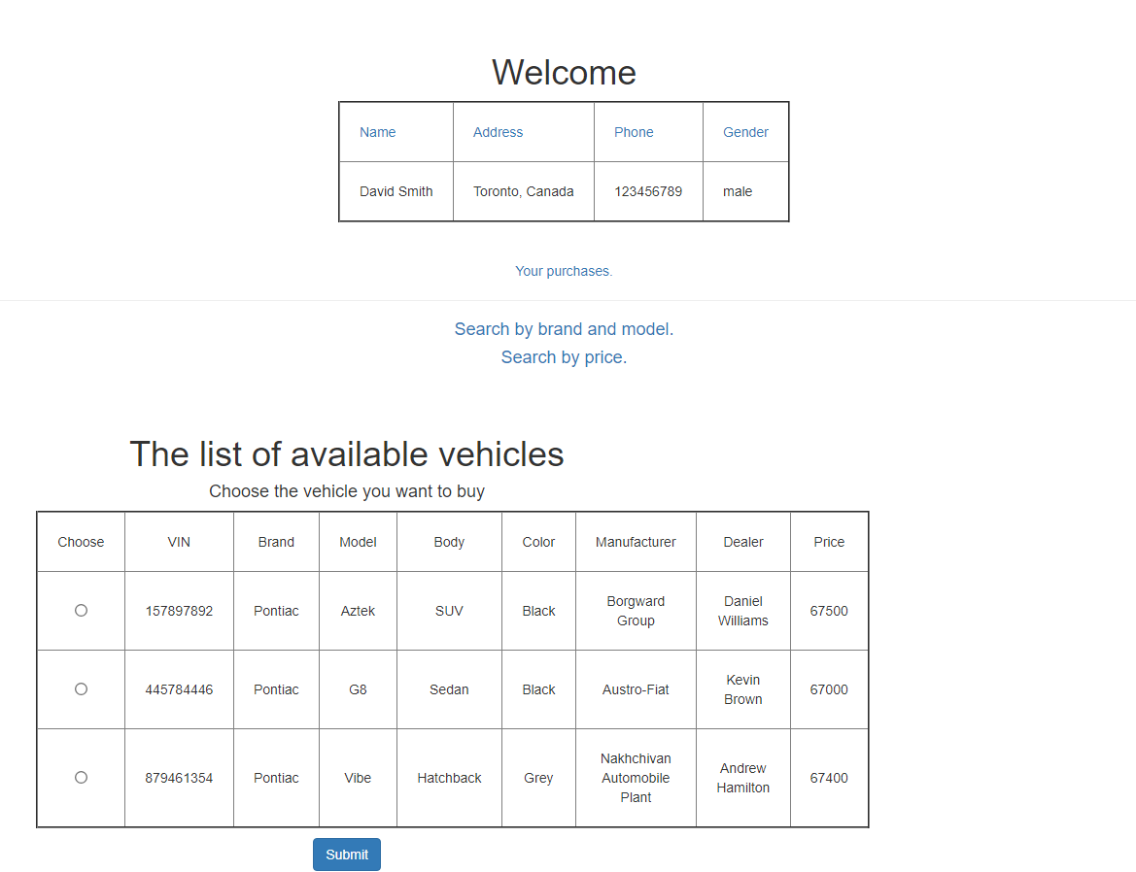

Select d.InvID, VIN, BrandName, ModelName, Body, Color, MName, DName, d.Price from

(Select InvID, Price, DName from dealers, inventories where inventories.DID=dealers.DID) as d right join

(Select InvID, inventories.VIN, BrandName, ModelName, Body, Color, MName from

(select VIN, BrandName, ModelName, Body, Color, MName from models, vehicles, brands, manufacturers where vehicles.ModelID=models.ModelID and brands.BrandID=models.BrandID and manufacturers.MID=vehicles.MID) as a right join inventories on inventories.VIN=a.VIN) as m on d.InvID=m.InvID where d.InvID not in (select InvID from sales);

**customer_search_price.php**

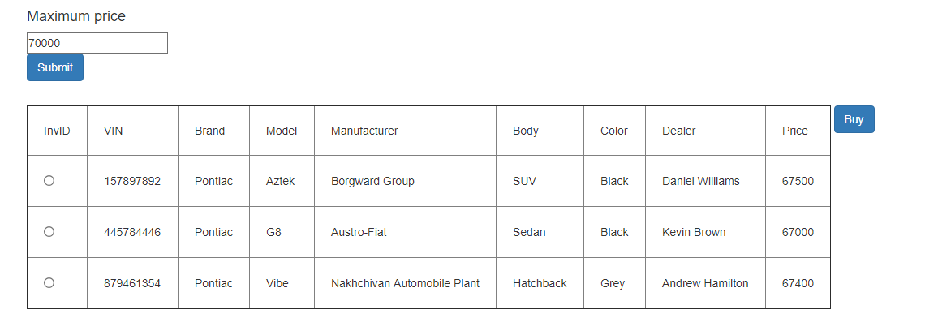

Select d.InvID, VIN, BrandName, ModelName, Body, Color, MName, DName, d.Price from

(Select InvID, Price, DName from dealers, inventories where inventories.DID=dealers.DID) as d

right join

(Select InvID, inventories.VIN, BrandName, ModelName, Body, Color, MName from

(select VIN, BrandName, ModelName, Body, Color, MName from models, vehicles, brands, manufacturers where vehicles.ModelID=models.ModelID and brands.BrandID=models.BrandID and manufacturers.MID=vehicles.MID) as a right join inventories on inventories.VIN=a.VIN) as m

on d.InvID=m.InvID where d.InvID not in (select InvID from sales) and d.Price<='.$maxprice.';

**customer_search.php**

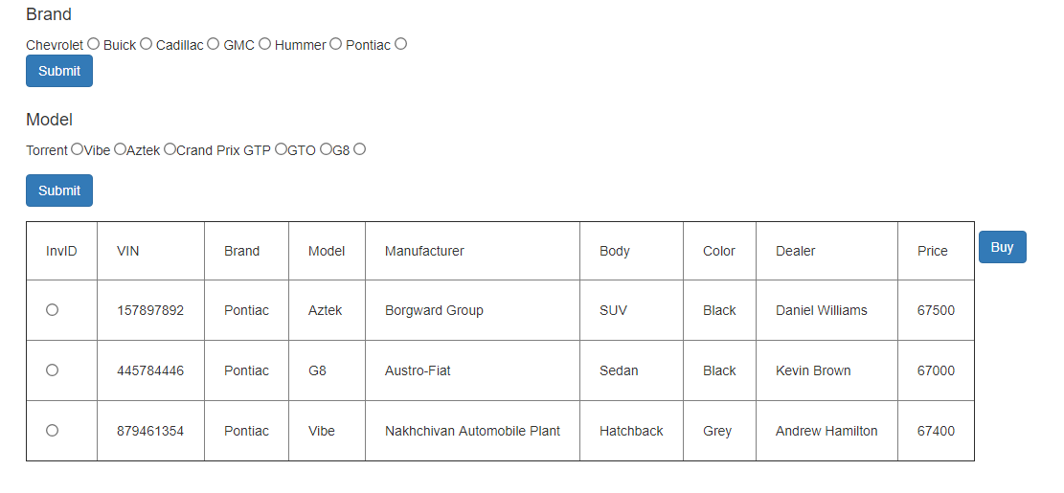

Select d.InvID, VIN, BrandName, ModelName, Body, Color, MName, DName, d.Price from

(Select InvID, Price, DName from dealers, inventories where inventories.DID=dealers.DID) as d

right join

(Select InvID, inventories.VIN, BrandName, ModelName, Body, Color, MName from

(select VIN, BrandName, ModelName, Body, Color, MName from models, vehicles, brands, manufacturers where vehicles.ModelID=models.ModelID and brands.BrandID=models.BrandID and manufacturers.MID=vehicles.MID) as a right join inventories on inventories.VIN=a.VIN) as m

on d.InvID=m.InvID where d.InvID not in (select InvID from sales) and BrandName="'.$brand.'" ;

Select d.InvID, VIN, BrandName, ModelName, Body,Color, MName, DName, d.Price from

(Select InvID, Price, DName from dealers, inventories where inventories.DID=dealers.DID) as d

right join

(Select InvID, inventories.VIN, BrandName, ModelName, Body,Color, MName from

(select VIN, BrandName, ModelName, Body, Color, MName from models, vehicles, brands, manufacturers where vehicles.ModelID=models.ModelID and brands.BrandID=models.BrandID and manufacturers.MID=vehicles.MID) as a right join inventories on inventories.VIN=a.VIN) as m

on d.InvID=m.InvID where d.InvID not in (select InvID from sales) and ModelName="'.$model.'";

**customer_purchases.php**

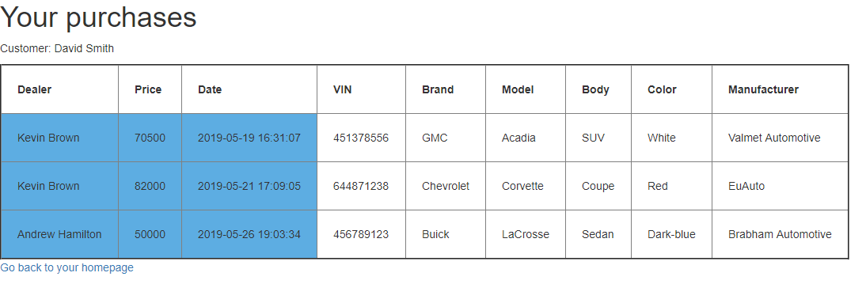

Select InvID, CName, DName, Price, Date, VIN, BrandName, ModelName, Body, Color, MName

From (Select sales.InvID, VIN, BrandName, ModelName, Body, Color, MName, DName, Price, sales.Date, sales.CID from

(Select d.InvID, VIN, BrandName, ModelName, Body, Color, MName, DName, d.Price from

(Select InvID, Price, DName from dealers, inventories where inventories.DID=dealers.DID) as d right join

(Select InvID, inventories.VIN, BrandName, ModelName, Body, Color, MName from

(select VIN, BrandName, ModelName, MName, Body, Color from models, vehicles, brands, manufacturers where

vehicles.ModelID=models.ModelID and brands.BrandID=models.BrandID and manufacturers.MID=vehicles.MID) as a right join inventories on inventories.VIN=a.VIN)

as m on d.InvID=m.InvID)

as x right join sales on sales.InvID=x.InvID)

as z left join customers on customers.CID=z.CID where CName='".$cname."';

**dealer_welcome.php**

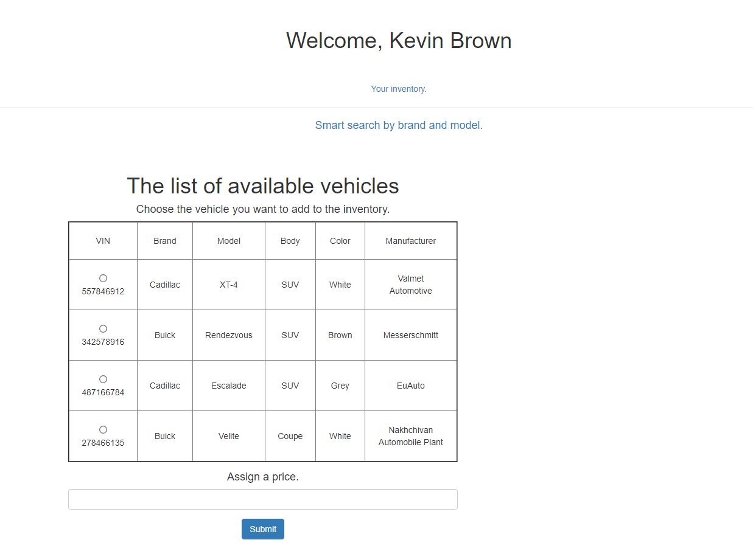

SELECT VIN, BrandName, ModelName, Body, Color, MName FROM vehicles, brands, models, manufacturers where models.BrandID=brands.BrandID and models.ModelID = vehicles.ModelID and manufacturers.MID=vehicles.MID and vehicles.VIN NOT IN (select VIN from inventories);

**dealer_search.php**

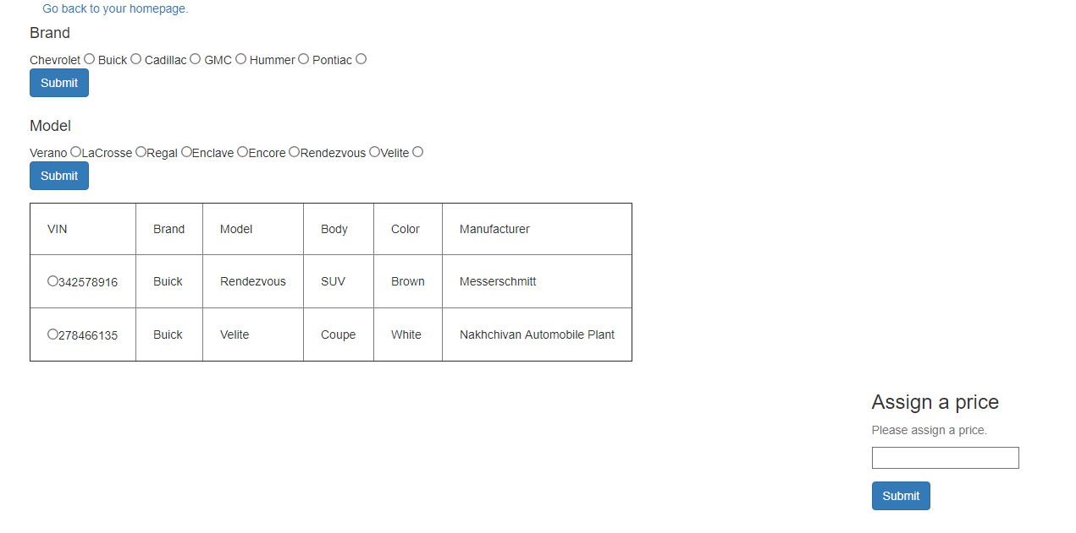

SELECT VIN, BrandName, ModelName, Body, Color, MName FROM vehicles, brands, models, manufacturers

where models.BrandID=brands.BrandID and models.ModelID = vehicles.ModelID and manufacturers.MID=vehicles.MID and vehicles.VIN NOT IN (select VIN from inventories) and BrandName="'.$brand.'" ;

SELECT VIN, BrandName, ModelName, Body, Color, MName FROM vehicles, brands, models, manufacturers

where models.BrandID=brands.BrandID and models.ModelID = vehicles.ModelID and manufacturers.MID=vehicles.MID and vehicles.VIN NOT IN (select VIN from inventories) and ModelName="'.$model.'";

**dealer_inventory.php**

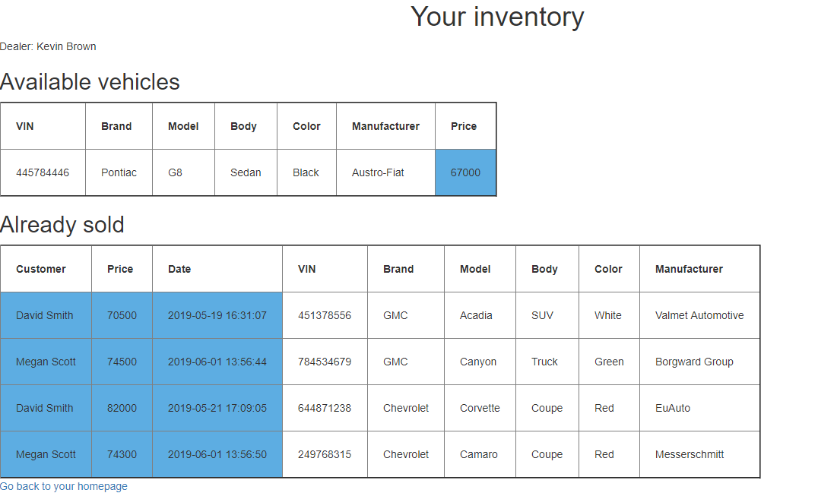

Select DID, inventories.VIN, BrandName, ModelName, Body, Color, MName, Price from inventories right join (SELECT VIN, BrandName, ModelName, Body, Color, MName FROM vehicles, brands, models, manufacturers

where models.BrandID=brands.BrandID and models.ModelID = vehicles.ModelID and manufacturers.MID=vehicles.MID) as a on inventories.VIN=a.VIN where DID=? and InvID NOT IN (select InvID from sales);

Select CName, Price, Date, VIN, BrandName, ModelName, Body, Color, MName

From (Select sales.InvID, VIN, BrandName, ModelName, Body, Color, MName, DName, Price, sales.Date, sales.CID from (Select d.InvID, VIN, BrandName, ModelName,Body,Color, MName, DName, d.Price from (Select InvID, Price, DName from dealers, inventories where inventories.DID=dealers.DID) as d right join (Select InvID, inventories.VIN, BrandName, ModelName, Body,Color, MName from (select VIN, BrandName, ModelName, MName, Body,Color from models, vehicles, brands, manufacturers where vehicles.ModelID=models.ModelID and brands.BrandID=models.BrandID and manufacturers.MID=vehicles.MID) as a right join inventories on inventories.VIN=a.VIN) as m on d.InvID=m.InvID) as x right join sales on sales.InvID=x.InvID)

as z left join customers on customers.CID=z.CID where DName=?;

**marketing.php**

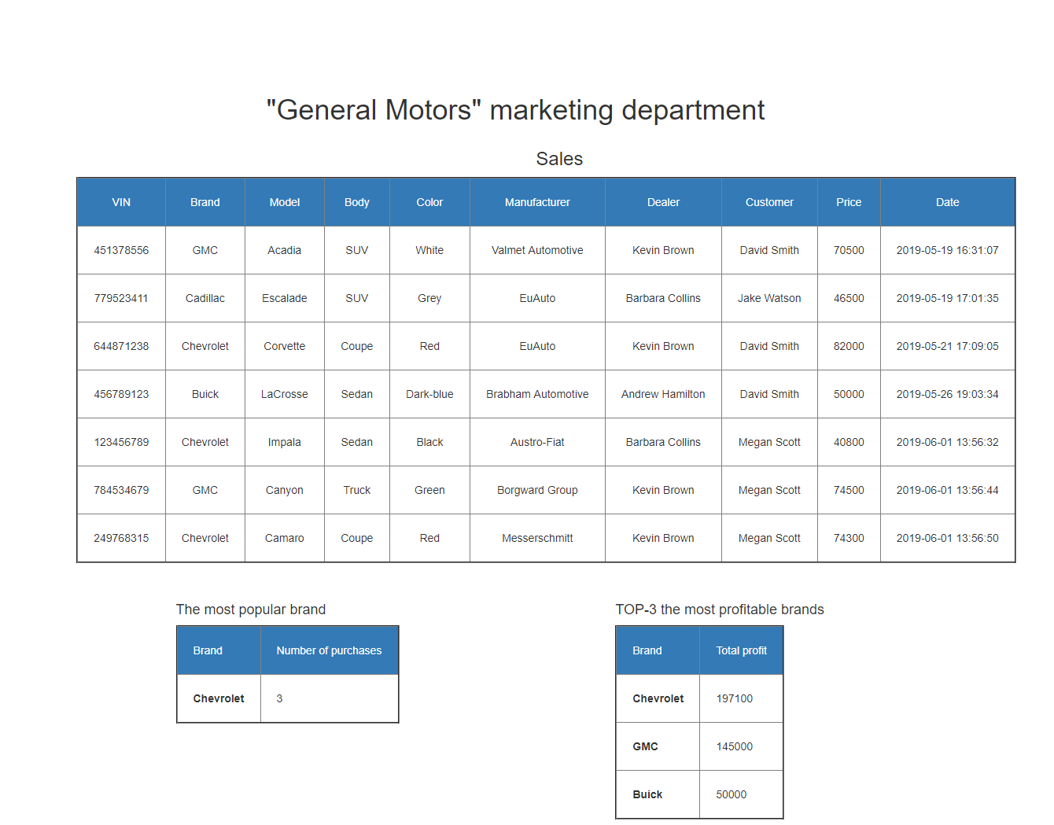

Select InvID, CName, DName, Price, Date, VIN, BrandName, ModelName, Body, Color, MName

From (Select sales.InvID, VIN, BrandName, ModelName, Body, Color, MName, DName, Price, sales.Date, sales.CID

From (Select d.InvID, VIN, BrandName, ModelName, Body, Color, MName, DName, d.Price from

(Select InvID, Price, DName from dealers, inventories where inventories.DID=dealers.DID) as d right join (Select InvID, inventories.VIN, BrandName, ModelName, Body, Color, MName from

(select VIN, BrandName, ModelName, MName, Body, Color from models, vehicles, brands, manufacturers where vehicles.ModelID=models.ModelID and brands.BrandID=models.BrandID and manufacturers.MID=vehicles.MID) as a right join inventories on inventories.VIN=a.VIN)

as m on d.InvID=m.InvID) as x right join sales on sales.InvID=x.InvID) as z left join customers on customers.CID=z.CID;

SELECT BrandName, count(*)

FROM (SELECT BrandName FROM sales, inventories, vehicles, models, brands where

sales.InvID=inventories.InvID and inventories.VIN=vehicles.VIN and vehicles.ModelID=models.ModelID and models.BrandID=brands.BrandID) a

GROUP BY BrandName

HAVING count(*) > 1

ORDER BY count(*) DESC LIMIT 1;

SELECT BrandName, sum(Price)

FROM (SELECT BrandName, Price FROM sales, inventories, vehicles, models, brands where

sales.InvID=inventories.InvID and inventories.VIN=vehicles.VIN and vehicles.ModelID=models.ModelID and models.BrandID=brands.BrandID) a

GROUP BY BrandName Order by sum(Price) desc limit 3;