

Blockchain Technologies 1
Final Project: Crowdfunding DApp
Instructor: Sayakulova Zarina
Team: Nauryzbay Tomiris (SE-2436)
Aisulu Azimkhan
Medina Klyumova
Submission Date: Feb 9, 2026

Astana IT University
2026
Table of Contents
1. Abstract - 3 -
2. Introduction - 3 -
3. Objectives and Requirements - 3 -
4. System Architecture and Overview - 4 -
5. Smart Contract Design - 6 -
6. Tokenization and Test Token - 7 -
7. Frontend and MetaMask Integration - 7 -
8. Deployment Scenarios (Local and Testnet) - 8 -
9. Testing and Validation - 9 -
10. Results and Demonstration - 9 -
11.Project Roles and Contributions - 11 -
12. Conclusion - 12 -
13. References - 12 -

1. Abstract
This report presents a decentralized crowdfunding application developed for the Blockchain Technologies 1 final examination. The system includes Solidity smart contracts, a custom ERC-20 reward token, and a JavaScript frontend integrated with MetaMask. The DApp runs on Ethereum test environments, with local network deployment used for demonstration and validation. The report details architecture, smart contract logic, frontend interaction, deployment steps, and test results supported by screenshots.

2. Introduction
Crowdfunding is a widely used fundraising model in which many individuals contribute small amounts of money toward a collective goal.
Traditional crowdfunding relies on centralized platforms that act as intermediaries and hold funds until a project reaches its target. In contrast, blockchain technology enables decentralized crowdfunding by using smart contracts as transparent and immutable rules for campaign creation, contribution management, and fund distribution.
This project implements a simple decentralized crowdfunding application (DApp) using Ethereum, Solidity, and a JavaScript frontend. The system is designed specifically for educational purposes and operates strictly in test environments. No real cryptocurrency is involved. The project demonstrates end‑to‑end blockchain interaction, including smart contract deployment, user authentication through MetaMask, and transaction execution.

3. Objectives and Requirements
Primary objectives
- Design and implement Solidity smart contracts that encode crowdfunding logic.
- Develop a frontend interface allowing users to create campaigns and contribute.
- Integrate the application with MetaMask for wallet access and transaction signing.
- Implement a custom ERC‑20 token as a reward mechanism.
- Ensure the entire system runs on an Ethereum test network or a local blockchain.
Functional requirements
- Campaign creation with a title, funding goal, and deadline.
- Contributions with accurate tracking of individual amounts.
- Campaign finalization after deadline.
- Refunds if the campaign fails to reach its goal.
- Automatic issuance of reward tokens proportional to contributions.
Constraints
- Only Ethereum test networks are allowed.
- No real cryptocurrency usage.
- Tokens must be purely educational and have no monetary value.

Our Git repository:
https://github.com/tomirisnauryzbai07/crowdfunding-dapp.git

4. System Architecture and Overview
The developed DApp follows a straightforward operational flow:
- Campaign creation
A user defines a new campaign by providing a title, a funding target (goal), and a duration (deadline).
- User contribution
Any user can contribute test ETH to a campaign before its deadline.
- Reward distribution
Each contribution triggers the minting of reward tokens, demonstrating tokenization concepts.
- Campaign finalization
After the deadline, the campaign is finalized.
- If the goal is achieved, the collected ETH is transferred to the campaign owner.
- If the goal is not achieved, contributors are entitled to refunds.
This process is fully automated by smart contracts and does not rely on trusted intermediaries.

The architecture consists of four principal layers:

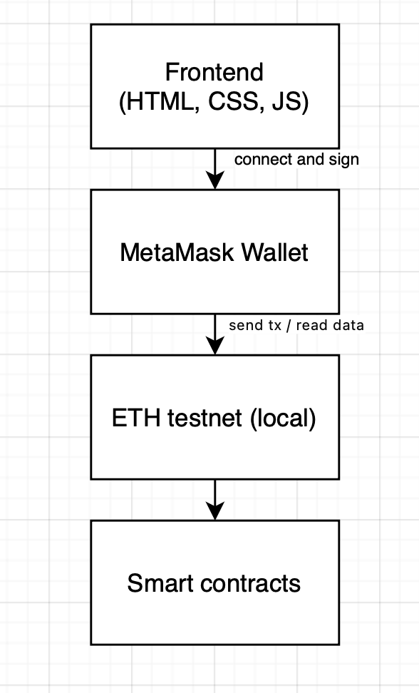
[Figure 1] System architecture of the DApp.
I should illustrate the interaction between these components (see Figure 1).
- Frontend Layer (HTML/CSS/JavaScript)
Responsible for user interaction, form input, and data display.
- Wallet Layer (MetaMask)
Provides access to user accounts and ensures transaction signing.
- Blockchain Layer (Ethereum Testnet / Localhost)
Executes smart contracts and stores campaign data.
- Smart Contract Layer
Implements the business logic: campaign lifecycle and token rewards.

5. Smart Contract Design
The blockchain logic is split into two contracts for modularity and clarity:
5.1 Crowdfunding Contract
This contract is responsible for campaign management. Each campaign is represented by a structured record containing:
- title: text identifier
- goal: funding target in ETH
- deadline: timestamp of campaign end
- owner: address of the campaign creator
- totalRaised: total ETH contributed
- finalized: Boolean flag indicating completion status
Key functions:
- createCampaign(title, goal, durationSeconds) — creates a new campaign.
- contribute(id) — accepts ETH and updates contribution records.
- finalizeCampaign(id) — closes campaign after deadline.
- refund(id) — allows refunds if goal not met.
5.2 Reward Token Contract
A minimal ERC‑20 token used for educational rewards. It includes:
- Standard ERC‑20 fields (name, symbol, decimals, totalSupply).
- mint function restricted to the crowdfunding contract.
The separation ensures that campaign logic and token logic remain cleanly isolated.

6. Tokenization and Test Token
The system uses two forms of test assets:
6.1 Test ETH
Test ETH is used as the contribution currency. In this project, testing was performed on a local Hardhat blockchain, where each account is pre‑funded with 10,000 ETH. This guarantees that all contributions are purely simulated and do not involve real funds.
6.2 Reward Token
The reward token represents a simplified incentive model:
- Rate: 1000 tokens per 1 ETH contributed
- Purpose: Demonstrate token minting and balance tracking
- Value: None (educational only)
Tokens are minted only in the local test environment and reset when the local blockchain is restarted. This aligns with the academic constraint that no real assets are used.

7. Frontend and MetaMask Integration

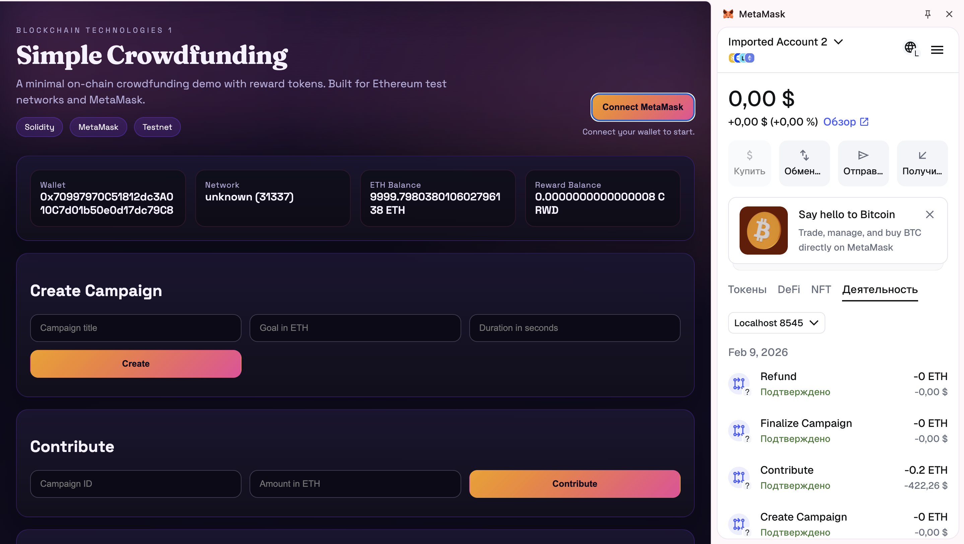
[Figure 2] Wallet connection and balance display.

The frontend provides a minimal yet complete user experience:
- Wallet connection — requests account access via eth_requestAccounts.
- Network check — confirms the user is connected to a valid network.
- Campaign creation — allows form input and on‑chain submission.
- Contribution flow — sends payable transactions.
- Finalization and refund — triggers end‑of‑campaign actions.
- Balance display — shows ETH and reward token balances.
- Campaign list — provides an overview of all campaigns.
Figure 2 should show the connected wallet and balances (see Figure 2).

8. Deployment Scenarios (Local and Testnet)
Local Deployment (used for development and demo)
- Start a Hardhat node (npx hardhat node).
- Deploy contracts locally (npm run deploy:local).
- Update frontend addresses.
- Connect MetaMask to Localhost 8545 (Chain ID 31337).
- Perform test transactions.
This method is safe, fast, and free, making it ideal for demonstrations.

9. Testing and Validation
Automated tests validate:
- Correct campaign creation.
- Contribution tracking.
- Reward token minting.
- Finalization conditions.
- Refund conditions.
Manual testing was also performed through the user interface to confirm full end‑to‑end functionality.

10. Results and Demonstration

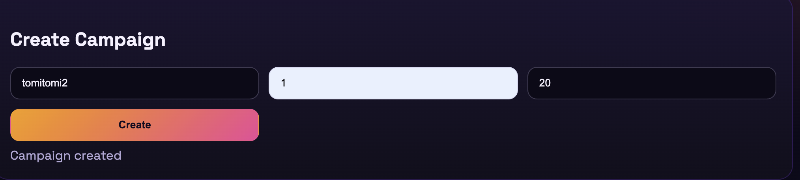
[Figure 3] Campaign Creation workflow
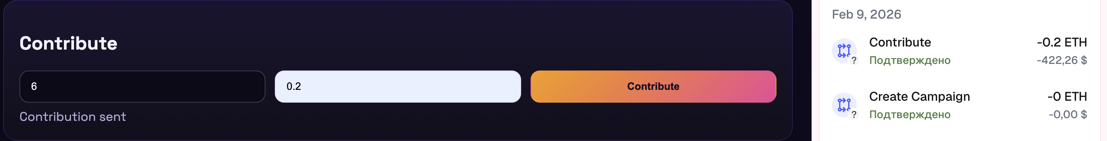
[Figure 4] Contribution transaction.
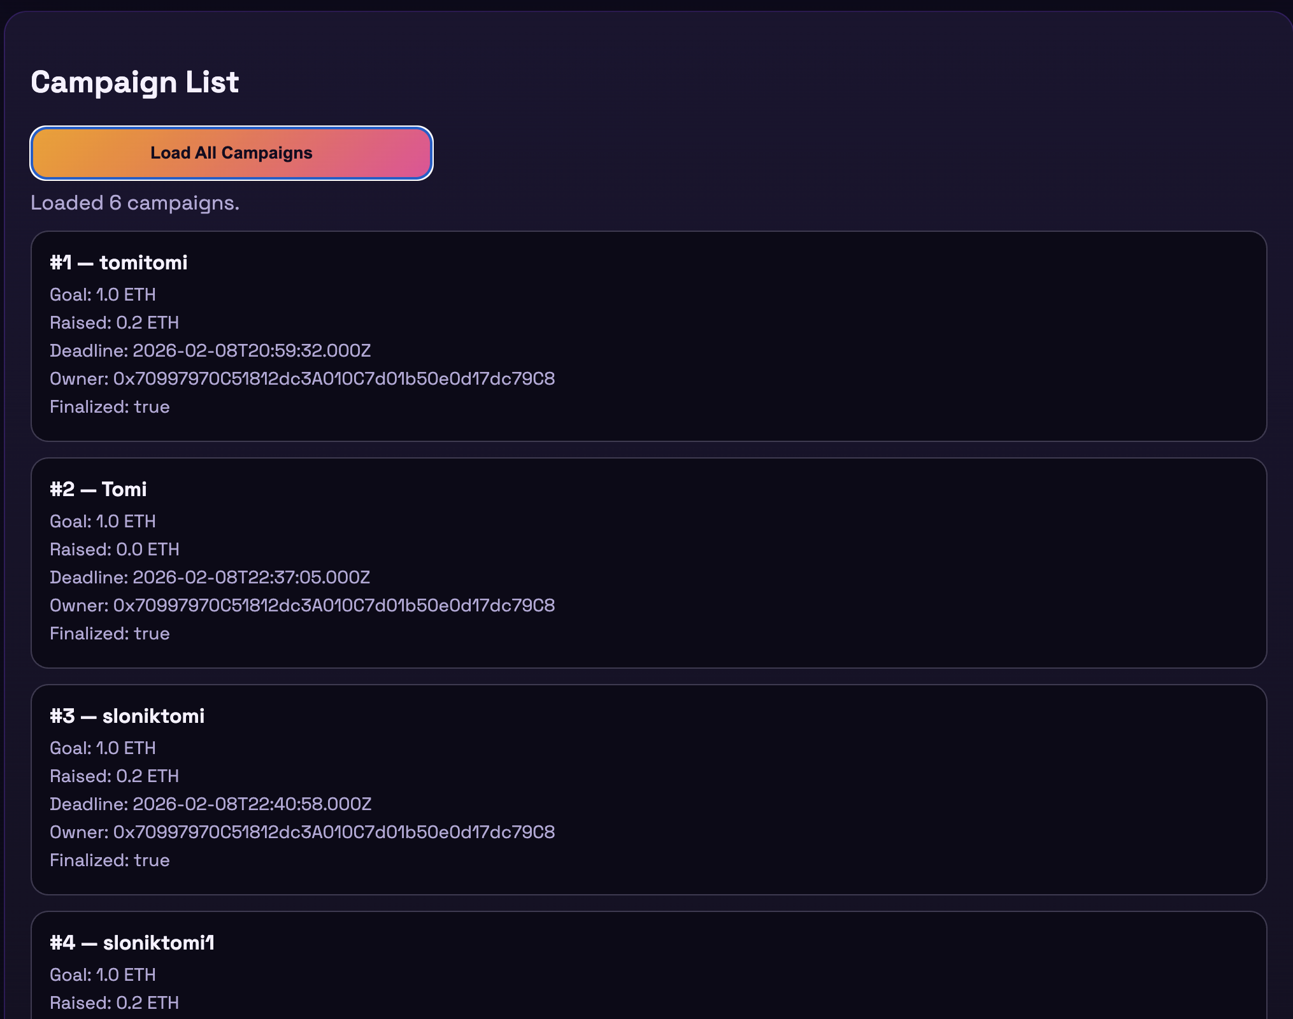
[Figure 5] Campaign list interface.

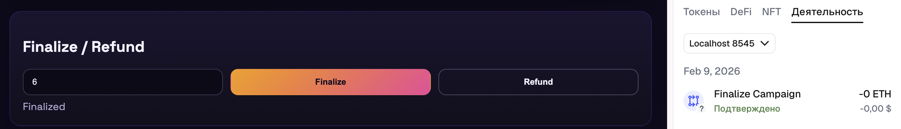
[Figure 6] Finalization Flow
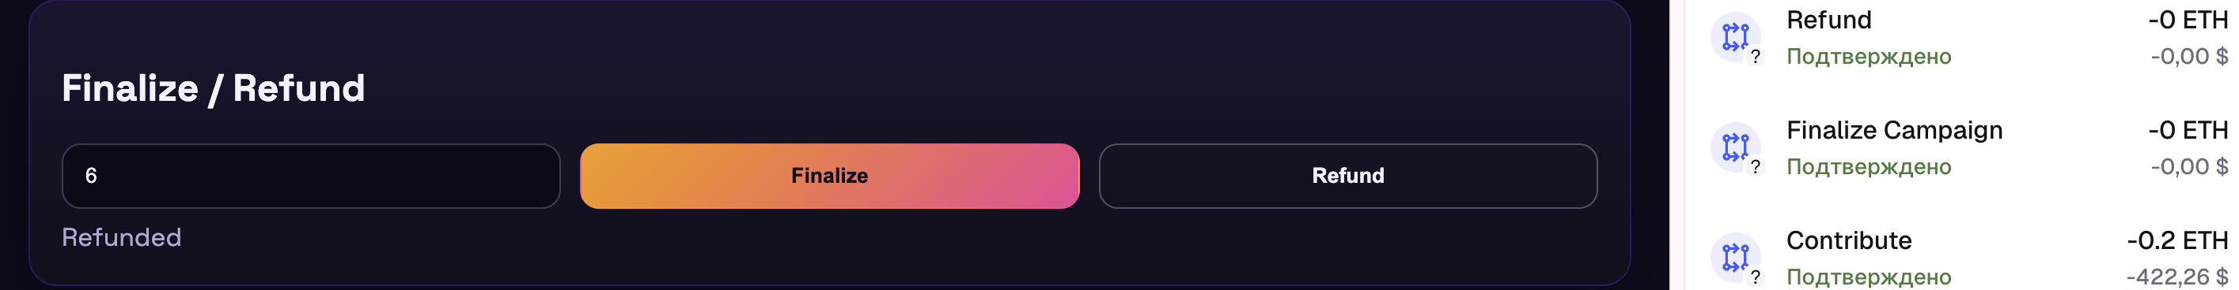
[Figure 7] Refund Flow

Campaign Creation
The campaign creation step verifies that a user can define a fundraising goal and deadline, and that the smart contract stores this data on-chain. After clicking Create, the DApp sends a transaction via MetaMask, and the UI confirms success (see Figure 3). This demonstrates that the system accepts campaign metadata and generates a new campaign
Contribution
This step confirms that contributions are properly recorded by the smart contract. The contributor sends test ETH, and the DApp displays a success message after the transaction is mined (see Figure 4). At this moment, the contributor also receives reward tokens, which verifies the tokenization requirement.
Campaign List
The campaign list view proves that the frontend can read data from the blockchain and render it correctly. Each card shows the campaign’s goal, total raised amount, owner, and finalization status (see Figure 5). This demonstrates read‑only blockchain interaction and transparency for users.
Finalization / Refund
Finalization can only be performed after the deadline, which confirms that the smart contract enforces time constraints. If the campaign reaches its goal, the funds are released to the owner; otherwise, contributors can request refunds. The UI confirms the transaction result (see Figure 6 and 7), proving that campaign closure logic works correctly.

11.Project Roles and Contributions

- Nauryzbay Tomiris: smart contract development, frontend integration, deployment, and documentation.
- Aisulu Bagdat: presentation preparation and design.
- Medina: participated in review and coordination discussions.

12. Conclusion

The project successfully demonstrates a complete decentralized crowdfunding workflow on Ethereum test infrastructure. The use of smart contracts guarantees transparent campaign logic, while the ERC-20 reward token illustrates tokenization principles. MetaMask integration provides real-world interaction patterns, and the local test environment ensures safe experimentation without financial risk. Overall, the system meets all academic requirements and provides a functional example of a blockchain-based DApp.

13. References

- Ethereum Foundation. Ethereum Documentation.
- Ethereum Foundation. Sepolia Testnet Documentation.
- MetaMask. MetaMask Developer Documentation.
- Hardhat. Hardhat Documentation.
- OpenZeppelin. ERC‑20 Token Standard Reference.

