RECUPERATORIO 4TO PARCIAL INGLES
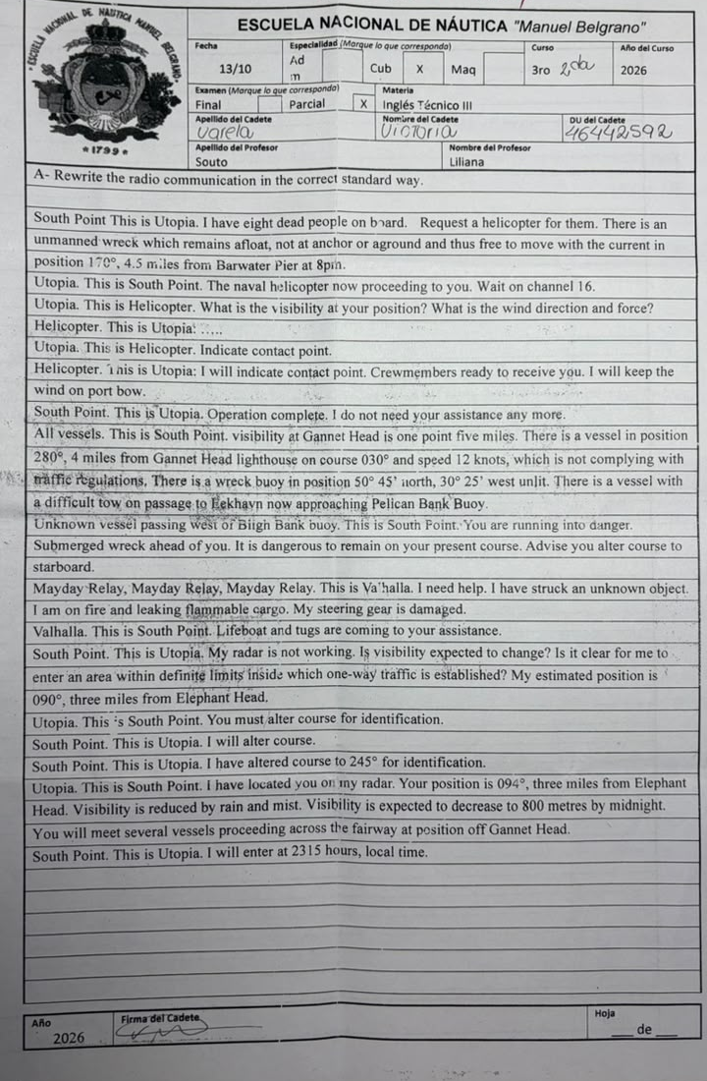

SPR,SPR,SPR. This is U,U,U. OVER
U,U,U. This is SPR,SPR,SPR. OVER

SPR. This is U. INFORMATION. I have 8 casualties on board. My position is 6-7 degrees 4-1 minutes north, 0-4-1 degrees 1-2 minutes east. REQUEST. I require a helicopter to pick up casualties. WARNING. There is a derelict adrift in position 1-7-0 degrees, 4 decimal 5 miles from BP at 2-0-0-0 hours, local time. OVER.

U. This is SPR. INFORMATION. The naval helicopter is on his way to you. INSTRUCTION. Stand by on channel 1-6. OVER.

SPR. This is U. INTENTION. I will stand by on channel 1-6. OVER.

U,U,U. This is NH,NH,NH. OVER.
NH,NH,NH. This is U,U,U. OVER.

U. This is NH. QUESTION. What is the visibility at your position? What is the relative wind direction and force? OVER. / and force in degrees and knots? OVER.

NH. This is U. ANSWER. Visibility at my position is 2 decimal 5 miles. Present relative wind direction is 2-4-5 degrees on port bow, force 4 / ,speed 2-5 knots. OVER.

U. This is H. INSTRUCTION. Indicate the pick up area. OVER.
NH. This is U. INTENTION. I will indicate the pick up area. I will keep the wind on port bow. INFORMATION. The landing party is ready to receive you. OVER.

SPR. This is U. Information. The operation has been completed. Your assistance is no longer required. OVER.

ATTENTION, ATTENTION, ATTENTION all vessels. This is SPR. Situation report.
Part 1. There is a vessel in position 2-8-0 degrees, 4 miles from GH lighthouse on course 0-3-0 degrees, speed 1-2 knots, which is not complying with traffic regulations. There is a vessel with a difficult tow on passage to E closing up PB buoy.
Part 2. Visibility at GH is 1 decimal 5 miles.
Part 3. There is an unlit isolated danger buoy in position 5-0 degrees 4-5 minutes north, 0-3-0 degrees 2-5 minutes west. OVER.

Vessel passing west of BB buoy, Vessel passing west of BB buoy, Vessel passing west of BB buoy. This is SPR,SPR,SPR. OVER.
SPR,SPR,SPR. This is V,V,V. OVER.

V. This is SPR. WARNING. You are steering a dangerous course. It is dangerous to keep your present course. INFORMATION. There is a wreck ahead of you. ADVICE. Advise you alter course to starboard. OVER.

MAYDAY, MAYDAY, MAYDAY. This is V. I have collided in position 8-6 degrees 0-2 minutes north, 1-2-3 degrees 2-2 minutes west. I am on fire. I am leaking dangerous goods. My steering gear is inoperative. I need help. OVER.
/ MAYDAY RELAY, MAYDAY RELAY, MAYDAY RELAY. This is SPR. Following received from vessel V. I have collided in position…

V. This is SPR. INFORMATION. Life boat and tugs are coming to your assistance. OVER.

