**The Role of Emotional Compared to Political Involvement in Attitude Polarization as Modeled by the Cusp**

Tom Yishay

Department of Psychology, University of Amsterdam

7203BTPMXY: Bachelor Project Psychology

Adam Finnemann

February 1, 2021

**Abstract**

The present study investigated the role of emotional compared to political involvement in the polarization of attitudes outlined by the cusp. Attitudes were thus modeled as a dynamic system consisting of sudden and non-linear interactions. A sample of Twitter posts (n = 4000) was evaluated using domain-specific lexicons. Users’ lexicon means (n = 2891) were encoded as the cusp’s dependent (AFINN lexicon) and involvement (Political or NRC Affect Intensity lexicons) variables. Fitting the cusp depended on restriction tests and involvement types, resulting in restricted and unrestricted political and emotional models. All cusp models fitted better than linear models. Likewise, the restricted emotional and unrestricted political models fitted the best. In line with the hypothesis, both elevated involvement types resulted in attitude polarization. Political involvement demonstrated more such polarization. Unexpectedly, emotional involvement was overall high and political involvement correlated with attitudes. The use of lexicons and Twitter data is therefore discussed.

**The Role of Emotional Compared to Political Involvement in Attitude Polarization as Modeled by the Cusp**

Polarization of attitudes, the growing disagreement between parties considering identical evidence, is an increasing social issue in recent decades (Martin, 2015; Iyengar et al., 2018). Emotional and political involvements have been shown to be central elements in this process. (Iyengar et al., 2012, 2018). Political involvement refers to the adoption of beliefs and values associated with one's political group. Likewise, emotional involvement refers to one's personal identification with a group resulting in an unfavorable depiction of out-group members. Attitudes regarding political topics have become progressively polarized in the last three decades (Martin, 2015). Research on attitude polarization has consistently linked such polarization to social discrimination (Iyengar et al., 2018). Americans were found to discriminate between Democrat and Republican individuals when considering romantic partners, friendships, and residency locations (Stoker & Jennings, 1995). Secondly, heterogenous party identification has been shown to decrease prosocial behavior and acceptance of job applications, and increase economic inequality in the US (Iyengar et al., 2018). Thirdly, medical advice and healthcare services were found to deviate across patients depending on their political identification (Hersh & Goldenberg, 2016). While scholars globally recognize the detrimental social ramifications of attitude polarization, a debate exists concerning this issue's root (Iyengar et al., 2018). Particularly, more research is needed to determine the role of emotional compared to political involvement regarding attitude polarization in the mass public (Iyengar et al., 2012, 2018; Abramowitz & Saunders, 2008). Modelling such phenomenon has also been shown to benefit from complex and non-linear models (van der Maas et al., 2003). Therefore, the present study investigates the role of emotional versus political involvement in the polarization of attitudes by fitting a large Twitter dataset to the cusp model of complexity science.

Theoretical frameworks of complexity science have been previously used to investigate attitude polarization (Strogatz, 2015; van der Maas et al., 2003). Such frameworks conceptualize attitude polarization in terms of its temporal, interactive, and rapidly changing components. One way of modeling such a complex phenomenon is as a dynamical system (Scheffer, 2009; van der Maas et al., 2003). The phenomenon is then formulated mathematically as a system in terms of change in its parameters with respect to time. Importantly, parametric change is often limited by external or internal factors thereby deeming the system's stability. One such limitation is the constraint imposed by the environment of the system- the system's carrying capacity. To illustrate, a human population can be seen as a complex system with a few parameters such as birth rates, limited by natural resources. Whether available resources are scarce or plentiful determines the population's overall stability (the system) via changes in birth rates (the parametric change). Consequentially, a potential null change in the system's parameters may be reached, indicating an equilibrium state. In the human population example, an equilibrium point occurs when there is zero change in birth rates. Such equilibria can be stable or unstable, depending on the system's alternations following a disturbance. In stable equilibria, the system's state is preserved given small disturbances; in unstable equilibria, the same disturbances result in a rapid shift from the system's original state (Sharov, 1996). This point is illustrated in Figure 1, where the ball represents the state of the system. In the case of unstable compared to stable equilibria, a small push to either direction will result in a considerable rather than negligible change in the ball's position. Therefore, stable unlike unstable equilibria, manifest a resilient state as small disturbances cause minor changes in the system. In dynamic systems, the parameters participating in equilibria can be outlined regarding their effect on the systems' total equilibria. For instance, a human population might have two equilibrium points when the average global temperature is X, but three points when it is X+1. A “bifurcation” is the term used to describe the numeric change in a system's equilibrium points relative to a given parameter, as depicted by Figures 2 and 3 (Strogatz, 2015). Both Figures demonstrate a change in the number of equilibria over time concerning a parameter (delta or r in the Figures). Bifurcations are further classified regarding their unique patterns. The Pitchfork bifurcation manifests an increase of the system's equilibria from one to three points with an increasing distance between the equilibria as the pattern progresses (Figure 2). Additionally, only two of the three equilibria are stable, affecting the system's overall stability (Figure 2, solid lines). In the human population, the state of X+1 (two stable equilibria) compared to X (one stable equilibrium) global temperature, implies less overall stability as two diverging states are available for the system. Secondly, the Double-saddled bifurcation displays a pattern where certain and unequal parametric values lead to sudden transitions in the system’s equilibria, thereby influencing the system's stability. Figure 3 shows a Double-saddled bifurcation in which for different values of delta (blue/green arrows), the system's stable equilibria rapidly shifts (red dots). The integration of these two bifurcations derives the "cusp "model.

**Figure 1**

*Visualized Stable and Unstable Equilibria (Winterbone, 1997)*

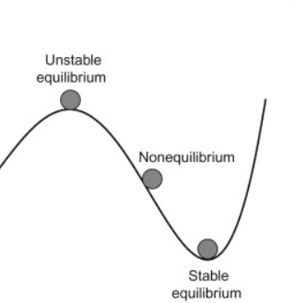

**Figure 2**

*The Pitchfork Bifurcation: A Shit from One to Two Increasingly Diverging Stable Equilibria in R (Masoller, n.d.)*

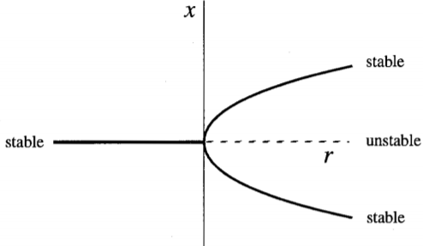

**Figure 3**

**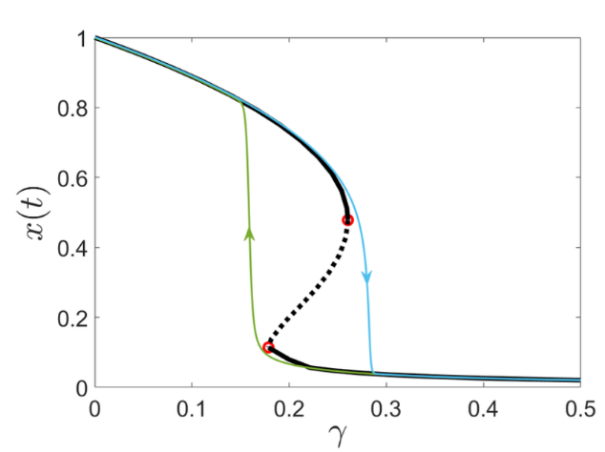***The Double-saddled Bifurcation Diagram of Parameter X Relative to Parameter Delta (Alkhayuon, 2018)*

Van der Maas et al. (2003) applied the cusp model to attitude change, unfolding the phenomena by non-linear interactions and sudden transitions (Strogatz, 2015; Scheffer, 2009). In this model, information, involvement, and attitudes are encoded as the escalating, splitting, and dependent variables respectively (Figure 4, axes). As Figure 4 shows, when involvement is low, the relationship between attitude and information is linear (path B). In this case, the system consists of a single equilibrium point, indicating smooth transitions and stability. However, as involvement increases and the cusp point is reached (the fold in Figure 4), two bifurcation patterns derive non-linear and sudden interactions between the models' parameters (path A). Firstly, the Pitchfork bifurcation reflects two stable equilibria diverging increasingly from one another as involvement rises. In Figure 1, assuming that X and r represent attitudes and involvement respectively, attitudes concentrate around two separated equilibria as involvement increases. Secondly, the transitions from one stable equilibrium to another depending on information are sudden and inequal, indicating the Double-saddled bifurcation. Meaning, attitudes show transitions for inequal values of information and are absent around intermediate values. In Figure 3, assuming that X and delta represent attitudes and information, attitudes exhibit sudden transitions between stable equilibria (solid lines) at different informational values (blue/green arrows). Likewise, intermediate values are neglected due to an unstable equilibrium (dashed line). The Pitchfork and Double-saddled bifurcations are thus fundamental to the systematic assessment of the cusp's fit to attitude polarization. First, when involvement is low, attitudes and information interact linearly with a unimodal distribution (Figure 4, path B). However, once involvement is high (Figure 4, path A), four consequences regarding attitude change (also called "catastrophe flags") arise: (1) multimodality- attitudes are multi-modally distributed, (2) inaccessibility- the array of intermediate values between these two modes is inaccessible for attitudes, (3) sudden transitions- changes in attitudes arise given minor alternations in information, and (4) hysteresis- depending on the mode, different values of information lead to sudden transitions in attitudes. Finally, van der Maas et al. (2003) found support for the cusp model's overall validity in attitude polarization, based on large datasets of political attitudes.

**Figure 4**

*The Cusp Model of Attitudes (van der Maas et al., 2003)*

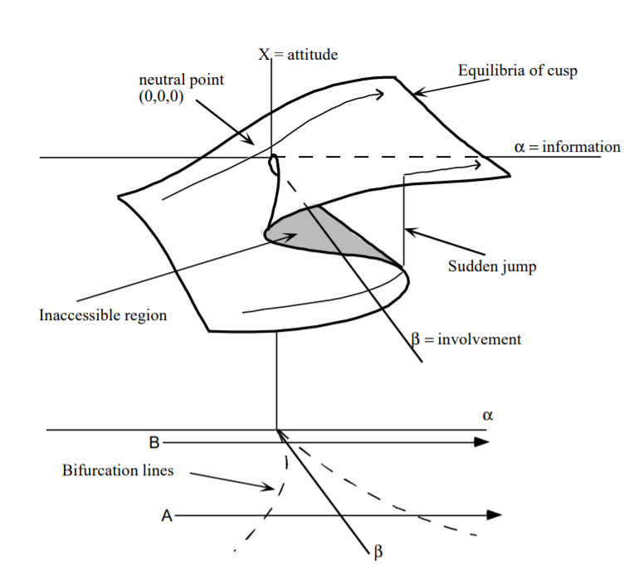

Previous research suggests that politically or emotionally involved individuals exhibit polarized attitudes regarding political topics (Keeter, 2015; Iyengar et al., 2018; Martin, 2015). Garimella and Weber (2017) analyzed longitudinal data from 679,000 Twitter users in the US, showing that attitude polarization rooted in political discourse has increased over the past eight years for involved individuals. Political involvement was assessed using users' Twitter networks and the posts' content. Likewise, surveys measuring political orientation between 1994 and 2014 demonstrated an increasing political polarization in involved individuals (Keeter, 2015). The medians of scores representing consistently Democrat or Republican identifiers have dramatically drifted apart over the twenty years period. Regarding emotional involvement, an analysis of 38 million tweets concerning climate change indicated polarization of attitude among emotionally involved individuals (Tyagi et al., 2020). Similar to political involvement, users' networks and posts were analyzed to determine emotional involvement and polarization. In conclusion, previous research offers some evidence that politically or emotionally involved individuals hold polarized attitudes on both social media and traditional platforms.

The above studies and literature support the application of the cusp model in the context of political attitude polarization using Twitter data. Firstly, the cusp model has been shown by prior research to constitute an adequate fit to attitude polarization (van der Maas et al., 2003). Secondly, previous studies support the notion of attitude polarization stemming from both emotional and political involvements and in off and online settings (Garimella, & Weber, 2017; Keeter, 2015; Tyagi et al., 2020). Thirdly, previous research supports the use of Twitter for the study of attitude polarization regarding different political topics such as climate change (Tyagi et al., 2020; Garimella, & Weber, 2017). To this end, the present study hypothesizes that highly politically or emotionally involved individuals will exhibit polarized attitudes. This hypothesis reflects an assessment of the cusp model’s Pitchfork bifurcation as attitudes are expected to distribute bio-modally for high levels of involvement.

Nonetheless, the literature on attitude polarization rooted in political and emotional involvements stresses two fundamental issues (Iyengar et al., 2018). Firstly, evidence regarding attitude polarization in the mass public is conflicted. While some studies found increased polarization in public political attitudes, others have failed to replicate this pattern (Fiorina et al., 2008; Abramowitz et al., 2008). Secondly, the notion of involvement types is actively debated in the literature of attitude polarization (Iyengar et al., 2012). The role of emotional versus political involvement regarding attitude polarization remains unknown. Research comparing the two types of involvement is thus highly relevant to understanding the development of attitude polarization (van der Maas et al., 2003). Altogether, scholars have stressed the need for studies employing large samples from the general public and the distinct role of political compared to emotional involvement in attitude polarization.

The present study sheds light on the above problems by fitting a large sample of Twitter users' data to the cusp model. Firstly, the analysis of Twitter data, Twitter analytics, is highly beneficial to the present study (Golder & Macy, 2014). Twitter analytics allows for the collection of large-scale and diverse datasets that are practically impossible to obtain otherwise. Therefore, Twitter analytics enables the exploration of attitude polarization in the general public and enhances the results' generalizability. Additionally, the suitability of Twitter data to non-linear models, as the cusp model, is empirically supported by past investigations (Arias et al., 2018). Nevertheless, Twitter data may consist of users' confirmation of their own opinions by reinforcing and seeking information cohesive with their worldviews. Furthermore, online communication contrasts with real-life interactions in fundamental ways, potentially reducing the validity of such scientific findings (Golder & Macy, 2014). Despite the above limitations, Twitter data analytics is used in the present study to investigate attitude polarization. As for quantifying involvement types and attitudes, the present study employs word lexicons. Lexicons are lists of words, each associated with a value used to calculate an individual's overall orientation in a certain domain (Taboada et al., 2011). In this study, attitudes are assessed for political (Vail, 2017; see Appendix A) and emotional (Mohammad, 2017) involvements as well as attitudes’ valence (Nielsen, 2011). These verbal lexicons were developed and tested using Twitter data and thus are in line with the present study’s design. Finally, in line with previous studies, individuals scoring high on the political or emotional lexicons are predicted to exhibit polarized attitude valence scores.

**Method**

**Sample**

A sample of 4000 Twitter posts was downloaded using the package "rtweet" in RStudio (Kearney et al., 2020; RStudio Team, 2021). Posts were limited to the US, written in English, and between the 29th of December 2020 and the 5th of January 2021. Retweets were excluded. Finally, only posts containing one of the following words and hashtags were included: "climate, climatechange, climatecrisis, #climate, #climatecrisis, #climatechange, #globalwarming”. After processing the data as described in the procedure section, 2891 Twitter users were included in the analysis. Given the large number of observations, concerns of statistical power were disregarded.

**Materials**

***Fitting the Cusp model***

All cusp model fittings were executed using the "cusp" function from the "cusp" package in RStudio (Grasman et al., 2009). Three inputs were passed to the function: (1) the dependent variable, (2) the involvement/splitting variable (beta), and (3) the information/escalating variable (alpha).

***Dependent variable***

Users' mean scores across posts based on the AFINN lexicon (Nielsen, 2011). This lexicon contains 2477 words, each corresponding to a or negative value. Values range from -5 (= extremely negative attitude) to 5 (= extremely positive attitude). To illustrate, the word "catastrophic" corresponds to a value of -4.

***Information variable (alpha)***

The alpha parameter was estimated or not depending on the restriction tests performed, as discussed in the analysis plan.

***Involvement variable (beta)***

Users' mean scores across posts according to the Political (Vail, 2017) or the NRC Affect Intensity (Mohammad, 2017) lexicons. The Political lexicon was originally designed to categorize attitudes as Republican or Democrat. This lexicon contains 966 words with values ranging from -4 (= very Republican) to 4 (= very Democrat). Since this study's aim is deeming any type of political involvement, the lexicon was rescaled. The lexicon's values were made absolute such that the transformed lexicon's values range from 1 (= low political involvement) to 4 (= high political involvement). Thus, lower or higher values correspond to any political involvement, Republican or Democrat. For example, the word "weapons" originally corresponding to a value of -4 (= very Republican), matches a value of 4 (= very politically involved) in the transformed lexicon. The NRC Affect Intensity lexicon consists of 4547 words, corresponding to values ranging from 0 (= no emotional) to 0.99 (= extremely emotional). An example item is the word "brutality" corresponding to a value of 0.96 (= extremely emotional).

***Model comparison assessment***

Model comparison, as discussed in the analysis plan, will be assessed using three methods. Firstly, the Akaike information criterion (AIC; Akaike, 1974) examines a model's ability to fit data simulated from itself using the maximum likelihood estimate of the model while accounting for the number of independent variables. Meaning, the model explaining the utmost variation in the data while using the fewest independent parameters, is the best fit. Secondly, the Bayesian information criterion (BIC; Schwarz, 1978) assesses a model's posterior probability function, assuming the model is true. For both measurements, lower scores indicate a better model's fit. Thirdly, models estimated from different data sets will be assessed visually using plots.

**Analysis plan**

***Fitting the cusp model***

Data were fitted to the cusp model four times. Firstly, the present study compares two variants of the cusp model based on the involvement variable. For political involvement models, users' mean scores on the Political lexicon were used to estimate the involvement variable. For emotional involvement models, the involvement variable was estimated using users' mean scores on the NRC Affect Intensity lexicon. Secondly, restriction tests were applied comparing restricted to unrestricted versions of the emotional and political cusp models. In this study, the restriction was examined by estimating alpha from the same data as beta (unrestricted models) or by setting alpha to one (restricted models). Restriction tests examine whether the benefit of adding a parameter to the model (thereby increasing the models' flexibility) is smaller than the cost of an extra parameter. In the present study, restriction tests indicated whether: (1) beta and the dependent variable (attitudes) correlate, and (2) the data used to estimate beta fits the Pitchfork bifurcation as depicted by the cusp. Since alpha is not operationalized in the present study, restricted emotional and political cusp models should fit best. This implies that users' involvement and AFINN lexicons means should not correlate. Likewise, users' means on involvement lexicons should load on beta (involvement parameter) larger than on alpha (information parameter). Thus, unrestricted models should perform worse or identically to restricted ones as only beta was operationalized in the present study.

***Model comparison procedure***

The four models (un/restricted emotional and un/restricted political models) underwent three levels of model comparison: (1) restriction, (2) linearity, and (3) involvement type. Firstly, restricted versus unrestricted versions of the political and emotional involvements models were compared. Secondly, all four cusp models were compared to linear models' fit of the same data. Thirdly, the polarization of attitudes was assessed for political compared to emotional involvement. Importantly, restriction and linearity compare models fitted on the same data set, whereas involvement types differ in the data used to estimate beta (Political or NRC Affect Intensity means). Consequently, the AIC and BIC were only applicable for restriction and linearity. Attitude polarization was inspected by visually assessing the presence of a Pitchfork bifurcation for emotional and political involvement types. Meaning, examining the shift from unimodal to bio-modal distribution for politically compared to emotionally involved individuals.

***Plots***

The Pitchfork bifurcation was visualized by plotting both the cusp's control plate, and the conditional distribution of users' AFINN means (Grasman et al., 2009). As for the first, beta/involvement values (y-axis) are plotted against alpha/informational values (x-axis). The Pitchfork bifurcation is evident whenever data falls within the gray area, namely the bifurcation lines (see Figures 6 and 7). As for the second, the distributions of users' mean scores on the AFINN lexicon (x-axis) were plotted against five quantile groups of users' means on the Political or NRC Affect Intensity lexicons (y-axis). For political involvement, only users scoring low on the NRC Affect Intensity lexicon were plotted while for emotional involvement, only users scoring low on Political lexicon were plotted. This ensured plotting data that corresponded to either involvement types, but not both. In these conditional distributions, the shift from unimodal to bimodal distribution for higher quantile groups, indicates the Pitchfork bifurcation.

**Procedure**

Twitter posts (n = 4000) were downloaded to RStudio using the function "search_tweets" ("rtweet" R-package). Posts were then sorted by Twitter usernames, tokenized per username, and matched with the Political, NRC Affect Intensity, and AFINN lexicons' words. Unmatching words or users lacking scores on either of the lexicons were removed. Consequently, users' mean scores (n = 2891) were calculated according to the values of each lexicon. This resulted in three means per user: (1) mean attitude valence (AFINN lexicon), (2) mean political involvement (Political lexicon), and (3) mean emotional involvement (NRC Affect Intensity lexicon). These means were then encoded as inputs to the function "cusp" (“cusp” R-package). The function fitted four models: (1) restricted emotional involvement, (2) restricted political involvement, (3) unrestricted emotional involvement, and (4) unrestricted political involvement. In all four models, users' mean scores on the AFINN lexicon were encoded as the dependent variable. The information variable was estimated (unrestricted) or set to one (restricted) depending on the restriction tests. The involvement variable was estimated from users' mean scores on the Political (political models) or NRC Affect Intensity (emotional models) lexicons. Cusp and linear models' AIC and BIC scores and coefficients were then calculated for all four models.

**Results**

The distributions of users’ mean scores on all lexicons (n = 2891) are displayed in Figure 5. Next, users’ means were fitted to the un/restricted emotional and political cusp models cusp models.

**Figure 5**

*Distribution of Users’ Means on the Political, NRC Affect Intensity, and AFINN Lexicons*

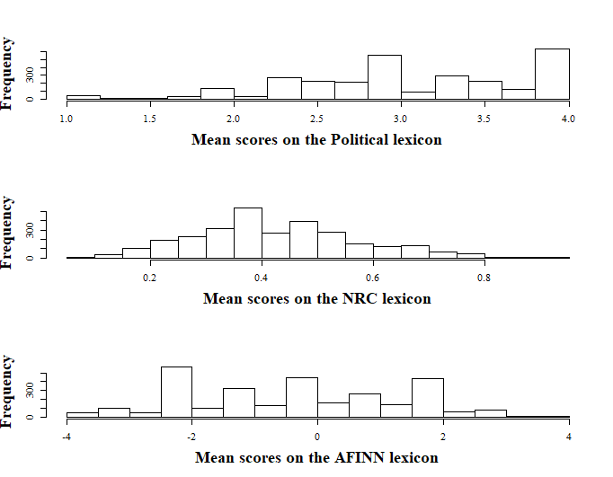

Cusp models were compared on three dimensions: (1) linearity, (2) restriction, and (3) involvement type (see Table 1). All cusp models' AIC and BIC scores were lower than those of the linear models. This indicates a better fit of the cusp compared to linear models overall. As for restriction, while both BIC and AIC scores were the lowest for the unrestricted political model, emotional models showed mixed results. Although the AIC criterion was slightly lower for the unrestricted (AIC = 7844.45, BIC = 7880.27) compared to the restricted (AIC = 7846.41, BIC = 7876.26) emotional model, BIC scores specified the opposite pattern. Since BIC versus AIC scores offer better explanatory model selection (Shmueli, 2010), and since the difference in models' BIC than AIC scores was larger, the restricted emotional model was deemed a better fit. Together, this implies that only users' means on the Political lexicon correlated with means of the AFINN lexicon. Correspondingly, this correlation is visualized in the distribution of users' AFINN means as it skews increasingly to the right for higher means on the Political lexicon (see Figure 8). As for involvement type, although both models demonstrated the Pitchfork bifurcation as data clustered within the bifurcation lines (Figures 6 and7, gray area), such bifurcation was more evident in for political involvement. Users' means on the AFINN lexicon were more bio-modally distributed for higher means on the Political compared to NRC Affect Intensity lexicon (see Figures 8 and 9). Moreover, in the restricted emotional model, users' mean scores on the NRC Affect Intensity lexicon loaded significantly on the involvement variable (*b1* = 0.81, *p* = .003). In the unrestricted political model, the effect of users’ mean scores on the Political lexicon was significant and larger on beta (*b1* = 0.95, *p* < .001) compared to alpha (*a1* = -0.42, *p* < .001) as indicated by the parameters’ estimates. In both models, users' means on the involvement lexicons fitted beta better than alpha.

**Table 1**

*Fit Statistics for all Four Cusp Models*

|  |  |  |
| --- | --- | --- |
| Model | AIC | BIC |
| Emotional restricted cusp  Linear | 7846.41  11331.88 | 7876.26  11349.79 |
| Political restricted cusp  Linear | 7602.31  11131.50 | 7632.16  11149.41 |
| Emotional unrestricted cusp  Linear | 7844.45  11331.88 | 7880.27  11349.80 |
| Political unrestricted cusp  Linear | 7440.90  11131.50 | 7476.72  11149.41 |

**Table 2**

*Standardized Parameter Estimates of the Unrestricted Cusp Models. Values in Parenthesizes are P values.*

|  |  |  |
| --- | --- | --- |
| Model | Normal Factor (*a*) | Splitting factor (*b*) |
| Emotional restricted cusp  0 Constant  1 Emotional involvement | -0.02 (.53)  - | 0.32 (.032)  0.81 (.003) |
| Political unrestricted cusp  0 Constant  1 Political involvement | 1.28***  -0.42*** | -2.30***  0.95*** |

*Note.* ***p < .001.

The Pitchfork bifurcation was examined by visualizing the data's fit on the cusp's control plate and by the conditional distributions of users' means on the AFINN lexicon. Visible in both Figures 6 and 7, all data points clustered within the bifurcation lines with higher beta values located further on the plate. In contrast to the unrestricted political model, data in the restricted emotional model were spread only within the bifurcation lines with merely positive beta values. This indicates high overall involvement in the emotional model. Secondly, users' mean scores on the AFINN lexicon were bio-modally distributed for users who scored higher on both involvement lexicons (Figures 8 and 9, quantile group number five). This is in line with the expectation that high scores on either involvement types will lead to polarized attitudes. However, users' AFINN means were more bio-modally distributed for increasing political compared to emotional involvement. This indicates that the Pitchfork bifurcation is more pronounced in political compared to emotional involvement.

**Figure 6**

*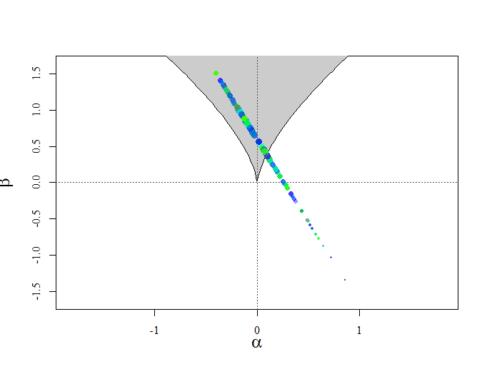Fit of Users’ Means on the Political Lexicon in the Unrestricted Political Cusp Model. Dots’ Color Refers to the Data’s Location on the Model’s Surface Being High (purple) or Low (green)*

**Figure 7**

**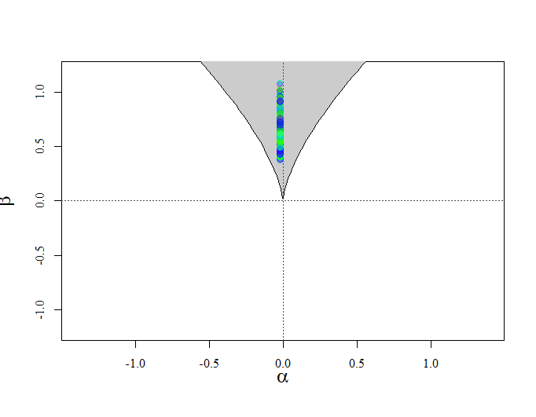***Fit of Users’ Means on the NRC Affect Intensity Lexicon in the Restricted Emotional Cusp Model. Dots’ Color Refers to the Data’s Location on the Model’s Surface Being High (purple) or Low (green)*

**Figure 8**

*The Distribution of Users’ Means on the AFINN Lexicon for Five Quantile Groups Based on Users’ Means on the Political Lexicon*

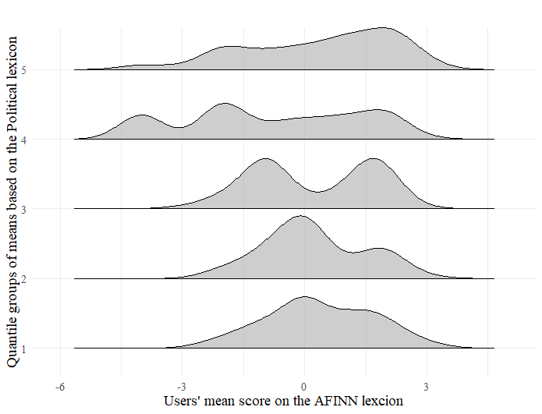

**Figure 9**

*The Distribution of Users’ Means on the AFINN Lexicon for Five Quantile Groups Based on Users’ Means on the NRC Affect Intensity Lexicon*

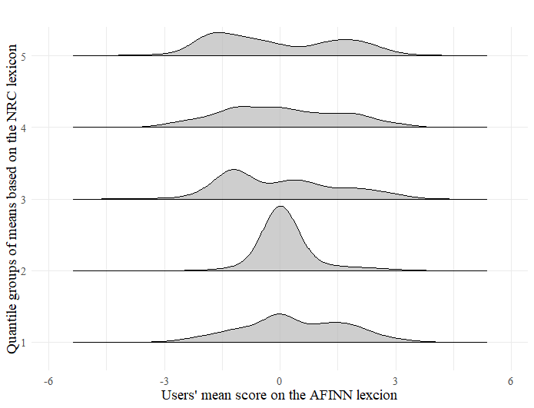

**Discussion**

The present study has investigated the role of emotional compared to political involvement in attitude polarization as modeled by the cusp. In line with the hypothesis, higher emotional or political involvement resulted in more attitude polarization. Both the political and emotional cusp models fitted better than linear ones with involvement loading significantly on the involvement parameter. These findings as well as increased bio-modality for higher involvement (see Figures 8 and 9), support the Pitchfork bifurcation pattern as described by the cusp. Likewise, the political compared to emotional model exhibited a stronger demonstration of the Pitchfork bifurcation. Attitudes were more bio-modally distributed for higher political than emotional involvement. Nonetheless, two unexpected findings challenge these conclusions. Firstly, the correlation between political involvement and attitude valence as indicated by an improved fit of the unrestricted compared to the restricted political cusp model. Secondly, the overall high emotional involvement in the investigated sample as indicated by the data’s clustering only within the bifurcation lines of the restricted emotional cusp (see Figure 7).

The conclusion that high political or emotional involvement leads to attitude polarization is in line with and constitutes a significant contribution to the literature. Specifically, this conclusion is consistent with past Twitter research, which centered political and emotional involvement types in the polarization of attitudes (Garimella & Weber, 2017; Tyagi et al., 2020). Although similar to conclusions drawn by such research, the present study tackles important issues regarding attitude polarization in the literature. Firstly, mixed results regarding attitude polarization in the mass public have imposed a demand for examining large samples in attitude research (Iyengar et al., 2018). Twitter is an easily and freely accessible social platform, thereby constituting a reasonable source for research regarding public attitude polarization. By analyzing close to 3000 Twitter users' posts, the present study finds primary but clear support for attitude polarization in the mass public. Secondly, numerous scholars have debated the comparative role of distinct involvement types in the polarization of attitudes (Iyengar et al., 2018; van der Maas et al., 2003). Despite the correlation between political involvement and attitudes as indicated by the restriction test, attitudes were more polarized for increasing political compared to emotional involvement in the present study (see Figures 8 and 9). Such a finding is an initial resolution to the debate regarding involvement types and polarization as political rather than emotional involvement seems to result in more polarization of attitudes (Iyengar, et al., 2012). Together, the present study's findings constitute primary but relevant answers to fundamental disagreements in attitude polarization literature.

In spite of unexpected findings in the emotional and political models, the cusp's overall validity as a model of attitude polarization was supported. Cusp compared to linear models exhibited a great improvement in models' fit. Respectively, modeling attitude change as a non-linear and complex rather than a linear process, enhances the understating of attitude polarization (van der Mass et al., 2003). Nevertheless, the relationship between involvement and attitudes' valence as portrayed by the cusp model is challenged by the improved fit of the unrestricted versus restricted political model. Contrary to the cusp's assumptions, political involvements and attitude valence were correlated as indicated by the restriction test. Such contradiction may stem from the use of the Political lexicon (Vail, 2017). Compared to the NRC Affect Intensity and AFINN lexicons (Mohammad, 2017; Nielsen, 2011), the Political lexicon consists of less than half of the words. Additionally, the Political lexicon includes merely Democrat or Republican involvements, limiting other types of political involvement. Such lack of a rich collection of terms regarding political involvement may have undermined the lexicon's ability to discriminate between attitudes' valence and involvement. Nonetheless, as the results indicate, involvement loaded significantly and largely on the involvement variable. Future research should examine the Political lexicon's discriminatory ability by applying the lexicon to texts pre-evaluated by researchers regarding their political and attitude valence contents. Likewise, the inclusion of solely high emotionally involved users further complicates the present study's conclusion. Based on the emotional cusp's fit, involvement values were entirely within the bifurcation lines and only positive, indicating elevated emotional involvement. The absence of low emotional involvement may have limited the necessary contrast between varying involvement levels when assessing attitude polarization. Potentially, the nature of Twitter posts might account for such an issue. Twitter posts may often provide an incomplete, brief, and impulsive expression of users' voices, leading to an overestimation of emotional involvement. Nevertheless, due to a reasonable data spread within the bifurcation lines, a relative compression between users' involvement was yet possible. Future research is needed to deem the suitability of Twitter data for the measurement of attitudes. This can be accomplished by measuring and comparing participants’ attitudes using both established tools (questioners or interviews) and their Twitter posts’ content.

In conclusion, modeling attitude polarization as a non-linear and complex rather than a linear phenomenon enhances the understanding of such phenomenon and its related social issues. The polarization of attitudes rising from emotional or political involvement is better modeled by the cusp than linear models. Likewise, political versus emotional involvement, although correlated with attitudes, appears to underline more polarized attitudes. Accordingly, formal modeling of attitude polarization manifests the background to social and practical issues as discrimination and segmentation. The revised conception of attitude polarization as complex and non-linear derived from the cusp model, may therefore optimize future social interventions.

**References**

Abramowitz, A. I., & Saunders, K. L. (2008). Is polarization a myth?. *The journal of politics, 70*(2), 542–555. <https://doi.org/10.1017/S0022381608080493>

Alkhayuon, H. (2018). Rate-induced transitions for parameter shift systems. *ResearchGate*. <https://www.researchgate.net/figure/The-bifurcation-diagram-of-12-contains-three-branches-of-equilibria-two-of-them-are_fig2_333433399>

Arias, M., Arratia, A., & Xuriguera, R. (2014). Forecasting with twitter data. *Transactions on intelligent systems and technology, 5*(1), 1-24. <https://doi.org/10.1145/2542182.2542190>

Akaike, H. (1974). A new look at the statistical model identification. *IEEE transactions on automatic control, 19*(6), 716- 723. <https://doi.org/10.1007/978-1-4612-1694-0_16>

Fiorina, M. P., Abrams, S. A., & Pope, J. C. (2008). Polarization in the American public: Misconceptions and misreadings. *The Journal of Politics, 70*(2), 556-560. <https://doi.org/10.1017/S002238160808050X>

Garimella, V. R. K., & Weber, I. (2017, May). A long-term analysis of polarization on Twitter. In *Proceedings of the International AAAI Conference on Web and Social Media, 11*(1).

Grasman, R. P. P. P., van der Maas, H. L. J., & Wagenmakers, E. J. (2009). Fitting the cusp catastrophe in R: A cusp package primer. *Journal of statistical software, 32*(8), 1-27.   
https://hdl.handle.net/11245/1.313254

Golder, S., & Macy, M. (2014). Digital footprints: opportunities and challenges for online social research. *Annual review of sociology, 40*, 129-152. <https://doi.org/10.1146/annurev-soc-071913-043145>

Hersh, E. D., Goldenberg, M. N. (2016). Democratic and Republican physicians provide different care on politicized health issues. *PNAS, 114*(42), 11811–16. <https://doi.org/10.1073/pnas.1606609113>

Iyengar, S., Lelkes. Y., Levendusky, M., Malhotra, N., & Westwood, S. J. (2018). The origins and consequences of affective polarization in the united states. *Annual review of political science, 22*, 129-146. <https://doi.org/10.1146/annurev-polisci-051117-073034>

Iyengar, S., Sood, G., & Lelkes, Y. (2012). Affect, not ideology a social identity perspective on polarization. *Public opinion quarterly, 76*(3), 405-431. <https://doi.org/10.1093/poq/nfs038>

Kearney, M.W., Heiss, A., & Briatte, F. (2020). Package ‘rtweet’. <https://cran.r-project.org/web/packages/rtweet/index.html>

Keeter, S. (2015). Political polarization and the American public [PowerPoint slides]. *PewReasearchCenter*. <https://consumerfed.org/wp-content/uploads/2016/10/CA15-Keeter.pdf>

Martin, C. J. (2015). Negotiating political agreements. *Political Negotiation: A Handbook*, 7-33.

Masoller, C. (n.d.). Nonlinear systems, chaos and control in engineering [PowerPoint slides]. Universitat Politecnica de Catalunya. <http://www.fisica.edu.uy/~cris/teaching/module1_masoller_part2.pdf>

Mohammad, S. M. (2017). Word affect intensities. *arXiv preprint arXiv:1704.08798.*

Nielsen, F. Å. (2011). A new ANEW: Evaluation of a word list for sentiment analysis in microblogs. *arXiv preprint arXiv:1103.2903.*

RStudio Team. (2021). RStudio: Integrated development for R. PBC, Boston. <http://www.rstudio.com/>

Sharov, A. (1996). Equilibrium: stable or unstable?. <https://web.ma.utexas.edu/users/davis/375/popecol/lec9/equilib.html#:~:text=Equilibrium%20is%20a%20state%20of%20a%20system%20which%20does%20not%20change.&text=An%20equilibrium%20is%20considered%20stable,then%20the%20equilibrium%20is%20unstable>

Scheffer, M. (2020). *Critical transitions in nature and society* (Vol. 16). Princeton University Press. Schwarz, G. (1978). Estimating the dimension of a model. *The annals of statistics, 6*(2), 461- 464.

Shmueli, G. (2010). To explain or to predict. *Statistical science, 25*(3), 289-310. <http://dx.doi.org/10.1214/10-STS330>

Strogatz, S. H. (2018). *Nonlinear dynamics and chaos with student solutions manual: With applications to physics, biology, chemistry, and engineering*. CRC press.

Stoker, L., & Jennings, M. K. (1995). Life-cycle transitions and political participation: The case of marriage. American political science review, 421-433. <https://doi.org/10.2307/2082435>

Taboada, M., Julian, B., Milan, T., Kimberly, V., & Manfred S. (2011). Lexicon-based methods for sentiment analysis. *Computational linguistics, 37*(2), 267-307. <https://doi.org/10.1162/COLI_a_00049>

Tyagi, A., Uyheng, J., & Carley, K. M. (2020). Affective Polarization in Online Climate Change Discourse on Twitter. *arXiv preprint arXiv:2008.13051.*

Vail, C. (2017). MBA 676: Political sentiment lexicon. <https://rpubs.com/colinvail/338458>

van der Maas, H. L. J., Kolstein, R., & van der Pligt, J. (2003). Sudden transitions in attitudes. *Sociological methods & research, 23*(2), 125–152. <https://doi.org/10.1177/0049124103253773>

Winterbone, D. E. (1997). State of equilibrium. *Advanced thermodynamics for engineers*, 1-12. <https://doi.org/10.1016/B978-034067699-8/50003-X>

**Appendix**

**The untransformed Political lexicon as an example (Vail, 2017)**

Words associated with values in the political lexicon. The scores range from 4, most Republican, to -4, most Democratic per word. Averaging the values of all overlapping 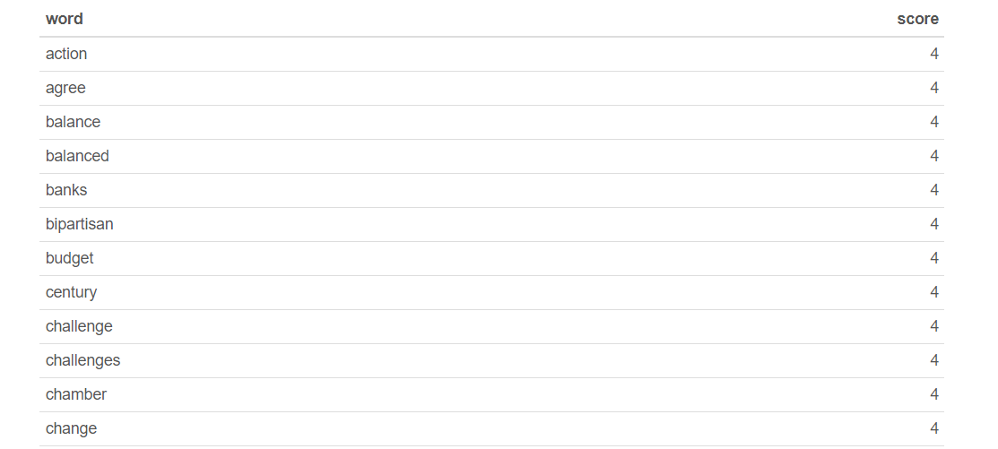words between the a given text and the lexicon, indicates a user’s political orientation/involvement.