#############################################

# #

# Author: Tomislav Miksa #

# Company: NetCheck Gmbh #

# Contact: tomislav.miksa@netcheck.de #

# #

# FOR INTERNAL USE ONLY!!! #

# #

#############################################

## Usage

**Step 1:** Open .pcap (or any other Wireshark form file) File in Wireshark

**Step 2:** *Export Packet Dissections* -> *as “Plain Text” file*

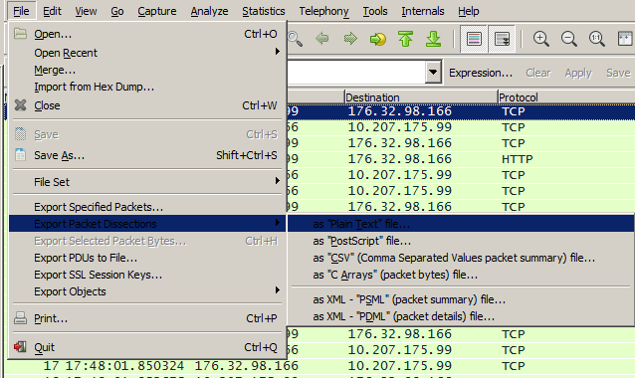

**Step 3:** Make shore *Packet Details* -> *All Expanded* is marked

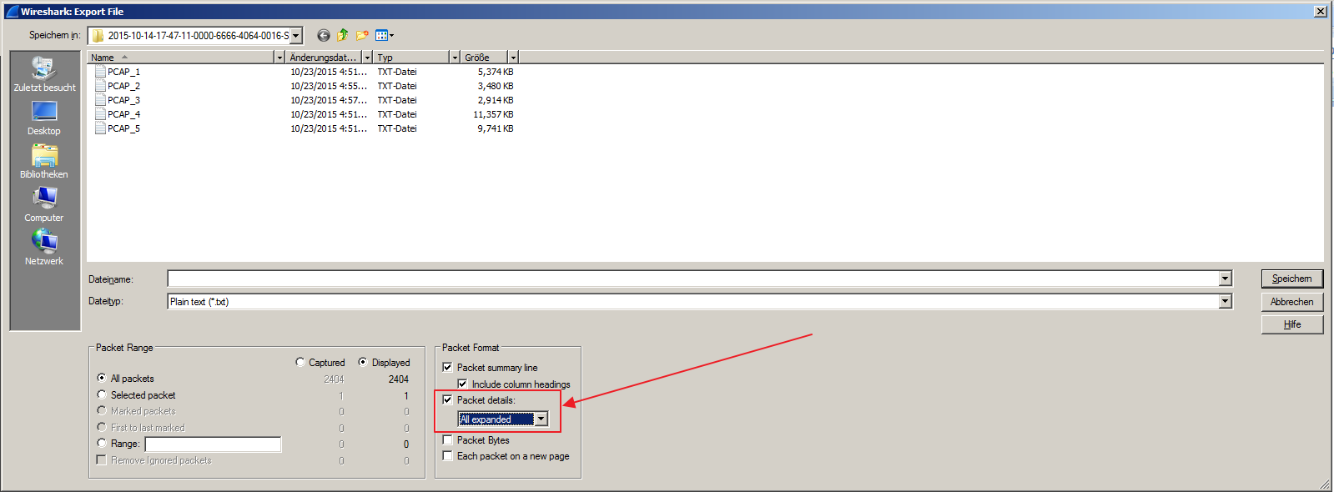

**Step 4:** Repeat Steps 1-3 for all sessions you want to analyze

**Step 5:** Open program to process data, and select file(s) you#ve exported from Wireshark

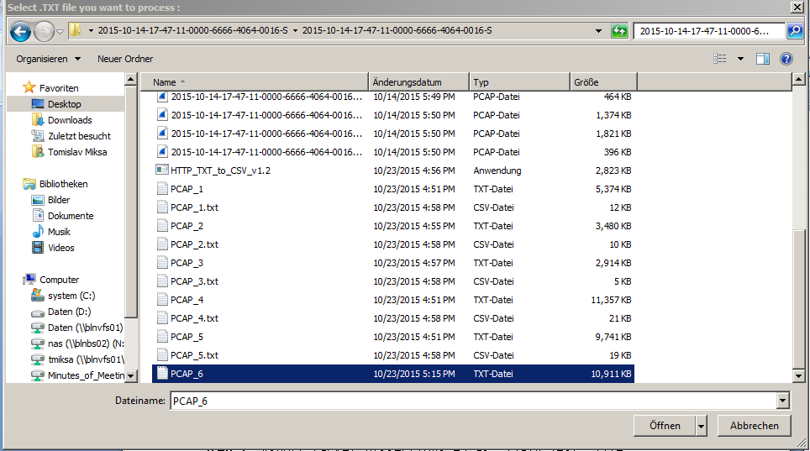

**Step 5:** Confirm File selection

**Step 6:** If your input Process file name was PCAP_6.txt in same folder program will create PCAP_6.txt.csv

In that file you can see information about object downloaded, in which frame was request, in which response. Size of objext, encoding, size transferred over network and so on.

File can be opened in Excell to get table representation of data

## History

v_1.0

- GUI Implemented

- List of Errors

- dummy entry shown in Result CSV

v_1.1

- repaired dummy entry shown in Result CSV

v_1.2

- Application can process multiple selected input files