Author: Israel Ilori
Goal: To implement a multiclass classification
Solution: predict product category based on a consumer complaint.

The Process:
- Import required libraries and read data into pandas
- Extract columns required to answer the problem statement
- Perform exploratory data analysis
- Clean the dataset
- Encode the data label and train the dataset using Traditional ML models
- Evaluate the model

Import required libraries and read data into pandas: To begin any Machine Learning/Natural Language Processing task, a number of packages need to be imported to ensure the entire algorithm runs end-to-end. After ensuring all packages were properly installed and imported, I proceeded to reading the dataset into pandas using the pandas function.

Extract columns required to answer the problem statement: Per the problem solution, which says to implement a multiclass classification model to predict the category of product based on the nature of the complaints, I proceeded into extracting the two columns necessary for this. Why? So as to shrink the size of the data and reduce turn-around-time later to be faced later during training. The two columns were used to form a reduced dataframe and then explored further.

Perform exploratory data analysis: In here, an exploration of the dataset was done, in a bid to use the dataset to answer a few questions. It was observed from the initial data that missing values were present, hence the first goal in this step was removing missing values from the reduced dataframe. The removal of the missing values, led to a further reduction in the entries. data.shape was used to explore the size of the entries which was reported as 813,316 entries for the two (2) columns present.
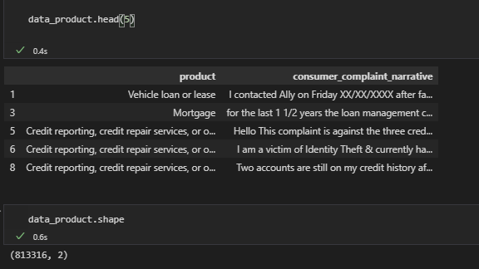
Fig 1.1 A snippet of the top 5 elements of the reduced dataframe, together with its new shape.

Further EDA was done to see which product category had the most number of complaints. A visualisation of the values was done also. In here, more data wrangling can be done to answer more questions such as:
- What month/quarter/year had the most complaints?
- What company reported the most complaints?
- What state were most complaints coming from by product category?
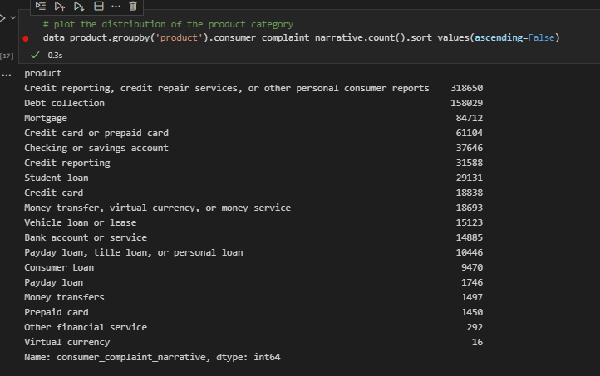
Fig 1.2 A snippet of the Product by Consumer Complaint Narrative which shows which Product category have the highest number of Complaints.
Clean the dataset, Encode the data label & Train the dataset using Traditional ML models: For most datasets which have texts as values, there is usually a need to clean the dataset. This ranges from removing unwanted words i.e., stop-words which will have zero or little effect in the model performance, to removing punctuations, changing texts to lowercase, removing numerical values etc. for the nature of this dataset and time constraints, these steps were considered. Other cleaning techniques such as lemmatization and stemming could also be introduced and its performance on the model observed.
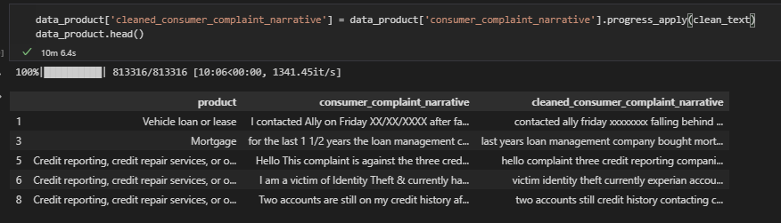
Fig 1.3 The reduced dataframe together with a new column which shows the cleaned text data.

Furthermore, since the class labels were in a non-numerical format, I had to encode so as to transform the labels to a numerical format and assign each class to a number. In this, ScikitLearn’s Label Encoder library was used to achieve this. Next step involved transforming the text data into a vector representation which is suitable for a Machine Learning algorithm. To vectorize the texts, another library in ScikitLearn, TF-IDF, was implemented. TF-IDF is one of the two widely used vector representations available in ScikitLearn. The other being Count Vectorizer. One reason why TF-IDF was used over Count Vectorizer is that it focuses on the importance/context of the words present in the document.

Upon transforming, a baseline model, Logistic Regression, was used to fit the transformed data with the accuracy observed. To serve as a comparison, a model which is regarded as a better performing model based on industry standards and application was applied on the transformed and its accuracy also observed.

Evaluate the model: During evaluation, a Stratified Kfold was used. I evaluated a logistic regression model on the transformed data using 5-fold cross-validation with three (3) repeats. The mean classification accuracy for the 3 repeats, on the dataset, was observed at 77%. Further observation into the classification report showed that of the 18 product categories, the model performed above average on 14 of them. With the model performing the most on category Money transfers and the worst on Credit Card and Virtual Currency. A possible solution to ensuring better performance could involve better pre-processing and/or collection of more training data for these categories.
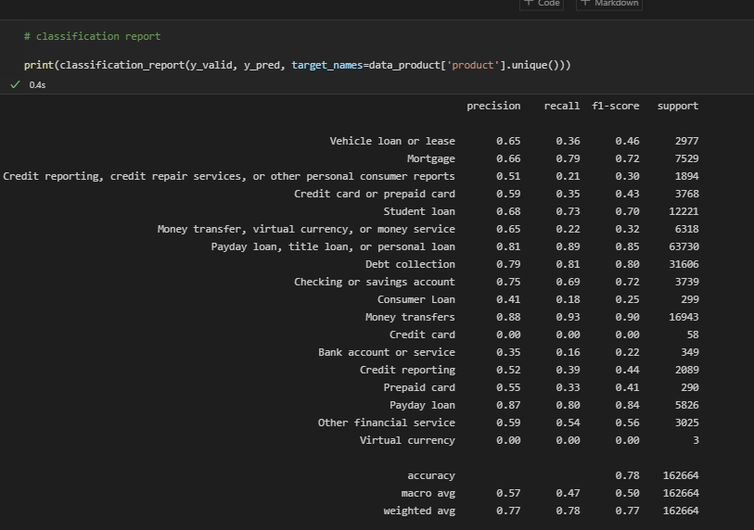

NB: Due to the size of the data, the training of the model using Random Forest was taking longer than expected as at the time of submitting this report. However, the full code was included in the github link to the code.

