Overview of Documentation 1
Document 1: 3
Assets Table 4
Document 2: 5
Development Process 6
Screenshot of webpages 6
Copy of HTML and CSS Code: 8
PHP Scripting 10

Overview of Documentation

Note: Five documents must be created for the exam.

- Asset Log of code, images, and any other content used from external sources. This must include the source of the asset(link) what it's being used for and when you access the asset. Remember you can only take small snippets of code from an external source.

- Development Process: This includes the development process of the website, SQL database, and PHP code.

- Test Log: Each version of a web page, SQL database and PHP code must be tested. See the Iterative development framework below. RECORD your tests using OBS.

- Code: Copy all your code this includes: each webpage with the name of the webpage at the top of the page; each PHP page with the name of the page at the top. SQL database structure for each table, with each table clearly labelled. Save as PDF and txt file.

- SQL Code: Export you SQL document.

Outcomes for submission
Prototype
Save copies of key versions of your functional prototype in your folder for submission.
Use any sensible folder structure and naming convention.

Development documentation
Save your development documents as PDF files in your folder for submission. Use this
naming convention:
• Task2[Document name]_[Registration number]_[Surname]_[First letter of first name]
Save your content and assets log as a PDF in your folder for submission. Use this
naming convention:
• Task2ContentAssetsLog_[Registration number]_[Surname]_[First letter of first name]

Test log
Save your test log as a PDF file in your folder for submission. Use this
naming convention:
• Task2_Test_Log_[Registration number]_[Surname]_[First letter of first name]

Code for prototype solution
Save copies of key versions of the source code for your prototype in your folder
for submission. This includes the SQL Exported file.

Use any sensible folder structure and naming convention

Document 1:

Assets Table
Below is an example of an Assets you should create. This should include table of contents, links to external sites and blogs.
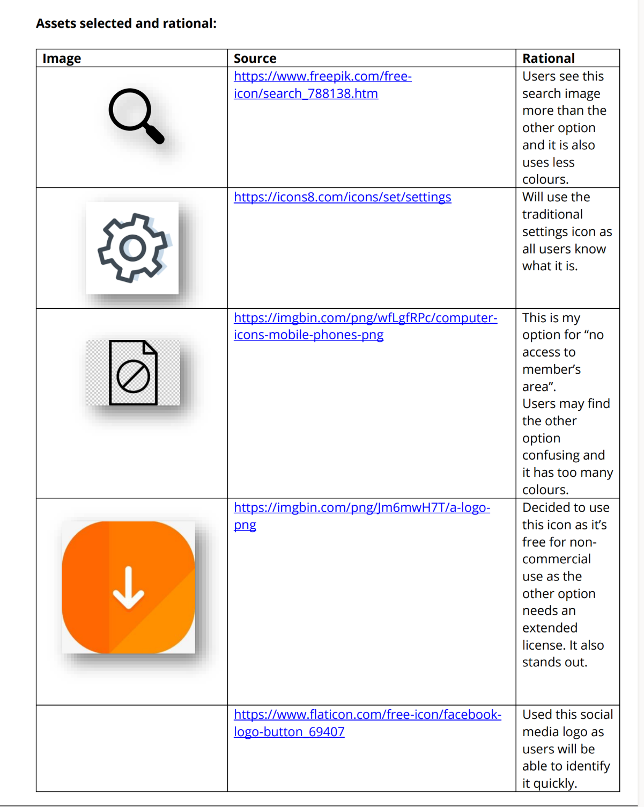

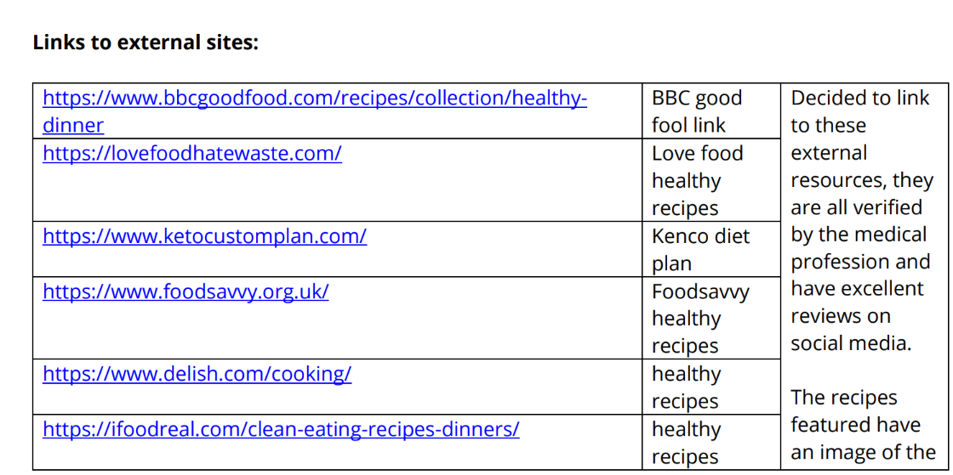
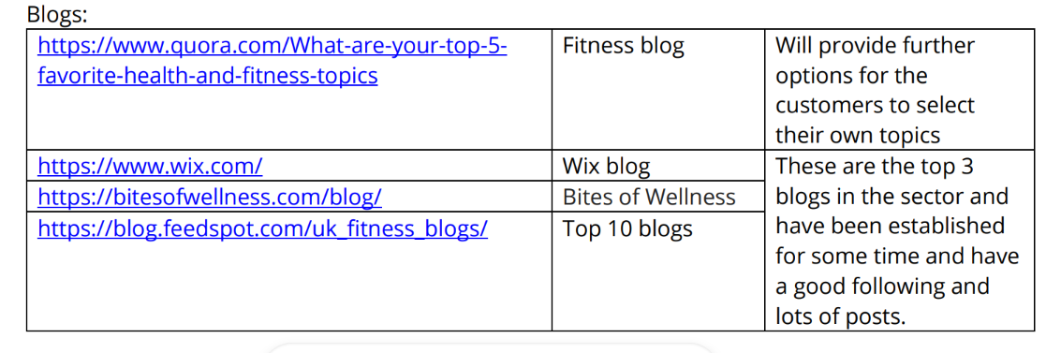

Document 2:

Development Process
Website Development Version Control
Overview of the prototype:
Include:
- Brief overview of the product and its requirements based on task 1
- Target Audience based on persona from task 1
- Use of Resources and their reliability used to build the website
- Accessibility considerations for the website
- Legal Consideration for the website
- Ethical Considerations for the website

Screenshot of webpages
You need to show evidence of the development of each page which includes changes. For each page paste a screenshot of what the page looks like. Note changes to be made. When you make changes paste the next version for that page highlighting the changes made.

Page One Version 1
Screen Shot of Page | Comment on the purpose of the page and any changes required.
Include comments on:
Accessibility
Meeting branding
Meeting user needs
Compliance to legislation
Meeting Requirements from task 1

Note: Clearly identify and suggest changes to be made.

Page One Version 2
Screen Shot of Page | Comment on the purpose of the page and any changes required
Clearly identify where the changes have taken place.

Comment on changes made and justify changes.

Below is an example for a log in page from BTEC.
This is a little mess as its not in tables. Also comments from the examiner mention that links to task 1 where week, along with legislation, ethics, target audience and accessibility.

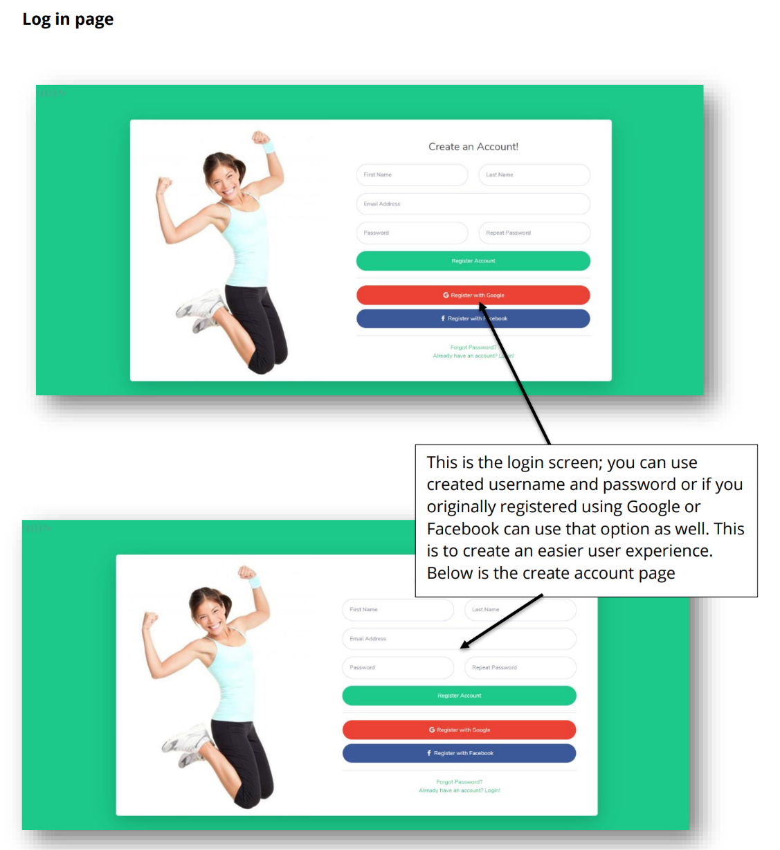

Page Two (repeat the process version 1)
Screen Shot of Page | Comment on the purpose of the page and any changes required

Page Two (repeat the process version 2)
Screen Shot of Page | Comment on the purpose of the page and any changes required

Continue for each page.

Copy of HTML and CSS Code:
You need to show evidence of the development of each page which includes the HTML and CSS changes. For each page paste the HTML and CSS code. Note the changes to be made. When you make changes paste the next version of HTML and CSS for that page highlighting the changes made.

HTML Code Home Page (even if its PHP page ) Version 1
Screen Shot of Page | Comment on code HTML and any changes required

CSS Code Home Page (even if its PHP page ) Version 1
Screen Shot of Page | Comment on code HTML and any changes required

HTML Code Home Page (even if its PHP page ) Version 2
Screen Shot of Page | Comment on code HTML and any changes required

CSS Code Home Page (even if its PHP page ) Version 2
Screen Shot of Page | Comment on code HTML and any changes required

HTML Code Login Page (even if its PHP page ) Version 1
Screen Shot of Page | Comment on code HTML and any changes required

CSS Code Login Page (even if its PHP page ) Version 1
Screen Shot of Page | Comment on code HTML and any changes required

HTML Code Login Page (even if its PHP page ) Version 2
Screen Shot of Page | Comment on code HTML and any changes required

CSS Code Login Page (even if its PHP page ) Version 2
Screen Shot of Page | Comment on code HTML and any changes required

Example screenshot of code from BTEC
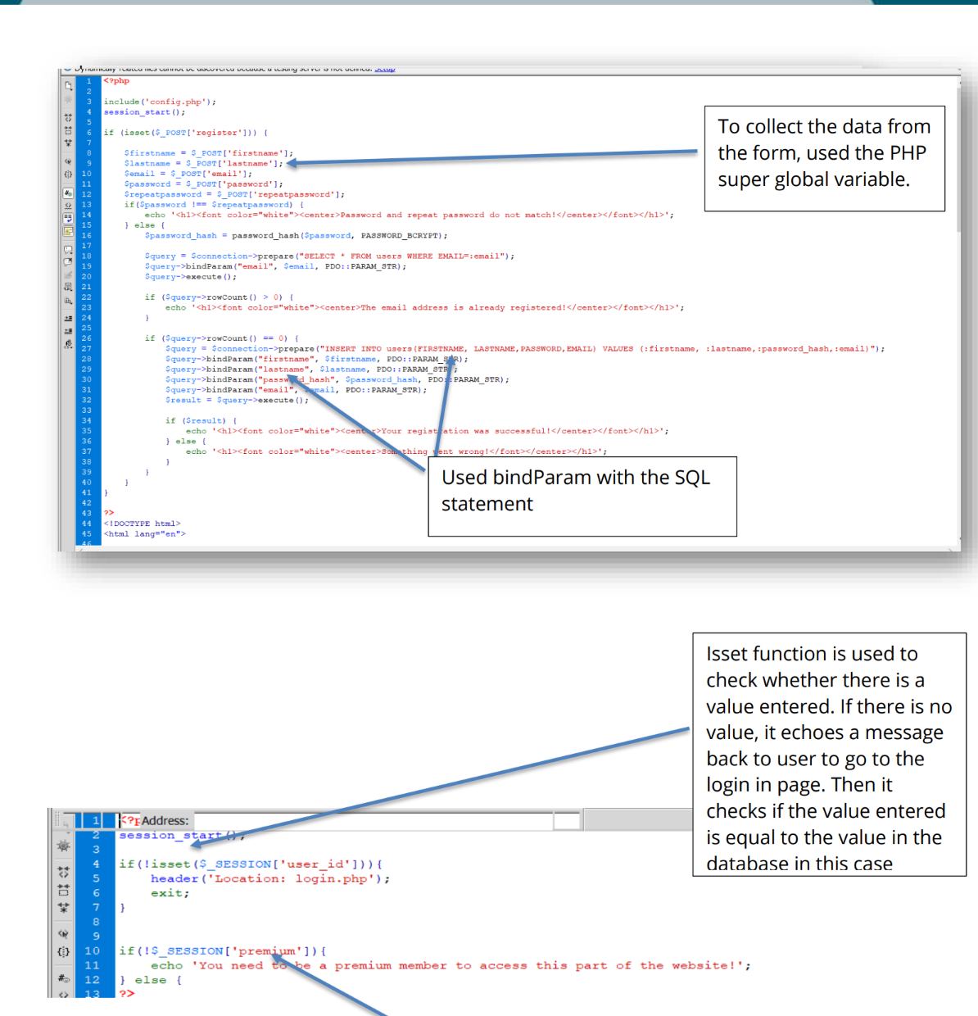
Continue for each page.

Continue for each page.

PHP Scripting
You need to show evidence of the development of PHP Scripts. Make a note of the changes made for each page. Then paste the different versions of PHP scripts for each page highlighting the changes made.
PHP Register code version 1
Screen Shot of code | Comment on the purpose of the code and any changes required
 | To change it I would put it into function to make it easier to read and more secure

PHP Register code version 2
Screen Shot of code | Comment on the purpose of the code and any changes required
Identify changes made.
Explain why these changes where made.
You can reference the test plan

PHP Login code version 1
Screen Shot of code | Comment on the purpose of the code and any changes required
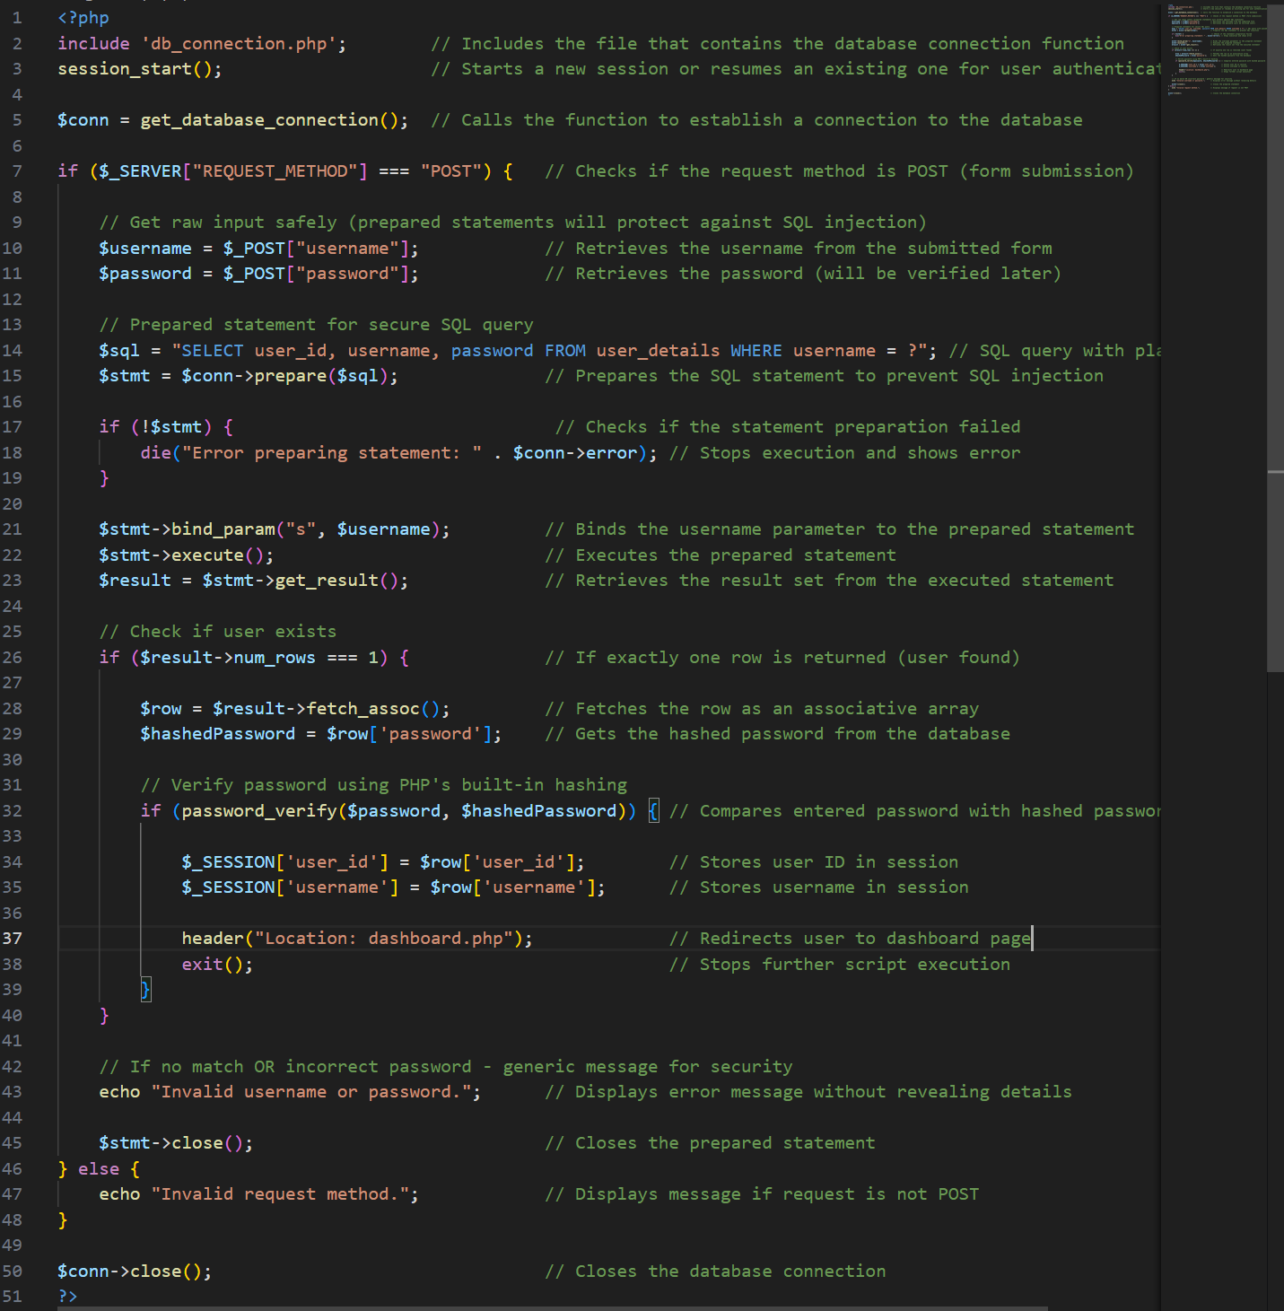 | The purpose of the login script php code is to take the inputted username and password and to find if there is matching data in the database. It will then redirect you to the dashboard page or It will tell you that the inputted username and password is not valid.  To change it I would put it into function to make it easier to read and more secure.

PHP Login code version 2
Screen Shot of code | Comment on the purpose of the code and any changes required
Identify changes made.
Explain why these changes where made.
You can reference the test plan

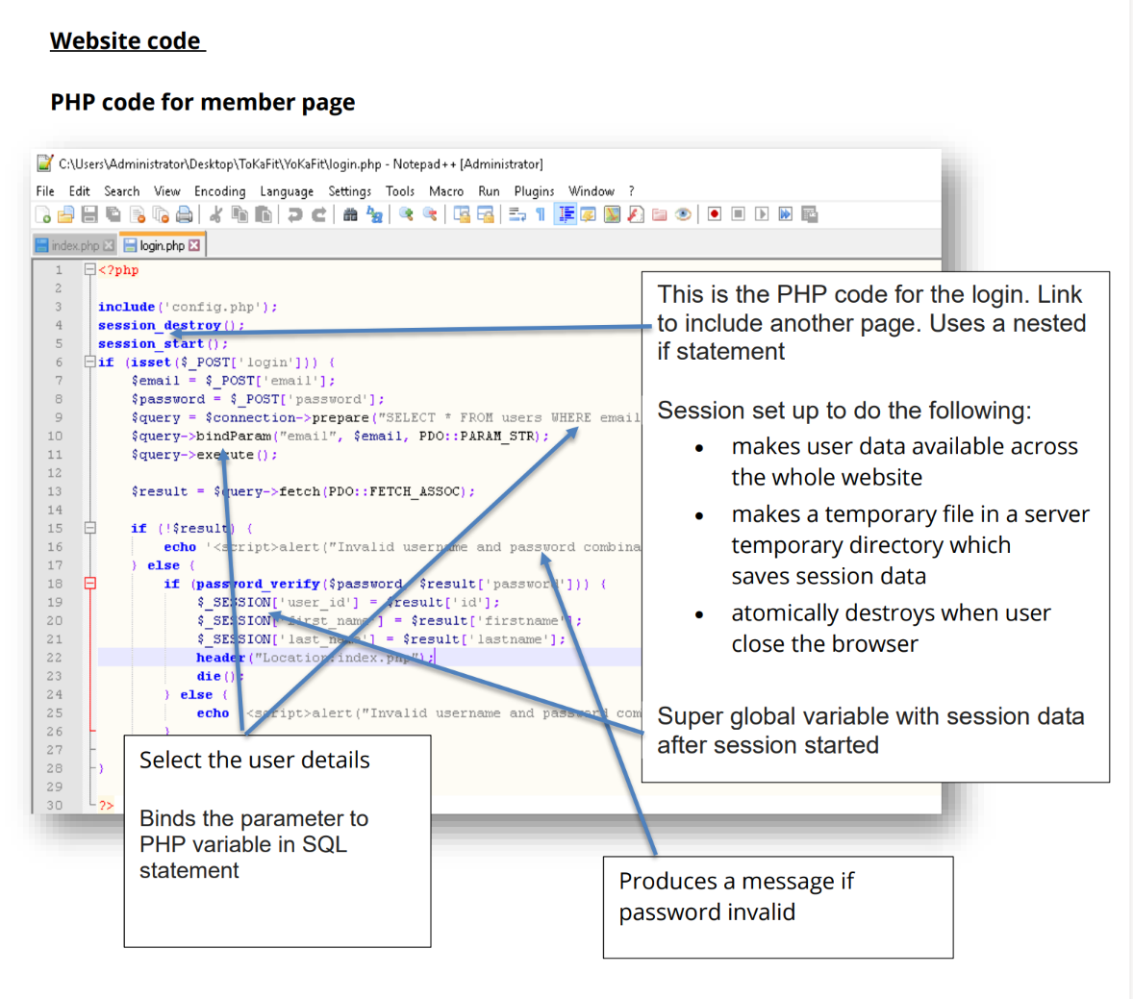
JavaScript code version 1
Screen Shot of code | Comment on the purpose of the code and any changes required

Examples from BTEC, again this is slightly messy

SQL Version Control

Take a screenshot of ER diagram created by php myAdmin. Comment on what the diagram is showing. Ensure you mention the type of relationships between each table, 1 to 1 etc.

Take a screenshot of each table. Explain the purpose of the table, the primary and foreign keys.

Record any changes to database tables each clearly showing the different versions. This includes your first version of each table even if no changes are made

Document 3: Test Log
Using the template provided create a test log.
After the development of each page / script you should test it. This is unit testing.
Ensure you include screen shots.
If the code needs to be changed, use local history to show the before and after. Explain what was changed and why. Clearly show the lines where the changes took place.
If the code was changed due to a runtime error, screen shot the error. Once fixed repeat the test to ensure that it now works.
You will need to carryout: functionality testing to show the requirements noted in task 1 have been fulfilled; unit testing as you develop the website; validation tests; boundary tests and user acceptance tests.
Testing Log Example
Web page Tests
Examples of UI tests you can use in your test log for version one home page.
- does the webpage load
- does the navigation show and is it in the correct location
- Does hover over work on the navigation
- Are the images in the correct place
- IS the font correct and is it an accessible font
- Is the colour scheme correct and is it accessible
- IS the page accessible for those with a visual impairment
- IS the page grammar and punctuation correct on the page
- Is the content appropriate for the target audience
- Is the page branded as you would like.

Test log PHP

Examples of tests you can use in your test log for version one home page.
- Does the web page load
- Can you input name
- Can you input password
- Continue to test each input.
- Check for validation on each input.
- Does the web server read the PHP code ie No 500 error?
- Is there are any lines of code that error, copy the error into your test log. Discuss how you are going to fix it. Make the change, check it works, and show the change you made to make it work.
- Check the functionality of the code, does it prevent duplicate usernames?
- Check the security of the code, does it hash the password?
- Check the security of the code, are inputs from the user placed into variables and not directly into the SQL statements.
- Check the security of the code, are statements prepared before being executed.
- Check the functionality of the code, for example: does it post the correct information to the database?
- Does the dashboard open when registration is successful?
- Does it show a message if the registration is not successful.
- ETC.

Document 4

The raw code for the website and export SQL. Do not change any of this code.

