Activity 3: Data Architecture Design for IT Asset Management

Activity Overview

Activity Title: Data Architecture Design for IT Asset Management

Objective: You will design the data architecture for your fictional company's IT asset management transformation, building on the TO-BE business processes developed in Activity 2. This activity focuses on defining the data entities, relationships, flows, and governance structures needed to support the future-state processes and address the pain points identified earlier.

Summary of Deliverables

Deliverable | Format | Description
Deliverable 1 | Document | Enterprise Data Model
Deliverable 2 | Document | System Data Model Mapping
Deliverable 3 | Diagram | Data Flow Diagrams (Level 0 and Level 1)
Deliverable 4 | Document | Data Domain Ownership Matrix
Deliverable 5 | Document | Data Governance Framework
Deliverable 6 | Spreadsheet | Data Quality Assessment
Deliverable 7 | Document | Traceability Matrix
Deliverable 8 | Presentation | Executive Summary

Detailed Deliverable Descriptions

Deliverable 1: Enterprise Data Model
Format: Professional document with diagrams, 4-6 pages
Filename: TeamName_Enterprise_Data_Model.pdf

Description:
The Enterprise Data Model provides a high-level, business-oriented view of the core data entities and their relationships. It is independent of any specific system and represents the "ideal" state of data management for your fictional company's IT asset operations.

Requirements:
- Entity Identification
List and define all core data entities relevant to IT asset management:
Entity | Definition | Examples
Asset | A physical or digital technology item tracked by the organization | Laptop, monitor, software license, accessory
User | An individual who uses or is assigned assets | Employee, contractor, intern
Department | Organizational unit that owns or uses assets | IT, Finance, Sales, Engineering
Location | Physical or logical place where assets reside | Office, warehouse, data center, home office
Vendor | Company that supplies hardware or software | Apple, Dell, Microsoft, CDW
Purchase Order | Document authorizing procurement of assets | PO-2024-00123
License | Software entitlement granting usage rights | Microsoft Office, Adobe Creative Cloud
Maintenance Record | History of repairs and service | Warranty claim, repair log
Assignment | Relationship between asset and user over time | Check-out record, transfer history
Status | Current state of an asset in its lifecycle | Deployed, Maintenance, Retired

2. Entity Relationship Diagram (ERD)
Create a conceptual ERD showing:
- All core entities
- Relationships between entities (with cardinality)
- Relationship descriptions
Notation:
- Use Crow's Foot notation or UML
- Include relationship labels (e.g., "User has many Assets")
- Show cardinality (1:1, 1:M, M:M)

Example Relationship:
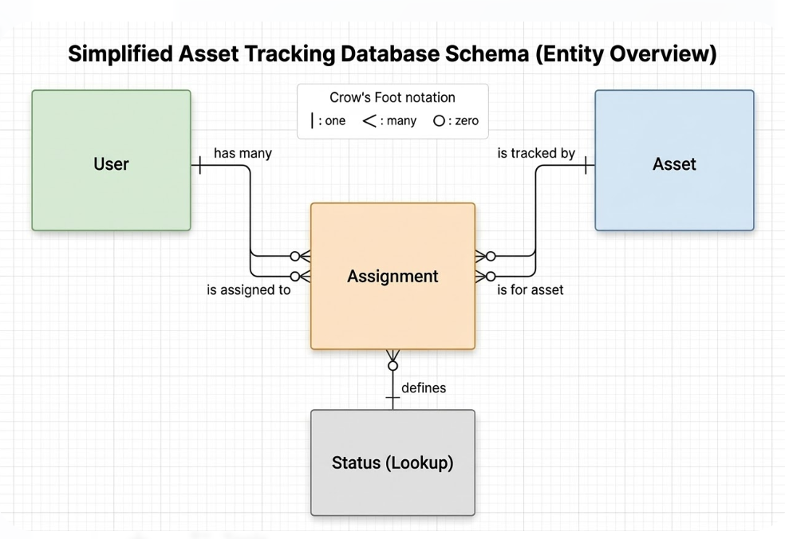
3. Entity Attribute Catalog
For each entity, list key attributes:
Entity | Attribute | Data Type | Description | Business Rules
Asset | AssetID | String | Unique identifier | Format: AST-YYYY-#####
Asset | AssetTag | String | Physical tag number | Must be unique
Asset | Name | String | Friendly name | Optional
Asset | Model | String | Manufacturer model | From model list
Asset | SerialNumber | String | Manufacturer serial | Must be unique
Asset | PurchaseDate | Date | Date acquired | YYYY-MM-DD
Asset | PurchaseCost | Decimal | Cost in USD | >0
Asset | WarrantyMonths | Integer | Warranty duration | 0-60
Asset | Status | Reference | Current status | From status list
Asset | AssignedTo | Reference | Current user | Null if unassigned
Asset | Location | Reference | Physical location | From location list

4. Business Rules Documentation
Document key business rules governing entities:
Rule ID | Entity | Rule Description | Enforcement
BR-001 | Asset | An asset cannot be assigned to an inactive user | System-enforced
BR-002 | Asset | Purchase cost must be >0 | System-enforced
BR-003 | License | License seats cannot exceed purchased quantity | System-enforced
BR-004 | Assignment | An asset cannot be assigned to two active users simultaneously | System-enforced
BR-005 | Asset | Retired assets must have disposal date recorded | Process-enforced

Deliverable 2: System Data Model Mapping

Format: Professional document with tables, 3-5 pages
Filename: TeamName_System_Data_Mapping.pdf

Description:
The System Data Model Mapping shows how your Enterprise Data Model maps to Snipe-IT's actual data structures, identifying gaps where Snipe-IT cannot directly represent enterprise concepts and proposing customizations to address those gaps.

Requirements:
1. Snipe-IT Core Tables Mapping
Enterprise Entity | Snipe-IT Table | Match? | Notes
Asset | assets | ✓ Full | Core asset table
User | users | ✓ Full | User accounts
Department | departments | ✓ Full | Department/location mapping
Location | locations | ✓ Full | Physical locations
Vendor | vendors | ✓ Full | Supplier/vendor records
License | licenses | ✓ Full | Software licenses
Status | status_labels | ✓ Full | Customizable statuses
Assignment | - | ✗ Missing | No direct assignment history table

2. Field-Level Mapping
For each enterprise attribute, map to Snipe-IT fields:
Enterprise Entity | Enterprise Attribute | Snipe-IT Table | Snipe-IT Field | Match? | Notes
Asset | AssetID | assets | id | ✓ | Auto-increment integer
Asset | AssetTag | assets | asset_tag | ✓ | Customizable format
Asset | Name | assets | name | ✓ | Optional
Asset | Model | assets | model_id | ✓ | References models table
Asset | SerialNumber | assets | serial | ✓
Asset | PurchaseDate | assets | purchase_date | ✓
Asset | PurchaseCost | assets | purchase_cost | ✓
Asset | WarrantyMonths | assets | warranty_months | ✓
Asset | Status | assets | status_id | ✓ | References status_labels
Asset | AssignedTo | assets | assigned_to | ✓ | References users
Asset | Location | assets | location_id | ✓ | References locations
Asset | Department | assets | company_id | ✓ | References companies

3. Gap Analysis: Missing Enterprise Concepts
Identify enterprise concepts not directly supported:
Missing Concept | Enterprise Entity | Required For | Proposed Solution
Assignment History | Assignment | Audit trail, lifecycle tracking | Custom plugin or API logging
Maintenance Record | Maintenance | Repair tracking, warranty claims | Custom field group
Asset Relationships | Asset | Dependencies (e.g., laptop + dock) | Custom field or plugin
Approval Workflow | Request | Manager approval tracking | Custom statuses + notifications

4. Custom Field Proposals
For each gap, propose custom fields:
Custom Field | Applies To | Data Type | Purpose | Business Rule
Asset Condition | Asset | Dropdown | Track physical condition | Values: New, Good, Fair, Poor
Last Audit Date | Asset | Date | Track physical inventory | Update annually
PO Number | Asset | String | Link to purchase order | Format: PO-#####
Cost Center | Asset | String | Financial allocation | From finance system
Assigned Date | Assignment | Date | Track assignment start | Auto-populated on checkout
Expected Return | Assignment | Date | For loaner devices | Optional

5. Custom Status Label Proposals
Status Label | Category | Description | Workflow Position
On Order | Asset | Ordered but not received | Before Ready to Deploy
Pending Imaging | Asset | Received, awaiting configuration | Between Received and Ready
Imaging Complete | Asset | Configured, ready for QA | Before Ready to Deploy
Awaiting Pickup | Asset | Assigned but not physically handed over | Between Assigned and Deployed
Maintenance - In Shop | Asset | Being repaired internally | During Maintenance
Maintenance - Vendor | Asset | Sent to vendor for repair | During Maintenance
Pending Return | Asset | Employee offboarded, awaiting return | Before Retired
Pending Disposal | Asset | Approved for disposal, awaiting processing | Before Disposed

Deliverable 3: Data Flow Diagrams (DFDs)

Format: Professional diagrams with accompanying documentation
Filename: TeamName_DFDs.pdf (include source files if possible)

Description:
Data Flow Diagrams illustrate how data moves through the organization—where it originates, how it transforms, where it stores, and where it ultimately resides. You will create two levels of DFDs for your TO-BE state.
Requirements:
Level 0: Context Diagram
Show the entire asset management system as a single process with external entities and data flows.
Elements:
- Central Process: "IT Asset Management System" (Snipe-IT plus integrations)
- External Entities: All sources and destinations of data
  - Employees
  - Managers
  - IT Staff
  - HR System
  - Procurement System
  - Finance System (ERP)
  - MDM Solutions (JAMF, Intune)
  - Vendors/Suppliers
  - External Auditors
- Data Flows: Labeled arrows showing what data moves between entities and the system
  - "Employee Data" from HR System
  - "Purchase Orders" from Procurement System
  - "Asset Assignments" to Finance System
  - "Device Status" to/from MDM
  - "Warranty Claims" to Vendors
Notation:
- External entities: Rectangles
- Process: Circle or rounded rectangle
- Data flows: Arrows with labels
- Data stores: Open rectangles (optional at Level 0)

Level 1: Decomposed DFD
Decompose the main process into major sub-processes, showing data stores and flows between them.
Sub-Processes (based on TO-BE processes):
1.0 User Synchronization (HRIS integration)
2.0 Procurement Intake (Procurement integration)
3.0 Asset Assignment
4.0 Asset Movement
5.0 Maintenance Processing
6.0 License Management
7.0 Retirement Processing
8.0 Reporting and Analytics
Data Stores:
- D1: Asset Store (Snipe-IT assets table)
- D2: User Store (Snipe-IT users table)
- D3: License Store (Snipe-IT licenses table)
- D4: Assignment History (custom table/log)
- D5: Procurement Data (external system)
- D6: HR Data (external system)

For each sub-process, document:
Process | Input Flows | Output Flows | Data Stores Accessed | Description
1.0 User Sync | Employee data from HR | User updates to D2 | D2, D6 | Syncs employee status changes
2.0 Procurement Intake | PO data from Procurement | Asset records to D1 | D1, D5 | Creates assets from POs
3.0 Assignment | Request from Employee | Assignment to D1, D4 | D1, D2, D4 | Check-out process

Data Flow Descriptions:
For each data flow, provide:
Flow Name | Source | Destination | Data Content | Frequency | Volume
Employee Status Update | HR System | 1.0 User Sync | Employee ID, Name, Dept, Status, Location | Real-time (webhook) | 50/day
PO Data | Procurement | 2.0 Intake | PO#, Vendor, Items, Costs, Expected Date | Daily batch | 20/day
Assignment Record | 3.0 Assignment | D4 History | Asset ID, User ID, Date, Expected Return | Per transaction | 50/day

Deliverable 4: Data Domain Ownership Matrix

Format: Table/chart in document, 2-3 pages
Filename: TeamName_Data_Ownership.pdf

Description:
The Data Domain Ownership Matrix establishes clear accountability for each data domain, defining who is responsible for quality, access, and lifecycle decisions.

Requirements:
1. Domain Ownership Table
Domain | Description | Data Owner | Data Steward | Data Custodian | Primary System
Asset | Physical and digital assets | IT Asset Manager | Asset Team Lead | IT Operations | Snipe-IT
User | Employees and contractors | HR Director | HRIS Administrator | IT Operations | HRIS / AD
License | Software entitlements | IT Asset Manager | Software Asset Specialist | IT Operations | Snipe-IT
Vendor | Hardware/software suppliers | Procurement Manager | Procurement Specialist | Finance Systems | Procurement System
Financial | Cost and depreciation | Finance Controller | Financial Analyst | Finance Systems | ERP
Location | Physical locations | Facilities Manager | Operations Coordinator | IT Operations | Snipe-IT
Procurement | Purchase transactions | Procurement Manager | Procurement Specialist | Finance Systems | Procurement System
Maintenance | Repair history | IT Support Manager | Help Desk Lead | IT Operations | Snipe-IT

2. Data Owner Responsibilities
For each data owner role, document responsibilities:
Role | Responsibilities
Data Owner (Business Leader) | • Define data quality standards  • Approve data access requests  • Resolve data issues escalated  • Ensure regulatory compliance  • Define retention and disposal policies  • Budget for data management
Data Steward (Operational) | • Monitor data quality daily  • Execute data cleanup  • Train users on data entry  • Report issues to owner  • Maintain data documentation
Data Custodian (Technical) | • Implement technical controls  • Manage database access  • Ensure backup and recovery  • Monitor performance  • Apply security patches

3. RACI Matrix for Data Decisions
For key data activities, define who is Responsible, Accountable, Consulted, Informed:
Activity | Asset Owner | Asset Steward | HR Director | IT Ops | Finance | Procurement
Define asset data standards | A | R | C | C | I | I
Enter new asset data | I | R | - | C | - | C
Update asset status | I | R | - | C | - | -
Approve asset disposal | A | C | - | I | C | -
Resolve data quality issue | A | R | I | C | I | I
Grant data access | A | C | - | R | - | -
(R = Responsible, A = Accountable, C = Consulted, I = Informed)

4. Data Issue Escalation Path
Document how data issues are escalated:
Issue Severity | Description | Escalation Path | Response Time
Critical | Data integrity breach, audit impact | Data Steward → Data Owner → IT Director | 4 hours
Major | Significant quality issue affecting operations | Data Steward → Data Owner | 24 hours
Minor | Isolated data error | Data Steward resolves | 5 business days

Deliverable 5: Data Governance Framework

Format: Professional document, 4-6 pages
Filename: TeamName_Data_Governance.pdf

Description:
The Data Governance Framework establishes the policies, processes, and structures for managing data as an enterprise asset. This framework ensures that data remains accurate, secure, and trustworthy.

Requirements:
1. Governance Structure
Define the governance organization:
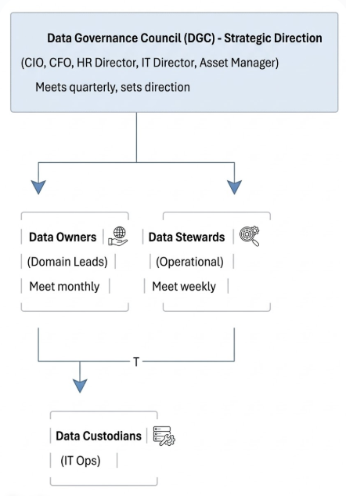

2. Data Policies
Document key data policies:
Policy | Description | Key Provisions
Data Quality Policy | Standards for data accuracy and completeness | • Asset records must be 99% complete  • Monthly quality audits  • Data entry validation rules
Data Access Policy | Who can access what data | • Role-based access control  • Least privilege principle  • Access review every 6 months
Data Retention Policy | How long data is kept | • Active assets: indefinitely  • Disposed assets: 7 years  • Audit logs: 3 years
Data Security Policy | Protection of sensitive data | • Encryption at rest and in transit  • PII data restricted  • Breach notification procedure
Data Classification Policy | Labeling data sensitivity | • Public, Internal, Confidential, Restricted

3. Data Standards
Document specific data standards:
Standard | Description | Rule
Asset Naming Convention | How assets are named | {Type}-{Manufacturer}-{Model}-{Unique}
Asset Tag Format | Format for physical tags | AST-{Year}-{5-digit sequence}
Status Values | Allowed statuses | From approved list (customized)
Date Format | Standard date representation | YYYY-MM-DD
Currency | Standard monetary unit | USD (converted if needed)

4. Data Quality Metrics
Define how data quality is measured:
Metric | Definition | Target | Measurement Method
Completeness | % of required fields populated | >98% | Monthly audit
Accuracy | % of records matching physical inventory | >99% | Quarterly cycle count
Timeliness | % of updates within 24 hours of event | >95% | System logs
Consistency | % of records following standards | >98% | Automated validation
Uniqueness | % of records without duplicates | 100% | Duplicate detection

5. Data Issue Management Process
Define the process for handling data issues:
- Identification: Issue detected (automated validation, user report, audit)
- Logging: Issue recorded in tracking system with severity
- Triage: Data Steward assesses and assigns
- Resolution: Root cause fixed, data corrected
- Verification: Fix confirmed
- Closure: Issue documented, lessons learned
- Prevention: Process improved to prevent recurrence

Deliverable 6: Data Quality Assessment

Format: Spreadsheet with analysis, 3-5 pages when printed
Filename: TeamName_Data_Quality_Assessment.xlsx

Description:
The Data Quality Assessment evaluates the current state of data quality in your AS-IS environment and identifies specific improvements needed to achieve TO-BE data requirements.

Requirements:
1. Data Quality Baseline
For each critical data element, assess current quality:
Data Element | Entity | Current Quality | Issues Identified | Impact
Asset Tag | Asset | 95% | Duplicates, format variations | Search failures
Assignment | Asset | 85% | Assets assigned to terminated users | Inaccurate inventory
Location | Asset | 70% | Outdated, missing | Can't find assets
Purchase Cost | Asset | 60% | Missing, estimated | Finance doesn't trust
Status | Asset | 80% | Wrong statuses used | Process confusion
Department | User | 90% | Some missing | Reporting gaps
License Allocation | License | 75% | Overallocation, underutilization | Compliance risk

2. Root Cause Analysis for Data Issues
Issue | Root Cause | Impacted Processes | Severity
Assets assigned to terminated users | No HRIS integration; manual process fails | Retirement, Audit, Finance | Critical
Outdated locations | No location update process | Movement, Physical Inventory | High
Missing purchase costs | Procurement not integrated | Finance, Depreciation | High
Wrong statuses | Unclear status definitions | All processes | Medium

3. Data Improvement Targets
Data Element | Current | Target | Improvement Needed | Method
Asset Tag | 95% | 100% | Eliminate duplicates, enforce format | Validation rules, training
Assignment | 85% | 99% | Automate offboarding | HRIS integration
Location | 70% | 98% | Self-service updates, periodic audits | Mobile app, process
Purchase Cost | 60% | 100% | Procurement integration | API integration
Status | 80% | 98% | Clarify definitions, simplify options | Documentation, training

4. Data Cleanup Plan
Activity | Responsible | Timeline | Resources Needed
Correct asset tag duplicates | Asset Steward | Month 1 | 20 hours
Update locations for top 500 assets | Help Desk | Month 1-2 | 40 hours
Research missing purchase costs | Procurement | Month 2 | 30 hours
Reconcile license allocations | Software Asset Specialist | Month 2-3 | 25 hours
Full physical inventory audit | Asset Team + Help Desk | Month 3 | 2 weeks, all hands

Deliverable 7: Traceability Matrix

Format: Spreadsheet or table
Filename: TeamName_Data_Traceability.xlsx

Description:
The Traceability Matrix links your data architecture decisions back to the pain points identified in Activity 1 and the TO-BE processes designed in Activity 2. This ensures that every data decision is justified by business need.

Requirements:
1. Pain Point to Data Solution Traceability
Pain Point ID | Pain Point Description | Data Solution | Deliverable Reference
P1 | Procurement-to-inventory delay | Procurement integration; automated asset creation | DFD 2.0, System Mapping
P3 | Poor mobile experience | Mobile-optimized data entry; offline capability | DFD, Custom Fields
P5 | Software license over-purchasing | License usage tracking; allocation automation | Domain Ownership, Governance
P7 | Asset non-return after offboarding | HRIS integration; automated status updates | DFD 1.0, System Mapping
P9 | Finance maintains separate spreadsheets | Depreciation data export; API integration | DFD, Data Standards
P12 | Audit findings | Complete audit trail; assignment history tracking | Custom Field, Governance

2. TO-BE Process to Data Support Traceability
TO-BE Process | Data Requirements | Data Solution | Deliverable Reference
1.0 Procurement Intake | PO data, vendor data, cost data | Procurement integration; custom PO field | System Mapping, DFD
2.0 Assignment | User data, asset data, assignment tracking | Role-based templates; assignment history | Enterprise Model, DFD
3.0 Movement | Location data, transfer approval | Self-service location updates; audit trail | Custom Fields, Governance
4.0 Maintenance | Repair history, warranty data | Maintenance records; status tracking | Enterprise Model, DFD
5.0 License Management | License allocation, usage data | Usage monitoring integration; compliance reporting | Domain Ownership, DFD
6.0 Retirement | Disposal data, sanitization certification | Retirement workflow; document storage | Custom Fields, Governance

3. Data Solution Justification Summary
Data Solution | Cost/Effort | Pain Points Addressed | Processes Enabled | Priority
HRIS Integration | Medium | P7, P12 | 2.0, 6.0 | Critical
Procurement Integration | Medium | P1, P9 | 1.0 | Critical
Mobile App | High | P3, P8 | 2.0, 3.0 | Important
License Usage Integration | Medium | P5 | 5.0 | Important
Assignment History Tracking | Low | P12 | All | Tactical

The "Why" Behind Each Deliverable

Deliverable 1: Enterprise Data Model
Why it matters: Before you can manage data, you must understand what data exists. This model creates a shared understanding of core entities (Asset, User, License, etc.) and how they relate. It's the blueprint that ensures everyone—business and technical stakeholders—means the same thing when they talk about "asset" or "assignment."

Deliverable 2: System Data Model Mapping
Why it matters: Your ideal data model (Enterprise) must work within Snipe-IT's reality. This deliverable identifies where Snipe-IT already meets your needs, where it falls short, and how you'll bridge those gaps through custom fields, custom statuses, or integrations. It's the practical bridge between vision and reality.

Deliverable 3: Data Flow Diagrams
Why it matters: Data doesn't stay still—it moves. DFDs show where data comes from, where it goes, how it transforms, and where it rests. They reveal integration requirements, identify potential bottlenecks, and ensure you've thought through the entire data lifecycle. If you can't draw how data flows, you don't understand your own architecture.

Deliverable 4: Data Domain Ownership Matrix
Why it matters: Data quality fails when no one is accountable. This matrix assigns clear ownership for each data domain, defining who decides what data means (Owner), who watches it daily (Steward), and who manages the technology (Custodian). Without this, data problems become "someone else's problem."

Deliverable 5: Data Governance Framework
Why it matters: Good data doesn't happen by accident. Governance provides the rules, standards, and processes that keep data reliable over time. This framework ensures that the improvements you design now will persist long after this course ends. It's the difference between a one-time cleanup and sustainable quality.

Deliverable 6: Data Quality Assessment
Why it matters: You can't improve what you don't measure. This assessment establishes a baseline of current data quality, identifies root causes of problems, sets improvement targets, and creates a concrete cleanup plan. It transforms vague concerns ("our data is messy") into specific, actionable improvements.

Deliverable 7: Traceability Matrix
Why it matters: Every data decision should be justifiable. This matrix traces each data solution back to specific pain points from Activity 1 and specific processes from Activity 2. It prevents "solutioneering"—building things because they're interesting rather than because they solve real problems.

Key Questions Each Deliverable Answers
Deliverable | Key Questions Answered
Enterprise Data Model | What are the core things we track? How do they relate? What rules govern them?
System Data Mapping | Can Snipe-IT represent what we need? Where are the gaps? How will we fill them?
Data Flow Diagrams | Where does data come from? Where does it go? Who touches it along the way?
Domain Ownership | Who is accountable for each type of data? Who watches it day-to-day?
Governance Framework | What are the rules? How do we enforce them? How do we measure success?
Quality Assessment | How bad is our data today? What's causing the problems? How do we fix it?
Traceability Matrix | Why are we doing this? What pain does it solve? What process does it enable?

How This Activity Connects to the Course
Activity 3 is the bridge between what you want to do (processes) and how you'll build it (applications and technology). Data architecture ensures that the information foundation is solid before you design the systems that will use it.

Success Criteria
Your data architecture is successful if it:
✓ Enables TO-BE processes—Every process from Activity 2 has the data it needs
✓ Resolves documented pain points—P1, P3, P5, P7, P9, P12 etc. are addressed
✓ Fits within Snipe-IT's capabilities—Customizations are practical, not fantasy
✓ Has clear accountability—Someone owns every data domain
✓ Includes sustainability—Governance ensures quality persists
✓ Is traceable—Every decision links to a business need

Common Pitfalls to Avoid
Pitfall | Why It's a Problem | How to Avoid
Skipping the Enterprise Model | You design for Snipe-IT without understanding what you really need | Start with entities, not tables
Ignoring Governance | Data quality degrades immediately after implementation | Design who will keep it clean before you build
Over-customizing | Snipe-IT becomes unmaintainable | Default to out-of-box; customize only for critical gaps
No Traceability | Decisions seem arbitrary | Keep asking "what pain does this solve?"
Missing Data Flows | Integration points are overlooked | Draw how data moves, not just where it sits
Vague Accountability | No one owns problems | Name specific roles, not "IT" or "the business"

Key Takeaway

Data architecture is the foundation of your entire transformation. You can design perfect processes and build elegant applications, but if your data is inaccurate, incomplete, or untrustworthy, the whole system fails.

This activity ensures that when you move to application and technology design, you're building on solid ground—with clear understanding of what data you need, how it should be structured, who owns it, and how it will stay reliable over time.

The quality of your data architecture will determine whether your transformed IT asset management system delivers lasting value or becomes just another source of frustration.

