Activity 4: Application Architecture Design for IT Asset Management

Activity Overview
Activity Title: Application Architecture Design Using the C4 Model
Objective: You will design the application architecture for their fictional company's IT asset management transformation using the C4 model (Context, Container, Component, and Code levels). This activity builds on the TO-BE business processes from Activity 2 and the data architecture from Activity 3, translating them into a structured, multi-level application design that will guide implementation.

Why the C4 Model for Application Architecture?
The C4 model, created by Simon Brown, provides a hierarchical approach to visualizing software architecture. It addresses a fundamental challenge: different stakeholders need different levels of detail. A business executive doesn't need to see your class diagrams. A developer doesn't need to see the system context diagram. The C4 model provides four levels of abstraction, each serving a specific audience and purpose.
Level | Name | Audience | Abstraction | Purpose
Level 1 | Context | Everyone | System boundaries | Show what system does and who uses it
Level 2 | Container | Technical & Non-technical | Technology building blocks | Show high-level technology choices
Level 3 | Component | Developers | Internal structure | Show modular decomposition
Level 4 | Code | Developers | Detailed implementation | Show critical components
For the PUP IT Asset Management transformation, the C4 model will document the architecture of the Unified Integration & Intelligence Layer, the Polyglot Persistence Layer, and the AI Analytics & Decision Support components shown in the TO-BE diagram.

Summary of Deliverables
Deliverable | Level | Format | Description
Deliverable 1 | Level 1: Context Diagram | Diagram + Documentation | System boundaries, users, external systems
Deliverable 2 | Level 2: Container Diagram | Diagram + Documentation | Technology containers, communication protocols
Deliverable 3 | Level 3: Component Diagram | Diagram + Documentation | Internal structure of API container
Deliverable 4 | Level 4: Code (Optional) | UML/ER Diagrams | Detailed implementation of critical components
Deliverable 5 | Architecture Decision Records (ADRs) | Document | Key design decisions and rationale
Deliverable 6 | Technology Stack Matrix | Spreadsheet | Selected technologies with justifications
Deliverable 7 | Traceability Matrix | Spreadsheet | Links to pain points, processes, data architecture
Deliverable 8 | Executive Presentation | Slides | Summary for stakeholders

Deliverable 1: Level 1 - Context Diagram

Format
- Professional diagram (Lucidchart, Draw.io, Structurizr, or similar)
- Accompanying documentation (2-3 pages)
- Filename: TeamName_C4_Context.pdf and TeamName_C4_Context_Source

Description
The Context Diagram shows the system boundaries and its relationships with external entities. It answers: What are we building? Who uses it? What other systems does it interact with? This is the "30,000-foot view" that everyone in the organization should understand.

Requirements

1. System Definition
Define the central system being modeled. Based on the TO-BE diagram, this is the Unified Integration & Intelligence Layer that encompasses:
- IT Asset Management System (Snipe-IT core)
- Polyglot Persistence Layer
- AI Analytics & Decision Support

2. Actors (Users)
Identify all user types who interact with the system:
Actor | Description | Interactions
Employee | Faculty, staff, students who request/use assets | Request equipment, view assigned assets, report issues
Manager | Department heads who approve requests | Approve/reject requests, view team assets
IT Help Desk | Tier 1 support staff | Check-in/out assets, update status, basic troubleshooting
IT Asset Manager | Specialized asset management team | Configure system, manage lifecycle, generate reports
Property Office | Property and Supply Office staff | Oversee asset accountability, approve disposals
Network Administrator | IT staff managing network infrastructure | View network relationships, configure auto-discovery
Finance Staff | Budget and accounting personnel | View asset values, depreciation, cost center allocations

3. External Systems
Identify all external systems that interact with the platform:
External System | Type | Data Exchange | Direction
HRIS (Human Resources) | HR System | Employee data (status, department, location) | Inbound only
Procurement System | ERP | Purchase orders, vendor data, costs | Inbound only
Finance System (ERP) | Financial | Depreciation data, cost allocations | Outbound only
MDM (JAMF/Intune) | Device Management | Telemetry data, compliance status | Bidirectional
Network Scanner | Infrastructure | Asset-to-network mappings, switch ports | Inbound only
Vendor Portals | External | Warranty claims, repair status | Bidirectional
Email/Slack | Communication | Notifications, alerts | Outbound only
Active Directory | Identity | Authentication, user groups | Inbound only

4. Data Flows
Document key data flows between the system and external entities:
Flow Name | Source | Destination | Content | Direction
Employee Data | HRIS | System | Employee ID, Name, Department, Status, Location | Inbound
Termination Event | HRIS | System | Employee ID, Termination Date, Last Working Day | Inbound
PO Data | Procurement | System | PO Number, Vendor, Items, Costs, ETA | Inbound
Asset Depreciation | System | Finance | Asset ID, Cost, Age, Current Value | Outbound
Telemetry Data | MDM | System | CPU Temp, Battery Health, Disk Usage, Location | Inbound
Health Alerts | System | IT Staff | Asset ID, Failure Probability, Recommendation | Outbound
Network Map | Network Scanner | System | Asset ID, Switch Port, AP, VLAN, Last Seen | Inbound
Relationship Data | System | Neo4j | Asset-to-network connections | Internal

5. Context Diagram Example
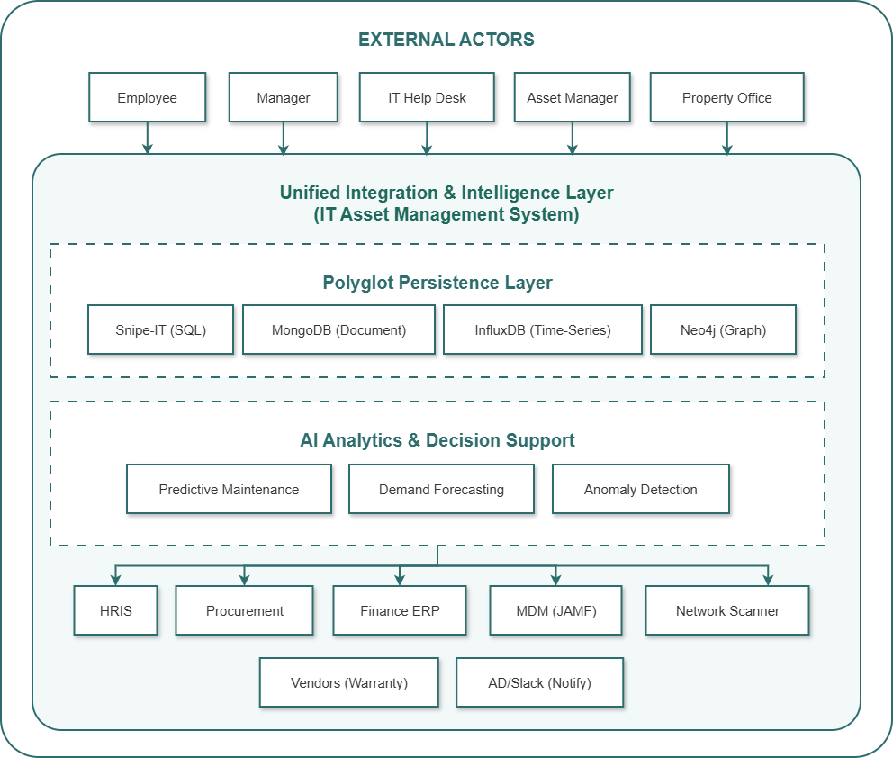

Deliverable 2: Level 2 - Container Diagram

Format
- Professional diagram (Lucidchart, Draw.io, Structurizr, or similar)
- Accompanying documentation with container descriptions (3-4 pages)
- Filename: TeamName_C4_Container.pdf and TeamName_C4_Container_Source

Description
The Container Diagram zooms into the system to show the high-level technology building blocks. A "container" represents a deployable unit—something that runs independently, such as a web server, mobile app, database, or message broker. This level answers: What are the major technical components? How do they communicate? What technologies are we using?

Requirements

1. Container Identification
Identify all deployable containers in the system:
Container | Type | Technology | Purpose
Web Application | SPA | React.js | Admin interface for IT staff, managers, property office
Mobile Application | Mobile | React Native | Field operations for scanning, check-in/out
API Gateway | Service | Kong / AWS API Gateway | Central entry point, authentication, rate limiting
API Application | Service | Python/Flask or Node.js | Business logic, orchestration, REST/GraphQL endpoints
Asset Synchronization Service | Service | Python/Java | CDC from Snipe-IT to other stores
Telemetry Ingestion Service | Service | Python/Go | Real-time ingestion of health data from MDM
Predictive Analytics Service | Service | Python | AI/ML model serving for predictions
Workflow Orchestrator | Service | Temporal | Workflow management for complex processes
PostgreSQL Database | Database | PostgreSQL 14+ | Core asset records (Snipe-IT)
Document Store | Database | MongoDB | Unstructured metadata, warranty PDFs
Time-Series Database | Database | InfluxDB/TimescaleDB | Telemetry data (CPU, battery, location)
Graph Database | Database | Neo4j | Network relationships, department hierarchies
Cache | Cache | Redis | Session storage, prediction caching, rate limiting
Message Broker | Queue | Kafka | Event distribution, CDC events
Search Engine | Search | Elasticsearch | Asset search, full-text indexing
Batch Processor | Batch | Airflow | Nightly reports, data exports

2. Container Communication
Document how containers communicate:
Source Container | Destination Container | Protocol | Purpose
Web App | API Gateway | HTTPS | All user interactions
Mobile App | API Gateway | HTTPS | Scanning, check-in/out
API Gateway | API Application | HTTPS | Authenticated requests
API Application | PostgreSQL | JDBC/ORM | CRUD operations
API Application | MongoDB | Native Driver | Product catalog, metadata
API Application | Redis | Redis Protocol | Session, caching
API Application | Kafka | Kafka Protocol | Event publishing
Asset Sync Service | PostgreSQL | CDC (Debezium) | Change capture
Asset Sync Service | Kafka | Kafka Protocol | Event publishing
Telemetry Service | MDM | HTTPS/REST | Pull telemetry data
Telemetry Service | InfluxDB | InfluxDB API | Store time-series data
Predictive Service | InfluxDB | InfluxDB API | Query historical data
Predictive Service | Kafka | Kafka Protocol | Consume events, publish alerts
Workflow Service | PostgreSQL | JDBC | State persistence
Batch Processor | PostgreSQL | JDBC | Query for exports

3. Container Diagram Example

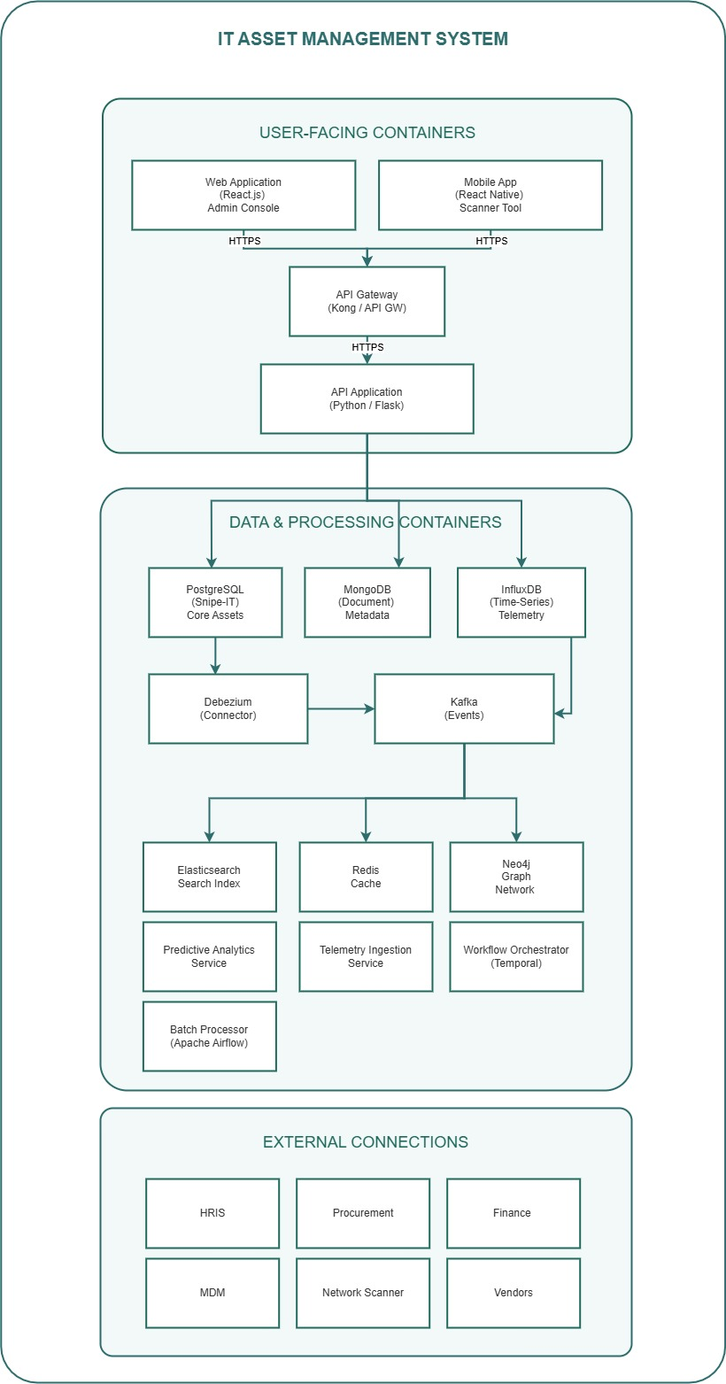

4. Container Descriptions Table
Container | Technology | Purpose | Key Features | Deployment
Web Application | React.js | Admin interface | Dashboard, asset search, reports, approval workflows | S3 + CloudFront
Mobile App | React Native | Field operations | QR scanning, offline capability, location updates | App Store, Play Store
API Gateway | Kong | Entry point | Authentication, rate limiting, request routing | EKS/ECS
API Application | Python/Flask | Business logic | REST/GraphQL endpoints, orchestration | EKS/ECS (scalable)
PostgreSQL | PostgreSQL 14+ | Core asset data | ACID compliance, complex queries | RDS Multi-AZ
MongoDB | MongoDB 6+ | Unstructured metadata | Flexible schema for warranty docs, configs | MongoDB Atlas
InfluxDB | InfluxDB | Telemetry storage | Time-series optimization, high write throughput | InfluxDB Cloud
Neo4j | Neo4j | Network relationships | Graph traversal, relationship mapping | Neo4j Aura
Redis | Redis 7+ | Caching | Session storage, prediction cache | ElastiCache
Kafka | Kafka | Event streaming | CDC events, notifications | MSK / Confluent
Elasticsearch | Elasticsearch 8+ | Search | Full-text search, asset lookup | Elastic Cloud
Debezium | Debezium | CDC | PostgreSQL change capture | Kafka Connect
Predictive Service | Python/Flask | AI inference | Model serving, predictions | EKS/ECS
Telemetry Service | Python/Go | Data ingestion | MDM integration, telemetry processing | EKS/ECS
Workflow Engine | Temporal | Orchestration | Order fulfillment, offboarding | Temporal Cloud
Batch Processor | Airflow | Scheduled jobs | Reports, exports, syncs | MWAA / Airflow

Deliverable 3: Level 3 - Component Diagram

Format
- Professional diagram for at least one critical container (typically the API Application)
- Accompanying documentation (3-4 pages)
- Filename: TeamName_C4_Component.pdf and TeamName_C4_Component_Source

Description
The Component Diagram zooms into a specific container to show its internal structure. Components are groupings of related functionality within a container. This level answers: How is the API application structured? What are the major internal parts? How do they interact?
For this deliverable, students should select the API Application container (or another critical container) and decompose it into its internal components.

Requirements

1. Component Identification
Identify all major components within the selected container:
Component | Type | Responsibility
Controllers | HTTP Layer | Handle requests, validation, response formatting
Services | Business Logic | Orchestration, business rules, coordination
Domain Models | Domain | Business entities, domain logic
Repositories | Data Access | Abstract data persistence
Event Publishers | Integration | Publish events to Kafka
External Clients | Integration | Call external services (HRIS, MDM, etc.)
Cache Manager | Infrastructure | Redis cache operations
Search Client | Infrastructure | Elasticsearch operations

2. Layered Architecture
Organize components into logical layers:
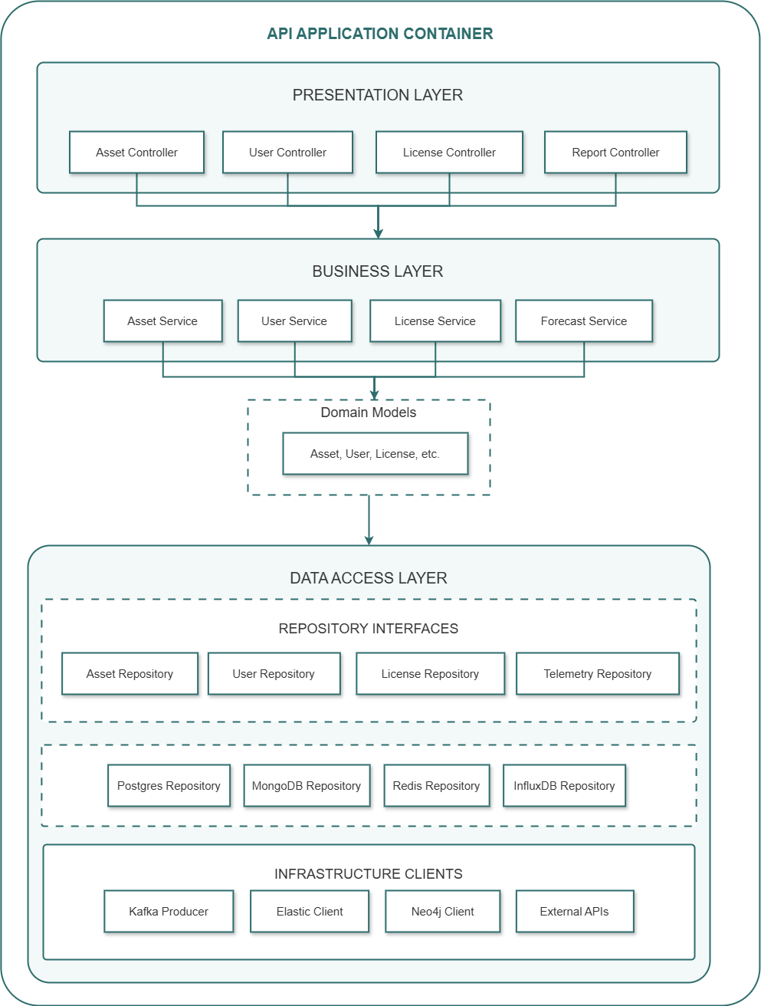

3. Component Descriptions
Component | Inputs | Outputs | Key Responsibilities | Dependencies
Asset Controller | HTTP Request | HTTP Response | Validate input, route to service, format response | Asset Service
Asset Service | Domain objects | Domain objects | Business logic, rule enforcement, coordination | Asset Repo, User Repo, Event Publisher
Asset Repository (Interface) | Query params | Domain objects | Abstraction for data access | None (interface)
Postgres Asset Repository | Query params | Domain objects | PostgreSQL CRUD operations | SQLAlchemy, Postgres DB
MongoDB Asset Repository | Query params | Domain objects | Metadata operations | MongoDB Client
Domain Models | Service calls | Domain objects | Encapsulate business behavior | None
Event Publisher | Domain events | Kafka messages | Publish change events | Kafka Producer
Cache Manager | Cache keys | Cached values | Redis operations | Redis Client
Search Client | Search queries | Search results | Elasticsearch queries | Elasticsearch Client

4. Component Interaction Flows
Document key interaction flows:
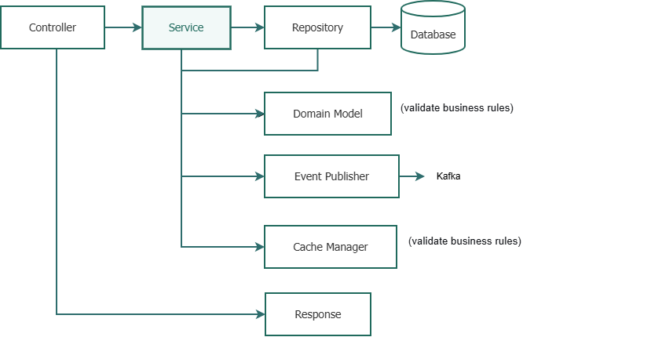
Flow 1: Asset Assignment Flow

2: Asset Search
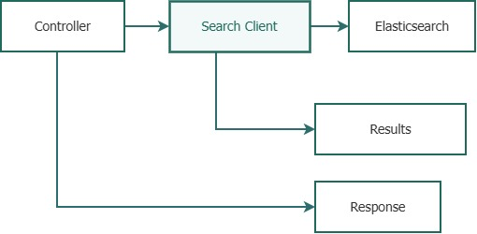
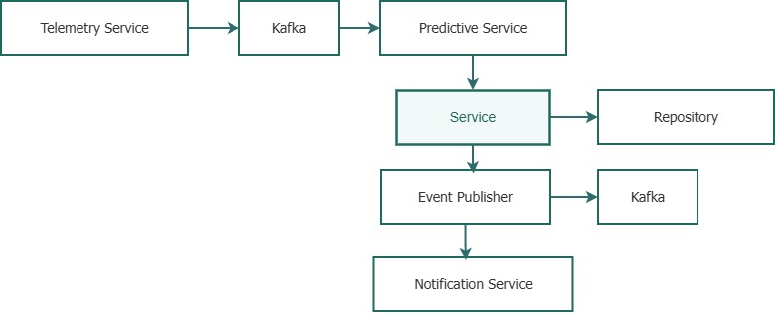
Flow 3: Predictive Maintenance Alert

Deliverable 4: Level 4 - Code (Optional/Introductory)

Format
- UML Class Diagrams or Entity-Relationship Diagrams
- For critical components only (2-3 diagrams)
- Filename: TeamName_C4_Code.pdf

Description
The Code level shows detailed implementation of critical components. This level is typically only created for complex or critical components that need special attention. It answers: How is this specific component implemented? What are its classes, methods, and relationships?

Requirements

1. Asset Entity Class Diagram
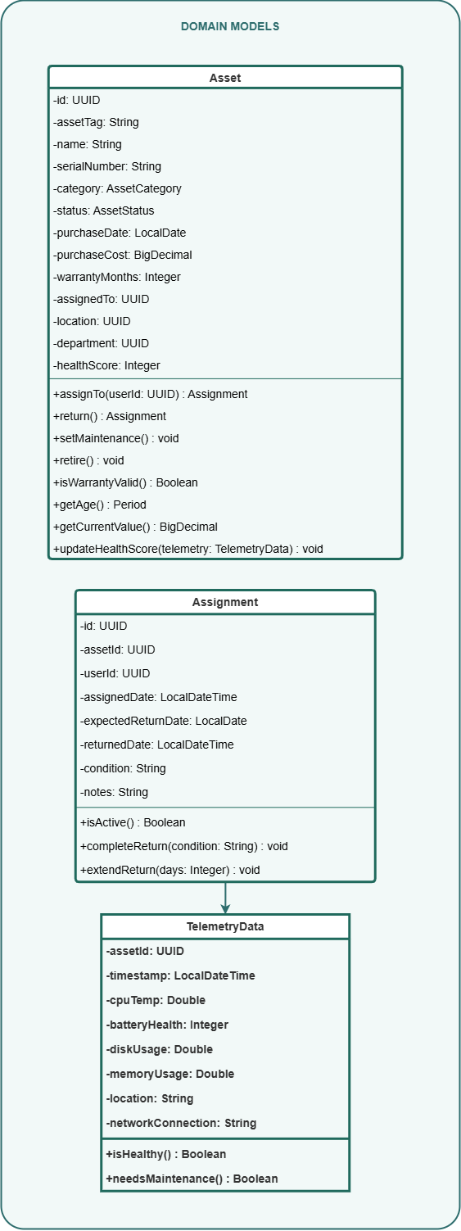

2. Asset Service Class Diagram
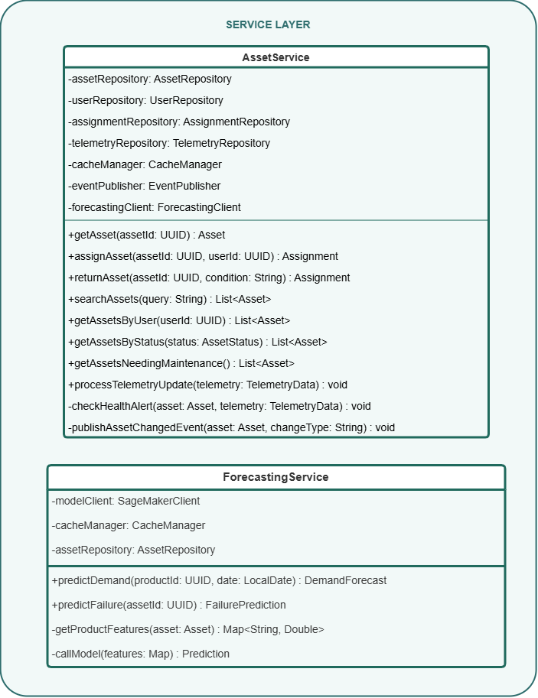
Deliverable 5: Architecture Decision Records (ADRs)

Format
- Document with individual ADR entries
- Filename: TeamName_ADRs.pdf

Description
Architecture Decision Records capture key design decisions, their context, rationale, and consequences. This ensures that future team members understand why the architecture was designed a certain way.

Requirements
For at least 5 key decisions, document ADRs using this template:
Field | Description
Title | Short, descriptive name of the decision
Status | Proposed, Accepted, Deprecated, Superseded
Context | The problem or situation requiring a decision
Decision | The chosen approach
Alternatives Considered | What else was considered and why not chosen
Consequences | Positive and negative implications
Related Decisions | Links to other ADRs
Date | When decision was made

Example ADRs
ADR-001: Polyglot Persistence Strategy
Field | Value
Title | Use Polyglot Persistence with Multiple Database Technologies
Status | Accepted
Context | The system must handle diverse data types: core asset records (relational), unstructured metadata (documents), telemetry (time-series), and network relationships (graph). A single database cannot optimally serve all these use cases.
Decision | Adopt polyglot persistence using: PostgreSQL (Snipe-IT) for core asset records, MongoDB for metadata, InfluxDB for telemetry, Neo4j for network relationships. Use Debezium for CDC synchronization.
Alternatives | Single relational database (rejected: poor performance for telemetry, inflexible for metadata). Single document database (rejected: weak ACID for transactions).
Consequences | Positive: optimal performance for each use case, flexible schemas. Negative: increased operational complexity, eventual consistency challenges, need for CDC infrastructure.
Related Decisions | ADR-002 (Event-Driven Synchronization), ADR-003 (CDC Strategy)
Date | 2025-03-15
ADR-002: AI Integration Pattern
Field | Value
Title | Use Event-Driven Pattern for Predictive Maintenance
Status | Accepted
Context | Predictive maintenance requires analyzing telemetry data from thousands of assets. Real-time analysis is not required; predictions can be generated asynchronously.
Decision | Implement event-driven AI using Kafka. Telemetry data published to Kafka; Predictive Analytics Service consumes events, runs models, and publishes alerts to Kafka for downstream processing.
Alternatives | Request-reply pattern (rejected: would require synchronous calls for every telemetry update, creating high load). Batch processing only (rejected: would miss real-time anomaly detection).
Consequences | Positive: decoupled, resilient, scalable. Negative: eventual consistency in alerts, additional infrastructure complexity.
Related Decisions | ADR-001 (Polyglot Persistence)
Date | 2025-03-16

Deliverable 6: Technology Stack Matrix

Format
- Spreadsheet or table in document
- Filename: TeamName_Technology_Stack.xlsx

Description
The Technology Stack Matrix documents all technology choices made in the application architecture, with justifications for each selection.

Requirements
Component | Technology | Version | Justification | Alternatives Considered
Web Frontend | React.js | 18.x | Strong ecosystem, team expertise, component reusability | Angular (rejected: steeper learning curve), Vue (rejected: smaller ecosystem)
Mobile App | React Native | 0.72 | Code reuse with web, large community, good for scanning apps | Flutter (rejected: requires learning Dart), Native (rejected: no code reuse)
API Application | Python/Flask | 2.3 | Rapid development, excellent ML/AI libraries, team skills | Node.js (rejected: weaker ML ecosystem), Java/Spring (rejected: slower development)
API Gateway | Kong | 3.x | Open source, plugin ecosystem, rate limiting, authentication | AWS API Gateway (rejected: vendor lock-in), NGINX (rejected: less built-in features)
Core Database | PostgreSQL | 14+ | ACID compliance, JSON support, mature, open source | MySQL (rejected: weaker JSON support), SQL Server (rejected: licensing cost)
Document Store | MongoDB | 6+ | Flexible schema, good for metadata, easy scaling | Couchbase (rejected: less adoption), DynamoDB (rejected: vendor lock-in)
Time-Series | InfluxDB | 2.x | Optimized for telemetry, high write throughput | TimescaleDB (rejected: PostgreSQL-based but higher overhead)
Graph Database | Neo4j | 5.x | Best for relationship queries, mature driver support | Amazon Neptune (rejected: vendor lock-in), ArangoDB (rejected: less mature)
Cache | Redis | 7.x | High performance, data structures, widely adopted | Memcached (rejected: fewer data structures)
Message Broker | Kafka | 3.x | High throughput, durability, ecosystem | RabbitMQ (rejected: lower throughput), AWS SQS (rejected: vendor lock-in)
CDC | Debezium | 2.x | Native PostgreSQL support, Kafka integration | Custom CDC (rejected: re-inventing wheel)
Workflow Engine | Temporal | 1.20 | Stateful workflows, durable execution, retries | Airflow (rejected: batch-oriented), Camunda (rejected: Java-centric)
Batch Processing | Airflow | 2.x | Mature DAG management, scheduling | Prefect (rejected: newer, less mature)
Search | Elasticsearch | 8.x | Full-text search, faceted search, analytics | OpenSearch (rejected: forked, less ecosystem)
AI Model Serving | SageMaker | - | Integrated with AWS, managed endpoint, monitoring | Custom container (rejected: more operational overhead)
Container Orchestration | Kubernetes | 1.28 | Portability, scaling, ecosystem | ECS (rejected: AWS-specific)
Infrastructure as Code | Terraform | 1.5 | Cloud-agnostic, mature, state management | Pulumi (rejected: less mature, smaller community)
CI/CD | GitLab CI | - | Integrated with source control, flexible | Jenkins (rejected: maintenance overhead), GitHub Actions (rejected: external repo)
Monitoring | Prometheus + Grafana | - | Industry standard, flexible, open source | Datadog (rejected: cost), CloudWatch (rejected: vendor lock-in)
Logging | ELK Stack | 8.x | Centralized logging, search, visualization | Splunk (rejected: cost), Loki (rejected: less mature)
Tracing | Jaeger | 1.50 | OpenTelemetry compatible, distributed tracing | Zipkin (rejected: less features)

Deliverable 7: Traceability Matrix

Format
- Spreadsheet
- Filename: TeamName_App_Traceability.xlsx

Description
The Traceability Matrix links your application architecture decisions back to the pain points from Activity 1, the TO-BE processes from Activity 2, and the data architecture from Activity 3. This ensures that every architectural decision is justified by business need.

Requirements

1. Pain Point to Application Solution Traceability
Pain Point ID | Pain Point Description | Application Solution | C4 Level | Component
P1 | Procurement-to-inventory delay | Procurement API integration; automated asset creation | Container | API Application, Kafka
P3 | Poor mobile experience | React Native mobile app with offline scanning | Container | Mobile Application
P5 | License over-purchasing | License Management Service with usage tracking | Component | License Service
P7 | Asset non-return after offboarding | HRIS integration; Temporal workflow for offboarding | Container | Workflow Orchestrator
P9 | Finance spreadsheets | ERP API integration; automated depreciation export | Component | Batch Processor
P12 | Audit findings | Graph database for relationships; assignment history | Container | Neo4j, Assignment History
P15 | Predictive failures | Telemetry ingestion; Predictive Analytics Service | Container | Telemetry Service, Predictive Service

2. TO-BE Process to Application Support Traceability
TO-BE Process | Application Support | Containers Involved | Components
1.0 User Sync | HRIS webhook receiver | API Application | User Controller, User Service, Kafka Producer
2.0 Procurement Intake | Procurement API integration | API Application, Kafka | Procurement Controller, Asset Service
3.0 Asset Assignment | Assignment workflow | API Application, Temporal | Asset Service, Workflow Client
4.0 Telemetry Ingestion | MDM integration, telemetry processing | Telemetry Service, InfluxDB | Telemetry Consumer, InfluxDB Repository
5.0 AI Analytics | Predictive models | Predictive Service, Kafka | Forecasting Service, Anomaly Detection
6.0 License Management | License allocation, compliance | API Application, PostgreSQL | License Service, License Repository
7.0 Asset Retirement | Retirement workflow | Temporal, API Application | Retirement Workflow, Asset Service

3. Data Architecture to Application Mapping
Data Architecture Element | Application Support | Container | Component
Enterprise Asset Entity | Asset domain model | API Application | Asset Entity, Asset Service
Snipe-IT Core Tables | Asset repository implementation | API Application | Postgres Asset Repository
Custom Assignment History | Assignment tracking | API Application, PostgreSQL | Assignment Repository, Audit Service
Telemetry Time-Series | Telemetry ingestion and query | Telemetry Service, Predictive Service | InfluxDB Repository, Forecasting Service
Graph Network Relationships | Network mapping queries | API Application | Neo4j Client, Network Service
CDC Event Stream | Change propagation | Debezium, Kafka | Kafka Producer, Sync Consumers

Deliverable 8: Executive Presentation

Format
- 8-10 slides, professional design
- Filename: TeamName_App_Architecture_Presentation.pptx

Description
A concise presentation summarizing your application architecture for executive stakeholders.

Slide Content
Slide | Content
1: Title | Project title, team members, date
2: Executive Summary | Overview of application architecture transformation, key outcomes
3: C4 Level 1 - Context | System boundaries and external interactions
4: C4 Level 2 - Containers | Major technology containers and communication
5: C4 Level 3 - Components | Internal structure of API application
6: Key Technology Decisions | Top 5 technology choices with justifications
7: AI Integration Approach | How AI is integrated (predictive maintenance, forecasting)
8: Deployment Architecture | How containers map to infrastructure (cloud/on-prem)
9: Traceability to Business Goals | How architecture addresses pain points
10: Next Steps | Implementation roadmap, Q&A

Evaluation Rubric
Criterion | Weight | Excellent (90-100%) | Satisfactory (70-89%) | Needs Improvement (<70%)
Level 1 Context Diagram | 15% | Clear, complete, professional; all actors and systems identified | Good; most actors identified | Missing key actors or systems
Level 2 Container Diagram | 20% | All containers identified; clear technology choices; communication protocols documented | Most containers identified; technology choices reasonable | Missing containers or unclear communication
Level 3 Component Diagram | 20% | Well-structured layers; clear component responsibilities; interaction flows documented | Good structure; most components identified | Unclear layering or missing interactions
Architecture Decision Records | 10% | 5+ ADRs with clear context, rationale, consequences | 3-4 ADRs with reasonable justification | Few ADRs or poor justification
Technology Stack Matrix | 10% | Comprehensive, justified selections | Good coverage, reasonable justifications | Missing or unjustified selections
Traceability Matrix | 10% | Clear links to pain points, processes, data architecture | Some traceability established | Missing or unclear traceability
Executive Presentation | 10% | Professional, compelling, tells coherent story | Good presentation, minor issues | Poor organization or unclear
Overall Coherence | 5% | All deliverables consistent, aligned with business goals | Generally consistent | Inconsistent across deliverables

Key Success Factors
- Start with the TO-BE Business Architecture: Your application architecture must enable the TO-BE processes. Use the TO-BE BPMN diagrams as your requirements.
- Use the C4 Model Hierarchically: Each level should logically decompose the previous level. The Container diagram should be a decomposition of the Context diagram; the Component diagram should decompose a specific container.
- Document Technology Choices: Every technology selection should have a clear justification. "Because we like it" is not sufficient.
- Create Traceability: Link every major decision back to pain points, processes, or data requirements. This prevents "solutioneering."
- Consider Deployment: Your container diagram should be deployable. Think about how containers will run in cloud or on-premises environments.
- Balance Detail and Clarity: The Component diagram should show enough detail to understand the structure but not every class. Save detailed class diagrams for Level 4.
- Use Standard Notation: Follow C4 model conventions. Be consistent across diagrams.

Connection to Course Modules
Module | Connection
Module 2 | C4 model introduced; this activity applies it to your project
Module 3 | Polyglot persistence and AI integration patterns are implemented in containers
Module 4 | Development and implementation will follow the C4 structure
Module 5 | Testing, deployment, and operations will be designed for these containers

End of Activity 4 Description

