TO-BE Business Architecture

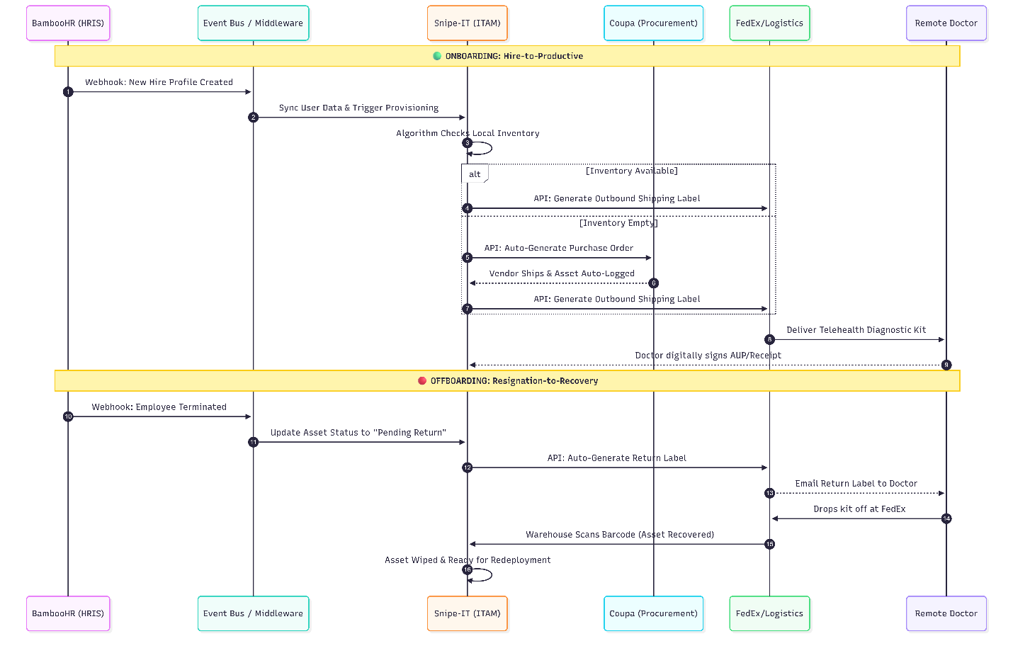

TO-BE Business Architecture: The Unified ITAM Intelligence Layer
In the modernized TO-BE architecture, IT Asset Management is no longer a single "box" or manual application. It is a complete restructuring of the IT ecosystem into a Unified Integration & Intelligence Layer.
While the AS-IS state relied heavily on manual hand-offs and emails between HR, Procurement, and IT, the new architecture replaces these gaps with an automated, data-driven ecosystem. The human is moved from being the processor of data to the implementer of AI-driven decisions.
1. Key Modernization Zones
1. The Intelligence "Hub" (Center) The most significant change is the introduction of a Polyglot Persistence Layer and an AI Analytics engine.
- Before: Asset data lived exclusively inside legacy Access databases or flat spreadsheets.
- Now: The system simultaneously pulls from Relational SQL (for identity), Document NoSQL (for HIPAA compliance), Time-Series (for real-time health), and Graph (for clinical relationships). The system "thinks" before a technician even sees a task.
2. Automated Trigger Points (Left Side)
- Before: IT actions began only when a person filled out a manual request form.
- Now: The process starts automatically via API integration. When BambooHR registers a new telehealth doctor, or when device telemetry indicates a failing battery, the Intelligence Layer immediately begins the provisioning or replacement process without waiting for a ticket.
3. The "No Data Entry" Zone (Right Side)
- Before: IT staff had to physically receive assets, verify availability, and manually type serial numbers into spreadsheets.
- Now: The IT lane requires zero manual data entry. Technicians only receive "Smart Notifications" via Temporal workflows to perform physical tasks (e.g., hand off a box to FedEx). All database records, status changes, and history logs are updated seamlessly in the background.
4. Interoperability & Lifecycle (Bottom Right) The asset lifecycle is heavily interconnected with other enterprise domains:
- HRIS Integration (BambooHR): For automated checkout during doctor onboarding and trigger-based return logistics during offboarding.
- Finance/ERP Integration (Coupa): To sync purchase orders, PO numbers, and depreciation records instantly.
- Clinical Operations Integration: To ensure specific doctors have the necessary telehealth diagnostic kits mapped to their scheduled virtual patient rounds.

2. The Polyglot Architecture Breakdown
This layer acts as the unified memory for the AI Analytics engine. Instead of forcing all data into one giant relational database, the architecture unbundles it, utilizing the "right tool for the right job."
1. Relational (SQL - PostgreSQL) | The "Identity"
- Source: Internal Snipe-IT core database.
- Role: The System of Record. It holds the "Static" truths: Asset Tag ID, Purchase Date, Current Assigned Doctor, and Cost.
- Modernization: It no longer stores massive blobs of unstructured data or telemetry, keeping it incredibly fast and lean for standard financial and inventory audits.
2. NoSQL (Document-Based - MongoDB) | The "Context"
- Source: External attachments and dynamic metadata.
- Role: Stores the "Messy" data critical for healthcare. This includes signed HIPAA Acceptable Use Policies, Cryptographic Wipe Certificates, and vendor-specific telehealth configuration JSON files.
- Modernization: When a compliance auditor searches for an asset, the API pulls the exact, verified wipe certificate from this layer instantly without bogging down Snipe-IT.
3. Time-Series (NoSQL - InfluxDB) | The "Pulse"
- Source: OS Telemetry from Jamf (Mac) and Intune (Windows).
- Role: Tracks change over time. It records laptop battery health cycles, CPU temperatures, and network connectivity drops every minute.
- Modernization: This is the fuel for Predictive Maintenance. The AI monitors these trends to say, "Dr. Miller's laptop battery is degrading 15% faster than average—ship a replacement now before it dies during a patient consultation."
4. Graph Database (Neo4j) | The "Relationship"
- Source: Network topology and Clinical Org Charts.
- Role: Maps dependencies.
- Modernization: Moves ITAM from "List Management" to Impact Analysis. If a specific regional VPN gateway fails, the Graph DB immediately identifies every remote doctor connected to it, the specific telehealth kits currently offline, and the scheduled patients affected by the outage.

3. The Modernized Data Sync Flow
To make the Polyglot Persistence Layer work, data must move out of Snipe-IT and into specialized databases in real-time. We utilize an Event-Driven Middleware (FastAPI / Node.js paired with Kafka) to act as the traffic cop.
How the Data is "Unpacked":
- The Trigger (Webhook/Polling): The middleware detects a change via a webhook (e.g., an asset is checked out to a new doctor) and pulls the JSON payload from the Snipe-IT /api/v1/hardware endpoint.
- The Distribution (The "Polyglot Split"): The middleware takes that single JSON object and "shreds" it into the respective databases:
  - To SQL: asset_tag, serial, status_id, assigned_to (Updates the System of Record).
  - To NoSQL: custom_fields, wipe_cert_url, diagnostic_logs (Stores the unstructured compliance context).
  - To Graph: assigned_to, location_id, model_id (Creates a relationship edge: e.g., "Doctor A" -> "Telehealth Kit B" -> "Virtual Clinic C").
- The Time-Series Injection: Simultaneously, the telemetry agent installed on the telehealth device pushes live health data directly into InfluxDB. The AI engine joins this "Live Pulse" with the "Asset Owner" from SQL to generate predictive alerts.
4. Sample Data Payload Transformation
Here is a technical look at how the middleware transforms and routes the data when a telehealth kit is assigned to a doctor.
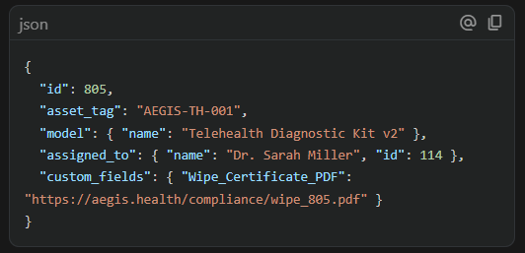
Incoming JSON from Snipe-IT:

Event-Driven Middleware Actions:
- To PostgreSQL (Relational): UPDATE assets SET status='deployed' WHERE id=805;
- To MongoDB (Document): db.compliance.insert({ asset_id: 805, wipe_certificate: "https://aegis.health/compliance/wipe_805.pdf" });
- To Graph DB (Relationship): CREATE (User {id:114, title:'Remote Doctor'})-[:OWNS]->(Asset {tag:'AEGIS-TH-001'});

