TO BE Busines Architecture
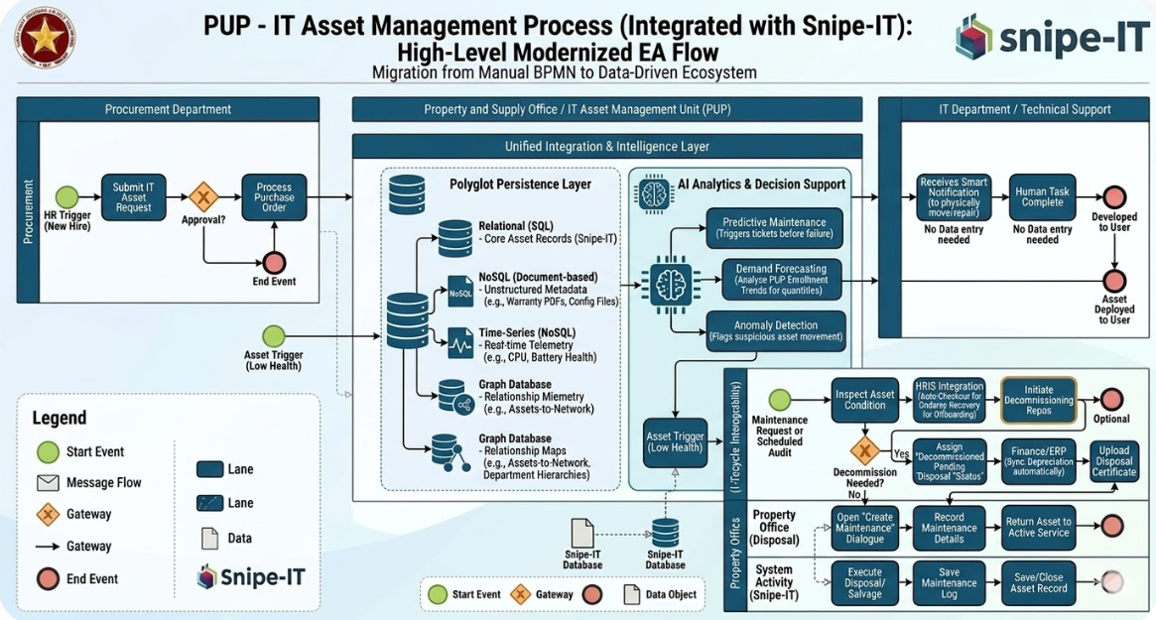
In the updated diagram, the modernization isn't just a single "box"—it is a complete restructuring of the center of the process.
While the original diagram relied on manual hand-offs between departments, the new architecture replaces those gaps with a Unified Integration & Intelligence Layer.
Here are the specific zones where the modernization occurred:

1. The Intelligence "Hub" (Center)
The most significant change is the introduction of the Polyglot Persistence Layer and the AI Analytics & Decision Support engine.
- Before: Data lived only inside Snipe-IT (Relational SQL).
- Now: The system simultaneously pulls from NoSQL (for metadata), Time-Series (for real-time health), and Graph (for relationships). This allows the system to "think" before a human even sees a task.

2. Automated Trigger Points (Left Side)
Notice the HR Trigger (New Hire) and Asset Trigger (Low Health).
- Before: A process started when a person filled out a manual request.
- Now: The process starts automatically via API integration. For example, when HR adds a new employee, the "Intelligence Layer" immediately begins the procurement or assignment process without waiting for a manual submission.

3. The "No Data Entry" Zone (Right Side)
Look at the IT Department / Technical Support lane on the top right.
- Before: IT staff had to receive assets, verify availability, and manually update Snipe-IT.
- Now: The lane is labeled "No Data Entry Needed." The technician only receives a "Smart Notification" to perform the physical task (move or repair). The system updates the records in the background automatically.

4. Interoperability & Lifecycle (Bottom Right)
The section labeled "Lifecycle Management" now includes:
- HRIS Integration: For automated checkout during onboarding.
- Finance/ERP Integration: To sync depreciation and financial records instantly.
- LMS Integration: (Implicitly handled by the intelligence layer) to ensure lab assets match student schedules.

Summary of the Shift: The "Modernization" is the transition from Departmental Silos to a Data-Driven Ecosystem. The human is moved from being the processor of data to the implementer of AI-driven decisions.
To zoom in on that Polyglot Persistence Layer, we have to look at how data is "unbundled." In the old system, everything was forced into a Relational (SQL) table. In the modernized architecture, we use the "right tool for the right job."
The Polyglot Architecture Breakdown
This layer acts as the unified memory for the AI Analytics engine. Instead of one giant database, it’s a synchronized ecosystem:
1. Relational (SQL) | The "Identity"
- Source: Internal Snipe-IT (MySQL/MariaDB).
- Role: This is your System of Record. it holds the "Static" truths: Asset Tag ID, Purchase Date, Current Assigned User, and Physical Location.
- Modernization: It no longer stores telemetry or massive blobs of unstructured data, keeping it fast and lean for standard audits.
2. NoSQL (Document-Based) | The "Context"
- Source: External attachments and dynamic metadata.
- Role: Stores the "Messy" data. Think of warranty PDFs, configuration JSON files from servers, or vendor-specific hardware specs that don't fit into a standard SQL row.
- Modernization: When a technician clicks an asset, the AI pulls the exact manual or wiring diagram from this layer instantly.
3. Time-Series (NoSQL) | The "Pulse"
- Source: IoT Sensors and OS Telemetry (e.g., Zabbix, Prometheus).
- Role: Tracks Change over Time. It records battery health cycles, CPU temperatures, and network uptime every minute.
- Modernization: This is the fuel for Predictive Maintenance. The AI looks at these trends to say, "This laptop's battery is degrading 15% faster than average—replace it now before the student's final exam week."
4. Graph Database | The "Relationship"
- Source: Network topology and Organizational charts.
- Role: Maps Dependencies. If a specific Core Switch in a PUP lab fails, the Graph DB immediately identifies every connected PC, the faculty member responsible, and the student courses currently booked in that room.
- Modernization: It moves ITAM from "List Management" to Impact Analysis.

How they sync up:
The Integration Layer uses a "Global Asset ID" to tie these together. When the AI makes a decision, it performs a Federated Query:
- SQL: "Is the asset still under warranty?"
- Time-Series: "Is the hardware actually failing?"
- Graph: "Who is the high-priority user affected if we pull it for repair today?"
This is the "engine room" of your modernization. To make the Polyglot Persistence Layer work, we need a way to move data out of Snipe-IT's traditional SQL database and into the more specialized "bins" (NoSQL, Time-Series, and Graph) in real-time.

The Modernized Data Sync Flow
Since Snipe-IT currently lacks full "Create/Update/Delete" webhooks, we use an Event-Driven Middleware (like a Python/Node.js microservice or a low-code tool like Pipedream/n8n) to act as the traffic cop.

How the Data is "Unpacked"
When an asset is updated in Snipe-IT (e.g., a laptop is checked out to a new faculty member), the following API flow occurs:

1. The Trigger: Polling or Check-out Webhook
The middleware detects a change via a Webhook (for check-ins/check-outs) or a Scheduled API Poll (for new asset creation). It pulls the JSON payload from the /api/v1/hardware endpoint.

2. The Distribution (The "Polyglot" Split)
The middleware takes that single JSON object and "shreds" it into the three specialized databases:
Target Database | Data Sent | Purpose
Relational (SQL) | asset_tag, serial, status_id, assigned_to | Updates the "System of Record" for the Audit Trail.
NoSQL (Document) | custom_fields, image, notes, manual_url | Stores the "Unstructured" context that doesn't fit a rigid table.
Graph Database | assigned_to, location_id, model_id | Creates a Relationship Edge (e.g., "User A" -> "Laptop B" -> "Switch C").

3. The Time-Series Injection
While the SQL data is static, a separate Telemetry Agent (installed on the device) pushes live health data directly into the Time-Series DB.
- Example: The agent sends {"cpu_temp": 85, "battery_health": 72}.
- The Magic: The AI engine joins this "Live Pulse" with the "Asset Owner" from the SQL database to alert the specific user before their laptop dies.

Sample Data Payload Transformation
Here is what the "Transformation" looks like in the middleware:
Incoming JSON from Snipe-IT:
JSON
{
"id": 402,
"asset_tag": "PUP-LIB-001",
"model": {"name": "Dell XPS 15"},
"assigned_to": {"name": "Dr. Arlene", "id": 88},
"custom_fields": {"Warranty_PDF": "http://pup.edu/docs/w402.pdf"}
}
Middleware Action:
- To SQL: UPDATE assets SET status='deployed' WHERE id=402;
- To NoSQL: db.manuals.insert({asset_id: 402, pdf: "http://pup.edu/docs/w402.pdf"});
- To Graph: CREATE (User {id:88})-[:OWNS]->(Asset {tag:'PUP-LIB-001'});

