Deliverable 2A: TO-BE Business Architecture
Company: Aegis Health Partners

1. The Unified ITAM Intelligence Layer
In the modernized TO-BE architecture, IT Asset Management transitions from isolated departmental silos into a Unified Integration & Intelligence Layer. This shift moves humans from being manual data processors to the implementers of AI-driven decisions.
1.1 Business Capabilities
The future-state architecture introduces several net-new business capabilities:
- Automated Asset Lifecycle Management: Seamlessly track hardware from procurement through disposal without manual spreadsheet entry.
- Zero-Touch Provisioning & Logistics: Automatically order, configure, and ship equipment directly to remote telehealth doctors based on HR webhooks.
- Automated Compliance & Risk Management: Algorithmically enforce HIPAA compliance by mandating cryptographic wipe certificates before an asset can be marked as disposed.
- Telemetry-Driven Predictive Maintenance: Monitor device health (battery life, CPU temperatures) to proactively replace failing equipment before it impacts a patient consultation.
1.2 Value Streams
By implementing this architecture, Aegis optimizes three primary value streams:
- Hire-to-Productive (Onboarding): BambooHR triggers an automated workflow that allocates inventory, creates a Coupa PO if needed, and ships the device.
  - Value: Reduces onboarding delays from 3-5 days to under 24 hours.
- Resignation-to-Recovery (Offboarding): Employee termination triggers an automated FedEx return label generation.
  - Value: Closes the logistical loophole, reducing the 30% asset loss rate and recovering ~$150,000 annually.
- Retirement-to-Compliance (Disposal): E-waste recyclers automatically upload Certificates of Destruction to the database.
  - Value: Mitigates massive HIPAA violation risks by guaranteeing verifiable sanitation.
1.3 BPMN Workflow & Automation Zones
- The Intelligence Hub (Center): The system simultaneously pulls from Polyglot databases to "think" and make routing decisions before a human is involved.
- Automated Trigger Points (Left Side): Processes begin via API webhooks (HR New Hire, Low Device Health) rather than manual ticket submissions.
- The "No Data Entry" Zone (Right Side): The IT Help Desk receives "Smart Notifications" to perform physical tasks (e.g., hand a box to FedEx), while the system updates the Snipe-IT database in the background.

Deliverable 2B: TO-BE Data Architecture
Company: Aegis Health Partners

The TO-BE Data Architecture transitions the organization from flat-file record keeping into a highly normalized, scalable data ecosystem capable of handling HIPAA compliance and AI analytics.
1. Enterprise Data Model (EDM)
The system standardizes data across multiple domains to create a "Golden Record" for every physical asset:
- Identity Domain (The "Who"): Sourced from BambooHR (Employee_ID, Clinical_Role).
- Asset Domain (The "What"): Sourced from Snipe-IT (Asset_Tag, Serial_Number).
- Financial Domain (The "Cost"): Sourced from Coupa (PO_ID, Depreciation).
- Compliance Domain (The "Risk"): Sourced from Document Stores (Wipe_Certificate_ID, EULA_Signature).
- Telemetry Domain (The "Health"): Sourced from MDM (CPU_Temp, Battery_Health).
2. Polyglot Persistence Strategy
To efficiently handle this diverse data, an Event-Driven Middleware "shreds" incoming payloads into specialized databases:
- Relational Database (Snipe-IT PostgreSQL): The System of Record for Asset and Identity domains. Handles standard financial audits.
- Document Store (MongoDB): The Context layer. Stores unstructured data like PDF Wipe Certificates and signed Acceptable Use Policies.
- Time-Series Database (InfluxDB): The Pulse layer. Ingests high-velocity hardware telemetry from remote telehealth kits to fuel predictive maintenance.
- Graph Database (Neo4j): The Relationship layer. Maps dependencies (e.g., tying a specific failing VPN router to the exact remote doctors and patients affected).

3. Data Flow Diagrams (DFDs)
Level 0: Context Diagram
This illustrates the Unified ITAM System interacting with external entities and vendors.
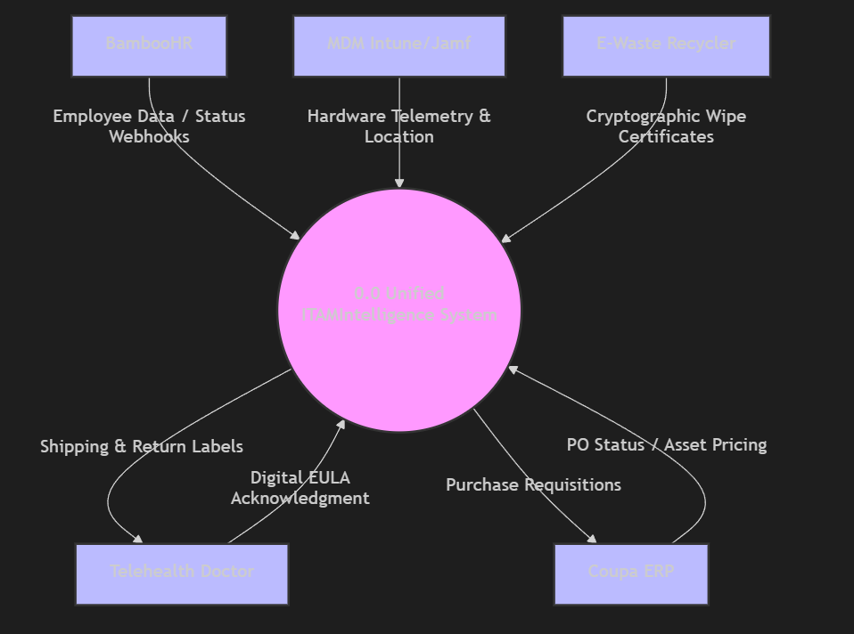

Level 1: Internal Processing & Shredding
This illustrates how the middleware ingests data, shreds it into the Polyglot layer, and fuels the AI predictive logic.
