A&E Report

org_code = RQM

## Attendances

ggplot(df, aes(period, attendances)) +  
 geom_line() +  
 geom_point()

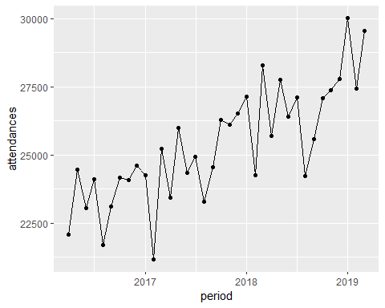

## Performance

df %>%  
 mutate(performance = 1 - breaches / attendances) %>%  
 ggplot(aes(period, performance)) +  
 geom_line() +  
 geom_point()

