Sample code to read PLX files created by NeuroPhys

Instructions:
1. Open a web browser, and go here: https://github.com/tomjhou/Matlab-example

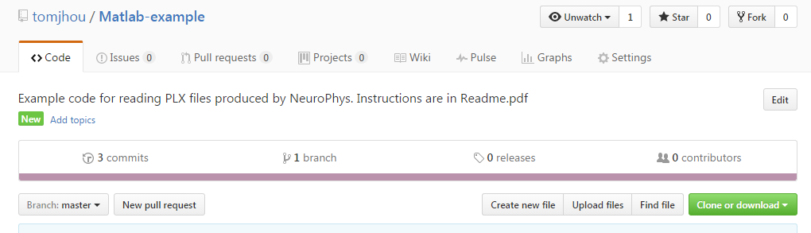
Click the big green button, and then choose “Download ZIP”

2. Unzip the downloaded file into your MATLAB folder. Alternately, you can put the files into a subfolder, then add that subfolder to your MATLAB path.
3. Type the following at the MATLAB command prompt:

>> test_read_plx

3. When you hit enter, select the sample file: “Sample_JAGA_acquisition.plx”, which contains 20 seconds of recording from a JAGA device. You should see the following:

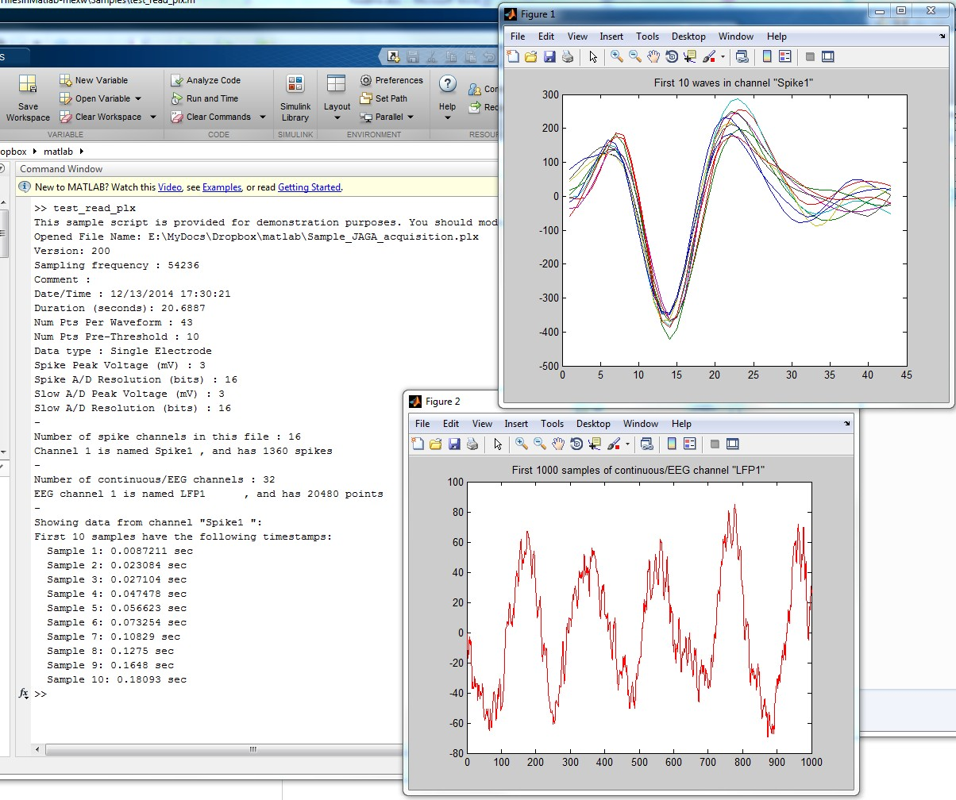

Here is a brief description of the example output:

- The first few lines of text output shows information from the file header. It tells you the file creation time, waveform sizes, sample rates, and sample resolution, among other basic facts.
- Figure 1 shows the recorded waveforms for the first 10 spikes (there are 1360 total recorded spikes in this example).
- Figure 2 shows the first 1000 sample of one EEG channel. The EEG channel is sampled at 1kHz, which is lower than the sample rate of the spike channel.

If you have questions about the code, please email me at tom@neurosysllc.com

Thank you for your interest.

