**4.** Explicit equation:

% calculate delay

Trx = (1/c)*sqrt((Xe-xf).^2 + (Ze-zf).^2) + zf/c; %[s]

% subtract max

Trx = Trx - min(Trx); %[s] add 1 to take away that pesky zero

Where,

Xf- lateral focus position

Xe- lateral element position

Zf- depth focus position

Ze- depth lateral position

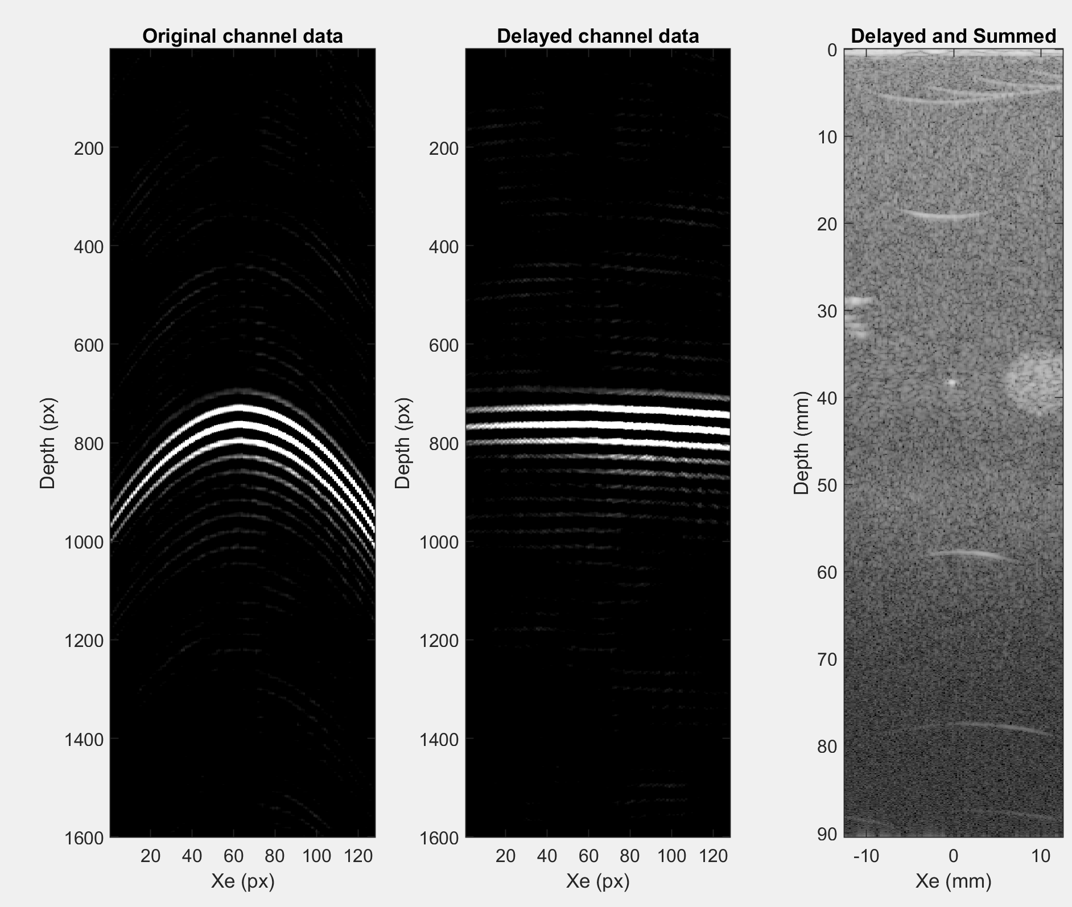

**Part 4, ctd:**

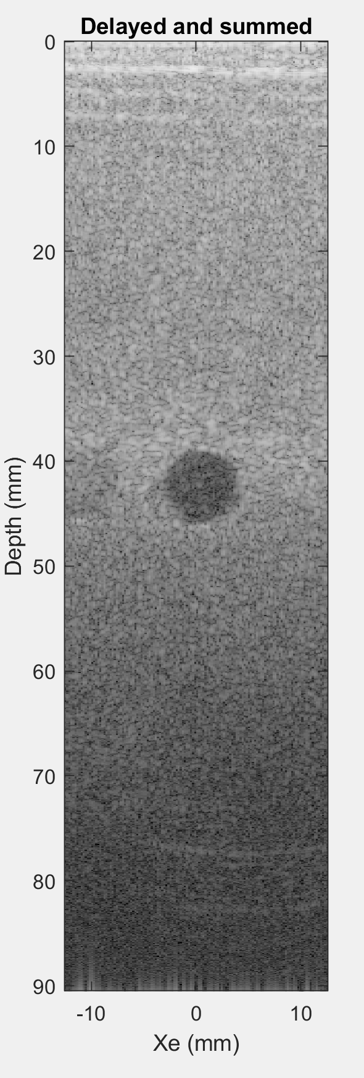

**Part 5:**

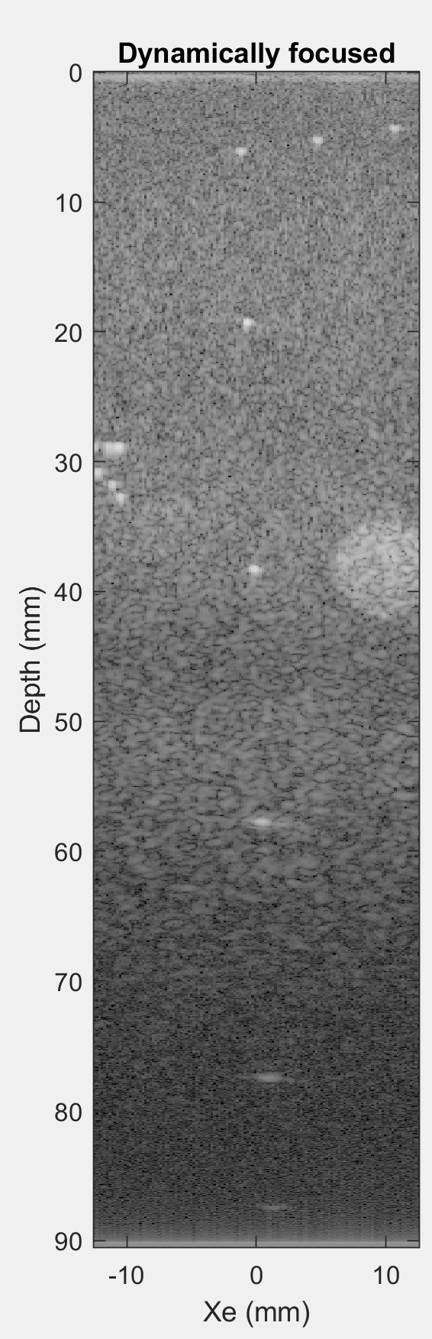 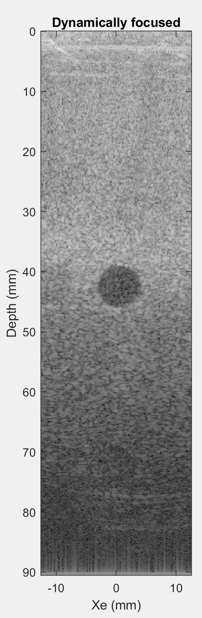

The difference in dynamic vs single focus is most clearly illustrated in the point targets which are not at the single focus. The dynamic focus is able to achieve a nice psf through depth, whereas the single focus is not.

**Part 6.**

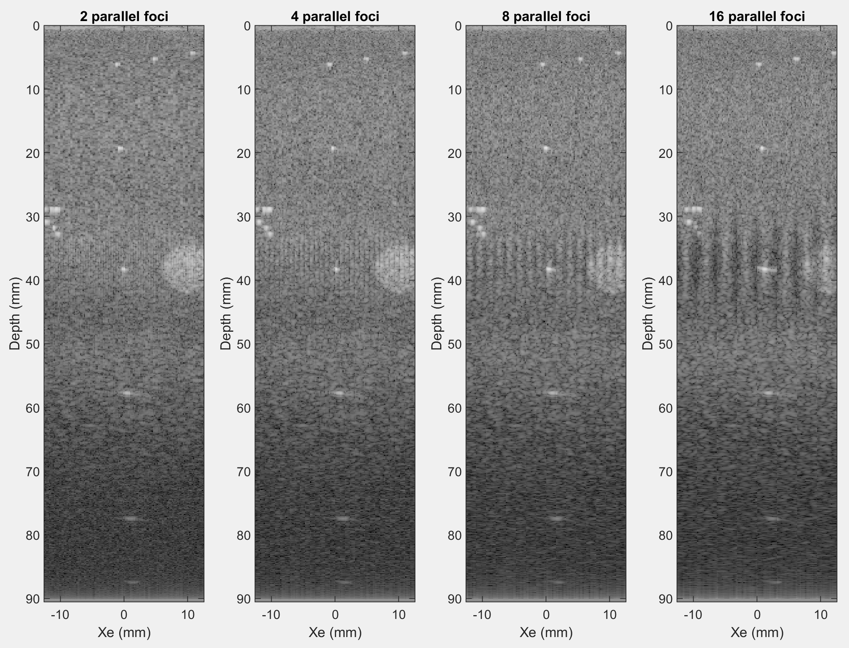

The most noticeable artifact is a banding pattern that is visible near the transmit focus. This is slightly visible as early as 4 parallel foci and very visible at 16 parallel foci.

**Part 7.**

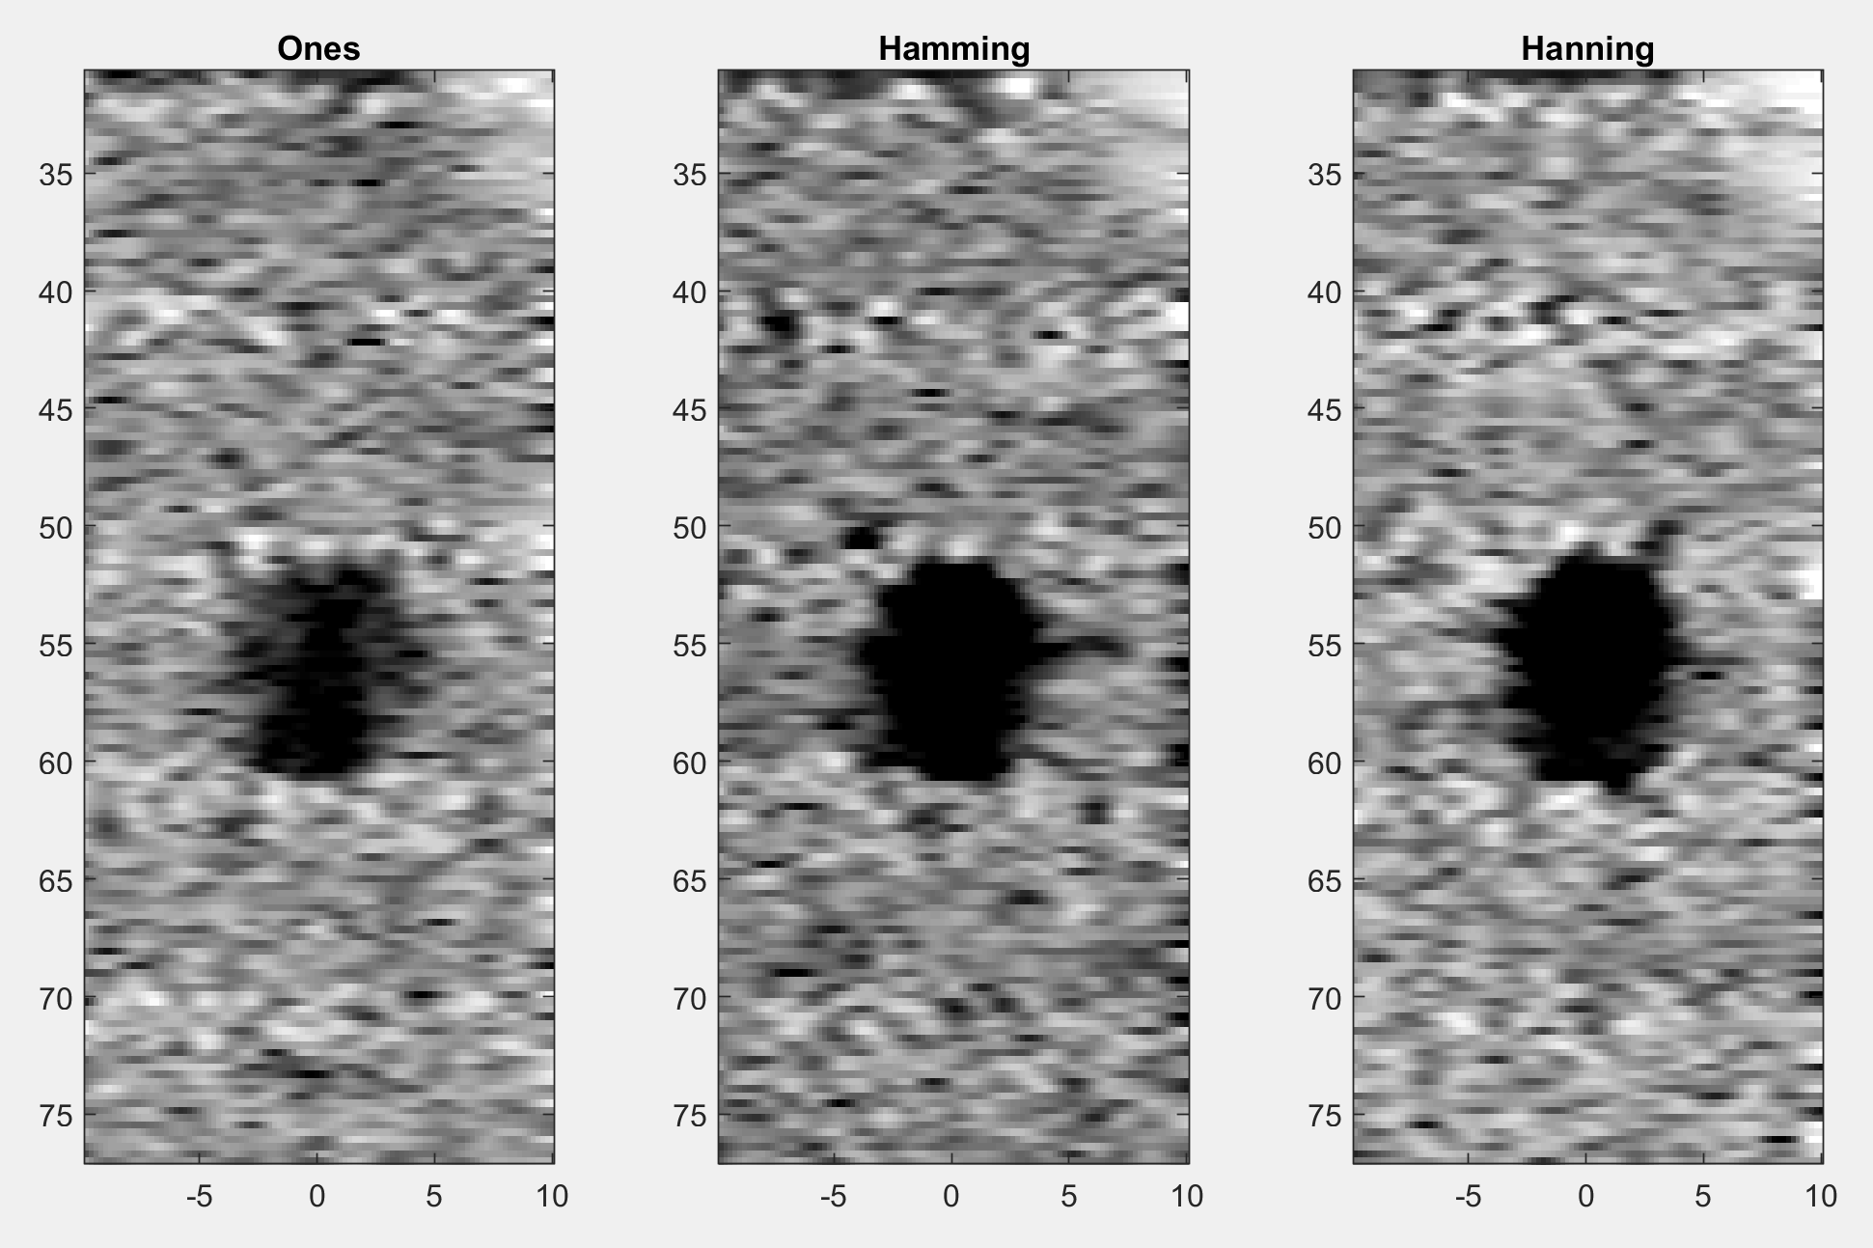

% Window; Contrast; CNR

% no apo 4.5 -9.9

% hanning 41 1.13

% hamming 29 1.63

**Part 8.**

Aperature mask. My code implements a discrete series of apertures instead of a continually growing aperature. This is shown below:

F# = 2

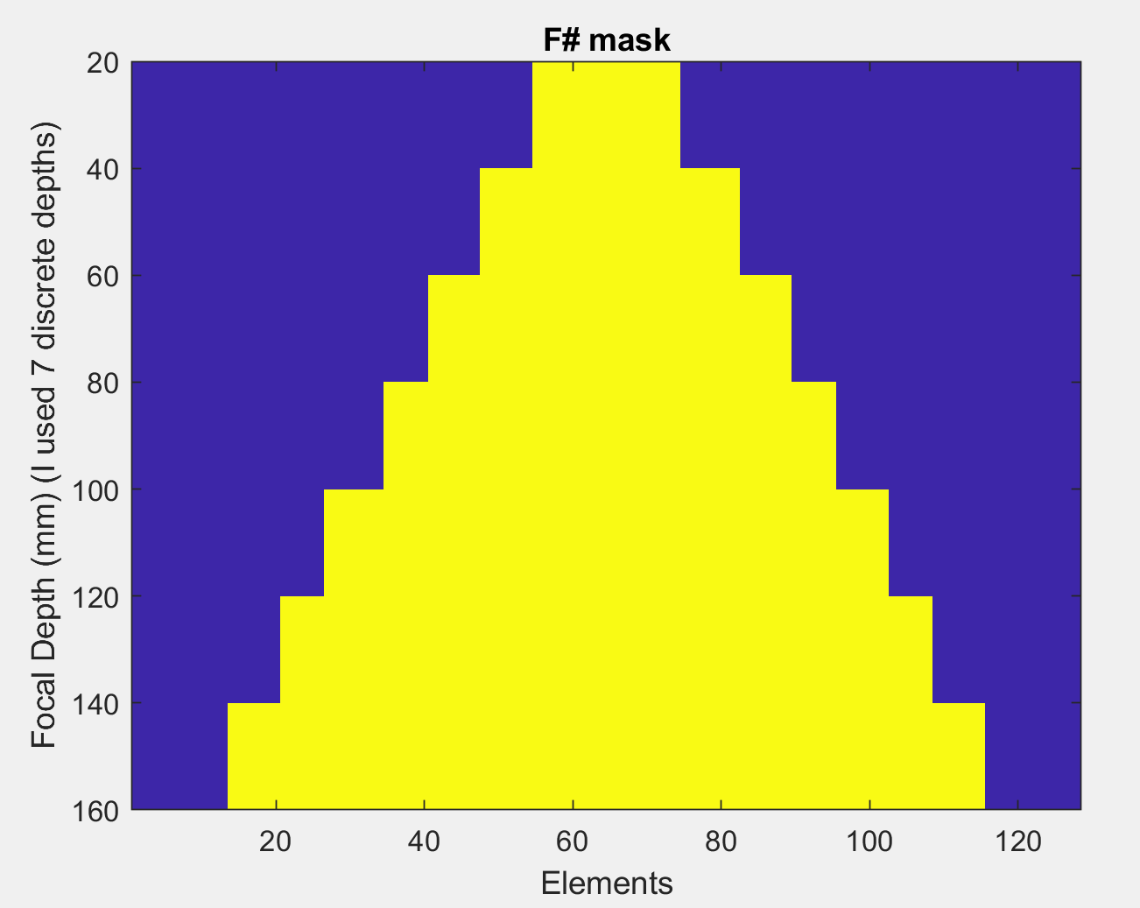

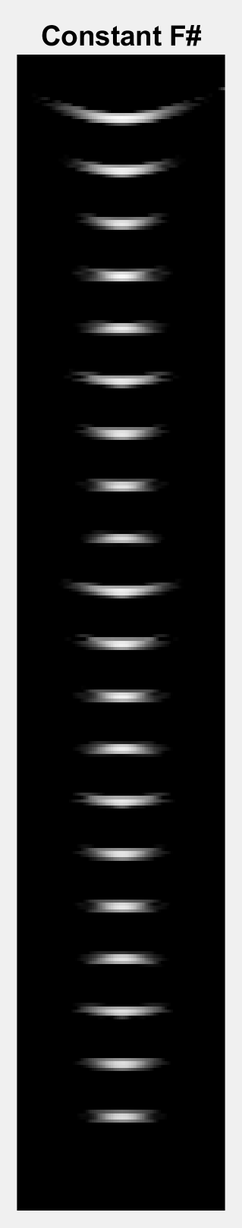 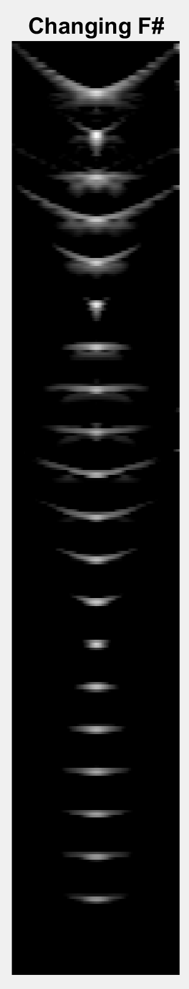

The point targets without aperture growth show a great deal of variance compared to with aperture growth. In some cases they are better and others they are worse.