Prob 1.

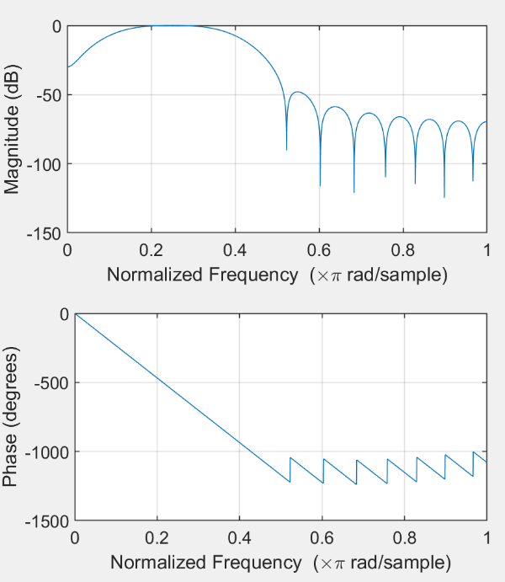I defined my filter with matlab’s fir function.

The frequency response of my filter is shown to the left.

* center frequency: .29 (which is slightly higher than our transmit frequency relative to our sample rate, .25).
* Bandwidth: .15
* Order: 10

b)

|  |  |  |
| --- | --- | --- |
|  | Contrast | CNR |
| Without filter | 20.18 | 2.42 |
| With filter | 20.71 | 3.65 |

This filter slightly helped contrast and improved CNR. Higher order filters helped CNR more but hurt contrast whereas lower order filters were better for contrast but hurt CNR.

c) Filters should be applied anywhere before forming the envelop of the image, as that step is nonlinear.

Prob 2.

See published matlab ‘Assign3_Prob2’ for implementation. Some notes:

I setup my code to analyze the signal in time windows. For each time window, I took the fft and fit a polynomial to this spectral support. I used that polynomial to find the center frequency as well as positions for the low and high filter cutoffs. I applied variable filter parameters to each window based on the width and location of the spectral support. I also included the ability to reduce the bandwidth of the filter with depth. I also tuned filter order. It would have been useful to have a target outcome in mind because I don’t have much of a basis for how well filtering can work in this scenario.

I played around with lots of parameter iterations. Ultimately, I got the best results using only two time windows, which surprised me.

Final results:

* Signal error: .1656
* Noise power: .3096
* Total: .4752

Parameters:

* Time windows:2
* Filter order: 10

3. Synthetic Aperature

a) low res (single transmit) b) mask

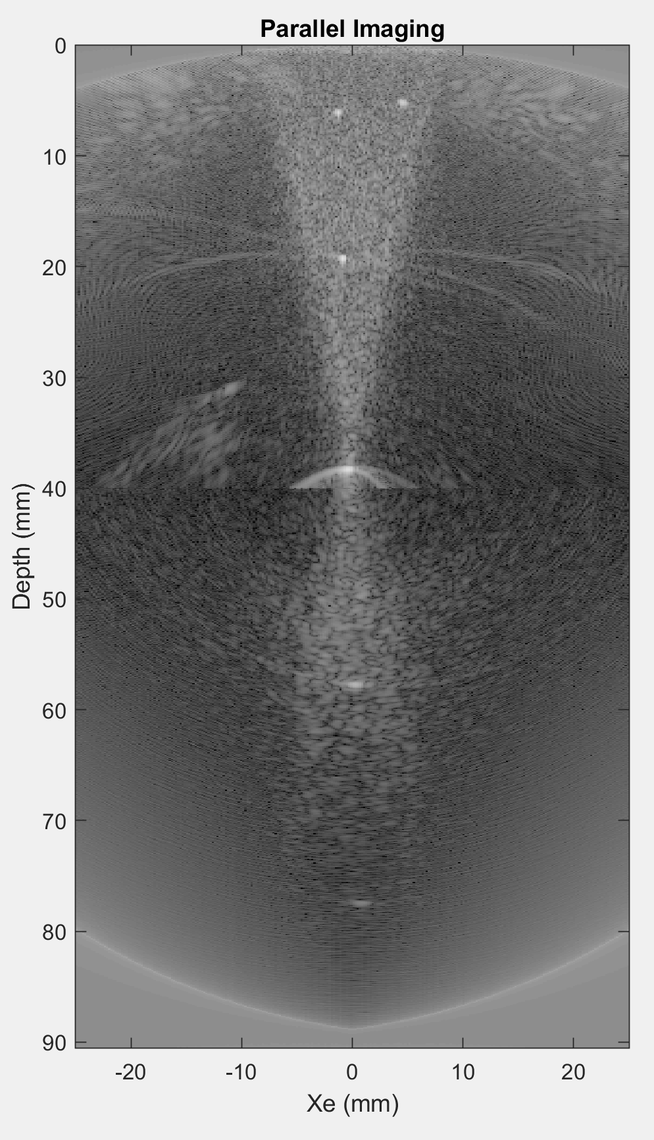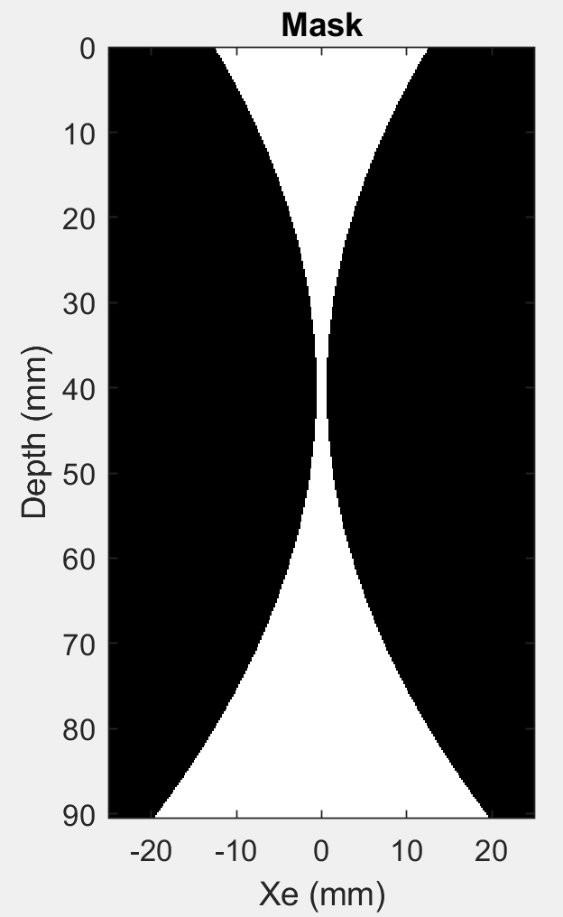

c) final image:

