**Effect of quantization on lateral resolution**

BME 395 Mini-Project 1

Tom Manuel

**Intro**: Delaying channel data is a fundamental step in all ultrasound beamforming approaches. Implementing these delays presents a classic sampling problem in which a signal, continuous in nature, must be quantized. The purpose of this report is to investigate the effect of this process on lateral resolution.

**Simulation Summary**: Simulations were run in field II which varied the minimum quantization value used in the delaying of channel data. For each quantization value, a point target was imaged at depths ranging from 15 to 110 mm with targets spaced 5 mm apart. A single transmit focus with dynamic receive focus was implemented. Quantization limits consisted of 0, .01 us, .1 us, and 1us. Hanning apodization was used.

**Results:**

***Test 1****:* The effect of minimum quantization values on a point target phantom. The same phantom was imaged with 4 different minimum quantization values: 0, .01, .1, and 1 microseconds. The effect on lateral resolution is apparent as higher quantization values impede delay focusing and result in lateral smearing.

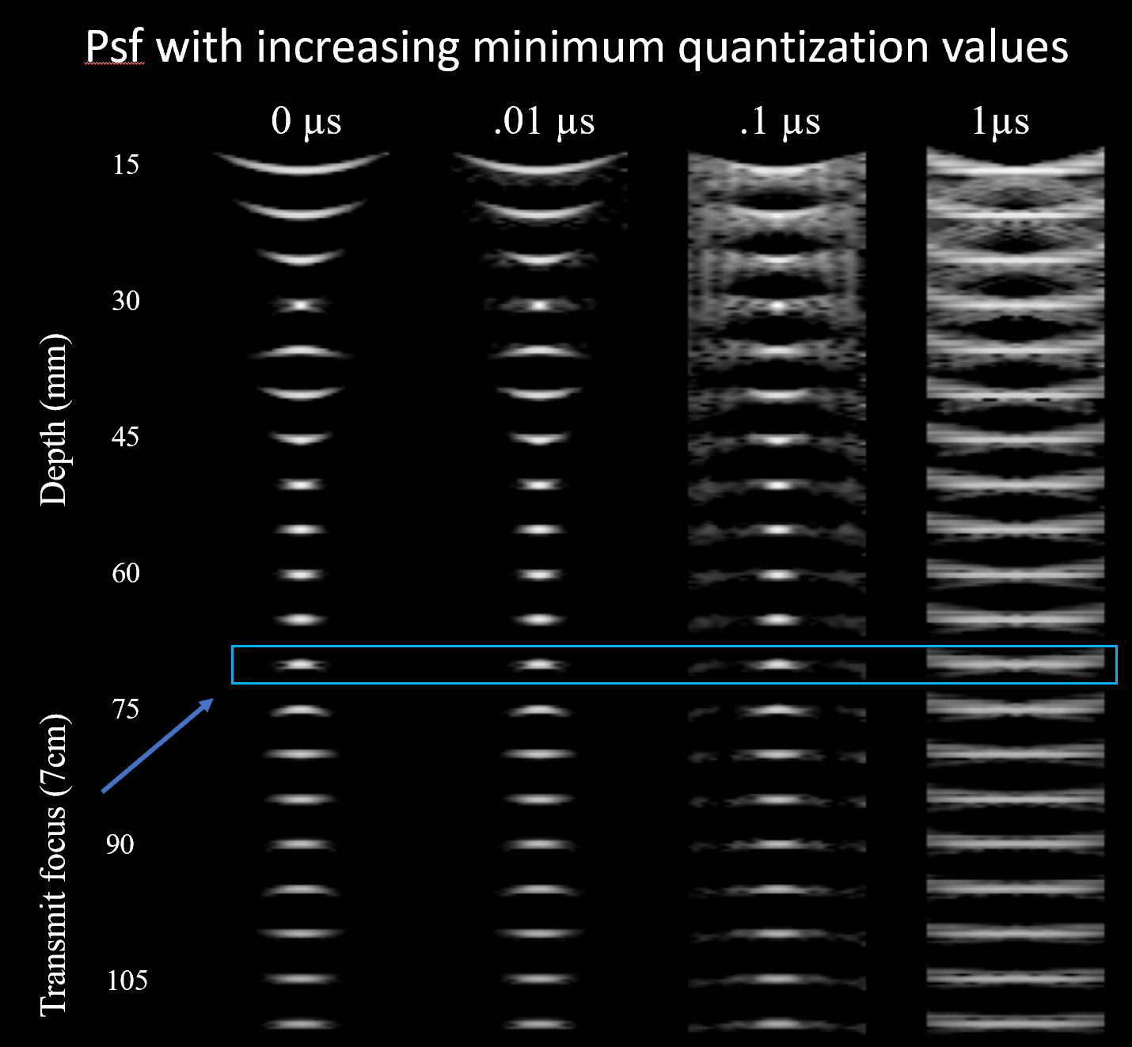

***Test 2:*** To further investigate the effect on lateral resolution, lateral resolution was quantified at the transmit focus for 6 different quantization values. Below are the point spread functions at the transmit focus are shown in greater detail (left). A plot is shown (right) or the lateral resolution (FWHM of the dB envelope image). Minimum quantization was more highly sampled in this test to show the relationship with higher granularity. The plot shows an exponential relationship between quantization minima and lateral resolution.

