IELTS TASK 1 CHART TYPES
https://ieltsliz.com/ielts-writing-task-1-lessons-and-tips/
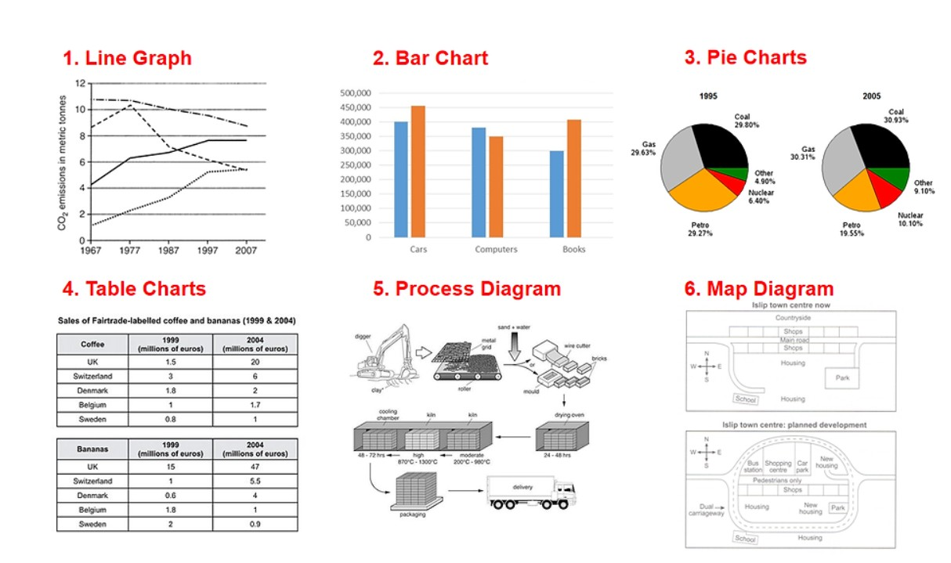
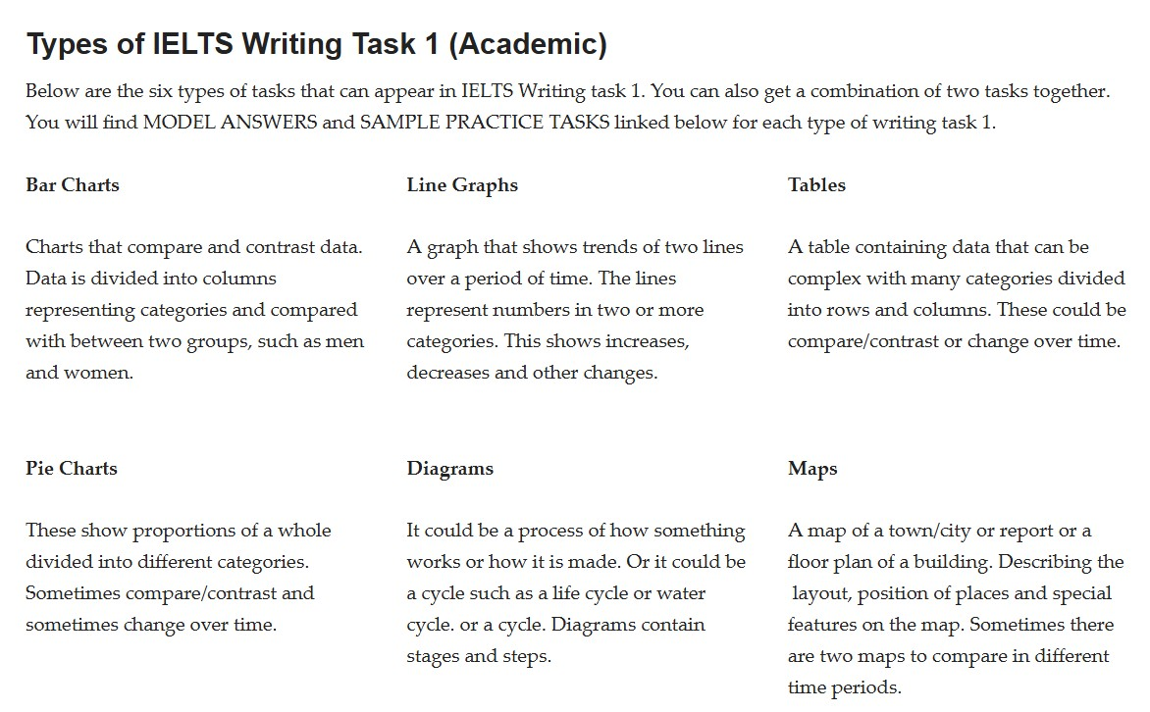

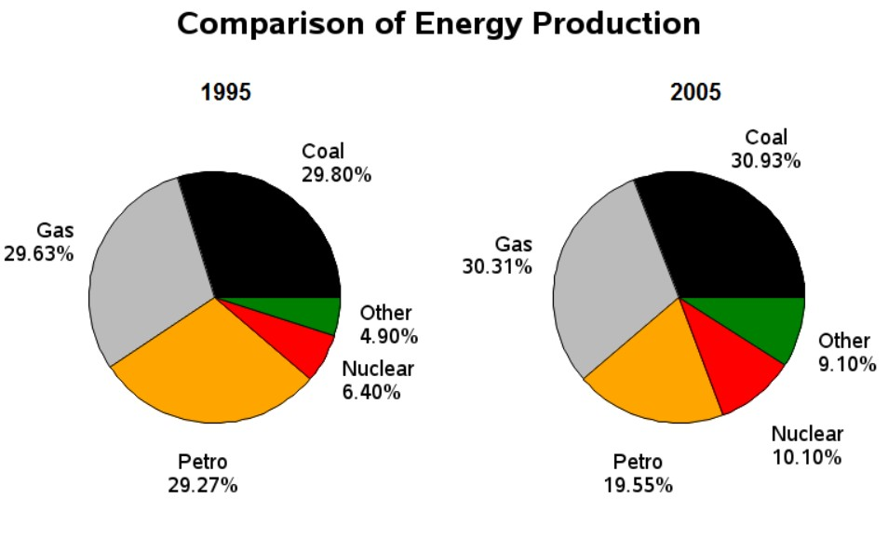
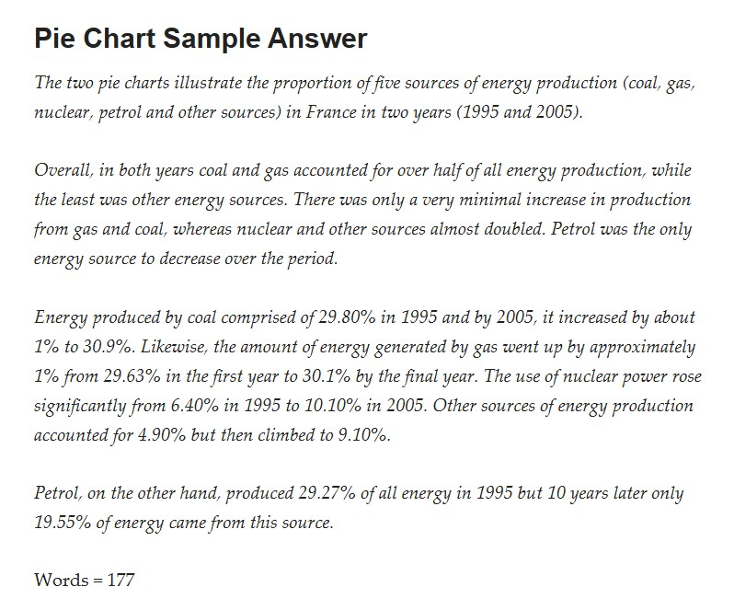

https://ieltsliz.com/ielts-pie-chart-task-1-model-score-9/
- You must write at least 150 words; you should not write more than 180 words. You’ll lose marks if you go outside these numbers.
- You must not try to write about all the information in the pie charts, you’re only summarizing the information
- The overview is the most important paragraph and should contain the main information in the pie chart(s). It must be more than one sentence long.
- Be aware whether the pie charts are ‘static’ (comparison of different categories only) or ‘dynamic’(comparing categories between different time periods). Use appropriate language to show any changes.
- There should be three paragraphs: The 1st paragraph is the Overview; the content of the 2nd and 3rd paragraph should contain different information, eg. for the example above, paragraph 2 could compare coal and gas production in 1995 and 2005. While paragraph 3 could compare petrol, nuclear and other sources of energy production.
- You must be clear about exactly what you are comparing, in the pie charts above this is already clear, but it isn’t always so.
- Use a variety of different structures to compare the percentages: 6.40% = approximately / around / about six and a half percent; 30.93% = nearly a third; comparison between gas production in 1995 and 2005: gas production remained about the same in 1995 and 2005
- There is no concluding paragraph in this type of report; the important or significant information must be highlighted in the overview.

