NOUGHTS AND CROSSES TEMPLATE
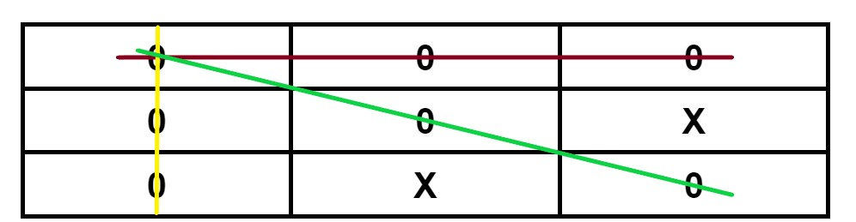

0 | X

