RADIO
Look at the image below; there are two questions you can ask about it:
1) What is it? What does it look like?
2) What shapes can you see in the image?
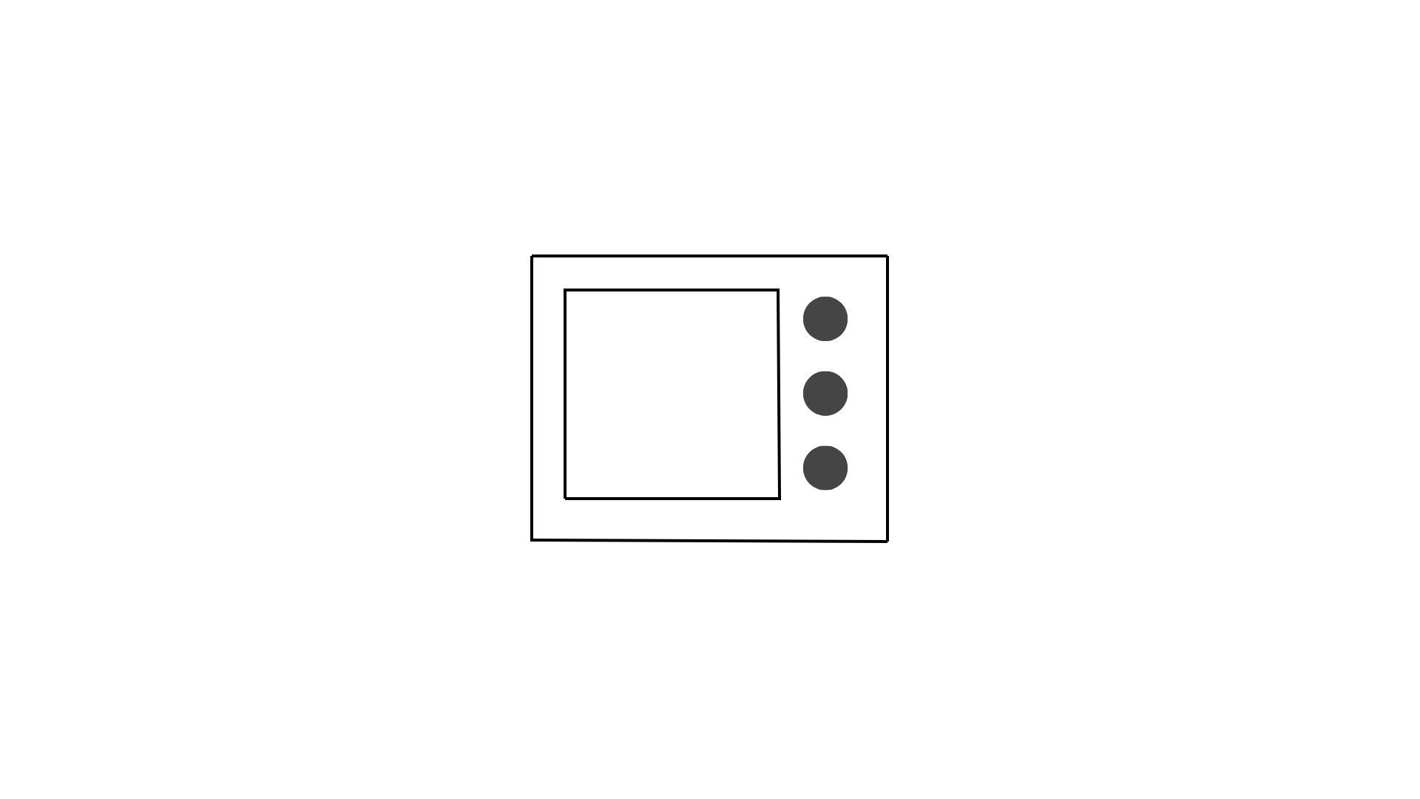

1) It looks like a radio / microwave or TV.
2) There are two squares, one smaller square is inside the other bigger square. To the right of the smaller square there are three black circles in a row. What do these look like? They look like controls or knobs.
3) How would you describe these shapes? Which is a horizontal row of three circles? Which is a diagonal row of three circles? Which is a vertical row of three squares? Which is a horizontal line etc.?
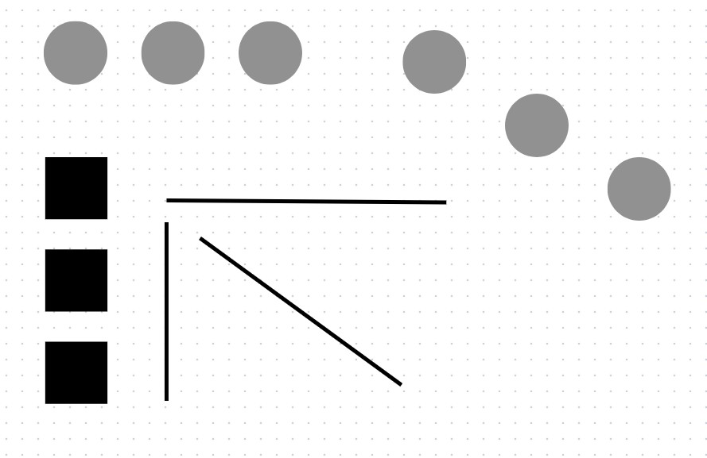

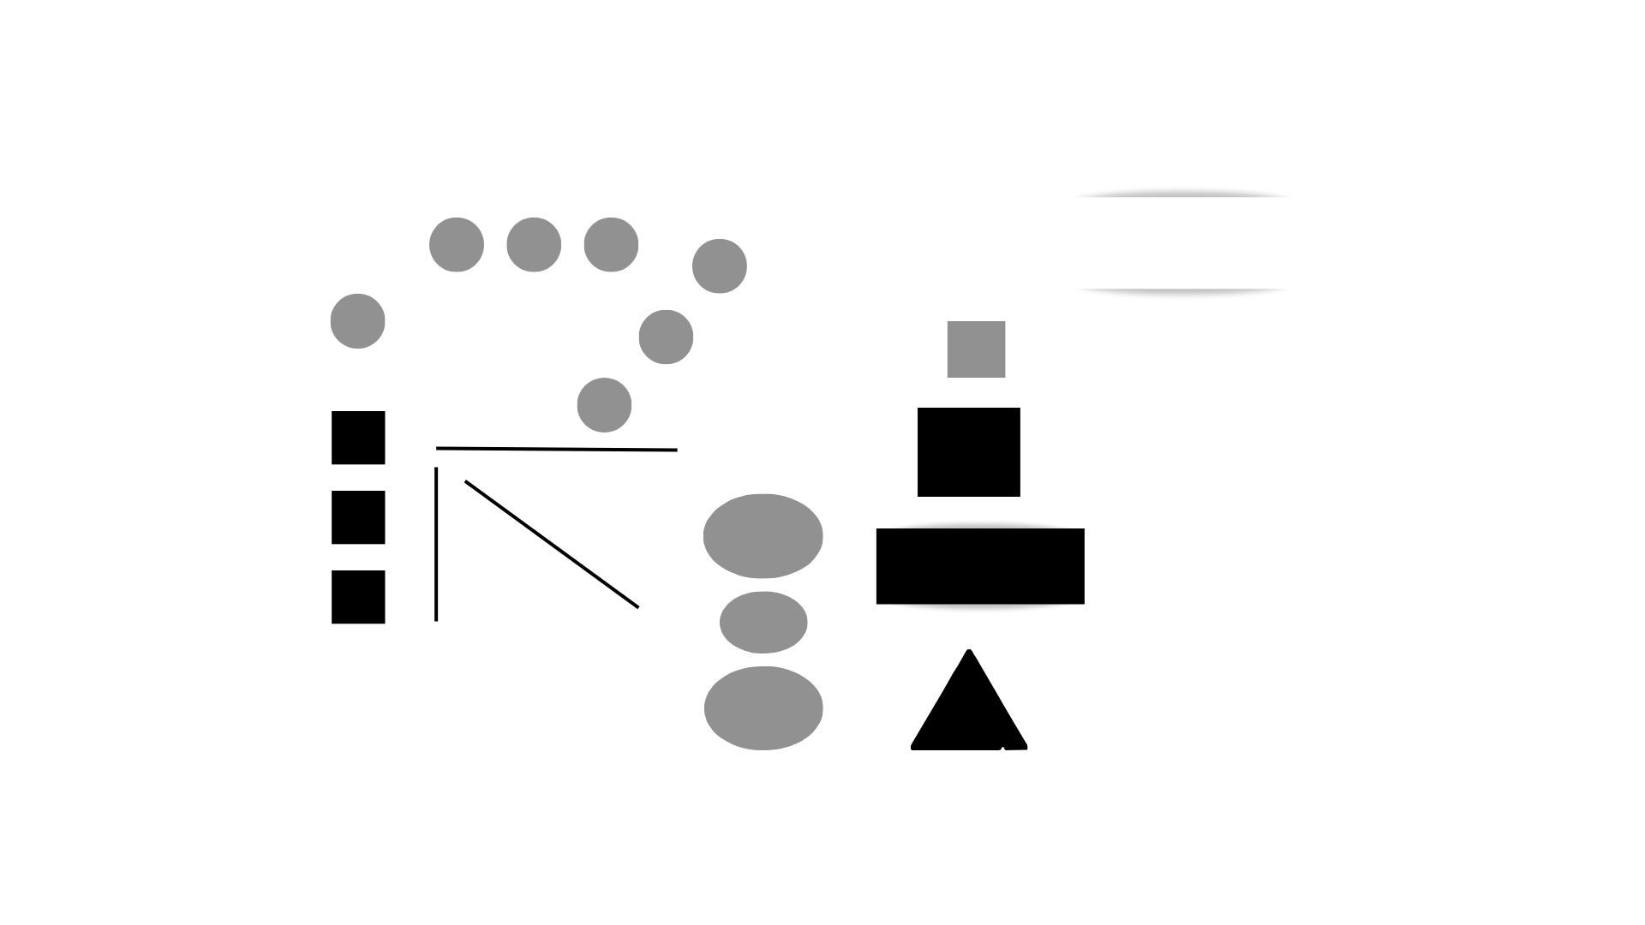
4) What shapes can you see on the right?
Use these words: ‘vertical, larger ovals, smaller oval, small, large square, rectangle, triangle’. Example: The small square is above the large square.

5) Look at the picture grid, choose an image, ONLY DESCRIBE THE SHAPES you can see in the image. The others must first guess which image you chose and second, guess what it might be. You can say: ‘It might be / could be / may be a radio. It looks like a radio, it resembles a radio’.

