Android Lab on 05-01-2022

1)create an android app for showing option and Intent

Main Activity.java

package com.example.myapplication;

import androidx.appcompat.app.AppCompatActivity;

import android.content.Intent;

import android.os.Bundle;

import android.view.Menu;

import android.view.MenuItem;

import android.widget.Toast;

public class MainActivity extends AppCompatActivity {

@Override

protected void onCreate(Bundle savedInstanceState) {

super.onCreate(savedInstanceState);

setContentView(R.layout.activity_main);

}

@Override //display the menu

public boolean onCreateOptionsMenu(Menu menu){

//option menu and .menu is the menu xml

getMenuInflater().inflate(R.menu.menu,menu);

return true;

}

@Override

public boolean onOptionsItemSelected(MenuItem item) {

switch (item.getItemId()){

case R.id.item1:

Intent i=new Intent(MainActivity.this,MainActivity2.class);

startActivity(i);

return true;

case R.id.item2:

Toast.makeText(getApplicationContext(),"Help",Toast.LENGTH_SHORT).show();

return true;

default:

return super.onOptionsItemSelected(item);

}

}

}

Activity Main.xml

<?xml version="1.0" encoding="utf-8"?>

<androidx.constraintlayout.widget.ConstraintLayout xmlns:android="http://schemas.android.com/apk/res/android"

xmlns:app="http://schemas.android.com/apk/res-auto"

xmlns:tools="http://schemas.android.com/tools"

android:layout_width="match_parent"

android:layout_height="match_parent"

tools:context=".MainActivity">

<TextView

android:layout_width="wrap_content"

android:layout_height="wrap_content"

android:text="Hello World!"

app:layout_constraintBottom_toBottomOf="parent"

app:layout_constraintLeft_toLeftOf="parent"

app:layout_constraintRight_toRightOf="parent"

app:layout_constraintTop_toTopOf="parent" />

</androidx.constraintlayout.widget.ConstraintLayout>

Menu.xml

<?xml version="1.0" encoding="utf-8"?>

<menu xmlns:app="http://schemas.android.com/apk/res-auto"

xmlns:android="http://schemas.android.com/apk/res/android">

<item

android:id="@+id/item1"

android:enabled="true"

android:icon="@drawable/img"

android:title="About"

/>

<item

android:id="@+id/item2"

android:title="Help"

android:visible="true"

app:showAsAction="never" />

</menu>

Main Activity2.java

package com.example.myapplication;

import androidx.appcompat.app.AppCompatActivity;

import android.os.Bundle;

public class MainActivity2 extends AppCompatActivity {

@Override

protected void onCreate(Bundle savedInstanceState) {

super.onCreate(savedInstanceState);

setContentView(R.layout.activity_main2);

}

}

Output

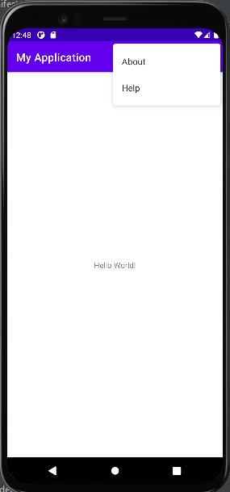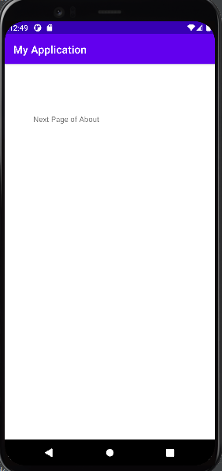

2) create a app for listview

Mainactivity.java

package com.example.listview;

import androidx.appcompat.app.AppCompatActivity;

import android.os.Bundle;

import android.view.View;

import android.widget.AdapterView;

import android.widget.ArrayAdapter;

import android.widget.ListView;

import android.widget.Toast;

public class MainActivity extends AppCompatActivity {

ListView listview;

String Countries[]={"india","china","america"};

@Override

protected void onCreate(Bundle savedInstanceState) {

super.onCreate(savedInstanceState);

setContentView(R.layout.activity_main);

listview=findViewById(R.id.list);

ArrayAdapter arrayAdapter=new ArrayAdapter<String>(MainActivity.this,R.layout.support_simple_spinner_dropdown_item,Countries);

listview.setAdapter(arrayAdapter);

listview.setOnItemClickListener(new AdapterView.OnItemClickListener() {

@Override

public void onItemClick(AdapterView<?> parent, View view, int position, long id) {

Toast.makeText(getApplicationContext(),"You Clicked "+Countries[position],Toast.LENGTH_SHORT).show();

}

});

}

}

Activitymain.xml

<?xml version="1.0" encoding="utf-8"?>

<androidx.constraintlayout.widget.ConstraintLayout

xmlns:android="http://schemas.android.com/apk/res/android"

xmlns:tools="http://schemas.android.com/tools"

xmlns:app="http://schemas.android.com/apk/res-auto"

android:layout_width="match_parent"

android:layout_height="match_parent"

tools:context=".MainActivity">

<TextView

android:id="@+id/textView2"

android:layout_width="wrap_content"

android:layout_height="wrap_content"

android:text="Hello World!"

app:layout_constraintBottom_toBottomOf="parent"

app:layout_constraintLeft_toLeftOf="parent"

app:layout_constraintRight_toRightOf="parent"

app:layout_constraintTop_toTopOf="parent" />

<ListView

android:id="@+id/list"

android:layout_width="409dp"

android:layout_height="354dp"

android:layout_marginStart="1dp"

android:layout_marginTop="1dp"

android:layout_marginEnd="1dp"

android:layout_marginBottom="1dp"

app:layout_constraintBottom_toTopOf="@+id/textView2"

app:layout_constraintEnd_toEndOf="parent"

app:layout_constraintStart_toStartOf="parent"

app:layout_constraintTop_toTopOf="parent" />

</androidx.constraintlayout.widget.ConstraintLayout>

Output

