Android lab on 14-02-2022

1. Write an android app for navigation drawer

Activity_main.xml

<?xml version="1.0" encoding="utf-8"?>

<androidx.drawerlayout.widget.DrawerLayout xmlns:android="http://schemas.android.com/apk/res/android"

xmlns:app="http://schemas.android.com/apk/res-auto"

xmlns:tools="http://schemas.android.com/tools"

android:layout_width="match_parent"

android:layout_height="match_parent"

android:id="@+id/drawerLayout"

tools:context=".MainActivity">

<LinearLayout

android:layout_width="match_parent"

android:layout_height="wrap_content"

android:orientation="horizontal">

<TextView

android:layout_width="wrap_content"

android:layout_height="wrap_content"

android:text="navigation"

android:textSize="20dp"

android:textAlignment="center"

android:layout_gravity="center" /> //to centrize layout

</LinearLayout>

<com.google.android.material.navigation.NavigationView

android:layout_width="wrap_content"

android:layout_height="match_parent"

android:layout_gravity="start"

app:menu="@menu/naviagtion_menu" /> //after start only we want menu

</androidx.drawerlayout.widget.DrawerLayout>

String.xml

<resources>

<string name="app_name">testing</string>

<string name="nav_open">Open</string>

<string name="nav_close">Clode</string>

</resources>

MainActivity.java

package com.example.testing;

import androidx.annotation.NonNull;

import androidx.appcompat.app.ActionBar;

import androidx.appcompat.app.ActionBarDrawerToggle;

import androidx.appcompat.app.AppCompatActivity;

import androidx.drawerlayout.widget.DrawerLayout;

import android.annotation.SuppressLint;

import android.os.Bundle;

import android.view.MenuItem;

import android.widget.Toast;

public class MainActivity extends AppCompatActivity {

DrawerLayout drawerLayout;

ActionBarDrawerToggle actionBarDrawerToggle;

@SuppressLint("RestrictedApi")

@Override

protected void onCreate(Bundle savedInstanceState) {

super.onCreate(savedInstanceState);

setContentView(R.layout.activity_main);

drawerLayout=findViewById(R.id.drawerLayout);

actionBarDrawerToggle=new ActionBarDrawerToggle(this,drawerLayout,R.string.nav_open,R.string.nav_close);

drawerLayout.addDrawerListener(actionBarDrawerToggle);

actionBarDrawerToggle.syncState();//commiting

getSupportActionBar().setDisplayHomeAsUpEnabled(true); //acton visible in activty page

}

@Override

public boolean onOptionsItemSelected(@NonNull MenuItem item) {

if(actionBarDrawerToggle.onOptionsItemSelected(item))

{

return true;

}

return super.onOptionsItemSelected(item);

}

}

Navigation_menu.xml

<?xml version="1.0" encoding="utf-8"?>

<menu xmlns:android="http://schemas.android.com/apk/res/android">

<item

android:id="@+id/person"

android:title="my account"

android:icon="@drawable/person" />

<item

android:id="@+id/setting"

android:title="setting"

android:icon="@drawable/setting" />

<item

android:id="@+id/logot"

android:title="logout"

android:icon="@drawable/logot" />

</menu>

Output

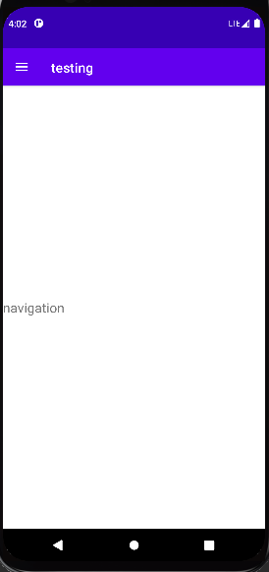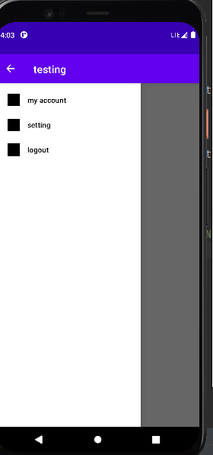

1. Write an android app for spinner

Activity_main.xml

<?xml version="1.0" encoding="utf-8"?>

<androidx.constraintlayout.widget.ConstraintLayout xmlns:android="http://schemas.android.com/apk/res/android"

xmlns:app="http://schemas.android.com/apk/res-auto"

xmlns:tools="http://schemas.android.com/tools"

android:layout_width="match_parent"

android:layout_height="match_parent"

tools:context=".MainActivity">

<Spinner

android:id="@+id/spinner"

android:layout_width="208dp"

android:layout_height="46dp"

app:layout_constraintBottom_toBottomOf="parent"

app:layout_constraintEnd_toEndOf="parent"

app:layout_constraintHorizontal_bias="0.359"

app:layout_constraintStart_toStartOf="parent"

app:layout_constraintTop_toTopOf="parent"

app:layout_constraintVertical_bias="0.297" />

</androidx.constraintlayout.widget.ConstraintLayout>

mainActivity.java

package com.example.spinner;

import androidx.appcompat.app.AppCompatActivity;

import android.os.Bundle;

import android.view.View;

import android.widget.AdapterView;

import android.widget.ArrayAdapter;

import android.widget.Spinner;

import android.widget.Toast;

public class MainActivity extends AppCompatActivity {

Spinner spin;

String course[] = {"mca", "bca", "mtech"};

@Override

protected void onCreate(Bundle savedInstanceState) {

super.onCreate(savedInstanceState);

setContentView(R.layout.activity_main);

spin = findViewById(R.id.spinner);

ArrayAdapter arrayAdapter = new ArrayAdapter(this, R.layout.support_simple_spinner_dropdown_item, course);

spin.setAdapter(arrayAdapter);

spin.setOnItemSelectedListener(new AdapterView.OnItemSelectedListener() {

@Override

public void onItemSelected(AdapterView<?> parent, View view, int position, long id) {

Toast.makeText(getApplicationContext(), "you clicked " + course[position], Toast.LENGTH_SHORT).show();

}

@Override

public void onNothingSelected(AdapterView<?> parent) {

return;

}

});

}

}

Output

