Android Lab on 23/02/2022

1)Android app for grid view

Activity_main.xml

<?xml version="1.0" encoding="utf-8"?>

<LinearLayout xmlns:android="http://schemas.android.com/apk/res/android"

xmlns:app="http://schemas.android.com/apk/res-auto"

xmlns:tools="http://schemas.android.com/tools"

android:layout_width="match_parent"

android:layout_height="match_parent"

tools:context=".MainActivity">

<GridView

android:layout_width="wrap_content"

android:layout_height="wrap_content"

android:id="@+id/grid"

android:numColumns="3"/>

</LinearLayout>

Grid_layout.xml

<?xml version="1.0" encoding="utf-8"?>

<LinearLayout xmlns:android="http://schemas.android.com/apk/res/android"

android:layout_width="match_parent"

android:layout_height="match_parent"

android:orientation="vertical">

<ImageView

android:layout_width="150dp"

android:layout_height="150dp"

android:id="@+id/img"/>

<TextView

android:layout_width="wrap_content"

android:layout_height="wrap_content"

android:id="@+id/text"

android:textSize="20dp"/>

</LinearLayout>

Mainactivity.java

package com.example.gridview;

import androidx.appcompat.app.AppCompatActivity;

import android.os.Bundle;

import android.widget.CursorAdapter;

import android.widget.GridView;

public class MainActivity extends AppCompatActivity {

GridView gridView;

String con[]={"c1","c2","c3","c4","c5","c6","c7","c8"};

int img[]={R.drawable.a1,R.drawable.a2,R.drawable.a1,R.drawable.a2,R.drawable.a1,R.drawable.a2,R.drawable.a1,R.drawable.a2};

@Override

protected void onCreate(Bundle savedInstanceState) {

super.onCreate(savedInstanceState);

setContentView(R.layout.activity_main);

gridView=findViewById(R.id.grid);

CustomAdaptor customAdaptor=new CustomAdaptor(MainActivity.this,con,img);

gridView.setAdapter(customAdaptor);

}

}

CustomAdaptor.java

package com.example.gridview;

import android.content.Context;

import android.view.LayoutInflater;

import android.view.View;

import android.view.ViewGroup;

import android.widget.BaseAdapter;

import android.widget.ImageView;

import android.widget.TextView;

public class CustomAdaptor extends BaseAdapter {

Context context;

String con[];

int img[];

LayoutInflater layoutInflater;

public CustomAdaptor(MainActivity mainActivity, String[] con, int[] img) {

this.context=mainActivity;

this.con=con;

this.img=img;

layoutInflater=(layoutInflater.from(mainActivity));

}

@Override

public int getCount() {

return img.length;

}

@Override

public Object getItem(int position) {

return null;

}

@Override

public long getItemId(int position) {

return 0;

}

@Override

public View getView(int position, View convertView, ViewGroup parent) {

convertView=layoutInflater.inflate(R.layout.grid_layout,null);

TextView textView=convertView.findViewById(R.id.text);

ImageView imageView=convertView.findViewById(R.id.img);

textView.setText(con[position]);

imageView.setImageResource(img[position]);

return convertView;

}

}

Output

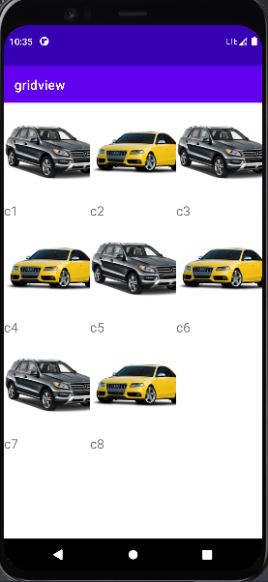

2)create an android app for insertion,view,deletion,updation.

Activitymain.xml

<?xml version="1.0" encoding="utf-8"?>

<LinearLayout xmlns:android="http://schemas.android.com/apk/res/android"

xmlns:app="http://schemas.android.com/apk/res-auto"

xmlns:tools="http://schemas.android.com/tools"

android:layout_width="wrap_content"

android:layout_height="wrap_content"

tools:context=".MainActivity"

android:orientation="vertical">

<TextView

android:id="@+id/textView"

android:layout_width="289dp"

android:layout_height="45dp"

android:layout_weight="1"

android:textColor="@color/black"

android:textStyle="bold"

android:text="Name"

android:textSize="20dp"/>

<EditText

android:id="@+id/Name"

android:layout_width="500dp"

android:layout_height="wrap_content"

android:layout_weight="1"

android:ems="10"

android:inputType="textPersonName"

/>

<TextView

android:id="@+id/textView2"

android:layout_width="match_parent"

android:layout_height="wrap_content"

android:textColor="@color/black"

android:textStyle="bold"

android:text="address"

android:textSize="20dp"/>

<EditText

android:id="@+id/edit2"

android:layout_width="500dp"

android:layout_height="wrap_content"

android:ems="10"

android:inputType="textPersonName"

/>

<Button

android:id="@+id/button"

android:layout_width="wrap_content"

android:layout_height="wrap_content"

android:layout_marginLeft="150dp"

android:text="Insert" />

<Button

android:id="@+id/button1"

android:layout_width="wrap_content"

android:layout_height="wrap_content"

android:layout_marginLeft="150dp"

android:text="view" />

<EditText

android:id="@+id/edit3"

android:layout_width="500dp"

android:layout_height="wrap_content"

android:ems="10"

android:inputType="textPersonName"

/>

<Button

android:id="@+id/button2"

android:layout_width="wrap_content"

android:layout_height="wrap_content"

android:layout_marginLeft="150dp"

android:text="Delete" />

<TextView

android:id="@+id/textView3"

android:layout_width="wrap_content"

android:layout_height="wrap_content"

android:layout_weight="1"

android:textColor="@color/black"

android:textStyle="bold"

android:text="Name"

android:textSize="20dp"/>

<Button

android:id="@+id/button3"

android:layout_width="wrap_content"

android:layout_height="wrap_content"

android:layout_marginLeft="150dp"

android:text="update" />

</LinearLayout>

Mainactivity.java

package com.example.database;

import androidx.appcompat.app.AppCompatActivity;

import android.database.Cursor;

import android.os.Bundle;

import android.view.View;

import android.widget.Button;

import android.widget.EditText;

import android.widget.TextView;

import android.widget.Toast;

public class MainActivity extends AppCompatActivity {

@Override

protected void onCreate(Bundle savedInstanceState) {

super.onCreate(savedInstanceState);

setContentView(R.layout.activity_main);

EditText e1 =findViewById(R.id.Name);

EditText e2=findViewById(R.id.edit2);

EditText e3=findViewById(R.id.edit3);

Button b1=findViewById(R.id.button);

Button b2=findViewById(R.id.button1);

Button b3=findViewById(R.id.button2);

Button b4=findViewById(R.id.button3);

TextView t5=findViewById(R.id.textView3);

helperdb helper=new helperdb(this);

b1.setOnClickListener(new View.OnClickListener() {

@Override

public void onClick(View v) {

String na=e1.getText().toString();

String pa=e2.getText().toString();

helper.insert(na,pa);

}

});

b2.setOnClickListener(new View.OnClickListener() {

@Override

public void onClick(View v) {

Cursor cr=helper.viewdb();

StringBuffer sb=new StringBuffer();//store fetched value cursor

while (cr.moveToNext()){

sb.append("id :"+cr.getString(0)+"\n");

sb.append("name :"+cr.getString(1)+"\n");

sb.append("address :"+cr.getString(2)+"\n");

}

Toast.makeText(getApplicationContext(),sb.toString(),Toast.LENGTH_LONG).show();

//t5.setText(sb.toString());

}

});

b3.setOnClickListener(new View.OnClickListener() {

@Override

public void onClick(View v) {

String del=e3.getText().toString();

helper.deletedb(del);

}

});

b4.setOnClickListener(new View.OnClickListener() {

@Override

public void onClick(View v) {

String up=e3.getText().toString();

String na=e1.getText().toString();

String add=e2.getText().toString();

helper.updatedb(up,na,add);

}

});

}

}

helperdb.java

package com.example.database;

import android.content.ContentValues;

import android.content.Context;

import android.database.Cursor;

import android.database.sqlite.SQLiteDatabase;

import android.database.sqlite.SQLiteOpenHelper;

import androidx.annotation.Nullable;

public class helperdb extends SQLiteOpenHelper {

private static String dbName="student";

private static int dbVersion=1;

SQLiteDatabase db;

public helperdb( Context context) {

super(context,dbName, null, dbVersion);

}

@Override

public void onCreate(SQLiteDatabase db) {

db.execSQL("create table tbl_stud(sid integer primary key autoincrement,sname varchar(20),saddress varchar(50))");

}

@Override

public void onUpgrade(SQLiteDatabase db, int oldVersion, int newVersion) {

}

public void insert(String name,String address)

{

db=getWritableDatabase();

ContentValues data=new ContentValues();

data.put("sname",name);

data.put("saddress",address);

db.insert("tbl_stud",null,data);

}

public Cursor viewdb(){

db=getReadableDatabase();

Cursor cr=db.rawQuery("Select * from tbl_stud",null);

return cr;

}

public void deletedb(String del){

db=getWritableDatabase();

db.delete("tbl_stud","sid=?",new String[]{del});

}

public void updatedb(String up,String na,String add){

db=getWritableDatabase();

ContentValues data=new ContentValues();

data.put("sname",na);

data.put("saddress",add);

db.update("tbl_stud",data,"sid=?",new String[]{up});

}

}

Output

insert

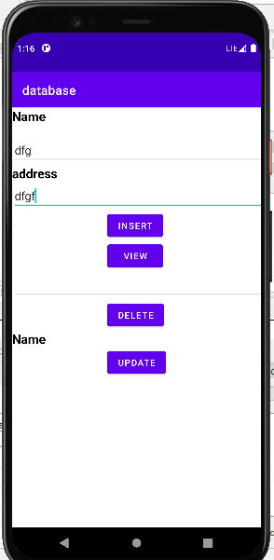

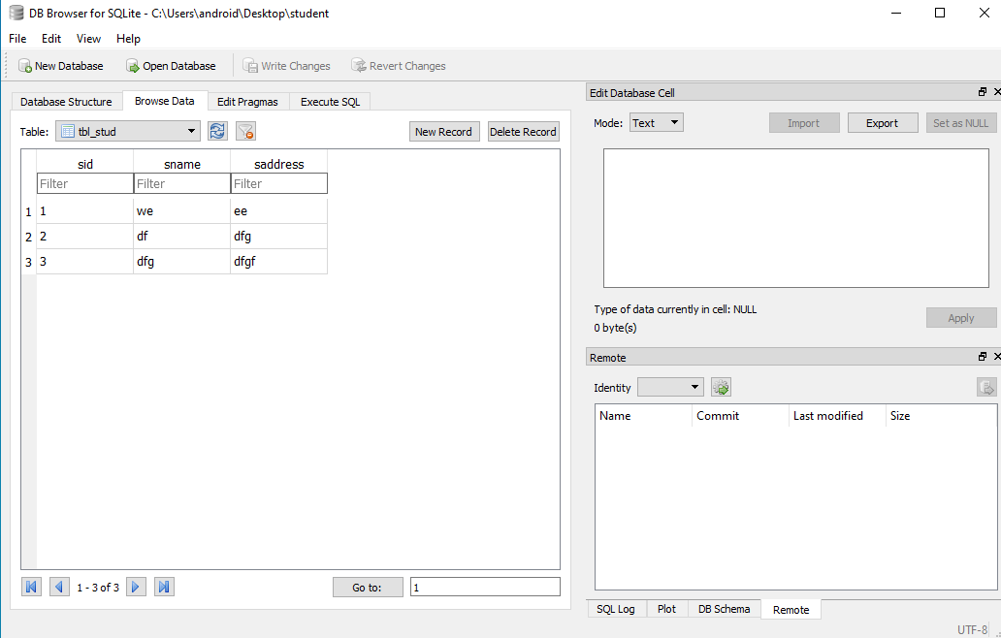

Delete

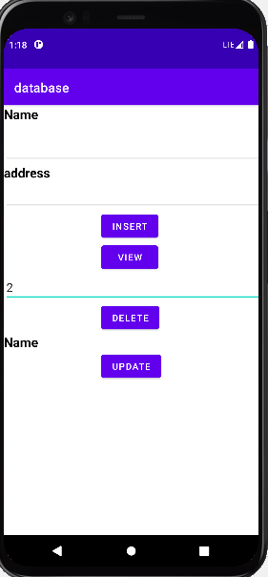

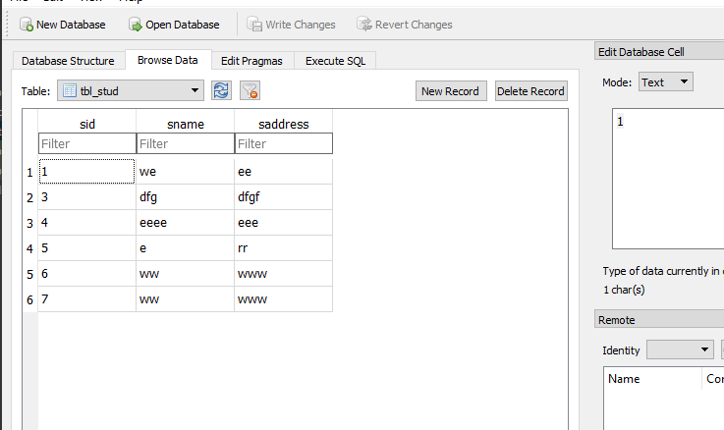

view

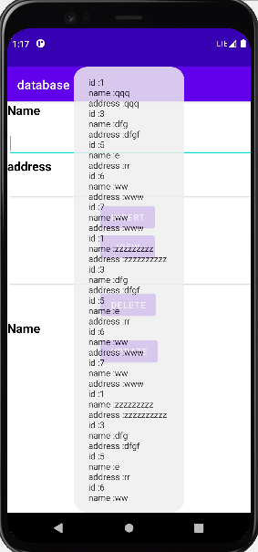

Update

