**Case Study Mechatronic System Simulation**

***Task-1: Simulation of a two mass oscillator with Open Modelica***

**Report by**

Prasad Raju Kalidindi – 12100544

Omar Shokr – 12101363

Mahadev Prem – 12100009

Tom Jojo Palamattam – 821354

**Supervised by**

Prof. Dr.-Ing. Peter Firsching

1. **Simulation of two mass oscillator model using OpenModelica and the Modelica Mechanics library.**

The simulation model of the dual mass oscillator is created in the OpenModelica by using the predefined blocks in the Modelica Mechanics library.

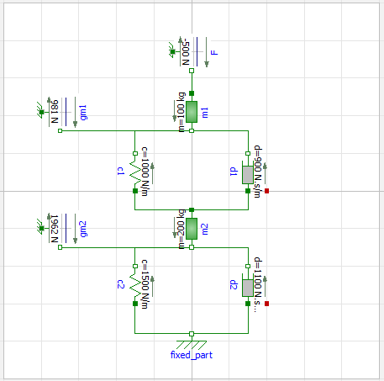

**Fig 1:** Class Diagram of two mass oscillator in Openmodelica

The mass blocks are placed vertically so the weight of the blocks act as load on the springs and dampers. The springs will be compressed by the weight of the blocks. When the 500N force is applied against the gravity the blocks move upwards. The above model is simulated for 10sec with only the weight of the blocks and then applying the external force of 500N. The respective deflections of the blocks are plotted.

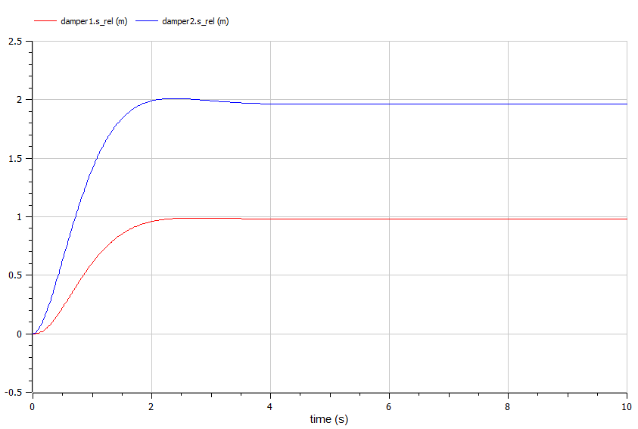

**Fig 2**: Relative Deflections without External Force

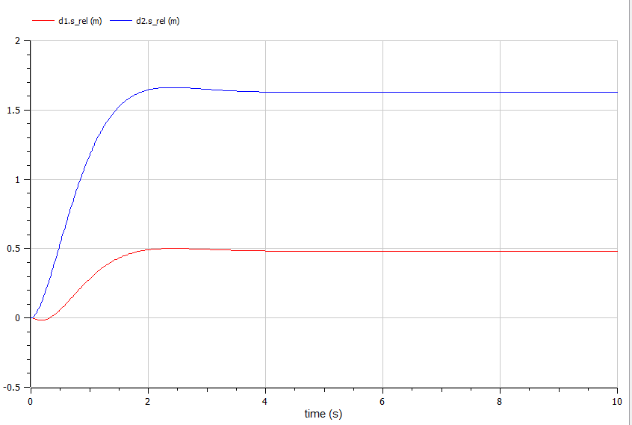

**Fig 3**: Relative Deflections with External Force

1. **Determination of the damper coefficients**

The damper coefficients for the oscillators are determined using trial and error method with Openmodelica so that the movement of the masses does not exceed 10cm.

For d1= 900 Ns/m and d2= 1100Ns/m (The values of the deflections are taken from the graph.

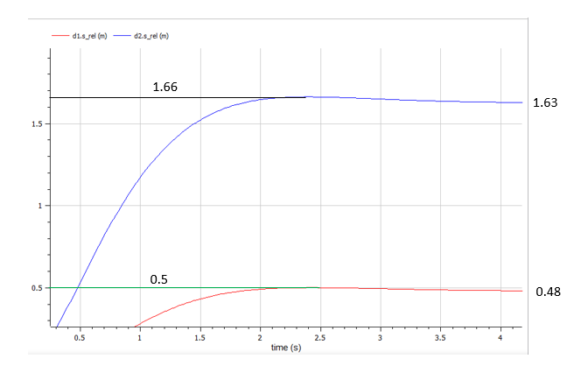

Z1max = 0.5m and Z1∞ = 0.48m ∆Z1=0.02m

Z2max = 01.66m and Z2∞ = 1.63m ∆Z2=0.03m

∆Z=0.02+0.03=0.05m=5cm

1. **Calculation of stationary deflection of the two springs for the specified force F**

Free-Body Diagrams for the masses

F m1a1 FSp1 m2a2 Fd1

m2

m1



FSp1 Fg1 Fd1 FSp2 Fg2 Fd2

FSp1= c1(z1-z2)

Fd1= d1(1-2)

FSp2= c2z2

Fd1= d22

The equations of motion for the dual mass oscillator in the vertical position

∑F=ma

For mass 1

m11= F- c1(z1-z2)-d1(1-2)- m1g

For mass 2

m22= c1(z1-z2)+d1(1-2)- c2z2-d22-m2g

Stationary deflections

∆Z1===0.981m

∆Z2===1.962m

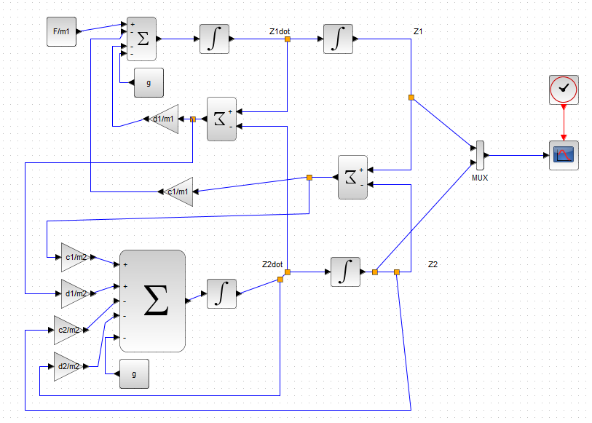

**Fig 4:** Dual Mass Oscillator using Xcos

1. **Simulation of Mass Oscillator in Horizontal Position**

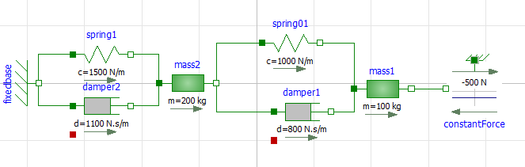

**Fig 5:** Dual Mass Oscillator in Horizontal Position

When the oscillator is placed in the horizontal position, the weight forces on the blocks do not act as load to the spring-damper system. So, the spring are stretched only by the external force of 500N.

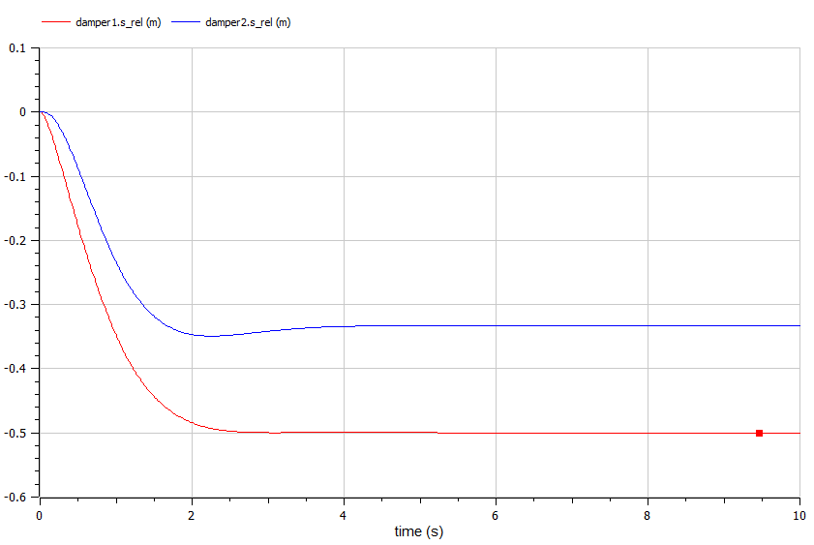

**Fig 6**: Relative Deflections of the Oscillator in Horizontal Position