Jenny GPU - Control Unit Specification

Main Decoder

UD = “User Defined”

|  |  |  |  |  |  |  |  |  |
| --- | --- | --- | --- | --- | --- | --- | --- | --- |
| Instruction | OP 5:0 | Reg0  enable | Reg1  enable | Reg2  enable | Reg3  enable | branch | Branch  DataWrite | immCalc |
| VADD | 000000 | UD | UD | UD | UD | 0 | 0 | 0 |
| VSUB | 000001 | UD | UD | UD | UD | 0 | 0 | 0 |
| Vmult | 000010 | UD | UD | UD | UD | 0 | 0 | 0 |
| Vdiv | 000011 | UD | UD | UD | UD | 0 | 0 | 0 |
| Vmod | 000100 | UD | UD | UD | UD | 0 | 0 | 0 |
| blt | 000101 | UD | UD | UD | UD | 1 | 0 | 0 |
| rot | 000110 | UD | UD | UD | UD | 0 | 0 | 0 |
| j | 000111 | 0 | 0 | 0 | 0 | 1 | 0 | 0 |
| vaddi | 001000 | UD | UD | UD | UD | 0 | 0 | 1 |
| loadv | 001001 | UD | UD | UD | UD | 0 | 0 | 0 |
| savev | 001010 | UD | UD | UD | UD | 0 | 0 | 0 |

|  |  |  |  |  |  |
| --- | --- | --- | --- | --- | --- |
| Instruction | branchZero | load | dataMemWrite | Rot 1:0 | ALUOP 3:0 |
| VADD | 0 | 0 | 0 | 00 | 0010 |
| VSUB | 0 | 0 | 0 | 00 | 1010 |
| Vmult | 0 | 0 | 0 | 00 | 0011 |
| Vdiv | 0 | 0 | 0 | 00 | 0100 |
| Vmod | 0 | 0 | 0 | 00 | 0101 |
| blt | 1 | 0 | 0 | 00 | 0110 |
| rot | 0 | 0 | 0 | UD UD | 0111 |
| j | 0 | 0 | 0 | 00 | 0000 |
| vaddi | 0 | 0 | 0 | 00 | 0010 |
| loadv | 0 | 1 | 0 | 00 | 0111 |
| savev | 0 | 0 | 1 | 00 | 0111 |

Datapath with Control Unit (in red)

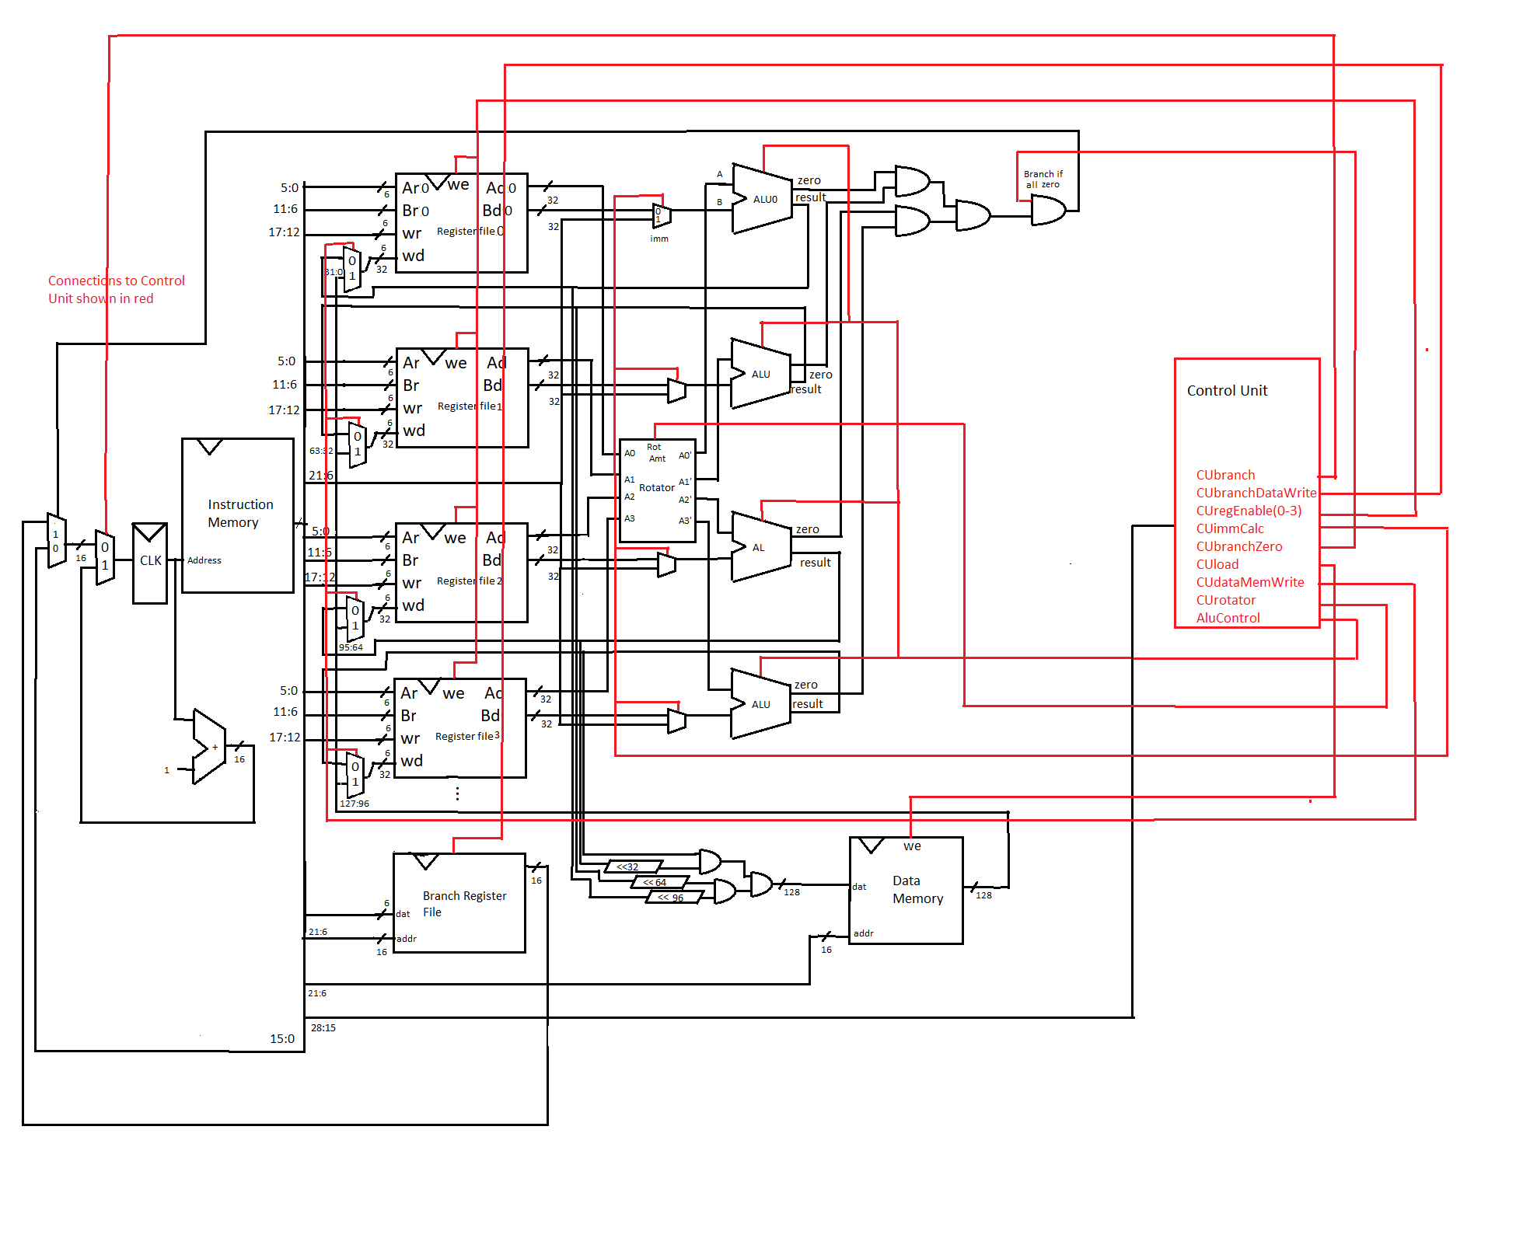

All instructions code

|  |  |
| --- | --- |
| Vadd v0 z z 0b1111 | f0010000 |
| Vadd v1 z z 0b1111 | f0020000 |
| Vadd v2 z z 0b1111 | f0030000 |
| Vaddi v0 3 0b1111 | f2010003 |
| Vaddi v1 1 0b1111 | f2020001 |
| Vadd v2 v1 v0 0b1101 | d0030810 |
| nop | 00000000 |
| Rot v3 v2 01 0b1111 | f1840d00 |
| Vsub v4 v0 v1 0b1111 | f0450420 |
| Vmult v4 v3 v2 0b1111 | f0840c20 |
| Vdiv v5 v4 v2 0b1111 | f0c61430 |
| Vmod v5 v4 v2 0b1111 | f1061430 |
| Blt v1 v2 b0 0b1111 | f1420c00 |
| Savev v4 0xda54 0b1111 | f285da54 |
| Loadv v5 0xda54 0b1111 | f246da54 |
| J 0x0 | 01c00000 |