C# Quiz

# Which of the followings is not allowed in C# as access modifier?

* + public
  + friend
  + internal
  + protected

The correct answer is "friend".

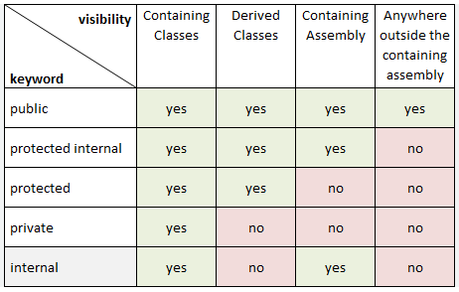

# Which of the following are the correct ways to increment the value of variable a by 1?

* 1. ++a++;
  2. a += 1;
  3. a ++ 1;
  4. a = a +1;
  5. a = +1;

1. 1, 3
2. 2, 4
3. 3, 5
4. 4, 5
5. None of these

**Answer:** Option B

# Which of the following is NOT an Arithmetic operator in C#.NET?

1. **
2. +
3. /
4. %
5. *

**Answer:** Option A

# Which of the following are NOT Relational operators in C#.NET?

1. >=
2. !=
3. Not
4. <=
5. <>=
6. 1, 3
7. 2, 4
8. 3, 5
9. 4, 5
10. None of these

**Answer:** Option C