Coursework Columbia+

Module 1

Module Overview
This module covers the evolution of AI and the essential components of becoming a proficient AI chef.

Module Objectives
By the end of this module, you will be able to
- understand the significance of data in AI and machine learning processes
- learn the principles of model selection, optimization, and evaluation in machine learning
- analyze the impact of different objective functions on model performance and decision-making
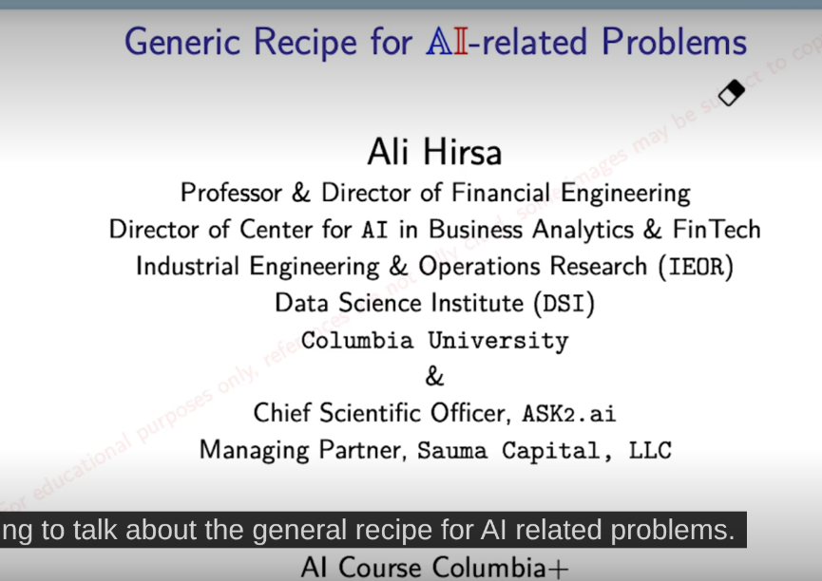

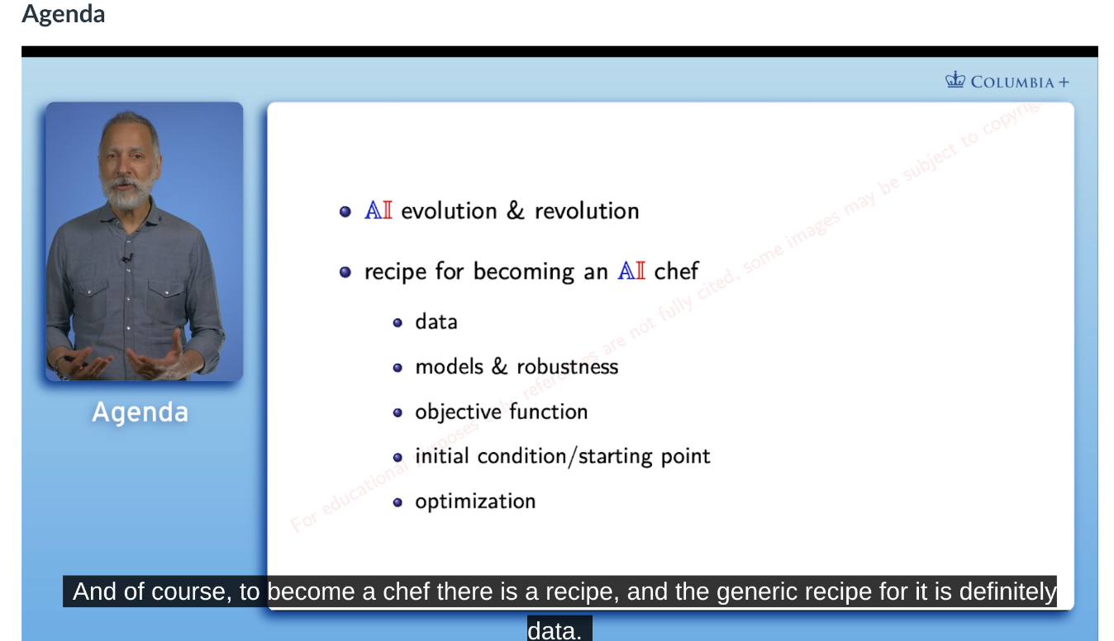

data
build model which is robust
assume a bunch of points and I want to find a line going thru those points
define what is the objective functions and your objective is finding the best line that has the minimum distance on average from those points
start with initial condition/starting point
must be optimized to get the line/slope and intercept

1.2 Introduction to AI/ML/DL

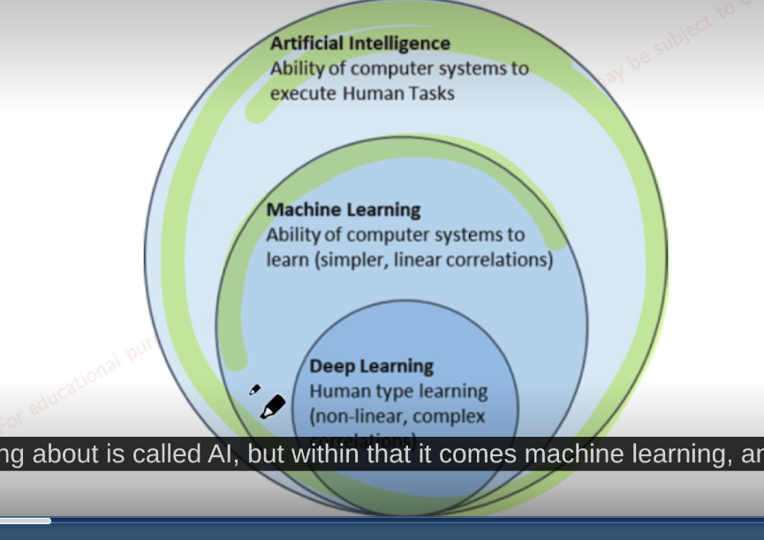

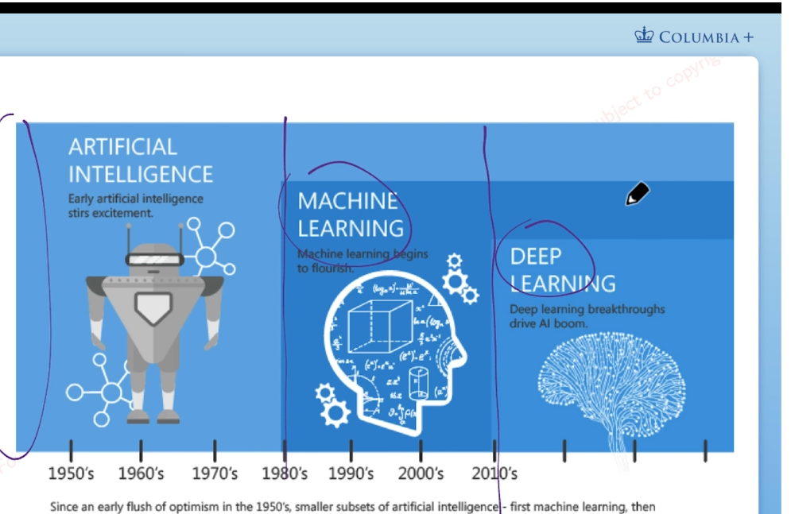

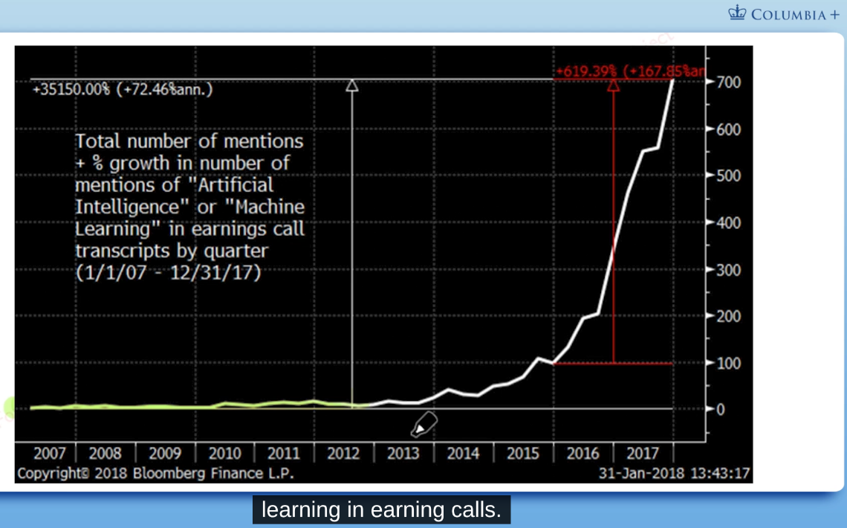

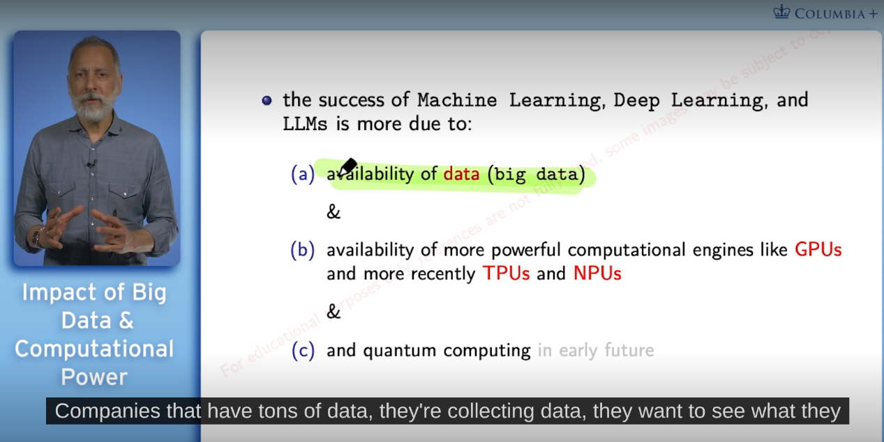

TPU tensor processor unit
NPU neuron processor unit

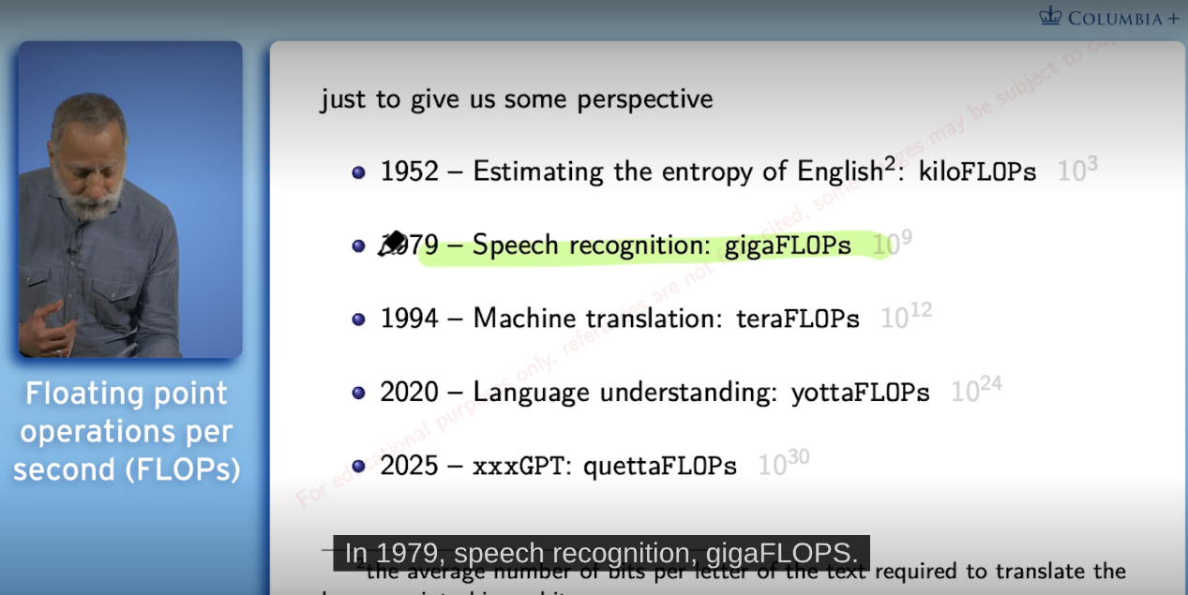

2 – the average number of bits per letter of the text required to translate the language into binary bits

1.3 AI Chef: Specification of Dataset

outlining the essential recipe for becoming an AI chef, focusing on data and model selection.

