Graphical Dart

Introduction
Graphical Dart is a Java-based tool that reads in DB2 Dart data (.DXG files obtained by using the /DXG parameter in db2dart) and visualizes them in a paginated fashion. The tool is meant to make debugging with Dart easier to use.

Interface

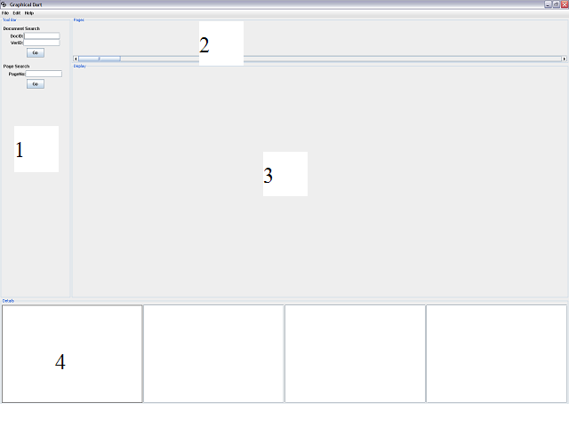
There are four main areas of the GUI that users should familiarize themselves with:

1. Tool Bar: this is where users can search for nodes by any combination of Document ID, Version ID, NID, and NID in hex. When users click on the Go button it brings them to the first match found. Clicking on the Go button addition times brings the next successive matches. When the search is exhausted a pop up window prompts users Graphical Dart has finished searching. Users can also search by Page Number. Both searches have a Reset button to clear all search information.
2. Pages panel: this is where all the pages are displayed in numerical order. Users click on a node here to display the page details in panel 3.
3. Display panel: this is where users can see a paginated view of a page. Users can highlight nodes and this will display the node details in Details panel (#4).
4. Details panel: this displays all the detailed node information in text.

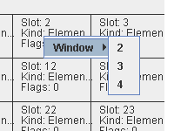

Furthermore, users can right click in the Display panel to choose which Details panel to display the node information (as shown above).

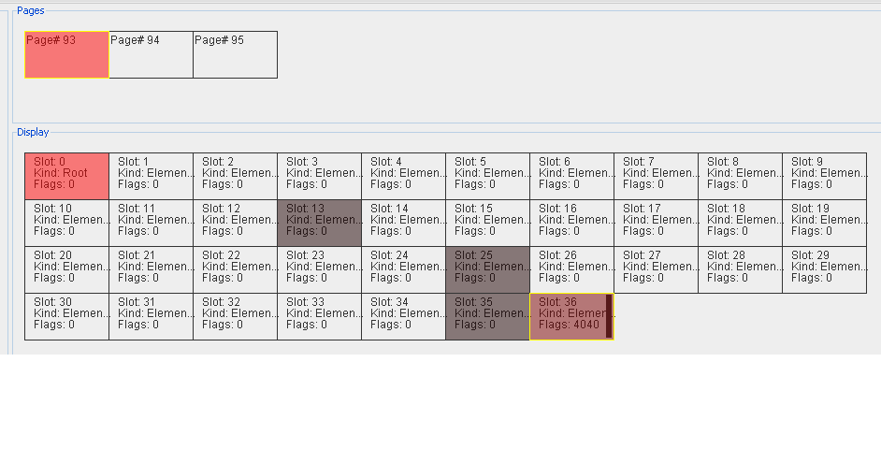
In the figure about, a page is selected in the Pages panel and the page details are displayed in the Display panel. The color scheme used is indicative of the currently selected node (feint red), its parent (bright red), and its children (grey).

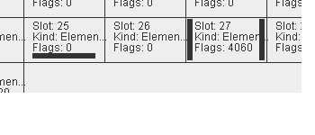
The figure above shows horizontal and vertical black bars used in the Display panel. These bars are used to represent continuation nodes and external nodes. A vertical bar on the left of a node indicates that the node is a continuation node. By clicking on it, it takes users to its predecessor in the continuation chain. A vertical bar on the right indicates that this node is continued in another node, and again, by clicking on it, it takes users to the continued node. A horizontal bar at the bottom of a node indicates that this node has children which are external nodes not in the current page. By clicking on it, it will pop up an array of external nodes which will take users to the external node [not fully implemented].

Development and Design
This section gives users an overview of the code to facilitate development.

packages.jpg - Shows the 4 packages
dart.jpg - Shows the GUI classes
datastructures.jpg - Shows the data structures
parser.jpg - Shows the parser
structures.jpg - Shows the interfaces

The links above are reversed engineered UML diagrams based on the existing Java code. The packages are separated in a way that is natural and intuitive and not much further explanation is needed.

Dart Package
Files in this package are related to the GUI and search algorithms.

GDart.java
This file contains main() and acts as Graphical Dart’s driver. It handles optional parameters that can be specified when running Graphical Dart and spawns off the GUI as a thread.

Parameter.java
All the constants and variables needed for drawing and the GUI are in this file to provide easy access to them. One can modify the variables in here and the changes are propagated along.

GUI.java
This contains the bulk of the GUI code. It includes all the Java Swing objects needed to create the GUI and the logic for detecting clicking. It also contains the search functionality shown in the tool bar panel.

Continuation.java
This contains the search algorithms for finding continuation, external nodes, and their helper methods.

Draw.java
This contains the algorithms to draw the collection of pages and nodes in the pages panel and the drawing panel (since each node knows about its own drawing function, this file only draws the nodes and pages as an aggregate).

DrawingBoard.java
This file is a panel within the GUI and handles things related to the drawing of slots/nodes within pages.

NodeTransferHandler.java
This is code that can be used to develop drag and drop ability in the future.

PagesBoard.java
Similar to DrawingBoard.java, this file handles the things related to drawing pages in the GUI.

SharedData.java
This file contains the common data structures needed to draw and search for the GUI and all its sub-panels. The common data structures are wrapped around public methods.

SplashWindow.java
This is code to display the splash window.

StatsBoard.java
This is an empty skeleton panel to display statistics about the loaded data.

TextBoard.java
This is the panel at the bottom of the GUI which displays the details about nodes in text.

ToolBoard.java
This is the panel in the left of the GUI. It is mostly empty because the logic for searching was pushed to the main GUI.java file.

Datastructures Package
This package contains all the data models used to represent the nodes.

AttributeNode.java
CDataSectionNode.java
CommentNode.java
DocumentNode.java
ElementNode.java
ProcessingInstructionNode.java
TextNode.java
These files represent all the nodes in XDA pages. They all inherit from DocumentTypeNode.java because they all contain the same information.

DocumentTypeNode.java
This file is used as a common data structure for the files listed above. It sets their common values in Node.java (which it inherits).

Node.java
This contains all the information that nodes have along with some continuation node, external node, and drawing methods. (Perhaps the drawing methods should be pushed to Cell.java)

Cell.java
This contains the information about the nodes that are non-related to the XDA information, e.g. drawing, position, and clickability.

Child.java
Child inherits from Node.java but only contains a small subset of information. A child is meant to represent the child slots of an XDA slot.

ContinuationChild.java
InlineChild.java
NodeChild.java
StringIDChild.java
RootChild.java
These are the different types of children in an XDA slot which inherit from Child.,java.

ExternalNode.java
This is unrelated to the other XDA nodes in that this is used for finding external nodes in Continuation.java.

RootNode.java
This inherits from Node.java directly, unlike the other nodes which inherit from DocuementTypeNode.java, because it doesn’t share the same information.

Parser Package
This package takes care of reading from file, parsing, and decoding.

ReadData.java
This reads in the information from disk all into memory.

Parser.java
This parses the information in memory into a nested hashtable data structure which represents a tree. It also initializes the hierarchy information, i.e. parent-child information and level.

Structures Package
This is a conceptual package where data models in the datastructure package implement.

Clickable.java
Implement this if you want to make a data structure clickable.

Drawable.java
Implement this if you want to make a data structure drawable.

Writable.java
Implement this if you want to make a data structure be able to print to console and return a string.

Known Issues
- When searching for continuation nodes, in the past, the NIDs weren’t always incremented or decremented by 1 (sometimes they skipped). The code needs to be adjusted to handle this since right now it is under the assumption that NIDs don’t skip around.

If any issues come up, please direct them to chent@us.ibm.com (Thomas Chen/Silicon Valley/IBM@IBMUS) or tomkit@gmail.com.

Future Development
These are some ideas about the future direction of Graphical Dart.

Major
- Dragging & dropping: In the future, it may be easier to make the cells/nodes draggable so that users can drag and drop the cells/nodes into the details panel.
- Pop up of inline children: Instead of displaying node detail in the details panel in text, when users click on nodes it could pop up a visual array of inline children.
- Statistics: A statistics panel could be created to display different types of statistics data such as how spread a document is across pages.
- Tree visualization: Display the nodes in a tree structure instead of a paginated view.
- On-the-fly parsing: Currently everything is read into memory in the beginning. For large dumps this takes too long to load. Instead, parsing can be done on-the-fly so that only pages needed are loaded in. What is the best way to do this? Locality? This would be necessary for large XML documents.
- Searching forwards and backwards (currently only forward is allowed).

Minor
- Color coded nodes: Different types of nodes can be colored differently to help users more quickly distinguish between the different node types.
- Root highlighting: It might help to always highlight the root node of a particular region the user is viewing.
- Re-OO: Perhaps a bit of OO juggling is needed in some small portions of the code.
- Status/wait load bar: Perhaps the loading process needs to have a wait or progress bar to show its progress.
- Formatting of text details.

