Obvody se soustředěnými parametry

# Odrazná metoda

%% Load data

sparam = sparameters('mereni/3-1kR-odraz.s1p');

Z0 = sparam.Impedance;

s11 = reshape(sparam.Parameters, [],1);

f=sparam.Frequencies;

zparam = s2z(s11, Z0);

ZL = Z0*((1+s11)./(1-s11));

%% Fit

Cx = 1.5e-13;

Rx = 1e3;

Rcs = 0.5e3;

ZL_fit = 1 ./ (1./Rx + 1./(1./(1i * 2 * pi() * Cx * f) + Rcs));

%% Plot

fig = figure('Name','Impedance','NumberTitle','off');

loglog(f/1e9,abs(ZL)/1e3, 'r', f/1e9,abs(ZL_fit)/1e3,'b')

legend('ZNB','Model','Location', 'Best')

xlabel('f [GHz]'), ylabel('|Z| [k\Omega]')

grid on

# Sériové zapojení

%% Load data

sparam = sparameters('mereni/26-50R-ser.s2p');

Z0 = sparam.Impedance;

f=sparam.Frequencies;

s_params = sparam.Parameters;

abcd_params = s2abcd(s_params, Z0);

B_param = reshape(abcd_params(1,2,:), [],1);

%% Fit

Lx = 2e-9;

Rx = 49.95;

ZL_fit = 1i*2*pi()*f*Lx+Rx;

%% Plot

fig = figure('Name','Impedance','NumberTitle','off');

loglog(f/1e9,abs(B_param)/1e3, 'r', f/1e9,abs(ZL_fit)/1e3,'b')

legend('ZNB','Model','Location', 'Best')

xlabel('f [GHz]'), ylabel('|Z| [k\Omega]')

grid on

# Paralelní zapojení

%% Load data

sparam = sparameters('mereni/21-50R-gnd.s2p');

Z0 = sparam.Impedance;

f=sparam.Frequencies;

s_params = sparam.Parameters;

abcd_params = s2abcd(s_params, Z0);

C_param = 1./reshape(abcd_params(2,1,:), [],1);

%% Fit

Cx = 3.8e-13;

Rx = 50;

Rcs = 10;

ZL_fit = 1 ./ (1./Rx + 1./(1./(1i * 2 * pi() * Cx * f) + Rcs));

%% Plot

fig = figure('Name','Impedance','NumberTitle','off');

loglog(f/1e9,abs(C_param)/1e3, 'r', f/1e9,abs(ZL_fit)/1e3,'b')

legend('ZNB','Model','Location', 'Best')

xlabel('f [GHz]'), ylabel('|Z| [k\Omega]')

grid on

# 3) Odpor 1kΩ odraznou metodou

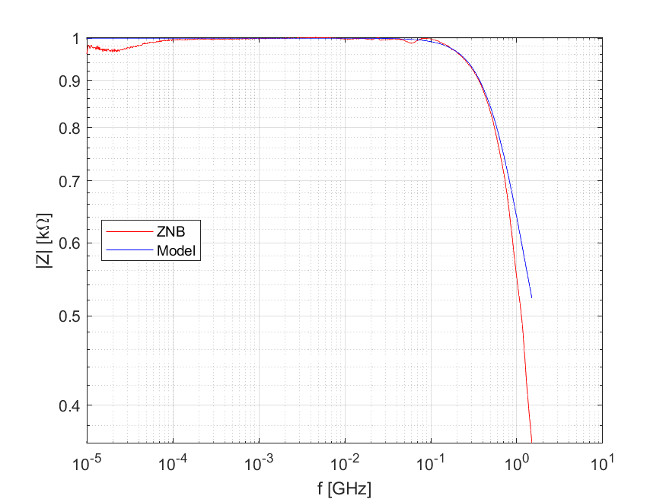

# 12) Kondenzátor 470pF odraznou metodou

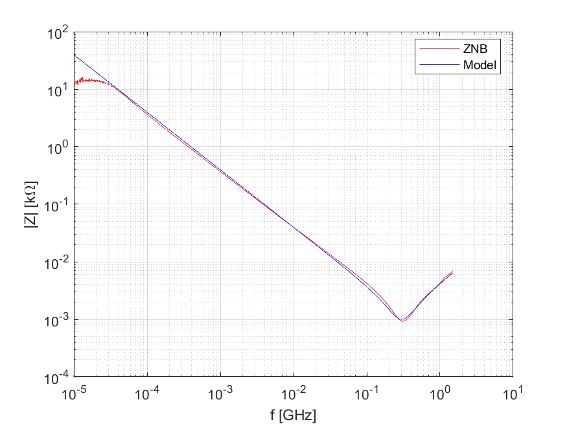

# 21) Odpor 50Ω zapojený paralelně

