Obvody se soustředěnými parametry

Odrazná metoda
%% Load data
sparam = sparameters('mereni/3-1kR-odraz.s1p');

Z0 = sparam.Impedance;
s11 = reshape(sparam.Parameters, [],1);
f=sparam.Frequencies;

zparam = s2z(s11, Z0);

ZL = Z0*((1+s11)./(1-s11));

%% Fit
Cx = 1.5e-13;
Rx = 1e3;
Rcs = 0.5e3;

ZL_fit = 1 ./ (1./Rx + 1./(1./(1i * 2 * pi() * Cx * f) + Rcs));

%% Plot
fig = figure('Name','Impedance','NumberTitle','off');
loglog(f/1e9,abs(ZL)/1e3, 'r', f/1e9,abs(ZL_fit)/1e3,'b')
legend('ZNB','Model','Location', 'Best')
xlabel('f [GHz]'), ylabel('|Z| [k\Omega]')
grid on

Sériové zapojení
%% Load data
sparam = sparameters('mereni/26-50R-ser.s2p');

Z0 = sparam.Impedance;
f=sparam.Frequencies;
s_params = sparam.Parameters;

abcd_params = s2abcd(s_params, Z0);

B_param = reshape(abcd_params(1,2,:), [],1);

%% Fit
Lx = 2e-9;
Rx = 49.95;

ZL_fit = 1i*2*pi()*f*Lx+Rx;

%% Plot
fig = figure('Name','Impedance','NumberTitle','off');
loglog(f/1e9,abs(B_param)/1e3, 'r', f/1e9,abs(ZL_fit)/1e3,'b')
legend('ZNB','Model','Location', 'Best')
xlabel('f [GHz]'), ylabel('|Z| [k\Omega]')
grid on

Paralelní zapojení
%% Load data
sparam = sparameters('mereni/21-50R-gnd.s2p');

Z0 = sparam.Impedance;
f=sparam.Frequencies;
s_params = sparam.Parameters;

abcd_params = s2abcd(s_params, Z0);

C_param = 1./reshape(abcd_params(2,1,:), [],1);

%% Fit
Cx = 3.8e-13;
Rx = 50;
Rcs = 10;

ZL_fit = 1 ./ (1./Rx + 1./(1./(1i * 2 * pi() * Cx * f) + Rcs));

%% Plot
fig = figure('Name','Impedance','NumberTitle','off');
loglog(f/1e9,abs(C_param)/1e3, 'r', f/1e9,abs(ZL_fit)/1e3,'b')
legend('ZNB','Model','Location', 'Best')
xlabel('f [GHz]'), ylabel('|Z| [k\Omega]')
grid on

3) Odpor 1kΩ odraznou metodou
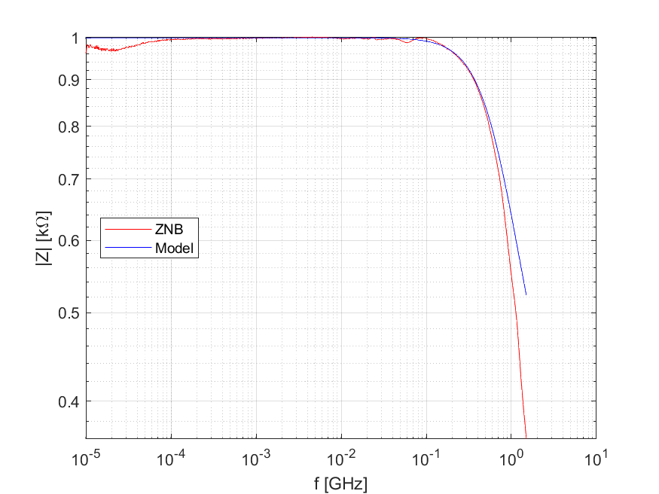

12) Kondenzátor 470pF odraznou metodou
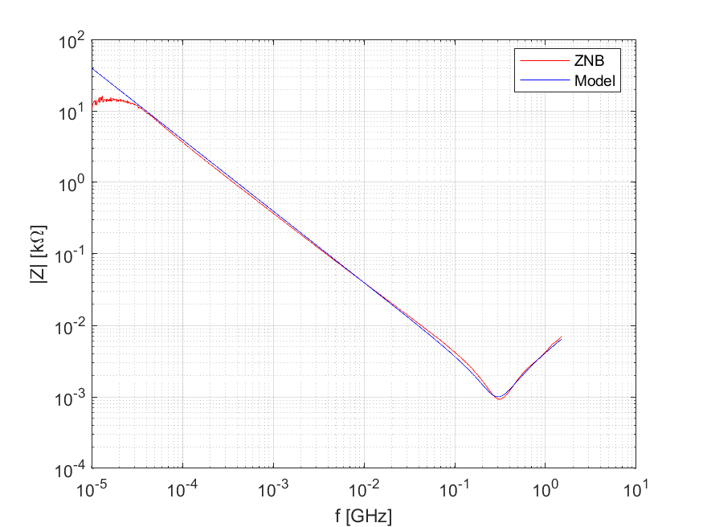

21) Odpor 50Ω zapojený paralelně
