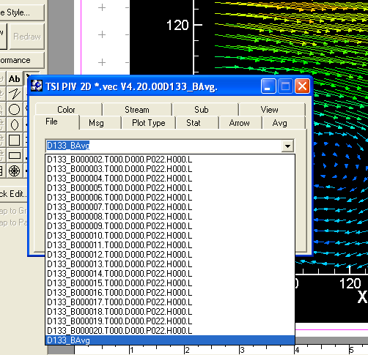

This is how you change the x and Y scale. V1 is the Xmm and V2 the Ymm etc. The offsets allow you to get the scale correct on your final plot.
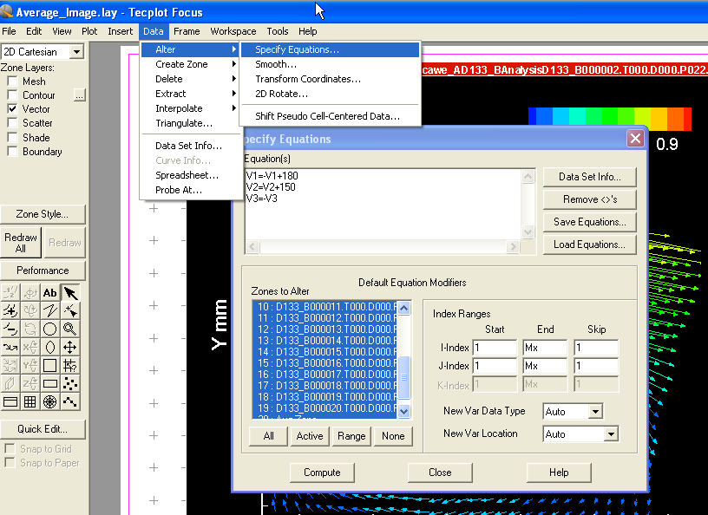

This shows you how the variables V1 and V2 are related to your data set
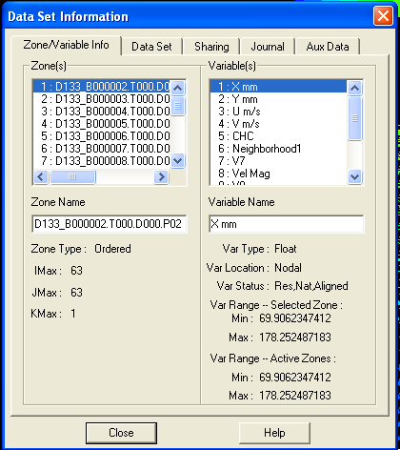

To edit the colour map range and number of divisions etc go to plot/Contour or double click on the colour legend.
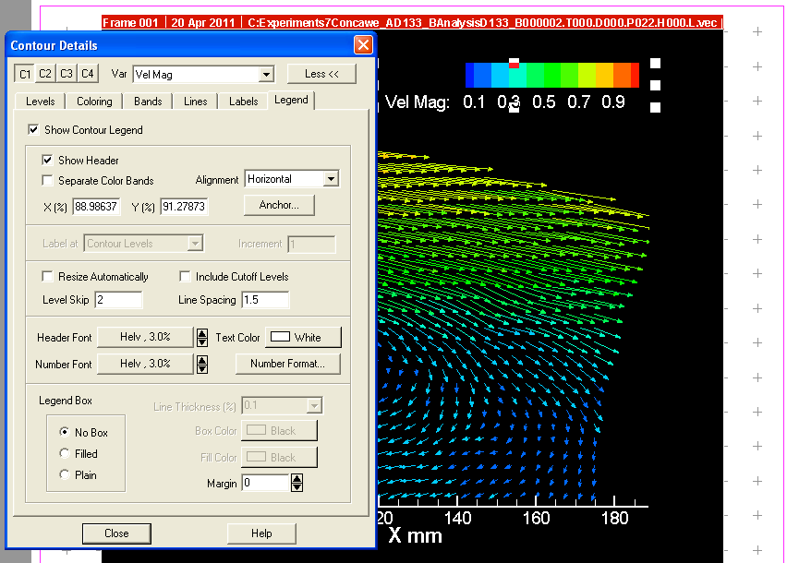
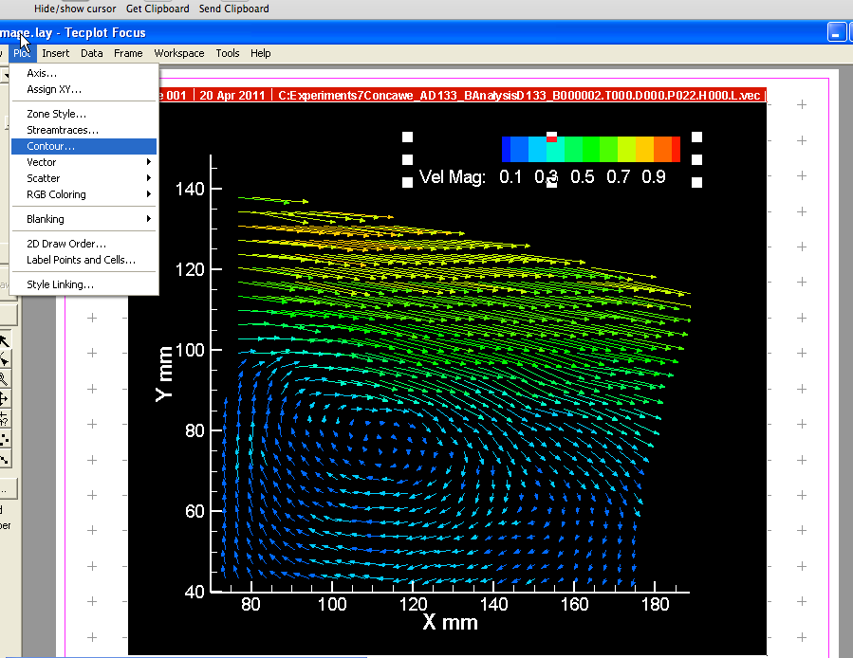
Press the New Levels button on Contour Details to change the max min and range

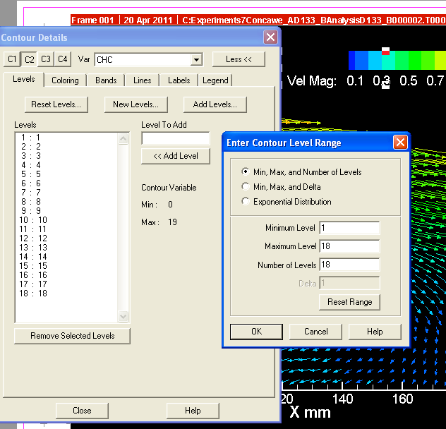

Final export

