The normalised mean concentrations that have been titled CU(ref)/Q has been calculated by:

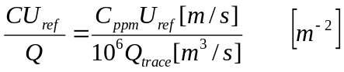

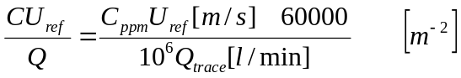

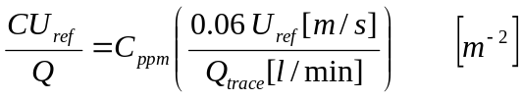

The normalised concentration variance that is titled c^2 non has been calculated by:

