# Heading 1

## Heading 2

This is what normal text will look like in the report.

* Bullet list item 1
* Bullet item 2

And this is what a numbered list should look like:

1. Number list item 1
2. Number list item 2

## Heading 2

Nichol, D. G. 1995. “Spawning and Maturation of Female Yellowfin Sole in the Eastern Bering Sea.” Journal Article. In Proceedings of the International Flatfish Symposium; October 1994, Anchorage, Alaska, 35–50.

———. 1997. “Effects of Geography and Bathymetry on Growth and Maturity of Yellowfin Sole, Pleuronectes Asper, in the Eastern Bering Sea.” Journal Article. Oceanographic Literature Review 12 (44): 1548. <https://spo.nmfs.noaa.gov/sites/default/files/pdf-content/1997/953/nichol.pdf>.

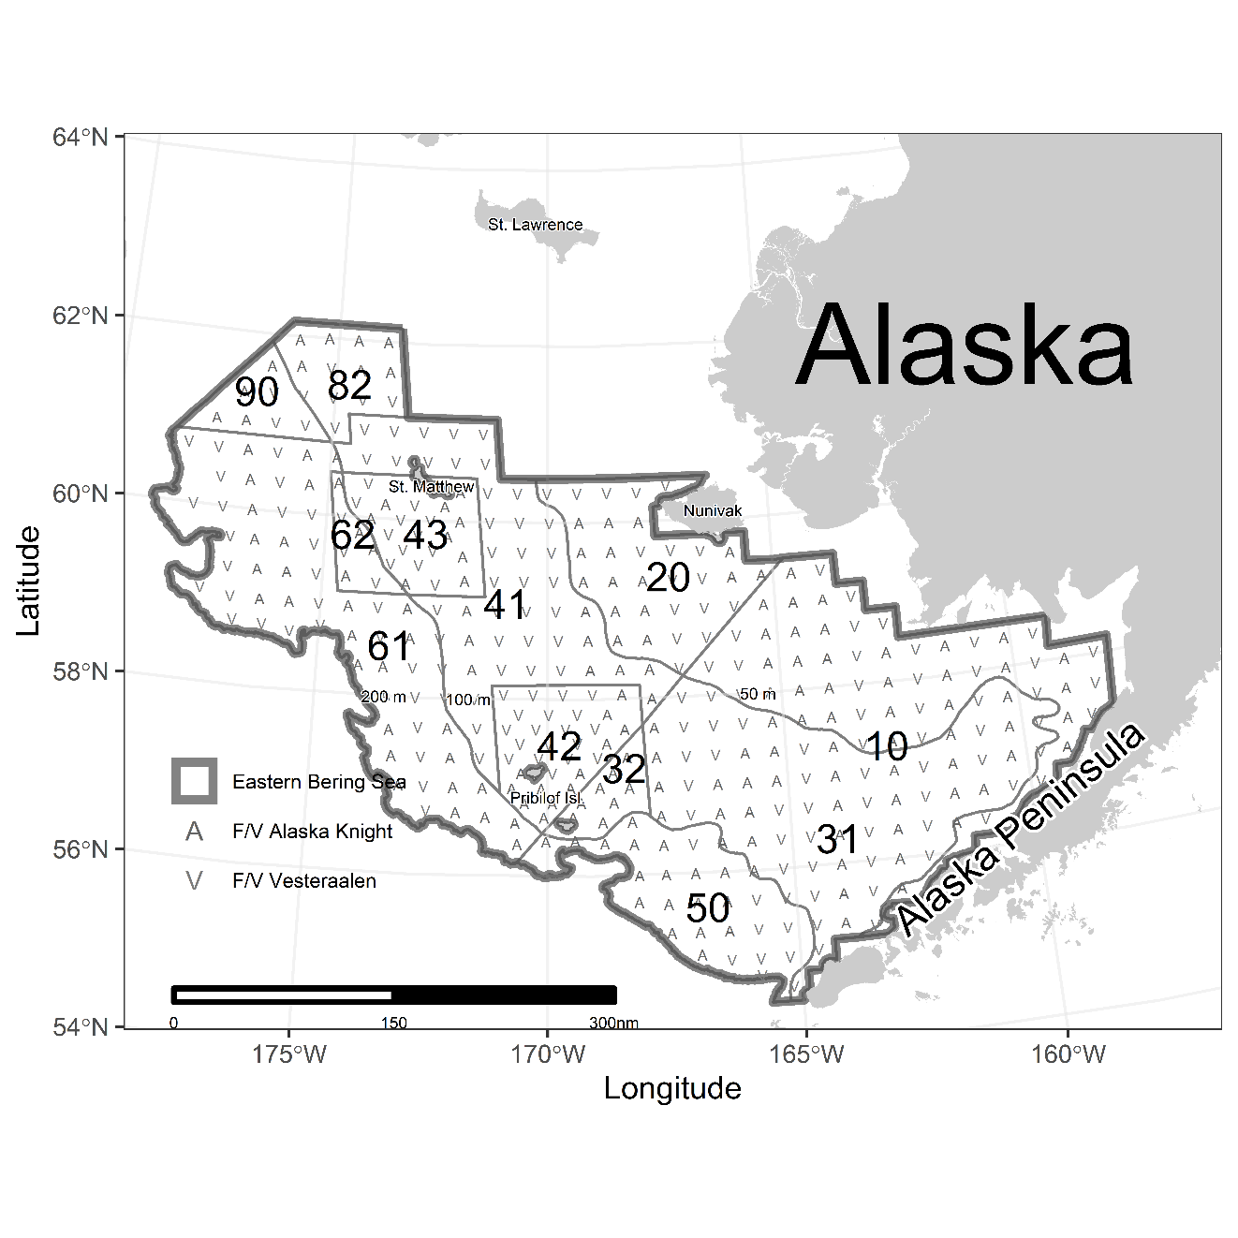

Figure . blah

Table 1. Test table.

|  |  |  |
| --- | --- | --- |
| Column 1 | Column 2 | Column 3 |
|  |  |  |
|  |  |  |