PROBLEM ANALYSIS
Application Requirements
- Write a restful api that takes in a name and address.
- Persist those inputs.
- Name field should be considered as a unique set.
- Return proper messages for validation, duplicates, and errors.
- Allow updates to those inputs.
- Allow deletes to those inputs.
- Return all inputs persisted.

Technical Requirements
- A .NET Core restful api.
- Use of Dependency Injection.
- Make use SOLID principals.
- Incorporate swagger to test endpoints.
- The persistence can be an in-memory database or a simple no sql db.
- Use a caching layer to retrieve persisted data and keep cache current for all updates.
- Write unit tests making use of mocks.

Tooling Requirements
- Use Visual Studio, latest version if possible.
- Keep all projects in one solution.
- The solution should compile with no errors.
- The application should run cleanly.
- Easy local setup to ensure solution can be executed.
- If nosql db used, preference is RavenDb .
- Use .NET Core 6.
- Caching layer can be In Memory
- Unit tests can be written using MSTests, NUnit, or Xunit.
- Use Mocks when unit testing persisted data.
- All tests should be rerunnable.

Please post solution to a public GitHub or any shareable file location.
SOLUTIONS & DESIGN
- Tools: Drawing.io
- Architectural Style: Microservice
- Design Patterns and Principles: SOLID, DDD, Onion-Like architecture, Repository Pattern, Unit of Work pattern, Generic Repository.

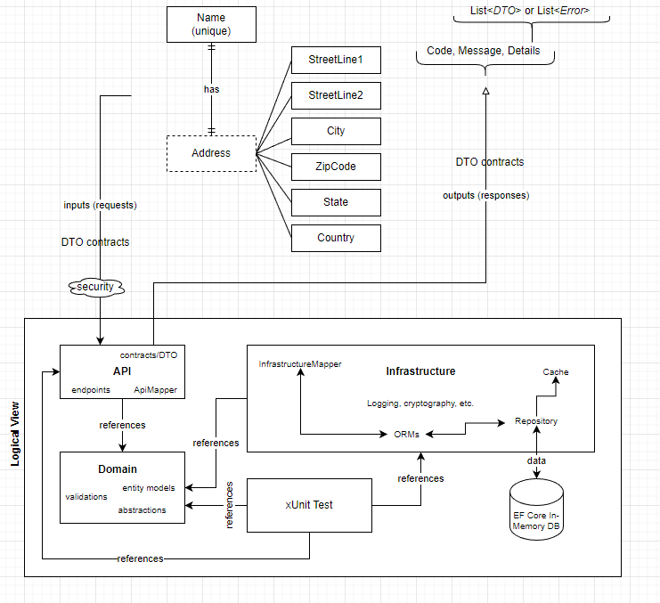

IMPLEMENTATION
- Tools: Visual Studio 2022, ReSharper
- Technology: .NET 6.0, C# 10.0, EF Core, ASP.NET Web API, EF Core In-Memory Database, In-Memory Cache.

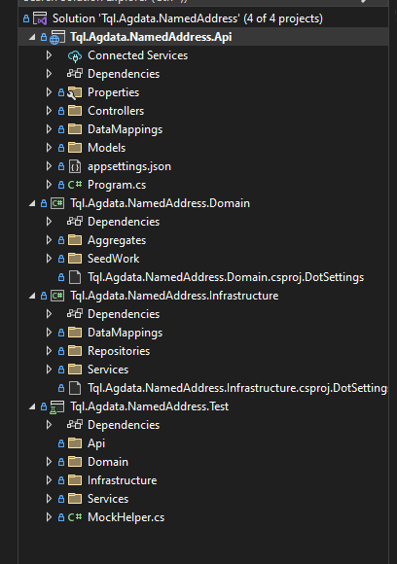

TESTING
- Tools: xUnit test framework, Moq framework, Swagger.
- Unit tests: 39
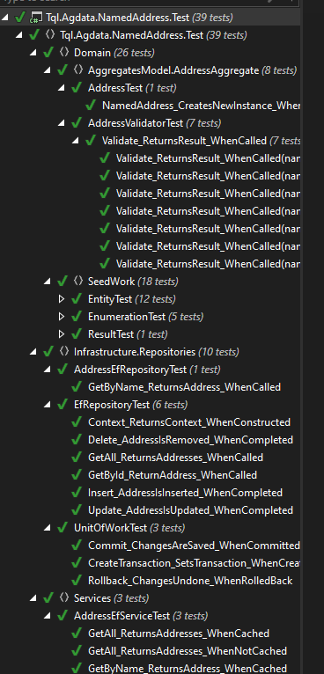

API Tests (using Swagger)
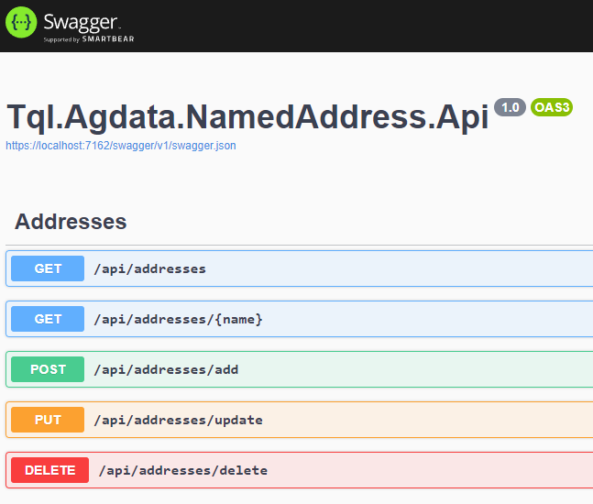

Example of adding a new address
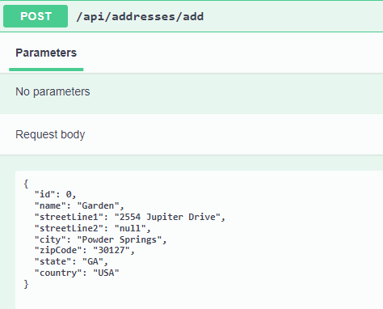
Example of updating and existing address
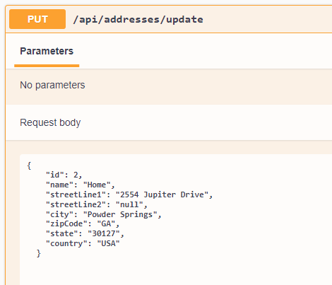
Example of deleting an existing address

