1.

(1)TRUE

(2)FALSE

has-a relationship才表示composition

(3)FALSE

學生並不是course的type

(4)TRUE

(5)TRUE

2.

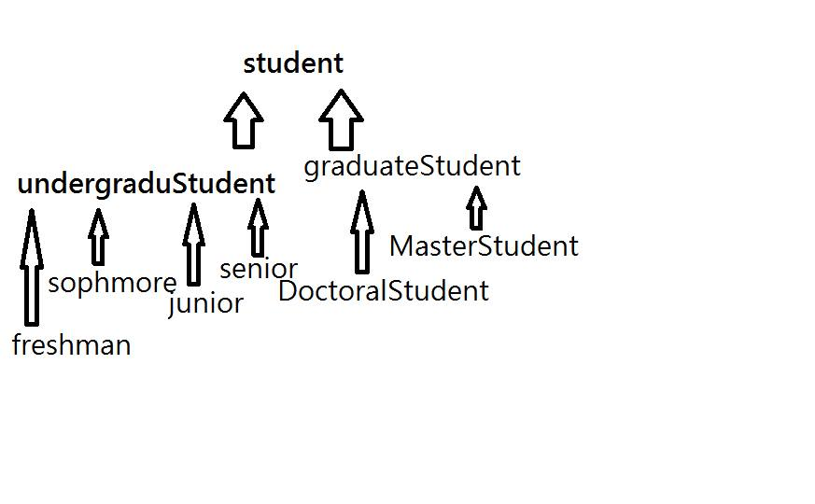

freshman, sophomore, junior, senior和undergraduateStudent是is-a relationship, 和student也是is-a relationship.

DoctoralStudent, MasterStudent和graduateStudent是is-a relationship, 和student也是is-a relationship.