CM3070 Literature review

# Introduction

My project is based on the ‘physics-based game’ template. My proposed design will be based on simulating a tabletop board game. Boardgaming is an area that holds especial interest for me, as a structure around which to base social engagements, and for the mental – and occasionally physical – challenges such games provide.

# Background

People have been playing boardgames for thousands of years and throughout the world. Archaeological examples exist from ancient cultures, and records show the evolution and propagation of games throughout history. Examples of such ancient games include *Go* (also known as *Baduk*) originating around the 4th millennium BCE in China [1], the *Royal Game of Ur* from c.2600 BCE in Mesopotamia [2] and *Senet* from a similar era in Egypt [3].

*Go, Royal Game of Ur, and Senet board games*

The industrial revolution and the attendant advent of commercial mass production led to what is considered the first ‘golden age’ of board games in the late 19th and early 20th centuries [4]. The increased availability of games included affordable versions of older games, such as the medieval *Game of the Goose* - first recorded in 1480 [5], as well as new creations such as Elizabeth Magie’s *The Landlord’s Game* in 1904, now better known by its popular descendant *Monopoly* [6]*.*

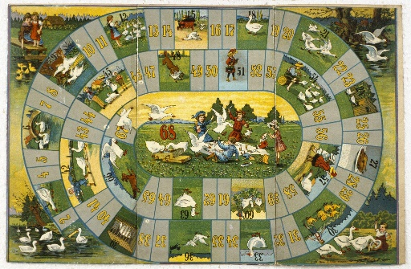  
*The Landlord’s Game (1904), and a 1910 publication of the Game of the Goose*

Since the 1990s the so-called ‘board game rennaisance’, or ‘second golden age’ has seen a resurgence in the popularity and innovation of modern tabletop gaming, originating primarily in Germany, but now spread around the world [7]. This rennaisance has coincided with the decline of certain types of social venues, causing a rise in a new type of ‘third space’ dedicated - or at least welcoming - to tabletop gaming [8].

While board games are inherently physical items, a subset - known as *dexterity games* - make explicit use of their physicality. Such games may challenge players to maneuver components using manual dexterity with varying objectives, such as building towers, accurately flicking pieces around a game space, or carefully maneuvering components using tools. Well-known examples of games in this genre include *Jenga,* *Operation*, and *Subuteo*. This focus on the physical interaction of game components may make a dexterity board game a suitable influence for a project confirming to the provided template of a ‘physics-based computer game’.

# Digital board games

There is little in the academic literature relevant to designing a project such as this; instead examples of existing similar projects will be evaluated.

The resurgence of interest in board games in recent decades, noted above, has coincided with the expanding availability and capabilities of home computing devices, and of the internet. This has led to several instances of digital adaptations of extant board games, as well as generic platforms for hosting various games through a single interface.

*Tabletop Simulator* [9]is a popular example of the latter. This software is a physics sandbox, designed as a platform for playing board games online. The software by default only includes a handful of public-domain games such as chess, but includes the option for users to import assets for other games. With a few exceptions, game rules and mechanics beyond simple physics are not implemented; the software merely provides a world in which players can manipulate components as on a real table. This makes for a very versatile platform in which a variety of games can be played, however it requires at least one - and ideally all - of the players to be familiar with the game and implement all game rules manually.

*Tabletop Simulator* implements a functional 3D environment and physics engine, in which components are rendered and are subject to both intrinsic forces such as gravity and friction, and extrinsic forces from player interaction. Game pieces will collide with each other, and elastic collisions are modelled convincingly. Camera controls are intuitive to players familiar with using mouse-and-keyboard in other 3D computer games. When it comes to manipulating components within the game world, however, the complexity of the control scheme increases. Due to the software’s generic nature, there are many options for moving, rotating, flipping, and viewing components, and these are not well communicated by the user interface. The software’s external knowledge base contains several pages on the player controls [10].

As noted, the physics engine within the software is functional, however it does not accommodate certain dexterity-type games well. Flicking games, such as *Crokinole* function reasonably; the interface provides a method for the player to impart a flicking force parallel to the ground, and objects will slide, roll, and collide realistically. Stacking games, such as *Jenga*, are virtually impossible to play using this software, due to the difficulty of manoeuvring held objects with six degrees of freedom. Objects can only be rotated in discrete intervals - the rotation angle can be set in the interface, but only within a small number of options. Movement of objects on the vertical axis is very restricted - a lift height can be set in the interface, and objects are pulled to this heigh while held and subjected to gravity when released. This does not allow for careful placing of objects atop each other.

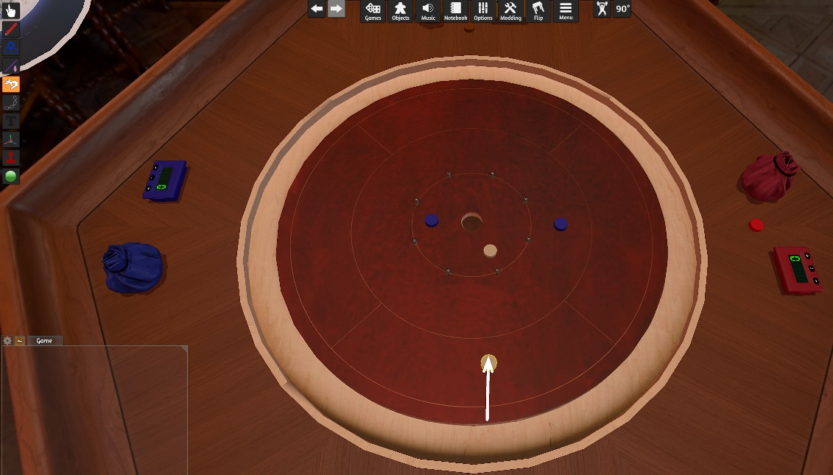  
*Tabletop Simulator, showing the 3D environment and force input interface for a flicking game*

In contrast to *Tabletop* Simulator, which is a piece of software sold to users and running on the users’ machines, *Board Game Arena* [11] is an online service, supported by a subscription model. This service allows users to play board games with others through a web browser, with a predefined, though large, selection of board games implemented. Each game implementation is developed to enforce game rules, and automate game mechanics wherever possible. The engine used to implement each game is two-dimensional, with no physics simulation. This is thus an unsuitable platform for implementing adaptations of any dexterity games. The fact that the service hosts a large number of games is beneficial to its subscribers, but it does mean that the interface is somewhat generic, and it can take some time for a user to become familiar with how a particular game is implemented, even if they are familiar with the rules of the game itself.

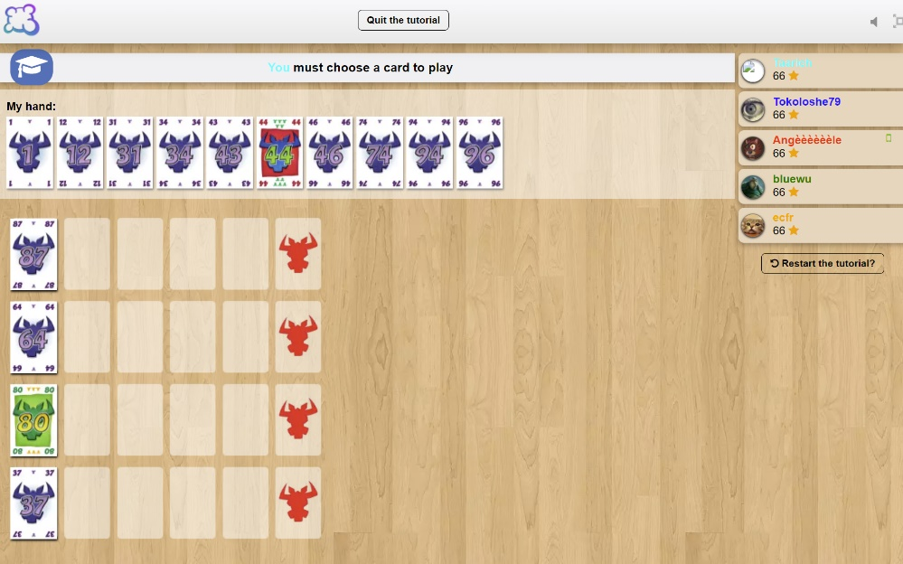  
*Board Game Arena, showing the 2D interface and platform-imposed rules enforcement*

Further to these examples of general board-gaming platforms, there are several examples of single-game implementations. One of the earliest board games in the modern ‘renaissance’ era was The *Settlers of Catan* [12], and there have been a number of digital adaptations of this game. The latest of these is *Catan Universe*, available as a stand-alone product for PC, Android, and iOS [13]. As is common with such stand-alone boardgame implementations, this is a highly polished piece of software. The interface is clear, with a built-in tutorial for the game and how it’s played through the software. The game components are modelled with a high degree of fidelity, and thought has been given to how the game will display, and be controlled, on devices of varying screen sizes. In this example, the game is modelled fully in 3D, however there is no physics engine implemented, as it is not required for the game to function; components snap to predefined places in the game space, and there is no need to model collisions or forces.

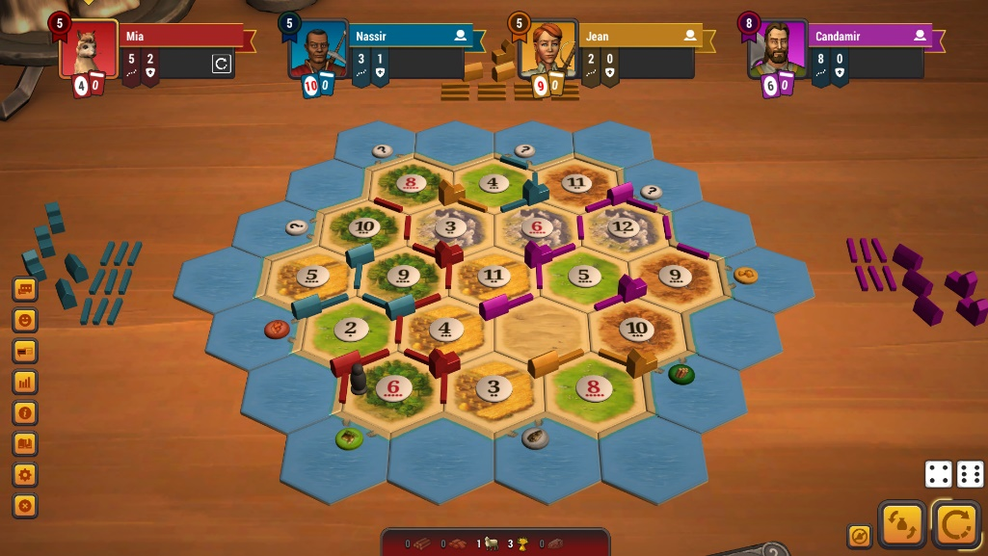  
*Catan Universe, showing the 3D rendered environment and clear multiplayer interface*

Other standalone boardgame implementations follow a similar pattern. I have not been able to find any examples of commercial products adapting a specific dexterity-type board game. Some examples exist of amateur implementations of basic stacking-type games such as *Jenga*. A technology demonstration for the Physijs plugin contains a 3D environment with a *Jenga* game set up [14]. This tech-demo has issues preventing it from being a playable game. While collisions and gravity forces are well modelled, controls are rudimentary. Pieces can be selected and dragged, but can only be moved with two degrees of freedom; it is not possible to rotate held pieces, nor to lift them to be placed atop the stack.

Other adaptations of the same game are even more rudimentary. *Jenga* publishers Hasbro released a single-player web version of the game at an indeterminate time in the past. This implementation was run through the Macromedia Flash platform, and is now archived on several websites hosting abandoned Flash software [15]. This version of the game features no physics simulation, with very simplistic controls and an algorithmic determination of when the stacked objects should collapse.

# Other physics-based games

The above examples show the state of digital adaptations of board games, and the strengths and issues of various approaches. It is evident that a key consideration for adapting a dexterity game will be the ability for the player to pick up an object and move it with six degrees of freedom - translations and rotations about three axes. This requirement to move objects around a 3D environment is common in many modern computer games.

*Portal* [16] from Valve Software is a well-known first-person puzzle game. The game makes extensive use of its physics engine with innovative application of momentum conservation through linked spatially distant ‘portals’. In addition to the player avatar traversing the levels, many puzzles require the manipulation of ‘weighted storage cubes’ to either create platforms for the player to access areas, or to actuate switches. The player is able to pick up and move these cubes (and other objects) fairly intuitively. A single button press grabs an object at the camera focus, so long as it is within a set range. While an object is being held, it is maintained at the camera focus point independent of gravity. The held object is still subject to collisions, and can be used to knock other moveable objects about the game space. As the object is locked to the camera’s view, it can be moved using the familiar player movement controls; Y-axis (vertical) movement is limited to by the fixed distance from the camera, unless the player finds a way to move their avatar vertically within the level. Rotation of the held object is more restricted: the held object’s rotation with respect to the camera is fixed when the object is picked up. It can be rotated about the Y axis with respect to the game world by moving the player, but other rotation axes would require the object to be dropped and picked up again. The simple and intuitive interface for object manipulation is well executed, and the limitations are irrelevant within the scope of this game, but this method would need to be built upon to satisfy the needs of a game focussed on precisely placing objects at arbitrary rotations.

*Garry’s Mod* [17], like Portal, is built on Valve’s *Source* engine. This software was designed as a general sandbox, and thus has object manipulation as a key feature. As with *Portal*, objects can be picked up and held at the camera focus, and moved within the game environment using the player avatar controls. There are several additional features over the *Portal* implementation which make the system in *Garry’s Mod* more useful. Held objects can be moved towards/away from the camera using the mouse scroll wheel. In combination with the camera view angle, this allows much greater flexibility in the Y-axis position of objects. The held object can also be freely rotated, though only about two axes. This is achieved by holding a key which locks the camera view angle and switches the mouse X-Y movement to controlling rotation of the held object about X and Y axes. Rotation about the Z axis (into the screen) is still not achievable while the object is held.

These additional features should prove useful inspiration for designing an intuitive control scheme for manipulating an object with six degrees of freedom in order to place it precisely with respect to a potentially unstable collection of previously placed objects.

# References

|  |  |
| --- | --- |
| [1] | P. Shotwell, “Some New Approaches to the Study of the History of Go in Ancient China and Siberia,” in *The 2nd International Conference on Baduk: proceedings*, Seoul, 2003. |
| [2] | C. L. Wooley, Ur Excavations Volume II: The Royal Cemetery, London: Publications of the Joint Expeditions of the British Museum and the Museum of the University of Pennsylvania, 1934. |
| [3] | M. Sebbane, “Board Games from Canaan in the Early and Intermediate Bronze Ages and the Origin of the Egyptian Senet Game,” *Tel Aviv,* vol. 28, no. 2, pp. 213-230, 2013. |
| [4] | M. Hofer, The Games We Played: The Golden Age of Board & Table Games, New York: Princeton Architectural Press, 2003. |
| [5] | A. Seville, “Early history and meaning of the Game of the Goose,” in *The Cultural Legacy of the Royal Game of the Goose: 400 years of Printed Board Games*, Amsterdam, Amsterdam University Press, 2019, pp. 22-36. |
| [6] | R. Kennedy Jr. and J. Waltzer, “The Game - A Brief History of Monopoly,” in *Monopoly: The Story Behind the World's Best Selling Game*, Layton, UT, Gibbs Smith, 2004, pp. 8-14. |
| [7] | S. Woods, Eurogames: The Design, Culture and Play of Modern European Board Games, Jefferson N.C.: McFarland & Company, 2012. |
| [8] | P. Konieczny, “Golden Age of Tabletop Gaming: Creation of the Social Capital and Rise of Third Spaces for Tabletop Gaming in the 21st Century,” *Polish Sociological Review,* vol. 206, no. 2, pp. 199-215, 2019. |
| [9] | Berserk Games LLC, “Tabletop Simulator,” [Online]. Available: https://www.tabletopsimulator.com/. [Accessed 26 10 2023]. |
| [10] | Berserk Games LLC, “Tabletop Simulator Knowledge Base: Controls & Movement,” 17 04 2021. [Online]. Available: https://kb.tabletopsimulator.com/player-guides/basic-controls/. [Accessed 10 11 2023]. |
| [11] | AD2G Studio SAS, “Board Game Arena,” [Online]. Available: https://boardgamearena.com/. [Accessed 26 10 2023]. |
| [12] | L. Levy, “Special K - Klaus Teuber,” 08 2001. [Online]. Available: https://web.archive.org/web/20160131095945/http://www.thegamesjournal.com/articles/SpecialK3.shtml. [Accessed 16 11 2023]. |
| [13] | KOSMOS Publishing, “Catan Universe,” [Online]. Available: https://catanuniverse.com/en/. [Accessed 16 11 2023]. |
| [14] | C. Prall, “Jenga - Physijs,” 19 10 2015. [Online]. Available: https://chandlerprall.github.io/Physijs/examples/jenga.html. [Accessed 16 11 2023]. |
| [15] | “Jenga,” Gamenora, [Online]. Available: https://www.gamenora.com/game/jenga/. [Accessed 16 11 2023]. |
| [16] | Valve Corporation, “Portal,” 10 10 2007. [Online]. Available: https://store.steampowered.com/app/400/Portal/. [Accessed 17 11 2023]. |
| [17] | Facepunch Studios, “Garry's Mod,” 29 11 2006. [Online]. Available: https://gmod.facepunch.com/. [Accessed 17 11 2023]. |