**Dragonfly in Eclipse (v1.2)**

**Tested on 64-bit Windows 7**

1. In Cygwin be sure to install gdb: The GNU Debugger, found in the Devel tab. 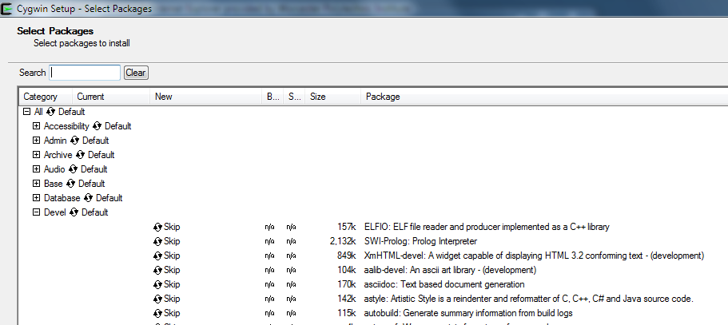
2. Remember to install the linbncurses-devel and libncursesw-devel version 5.7-18 found in the Devel tab.
3. Download project archive and unzip somewhere on your machine.
4. Open up Eclipse in C++ view (<http://www.eclipse.org/downloads/> for a download)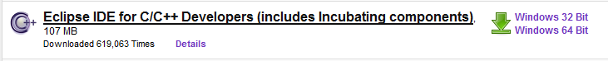
5. Create a new managed makefile project from existing code.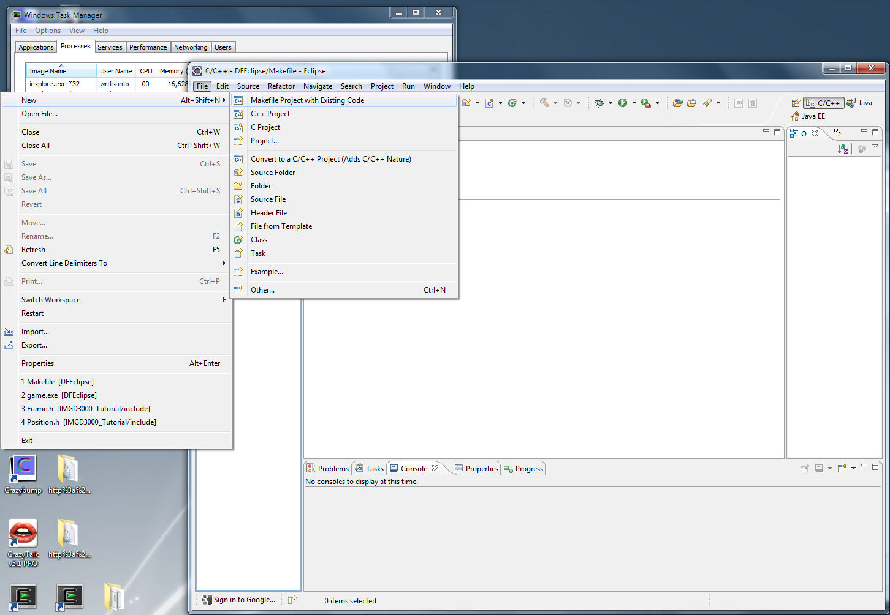
6. In the import existing code module select the Cygwin GCC toolchain from the list, and set the Existing code location to that of the directory of your project. You may also name your project. Click Finish and open the new project in the Project explorer tab found on the left hand side of the Eclipse GUI when in C++ perspective view.

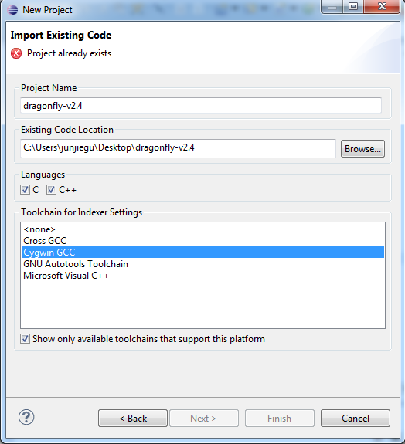

1. Click on the Project drop down menu at the top of the GUI and select Properties. Then navigate to the C/C++ Build – Environment tab and make sure the C:\cygwin\bin; folder path is included in the PATH variable. If not make sure to add it to the front of the list. If you are using your own installation of Cygwin include the path to your local cygwin\bin folder. E.g., C:\Users\LoginNameHere\Documents\bin.

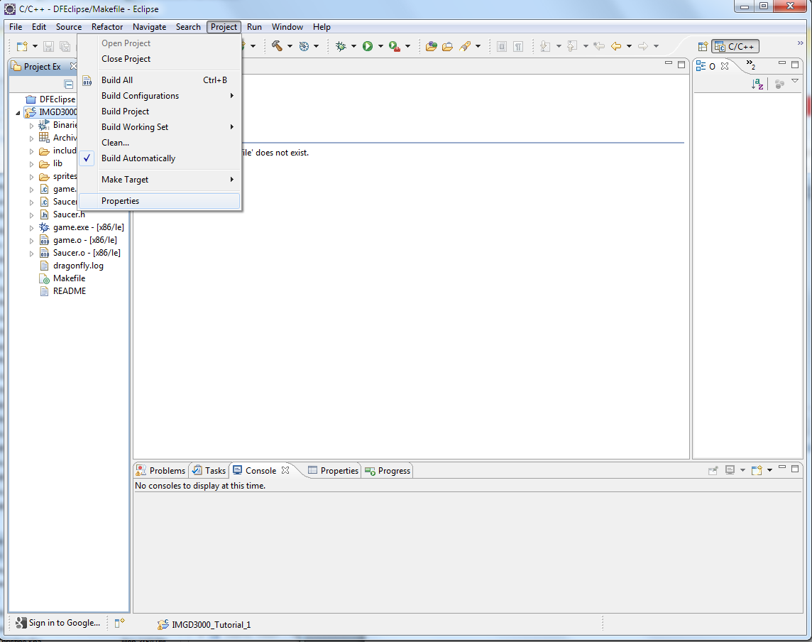

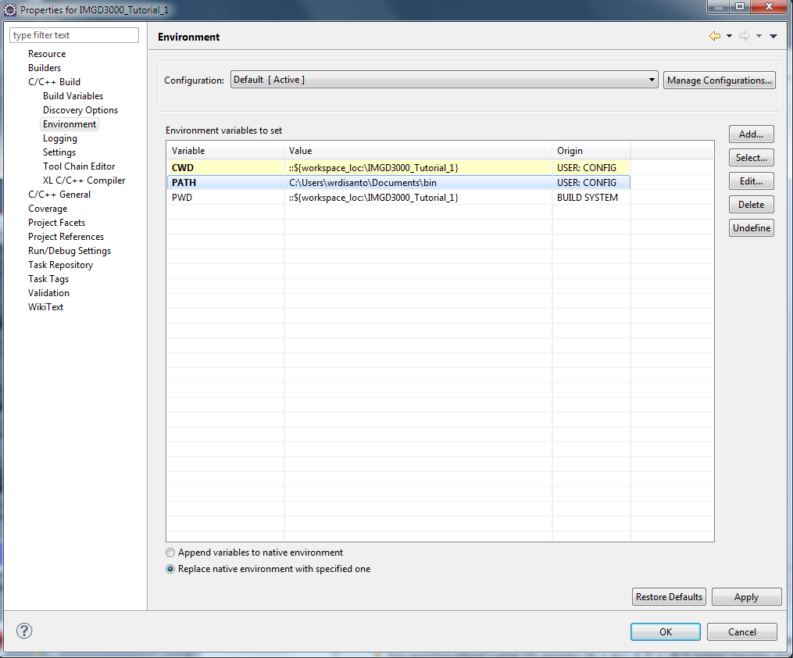

1. Right click the dragonfly-2.4 project folder in the Project Explorer and select “make targets” – “create”. This will bring up the “Create Make Target” window. In this window enter the name of your executable. For this project enter the name game.

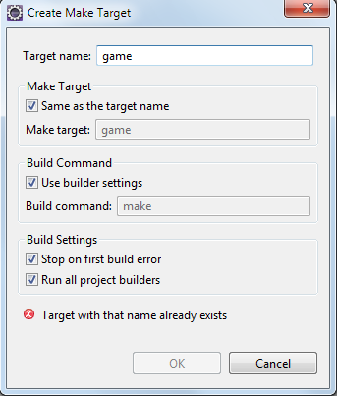

1. Now attempt to build your project, make sure you have make.exe installed in your “cygwin/bin” folder. If not install make in the Devel tab of the setup.exe Cygwin installer. Now right click your project folder and click build project. If the project fails to build because the program “make” could not be run in the provided directory, check that you installed the make executable in the correct folder and that the PATH variable checks this folder for executable as in step 5.
2. Now configure your project to run. Select the “External Tools” – “External Tools Configurations” from the “run” dropdown menu of Eclipse. Double click “Program” to create a “New_configuration”.

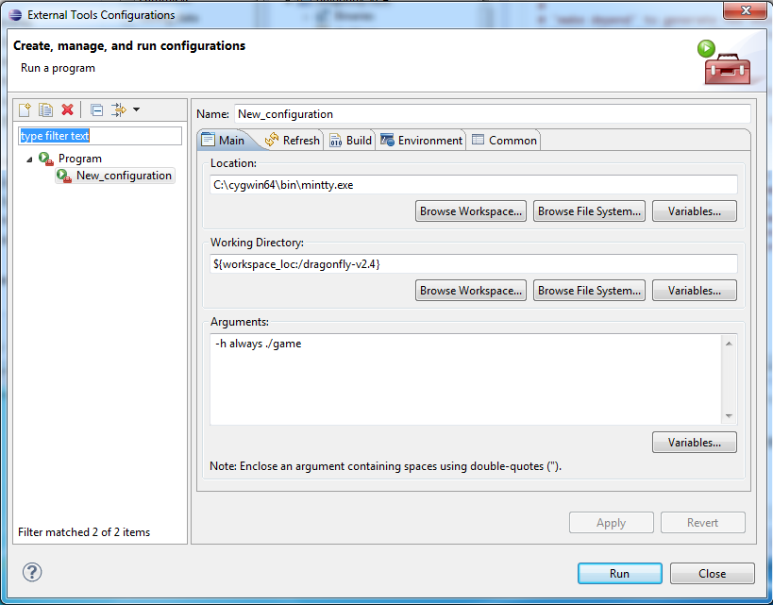

1. Click the “New configuration” in the “program” branch of the tree view. On the main tab in the “Location” text box search for the “mintty.exe” file in your working cygwin bin directory. For example: C:\cygwin64\bin\mintty.exe. Then enter the following into the “arguments” text box: ./game
   1. You may need to add an argument, -h always, to the arguments list to hold your mintty terminal open, for example: “-h always ./game”.

Click the “Environment” tab, click “New”, text whatever name in the “Name” text box and your working Cygwin bin directory in the Value text box, and then click “OK”.

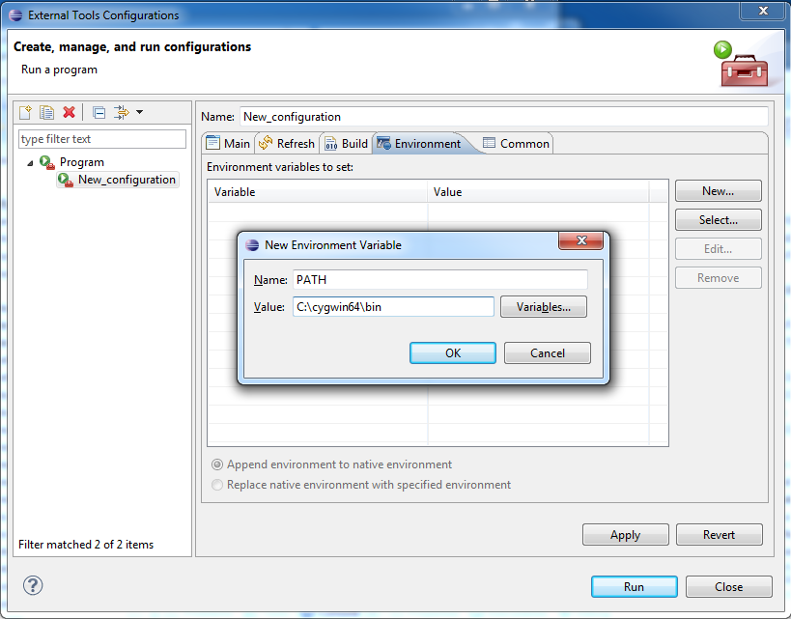

1. Check that the program runs by first clicking apply then clicking the Run button at the bottom of the “External Tools Configurations” window.