(Name Pending)

Japanese Typing Game

Design Document

Deadline: ETA

Written: April 15, 2018

Table of Contents

Executive Summary 3

Gameplay 4

# Executive Summary

The goal for the player is to type out a matching Japanese character (hiragana, katakana, or kanji) to eliminate the many falling blocks with Japanese characters embedded into them from the sky, in order to rack up a high score. This is a teaching game that aims to let the player familiarize with typing out the character, as well as understanding and memorizing the character as vocabulary.

# Gameplay

The game consists of a simple hierarchical structure, all purely for functional and practical gameplay. It will have a main menu, the core game, the options menu, the credits screen.

This is the main menu. It should be clean, concise, and simple enough for any players of all ages (at least +3 years old, or enough to understand and read words) to navigate around the menu.  
  
Some menu options will be removed, depending on specific needs, and graphical user interface designs.

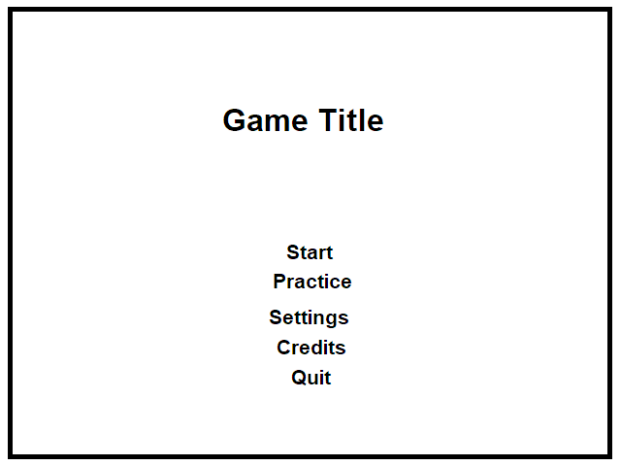

Figure – Main menu mockup.

This is the main game screen layout. Most of the game will take place in the bottom play area. The top part of the game will display the player’s current score, and may show previous scores that were on the leaderboard.

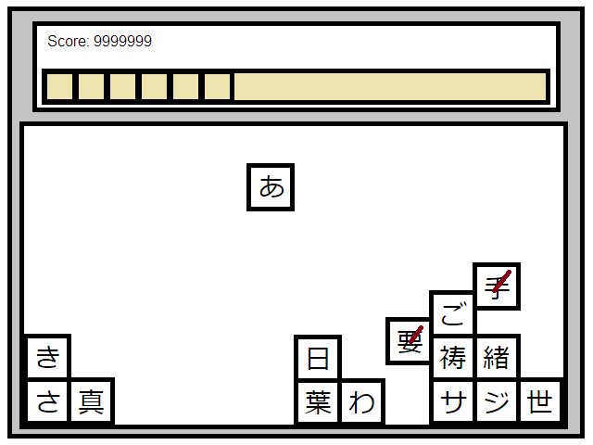

Figure – Game screen mockup.

The yellow area will be the in-game preferences, for the player to change freely. This will contain options such as the speed of the falling blocks, the gravity in the play area, the difficulty, and so forth.

Each individual Japanese character will be inside 1 square block. Each block will fall from the top based on the options the player has set in the yellow area. When the blocks fill up the entire play area, the game is over, and the game keeps track of the player’s current score.

If the player guesses the correct vocabulary for the characters inside the blocks, an arrow or some indicator will be shown on the block, indicating this is “marked”, and a score is given. The marked block will then rise up towards the top. No collisions will occur, and the unmarked blocks on top of the marked blocks will fall through them. This is the only way for the player to continue progressing through the game.

The game repeats until the entire play area is filled with blocks. Then the game is over.