Huawei Tech Arena 2026
AIDC Power Supply Resilience — Hierarchical Prediction of Power Continuity Risk
Resilience Prediction of AIDC Power Supply under Extreme Scenario

Datasets
- Outage Data. NaFIRS LV Faults serves as the primary source, organized at the distribution-district level and covering central-southern England and northern Scotland. Eagle-I, which records outage data within the United States, is provided as an optional reference.
- Weather Data. Open-Meteo is the recommended source. Participants are responsible for determining the selection of one or multiple geographic coordinates, with spatial granularity defined as a circular region of three to nine kilometres in radius centred on each chosen coordinate.
- Site Power-Supply Architecture Topologies and Configuration Parameters. The organizing committee will provide four reference power-supply topologies, as shown in Fig. 1. Participants may model different configurations under each topology. During testing, the topology type and corresponding configuration parameters will be provided as model inputs.
- Power Infrastructure (Optional). OpenStreetMap via the Overpass API. Participants may at their discretion select substations, transmission lines, and utility poles to construct an infrastructure topology.
- Extreme Weather Events (Optional). NOAA Storm Events Database (https://www.ncei.noaa.gov/stormevents/).

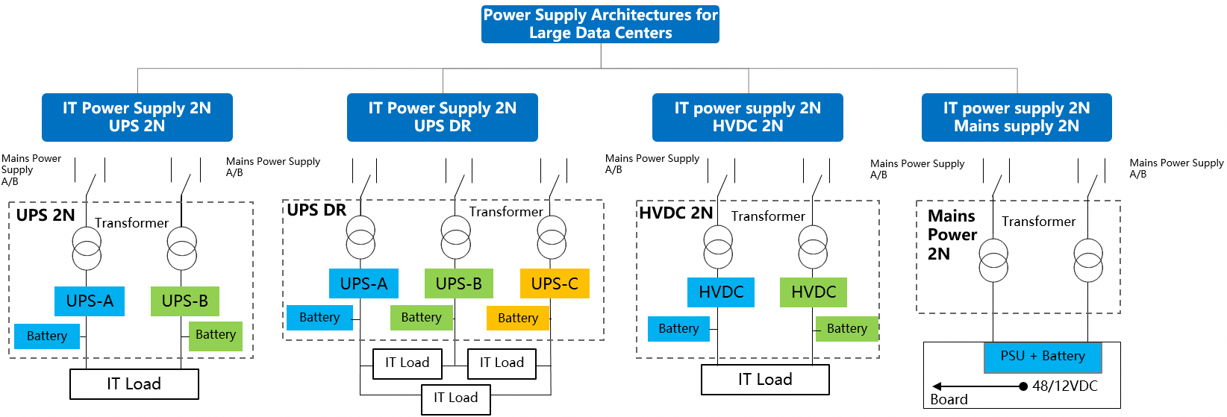
Fig.1 Site Power-Supply Architecture Configurations

