1a.

Usernames: AWilbert96, BAcacia96

Cookies:

* Session: eyJjc3JmX3Rva2VuIjoiNmMwZjJmOTQ3NGQ4ODhkN2EwODA4OGQwMWM2OGQyYTQ4MzY3MmE1NSJ9.ZWxnEg.qc6zdwQFdQralMZC-v8KYi_Lz3A
* LOGIN_INFO: 3b6c31fa5bfac2f7a976c6080f52f1fcbd16f14851db06d5c453ed6038912874
* USER: BAcacia96

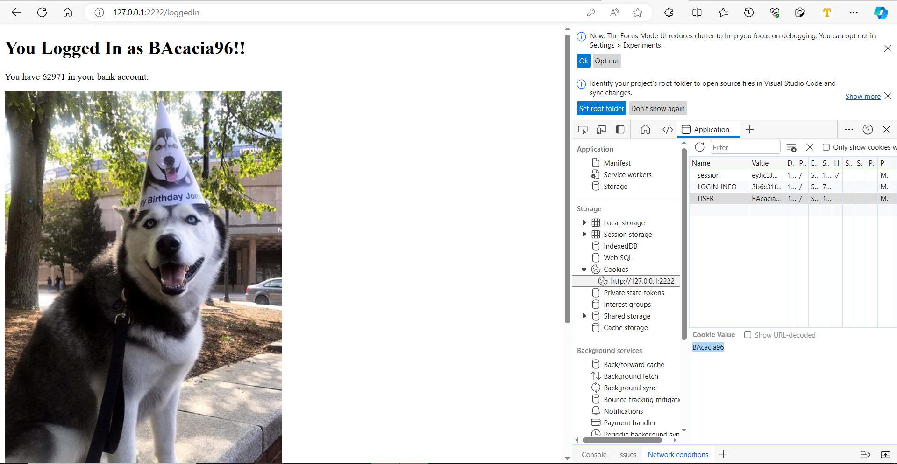

3. Cookie: 45807

4. Cookie: 73536