Stupid Excel Tricks for power users

Sarah Cohen
The Washington Post
Okay. You've gotten past your fear of formulas, you've mastered absolute cell addresses, and you hardly ever screw up your sorts anymore. But you have a nagging feeling that you're still working the slow way -- using the mouse, doing a lot of clean-up by hand and saving lots of copies of your spreadsheets sorted slightly differently.
You're ready for the next step.
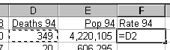
There are three areas we'll explore in this handout -- Speeding up your work with keyboard shortcuts and other tricks; working with text in formulas; working with dates and times. Two others you may choose to learn on your own: Looking up values in lists using formulas (or "lookup formulas"), and writing new functions to automate your work.

Speeding up your work

Keyboard shortcuts for selecting cells, areas and special cases
The first thing to get used to when you start dealing with larger data sets and more complex data is to learn to use the keyboard rather than a mouse for the most common tasks. Here are some that I use a lot:
CTL-SHFT-8 : Select the current region. This selects everything in the contiguous square and is equivalent to selecting by using CTL-SHIFT-Right arrow and CTL-SHIFT-Down arrow.
CTL-SHFT-END: Selects everythng that's been filled out in the worksheet
And don't forget the Edit, Go To, Special menu item.
With it, you can select all of the formulas, errors, blanks or other special categories in your spreadsheet. This is particularly useful when you need to fill in blanks in a print image by using the row above it as the guide. Combine it with CTL-Enter below.
The three I use the most are:
- Blanks - To pick out all of the blank cells in a region
- Precedents: - To pick out all of the cells that feed into this one.
- Dependents - To pick out all of the cells that this one feeds into.

Don't forget that it's not necessary to type cell addresses into a formula. You can select them while you're in the middle of the formula, using your keyboard or using a mouse. You'll see the border of the one you're inserting in the formula move around as a visual clue:

Filling in cells - copying
CTL-D: Copies whatever you have selected down into whatever range you've pre-selected.
CTL-R Copies whatever you've selected right into whatever range you've pre-selected.
CTL-ENTER Another way to copy a formula is to select the area you want to fill first, then hit CTL- while you hit the Enter key. Great with the Select all blanks above.
Finally, keep track of the right mouse button. Many of the most common tasks you need to perform are given to you when you click it.
Using these together can speed up your work considerably. If we start out with a file that looks like a print image, like this:
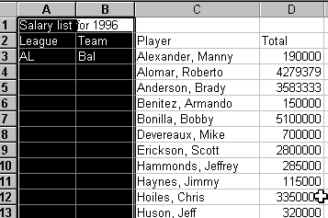
Then use the menu item, Edit, Go To and hit the Special button and choose Blanks,
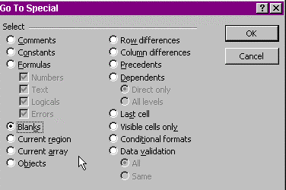
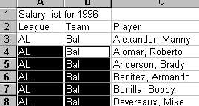
In this case, if you hit Enter until your active cell is B4, you can just type in =B3 (or type = and use your cursor to select it) , hit CTL-Enter, and :

Using named ranges
Naming ranges makes your life simpler by letting you use words rather than cell addresses in your formulas.
This is when smart design in your spreadsheet pays off.
If you've labeled each column using a single word (or phrase without spaces) directly above the data, all you have to do is select the region and choose Insert, Names, Create.
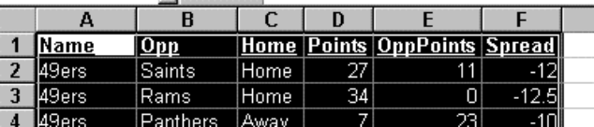
Then turn off the box that says, Left Column:

You'll usually un-check the names in the Left column, leaving only those in the Top row.
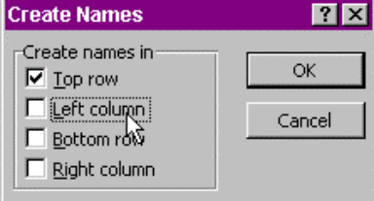
Now, when you want to select or refer to the column, you can use the name
You can use the name whenever you need to refer to either a cell in the current row, or the entire column.
Here's an example of a formula using names:
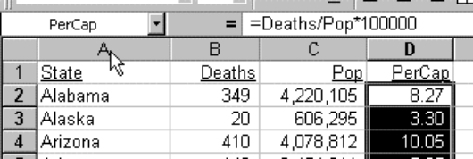

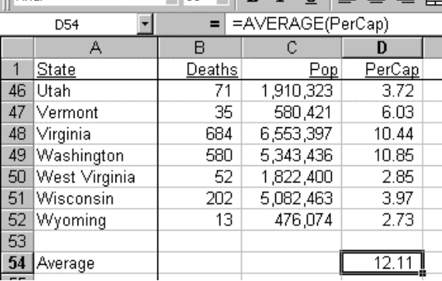
You can also name entire areas of your spreadsheet, not just columns. First select the area you want to name, such as an entire database. Then choose Insert, Name, Define and type in a name for the area:
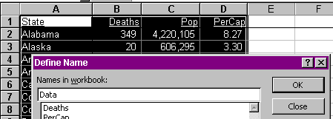

Power users hint: If you capitalize your titles and leave most of them lower-case, you can get Excel to check your spelling for you. No matter how you type an Excel function, it becomes all upper case. When you type a name of a range, it corrects the capitalization for you. So if you always type in lower case, just look for the words that aren't in all caps or beginning caps to find your mistake.

The "if - yes - no " formula
One of the most common formulas reporters need is a way to force Excel to make decisions based on a value in another cell. Examples include:
- Avoiding the dreaded #DIV/0! disease, in which Excel refuses to divide any number by zero.
- Avoiding missing values, such as N/A in FBI crime reports
- Deciding one category from a value, such as a Win-Lose indicator from scores.
The IF(Condition, If True, If False) formula is the most common solution to this problem. Here is an example of using the formula:
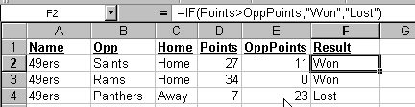
This says in English: "If my team scored more points than the opponent, I won. Otherwise, I lost." Commas separate each portion of the formula.
To check for valid values for percent changes, use >0 as your condition: Missing values and words are less than zero, so the condition will be FALSE:
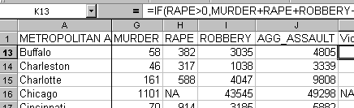

Ranking values
Many reporters have learned the cheating way to rank values in Excel -- sorting then filling in a column with consecutive numbers.
Once you get more comfortable with formulas, though, you'll choose to use a more sophisticated method -- one that doesn't depend on sorting the values first and treats ties correctly.
Like many formulas in Excel, ranking needs to know two pieces of information: The number you want ranked and the list of numbers you want it ranked within:
=RANK(This Number, List of numbers)
If you don't use named ranges, be sure to include the dollar signs so you can copy this down:
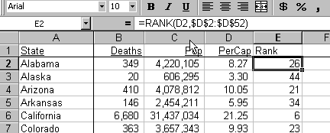

If you choose to use named ranges, this is even easier:
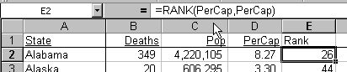

Excel is smart enough to figure out that the first PerCap refers to the current line and the second PerCap refers to the entire list.
You can use a similar formula to figure out an item's percentile. In Microsoft's wisdom, the order is reversed:
=PERCENTRANK(List of items, this item)

Understanding String functions

Let's face it: We deal with words more often then with numbers. And they're far from consistent from one database or spreadsheet to the next.
You often need to put words together to form a phrase or you need to pull a phrase apart to find a word.
Either way, you'll need string functions.
Most of these string functions have direct parallels in Access. There are a few useful string functions missing in both packages, though. If you get really good at either package, you'll want to investigate making some for yourself.

Extractng first and last names
The most common use of string functions is to separate first and last names from a value.
Here are some functions you'll need to pull apart phrases:
=LEFT(string, # characters) extracts everything from the beginning of a string for the number of characters you specify.
=RIGHT(string, # characters) extracts the last portion of a string.
=MID(string, start, # characters) extracts characters from the middle of a string.
=LEN(string) gives you the length of a string.
Four others can be helpful:
FIND() and SEARCH() are slightly different versions of the same thing. I usually use SEARCH(), which allows for wild cards and isn't case sensitive.
REPLACE() and SUBSTITUTE() are similar as well.
REPLACE(text, begin, # chars, new text) is used when you know WHERE you want the replacement to occur, no matter what's there now.
SUBSTITUTE(text, old text, new text, instance #) is used when you know WHAT you want to replace, but don't know where it is.
TRIM(string) removes leading and trailing blank spaces.
Using string functions takes some practice. At first, I suggest using extra columns to hold your interim information, particularly functions that give you the position of certain characters.
Here's an example of pulling apart names using the extra columns. The first item shows you the formula. The following rows show the result when copied:

Original data

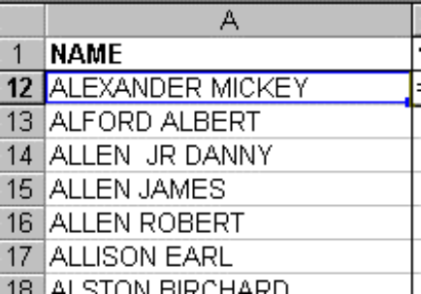

Find the first space
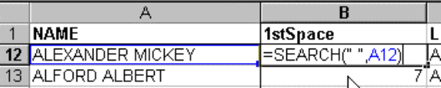

Get the Last Name:
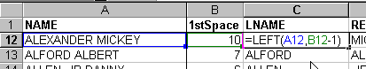

Get the rest of the name
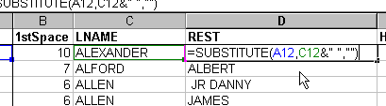

Check for suffixes by checking first character
This comes from looking through your data and understanding how it's structured. In our example, suffixes (including JR, III, etc.) are offset by an extra space after the last name. For instance, ALLEN JR DANNY has two spaces before the "JR". All of the names without a suffix have only one space between the last and first names.
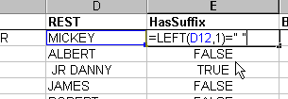
searches for two spaces within the quotation marks.

Find start position for first name:
The 2 at the end of the SEARCH function tells Excel to begin looking in the 2nd character of the string rather than the usual first.
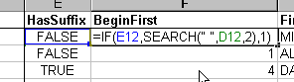

Extract the name:
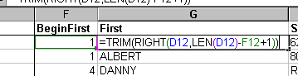

String function strategies
String functions are intimidating. They seem impossible to master. But you can get used to them by using some common strategies:
- Don't be afraid to add lots of columns to give you what you need. You can hide them later. Or you can copy your final result without formulas to a new spreadsheet. But it's easier to write short formulas than long ones.
- Keep your goal in mind. If you only care about family names, don't get upset if you can't make first names consistent. Only clean to the extent it's necessary to get the project done.
- Richard Mullins recommends the "divide and conquer" strategy. Keep picking away at a phrase, an address or a name by pulling out little pieces at a time until what's left is what you want.
- Try to find at least a little consistency in the data.
Some government agencies deliberately thwart any ability to work with names, especially when they combine company names with individual names in the same file with no indication of which record is which type.
You can often find some pattern that works most of the time. Use it. Then search for exceptions by sorting the data in different ways. Don't get frustrated if you can't find a bullet-proof pattern. There may not be one. You'll have to settle for getting most of them right. It's better than doing them all by hand.
- Get accustomed to working with the position of a character within a string or its length. It's the key element you'll need almost all of the time.
- Use all of the tools available to you. For example, word processors have much more sophisticated search-and-replace functions than spreadsheets do. FoxPro has much more powerful string functions than either Access or Excel. If you find yourself doing a lot of cleaning, consider learning these tools.

Excel Power functions 3: Dates and times

Understanding date and time values in Excel and Access is crucial to using their power. The applications are common in computer-assisted reporting:
- Calculating ages from dates of birth.
- Calculating the amount of time felons spend in prison.
- Calculating ambulance or fire department response times, even when a call comes in at 11:55 PM and is answered the next day at 12:05 AM.
- Figuring out whether domestic violence is more prevalent on weekends.

Understanding date and time
Dates are held in Excel, as they are in many modern computer programs, as numbers that reflect the number of days since Jan. 1, 1900.
(Note to Mac users: Your answers will differ slightly, since Excel for the Mac begins in 1904 instead. But it doesn't really matter which system you use. It only matters that it's internally consistent.)
This is a powerful way to think of dates. It means you can look at them any way you like, but you can always sort them correctly and you can do math on them.
Time is similar. A time is really just a fraction of a day.
In Excel, then, the date and time combination of March 3, 1998, 2:30 PM is really 35857.6041666667.
Don't worry. You can look at dates any way you want using a format.
The formats work just the way the more familiar percentage and currency formats work for you all the time. You just need codes to tell Excel how to present them:
Here's how Excel presents that same date and time combination once you supply the format:
mmm d, yyyy | Mar 3, 1998
mmmm d, yy | March 3, 98
dddd, mmmm d | Tuesday, March 3
ddd h:mm AM/PM | Tue 2:30 PM
h:mm AM/PM | 2:30 PM
h:mm | 14:30
yyyymmdd | 19980303
To give Excel a format, select the cells and then choose the menu item, Format, Cells, Number. Choose Custom and type the code representing the format into the box:
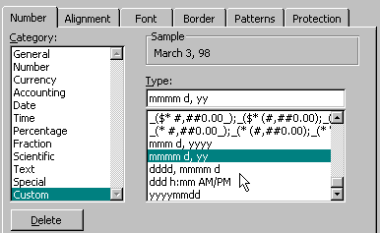

Converting data to dates and times
Depending on how your data starts out, you'll probably use one of two methods to convert data to dates:
DATEVALUE(string) converts something that Excel recognizes as a date to a date value.
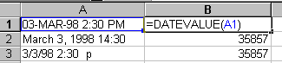
=TIMEVALUE works the same way:
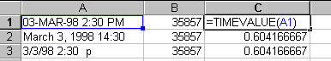
Then you can add together the date and time to get the full figure. This is most useful when you're working with response times for ambulances.
=DATE(Year, Month, Day) only works if you have your months in numbers rather than words.

Extracting information from dates and times
You'll use a variety of functions to work with dates and times. The most common are:
INT(datetime): Extracts only the date portion of the figure by pulling out the integer.
MOD(datetime,1): This extracts everything to the right of the decimal place by asking for the remainder of the value from 1.
WEEKDAY(datetime, type): Tells you what day of the week it is. If you leave type out, it will begin with Sunday as 1 through Saturday as 7. If you use 2 as a type, it will start with Monday instead. This is useful when you want to check for weekends.
DATEDIF(Date1, Date2, Type): Useful for calculating ages. It gives you the difference between two dates in whatever unit of measure you specify for Type. "y" expresses the difference in years, "m" in months, "ym" as the number of months since the last full year, etc.
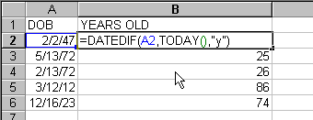
It knows not to round up to the next year old even when the birthday is coming up.

