Getting around Excel
Sarah Cohen, IRE and NICAR, sarah@nicar.org

Excel, like other spreadsheets, is used by reporters to make the same computations over and over again on a whole bunch of numbers.
It lets you sort small lists in different ways, produce lists for publication, clean up files you find on the Internet and organize virtually anything that come in list form, including notes and chronologies.
Some reporters bristle at typing in, say, 30 numbers into a spreadsheet. You shouldn’t. If you want to calculate the numbers by hand, you’ll end up typing them into a calculator far more times.

The Excel grid - cell addresses
When you first start up Excel, here’s how it looks. Across the top are letters, and down the side are numbers.
Just like on a map, you refer to each square or cell by its intersection of column and row:
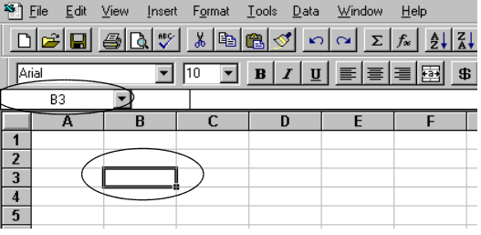
B3 is the cell that’s currently active. You can tell because its address is shown on the upper left corner, and the cell itself is outlined with a black border, which has a little knob on the lower right corner.

Excel mouse shapes
Here are the four main mouse shapes you’ll see:
- The Big Fat White Plus Sign, or BFWPS:
You can never get into trouble with this symbol. Whenever you see it, you can select a cell or a group of cells.
- The Copy Tool, or the thin cross:
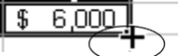
When you see this, you’ll copy anything that’s selected in whichever direction you drag. This can be good or bad. Normally, you only copy formulas.
- The Evil Arrow:
This will actually move whatever you have selected, sometimes directly on top of something else. Don’t use this most of the time.
- The Column- and Row-adjuster
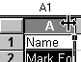
You’ll only see this when your mouse is hovering in the gray, title, area of either a row or column. It widens or narrows a column, or lengthens or shortens a row.

Selecting cells
Excel acts on cells you have selected.
If you begin typing, you’ll start entering information into the currently selected cell, even if there’s already something in it. Use the BFWPS when selecting, or you might wreck your spreadsheet:

To select a cell:
Hover the BFWPS over the cell you want to select, and click once on the left mouse button. Until you become accustomed to the screen, check the formula bar to make sure you’ve selected what you thought you did. You’ll get used to it after a while, and won’t have to check anymore:
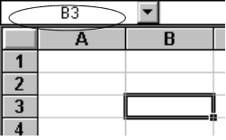
B3 is selected.

To select a group of cells and act on them all at once:
Hover the BFWPS over one corner. Click once and drag to the diagonal corner.
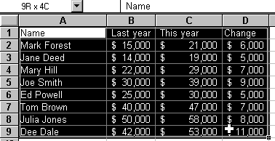
The entire area will be shaded in, except the cell that’s currently active. That cell will still look normal. It’s the one that you would type over if you began typing now.
(While you’re selecting, Excel will momentarily show you how many rows and columns you’ve selected, as in the 9R x 4C above. When you stop, it will show you the currently selected cell address (A1) again).
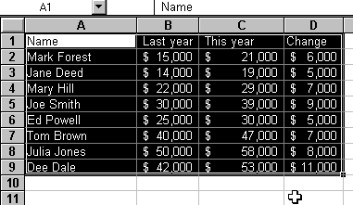
To select an entire column:
Hover your BFWPS over the title letter of the column and click once on the left mouse button

To select an entire row:
Hover your BFWPS over the title row number (all the way on the left), and click once. The title row number and the line will be highlighted:
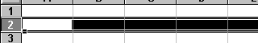

Entering data
Select the cell you want to enter data in, and start typing. Then lock in entry by
- Pressing the Enter key
- Selecting a different cell with the mouse, or
- Using the arrow keys on your keyboard to exit the cell.
You can’t do a lot of things while Excel thinks you’re in the process of typing.
Excel gives you some visual clues that you’re in the process of typing:
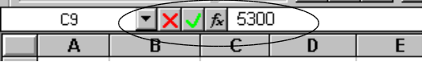
If you see these symbols in your formula bar, Excel thinks you’re editing.

Entering words
Just type them.
Don’t worry if the cell isn’t wide enough to show your entire entry. It might look cut off, or it might spill over into the adjacent cell. Your formula bar shows what you’ve actually typed.
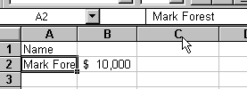

Entering numbers
Type numbers without any dollar signs or commas.
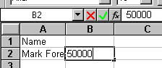
Although Excel is pretty forgiving if you forget, it’s a good habit to get in to. Other software programs may not recognize numbers that contain these special characters. They’ll think they’re words.
Don’t worry if the number appears as a bunch of hashmarks (#):
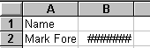
Excel is saying, “I don’t have enough room to show you all of the digits you’ve requested. I can’t figure out whether to chop off the first or the last. So I’ll show you garbage instead.” You’ll widen the column to show all the digits. Again, your formula bar will show you what you’ve typed.
If it’s a very big or very small number, you might see something like this instead:
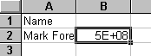
because scientific notation takes up lots less space. Again, don’t worry. You can fix this later.

Fixing mistakes
Start over while you’re editing:
If you realize halfway through that you made a mistake and want to start over, press the Esc key on your keyboard (usually in the upper left corner). This will take you out of editing mode without locking in your change.
Correct a few characters:
Press the Backspace key (not the left-arrow key) on your keyboard to wipe out the characters or numbers to the left of your cursor. Press the Del key to wipe out characters to the right of your cursor.
Correct an entry after you’ve locked it in
Select the cell with the mistake.
To retype it, just start typing. Excel will start you over.
If you just want to correct a few characters, press the F2 key on your keyboard (at the very top), or click in the formula bar where the mistake is:
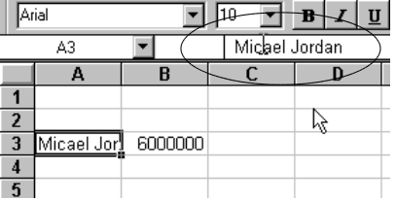

Changing column widths
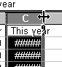As with most things in Excel, there are a number of ways to change a column width. One is to use mouse to drag the border where you want it:

Inserting columns and rows
To insert a blank column in your spreadsheet and adjust all of your formulas, select the column to the right of the one you want. Then use the Insert, Columns menu item to move everything to the right:
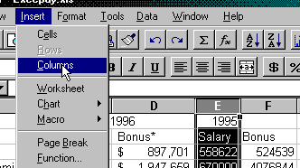
Insert a row by selecting the row below your new one, and use the same menu item, inserting Rows instead.

Deleting columns and rows
To delete a column, select it, then select the menu item, Edit, Delete.
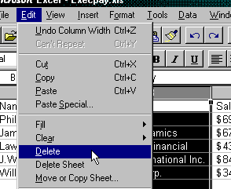
This isn’t the same thing as pressing the Del key, and isn’t the same thing as using the menu item Edit, Clear. Use the same process to delete a row after selecting it.

Locking in headings
As your spreadsheets grow, you’ll want to see the first row or two whenever you page through your data, preserving their headings. The same thing happens as you create more and more columns – You’ll want to see a column to show you what’s in each row.
Select the cell immediately below the row you want to lock in. Select the cell immediately to the right of the column you want to lock in. So for a combination, you’d select cell B2 to lock down row 1 and column A.
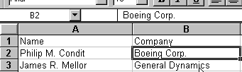
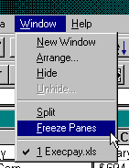
Choose the menu item Window, Freeze Panes to lock in the headings.
Choose it again to un-freeze the panes and start over if you need to.

Tips and traps
Slow down!
Pressing lots of buttons as you try to recover will often just get you into more trouble. So will repeating your last mistake. Try to take your hands off the mouse and the keyboard, and think about what’s gone wrong.
Type any totals you know
You’ll learn how to calculate totals automatically. But sometimes it’s easier to check totals than every individual entry. So use any information your sources have given you as an easy check on your data entry.
Type short titles directly above your data
Keeping the titles short means you never have to widen a column just to find out what it is. Keeping titles in the cell directly above the data means Excel will recognize them as titles in later work:
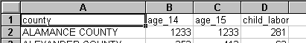
Make numbers easier to read
You can format numbers in literally dozens of ways. Two of the most common are: Comma Format, and Currency Format. Excel provides buttons for you to use:
Comma (the , symbol) puts commas in between the thousands, making pure numbers easier to see. It often also adds two decimal points. Get rid of them by selecting the cells with the extra decimal points, and pressing the button with an arrow pointing to one .0 above.
Same with dollar (the $ symbol).
Having trouble with the mouse? Use the keyboard.
Some people find all this clicking annoying, difficult or just plain slow. Get to know keyboard shortcuts instead. We don’t have room to go through all of them, but go into Excel’s Help system, and in the Index look for “Keyboard shortcuts.”

