The power of excel: Formulas
Sarah Cohen, IRE and NICAR, sarah@nicar.org

Excel’s power comes from its ability to let you use data you’ve entered once by simply referring to its location on the spreadsheet, not its value.
You’ll do this by entering formulas and copying them. Get good at this, and you’ll rarely have to calculate anything by hand again.

Entering a formula: The = sign
To enter a formula, announce to Excel that one is about to come with the equal sign. The easiest formulas are simple arithmetic:
+ is plus / is divided by
- is minus * is times (multiplication)
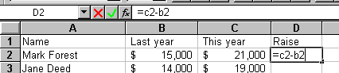
Press Enter to lock in the formula:
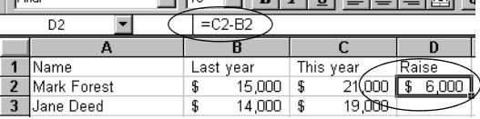
The formula is still in the cell, but you see the answer.
Notice that you type the cell address (c2) not the value ($21,000) to create the formula. That means if you change the original value, the calculation will change also. That’s because Excel doesn’t care what number it uses, only its location on the spreadsheet:
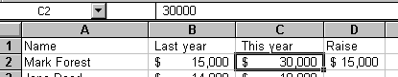

Copying a formula
Not only will Excel help you when you find a mistake. Its biggest power is to repeat your instructions hundreds of times.
First select the cell you want to copy. Now:
- Drag with the copy tool. Make sure you haven’t got the Evil Arrow instead.
or
- 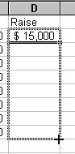Double-click on the copy tool (if the column to the left is filled out)
or
- Copy using the menu or one of many keyboard shortcuts, then paste using the same

Note the reason this works: Excel looks at your original formula, and says, “Hey – you’re going down a row. I bet you want me to adjust the formula so it refers to the row below the one you started on.”

This also works going across. Instead of changing the row element (the number), Excel adjusts the column element (the letter.)

The percent change
Reporters think Excel will calculate percent changes automatically. It won’t. But you’ll only have to remember how to make one once. Excel will copy that formula for you over and over.
Get it down now:
Percent change = (new - old) / old
We usually compute the difference (new - old) anyway, so it’s often just:
Percent change = difference / original value:
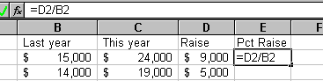
After locking in the formula and copying:
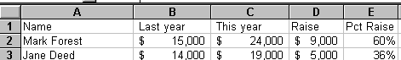

Totals, averages and medians
Excel recognizes that you often want to summarize data. It has about 500 built-in ways to work with information you’ve entered.
Most of those you’ll use at first are simple summary functions for totaling (summing) or averaging of some kind. You tell Excel to calculate a function over a range of cells:
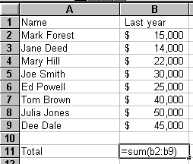
=SUM(start:end)
says, Sum everything beginning with the cell I say is the start (say, B2) through (the colon) ending at the end, (say, B9).
You can also use:
=average(start:finish)
=median(start:finish)
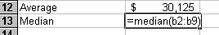
After selecting all three summary statistics, and copying them to the right:
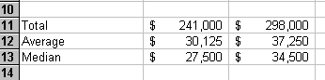

Anchoring totals: Percent of total
Sometimes you don’t want Excel to adjust formulas for you. Consider the formula for a “percent of total”:
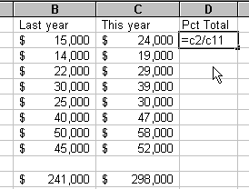
When you copy, this is what happens:
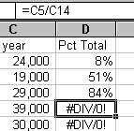
because Excel has adjusted both the numerator and the denominator:
Anchor the denominators with stick-pins you make with dollar signs:
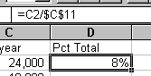
Now it will copy correctly.

Frequently asked questions

Excel won’t let me copy my formula.
Lock in the formula first by pressing the Enter key, or selecting any other formula. Select it again, and then copy.

I want to use the sum button instead.
Go ahead. But check what it does carefully. Typing in the formula is safer.

Should I use the average or median?
It depends. Averages are easier to explain. But when they’re very different, you’re probably safer to use the median. Medians are almost always used for salaries, home prices and other values measured in dollars.

My percents look like small numbers with decimal points
They’re probably not formatted as percentages. Select the numbers and click the % button on your toolbar.

