This is my entry for Dephy's Software/Controls Engineer Design Challenge

In the challenge, a subject walks 6 steps forward with a sensor containing a 3 axis accelerometer and a 3 axis gyroscope on their foot. I am given 2 .csv files (walkData1.csv and walkData2.csv) containing the sensor output for two trials.

The challenge was to identify the start of gait cycle, along with each phase as a bonus, using the data in real time.

My approach began by downloading the data and analysing each input in excel. Using the Y-Gyroscope, I was able to identify the portions of the gait where the foot is on and off the ground. The Y-Gyroscope shows the forward and backward rotation of the foot, so I compared the data in the figure below with my own walking.

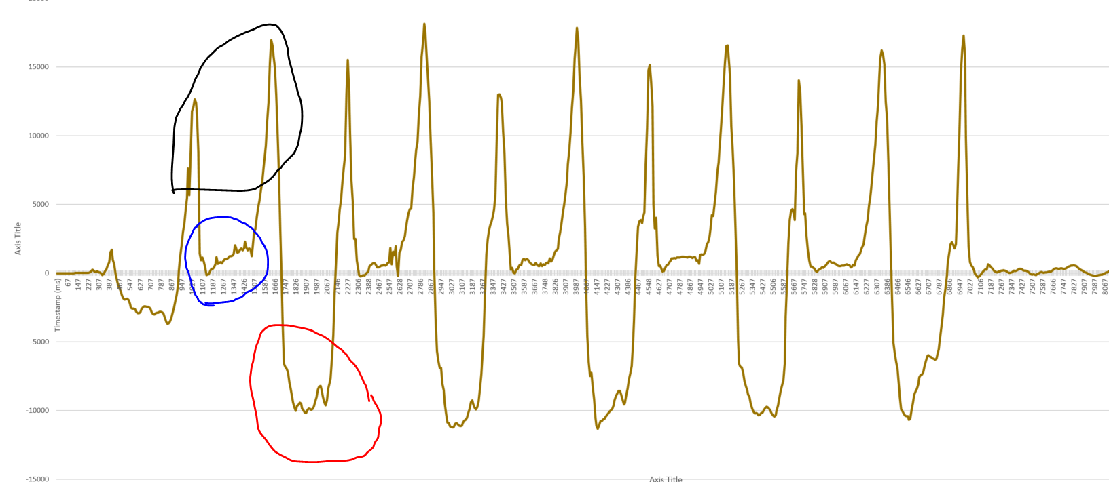

The blue circle shows a flat portion of the data, where the foot is flat on the ground and not rotating at all, and the red circle shows a longer period of acceleration which I identified as the swing. The two sharp spikes circled in black show fast rotation as the heel lands and the toe pushes off.

I then identified each of the 6 phases of the gait cycle and noted characteristics of them so I could identify them from the data. At this point I decided to only use data from the X-Accelerometer, Z-Accelerometer, and Y-Gyroscope.

In my identification of each phase I used a set of constants in “gaitcycle.h” to define when inputs were considered to be high, low, or in certain ranges. Analysis was done based on my observations described on the next page, and displayed using qt, which I learned to use for this challenge as I haven’t used it before.

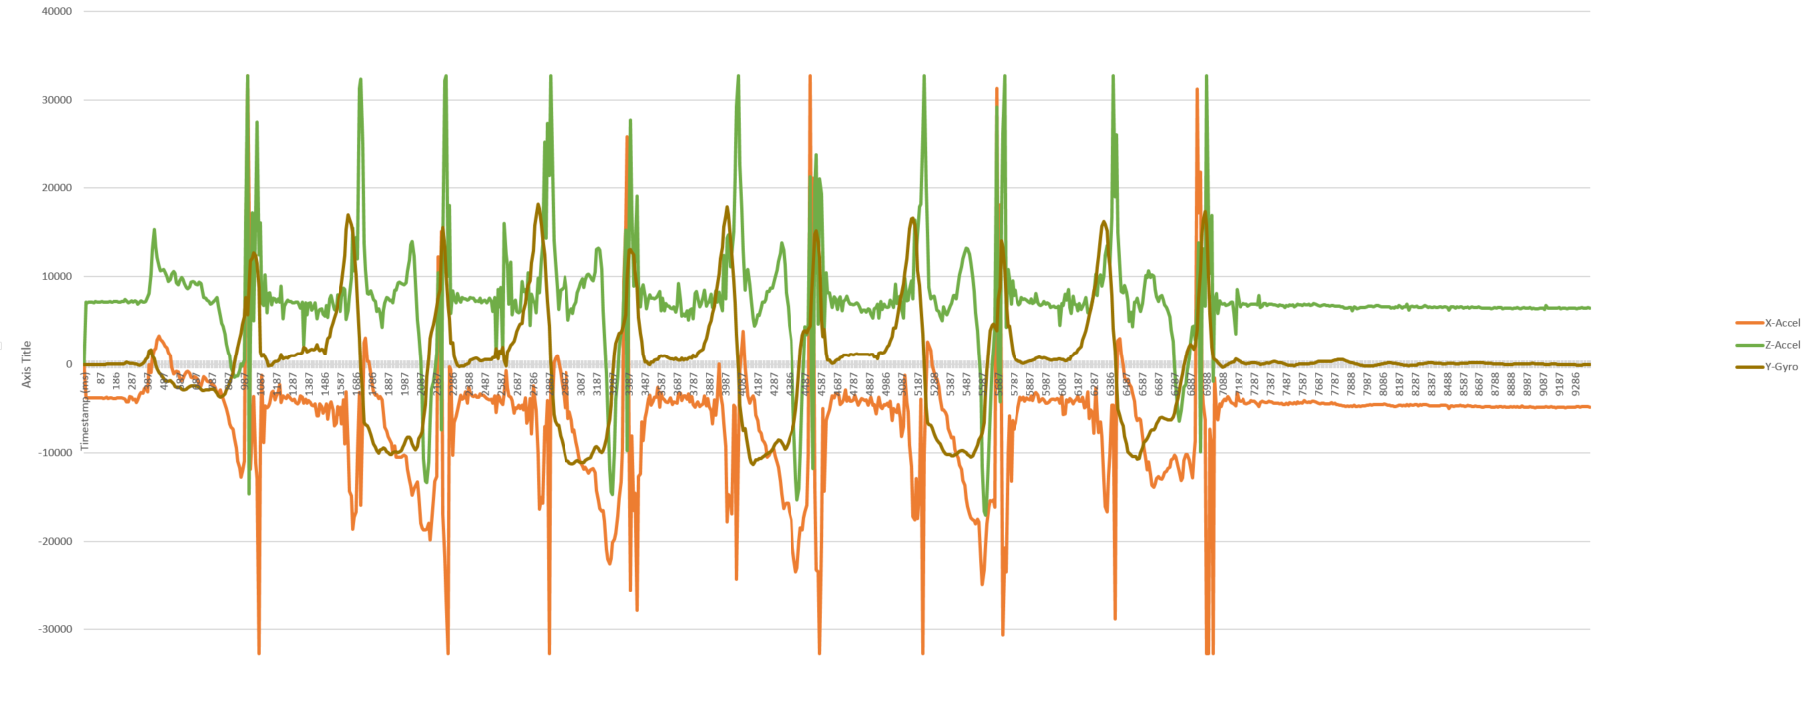

**Heel Strike**

My first observation of the heel strike is that it is the only part of the cycle where x-accel jumps to a large positive number, so this is my main identifier. To supplement this, I also noted that y-gyro jumps high, and that z-accel jumps both very high and very low. Therefore, I identified a heel strike when all 4 of these conditions are met within a small timeframe of each other.

**Foot Flat.**

I identified foot flat as the beginning of the region where all three inputs stay relatively constant within a range. To find when the inputs are in this region, I track when successive data values are inside the respective ranges of each input for a minimum period of time to avoid identifying times when the inputs simply pass through the region. In addition to this, I added the constraint that y-gyro was recently high so that only the beginning of the flat region is identified as foot flat.

**Mid Stance**

I identified mid stance as being in the middle of the flat regions. I used the same technique as for foot flat to check how long the inputs have been in their ranges, but increasing how long they have to have been in the range for. I also added a maximum time period to avoid flagging the extra data at the end.

**Heel off**

I identified heel off as the second large spike in the cycle, where z-accel and y-gyro spike high and x-accel spikes low. I used these triggers to identify the heel off phase, but to differentiate it from the heel strike phase I added the constraints that x-accel and z-accel cannot have recently spiked high and low respectively.

**Toe off**

I identified toe off as there start of the swing, where the inputs come down from their spikes and y-gyro comes to the characteristic low portion of its cycle. To identify this in the code, I check whether Y was low. In addition to this, I added that z-accel and y-gyro had to recently be high in order to target where the spike ends and the swing begins.

**Mid swing**

I identified mid swing as the part of the swing region where z-accel has a spike. To find this, I checked for when z-accel was moderately low (a bit below the spike) but was decreasing from a “moderately high” value (a bit higher, but still below the spike). Since this happens often in the cycle, I narrowed it down by saying z-accel could not have recently been very high and that y-gyro had to be in its low area at the time.

Here are the results of each csv file:

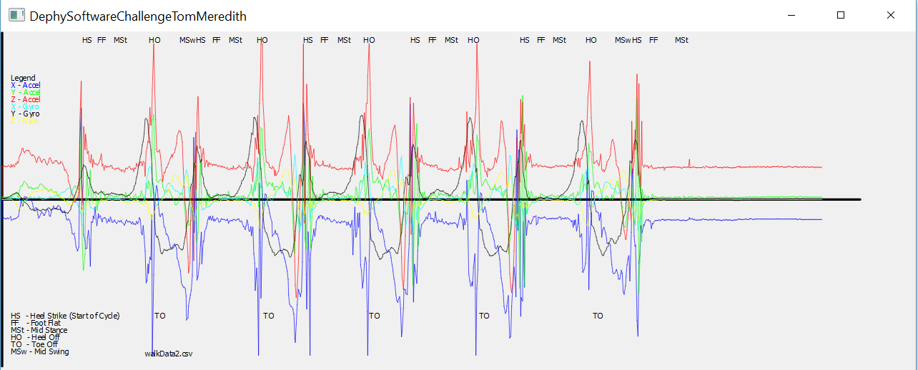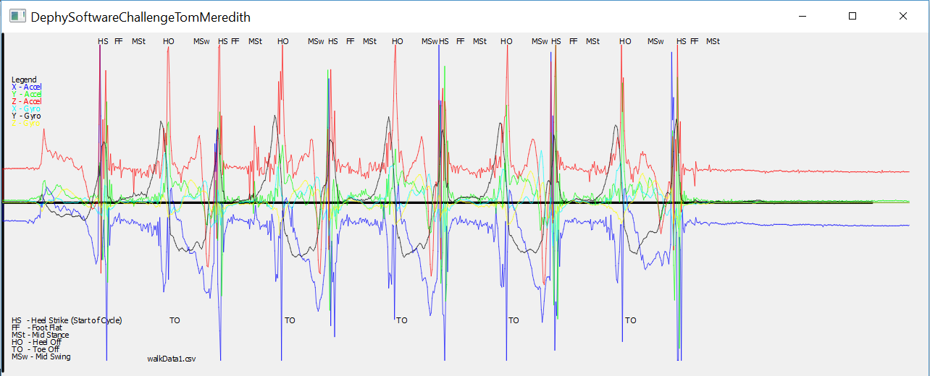

**References**

For using qt, I had the help of these pages so that I could simply draw the data and write text to note when phases were hit:

<http://doc.qt.io/qt-5/qtwidgets-painting-basicdrawing-example.html>

<http://stackoverflow.com/questions/24672146/qpainter-draw-line>

For learning about gait phases, I used the data provided in csv files, my own walking, and these pages to learn the terminology:

<https://en.wikipedia.org/wiki/Bipedal_gait_cycle>

<http://www.physio-pedia.com/Gait>