1- Activate Window

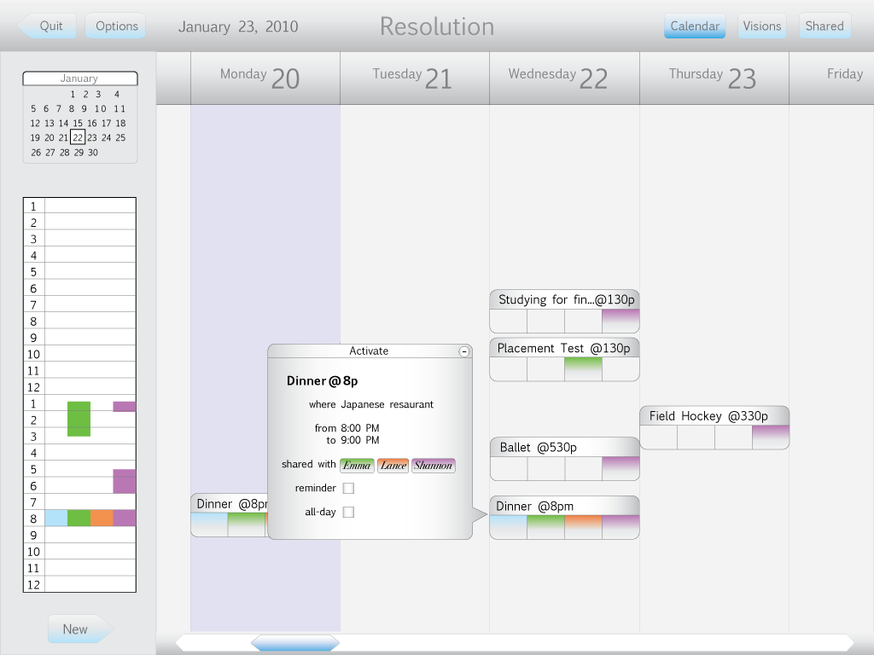

I removed several options from Activate (fig. 1), so it’s really just an organizer window now. The activity icons are bars. There is a space for each family member participating in the activity. There is a window on the left that gives an overview of the day. The activities are organized by time, but are placed randomly in the day otherwise. The Activate window is much smaller now.
Figure 1

2- Reflect Window

The Reflect Window (fig. 2) is now really simple. A double ball (with the options, Great, Good, Boring, Bad, and Awful) allow you to rate the activity. The double ball illustrates the text rating:

The lowest box below asks why the rating is given, allowing 200 characters for a response.

When one family member fills in the Reflect box, all other family members will be notified via the Notices window on the menu bar (fig.3).

5 - Visions List (3)

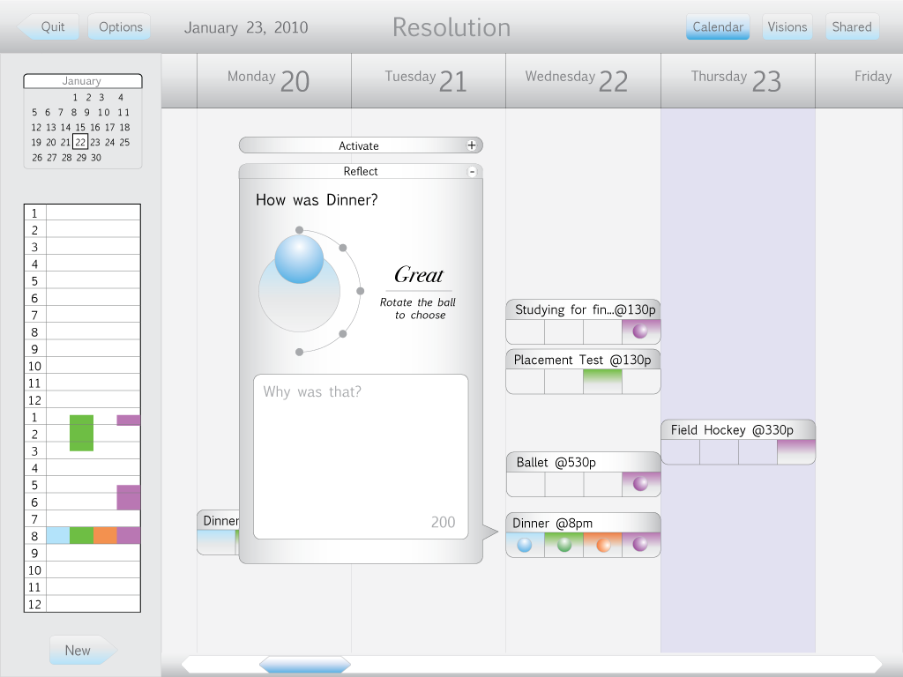
When the user presses Visions, (s)he can choose one of three to follow. Launch trends in the same activities. Remix gives the user an overview of commonly written words in ratings, and the option to use these words to compose stories, poems, ect. Spin is a guessing game that asks the user to figure out which rating quote was said by a certain family member.
Figure 2

6 - Launch

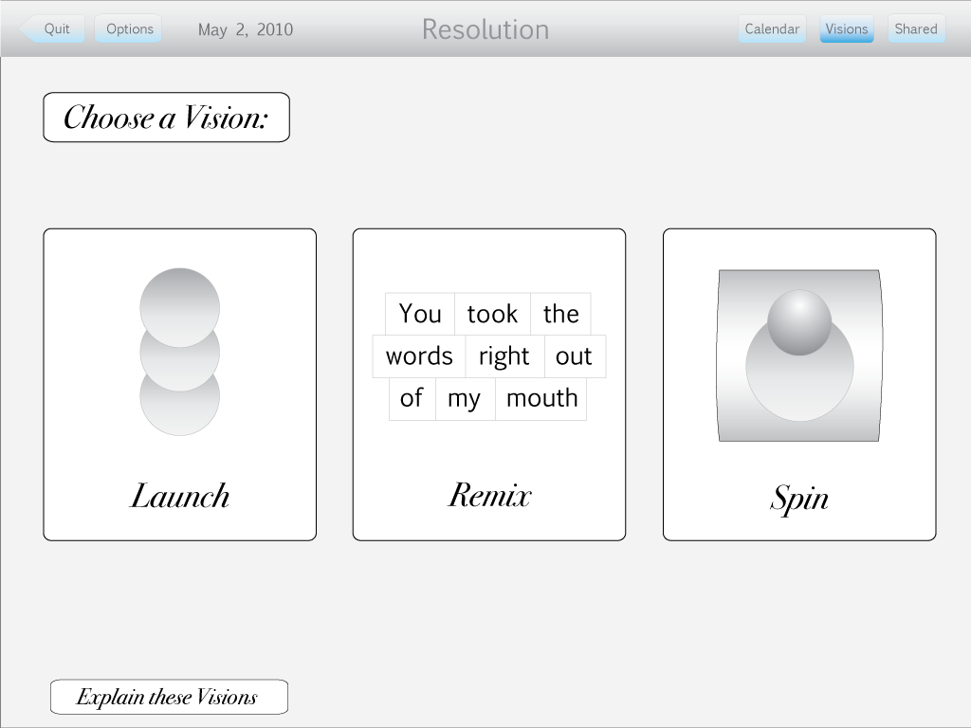
User chooses Launch, is taken to the calendar, and asked to type any activity, or choose from a list of the most common ones (fig. 4). The next window shows the five activity ratings and a small ball at the bottom of the screen (5). Pressing the ball will make it fly up, and it will separate into the ratings for each family member inside it. For example, a family dinner was rated great by Leroy, good by Emma, boing by Lance, and bad by Shannon. When the grey ball gets launched up, it splits into four balls, and they all get attached to the big grey balls (6). When a lot of balls have been launched, it the colored ratings are attached in circles (7). Clicking on one of the colored balls will bring up the text written in the reflect box. (8).
Figure 3

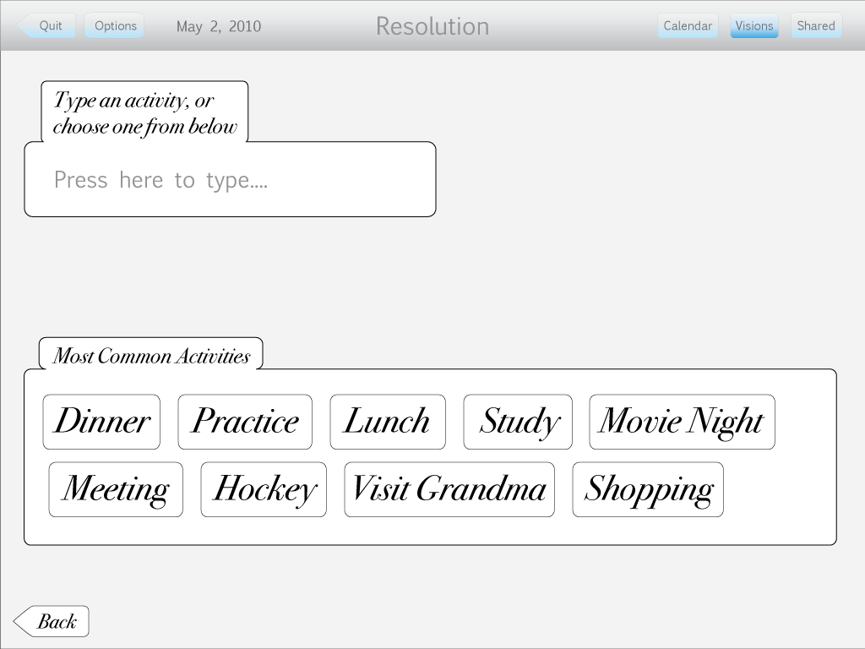
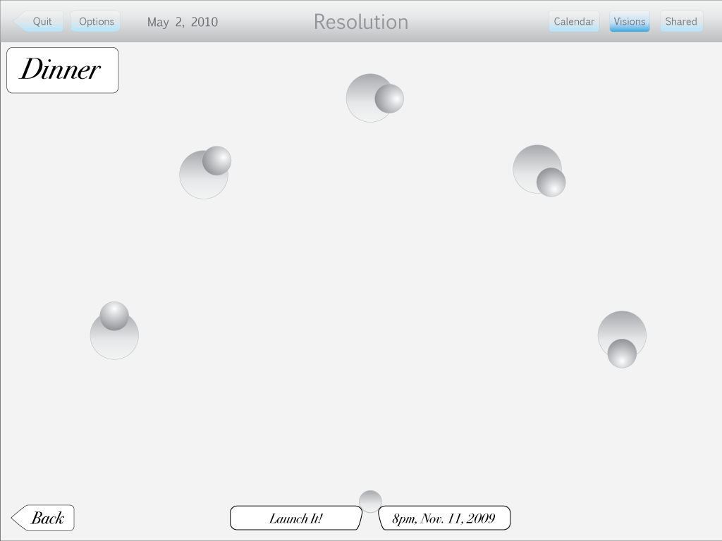
Figure 4
Figure 5

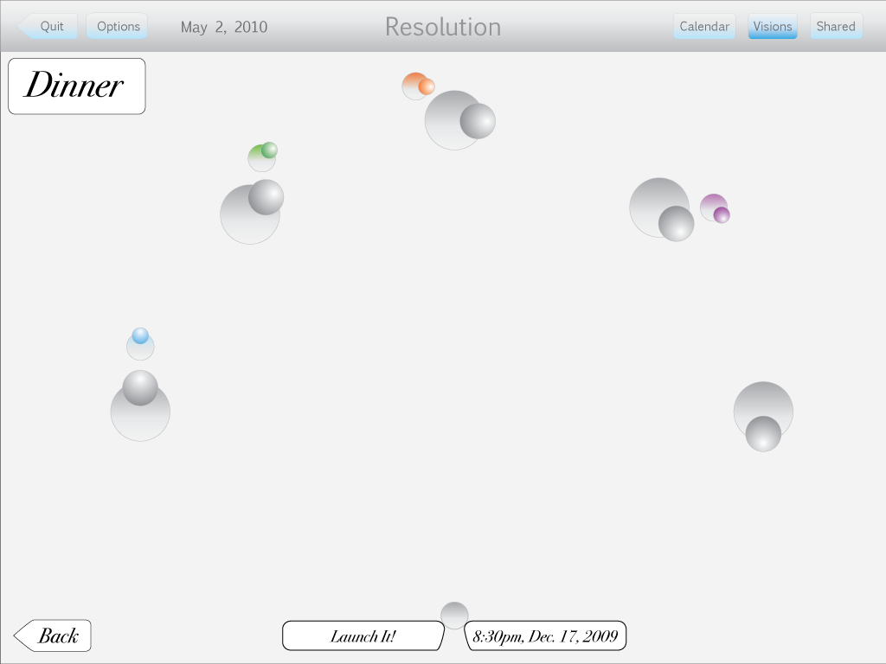
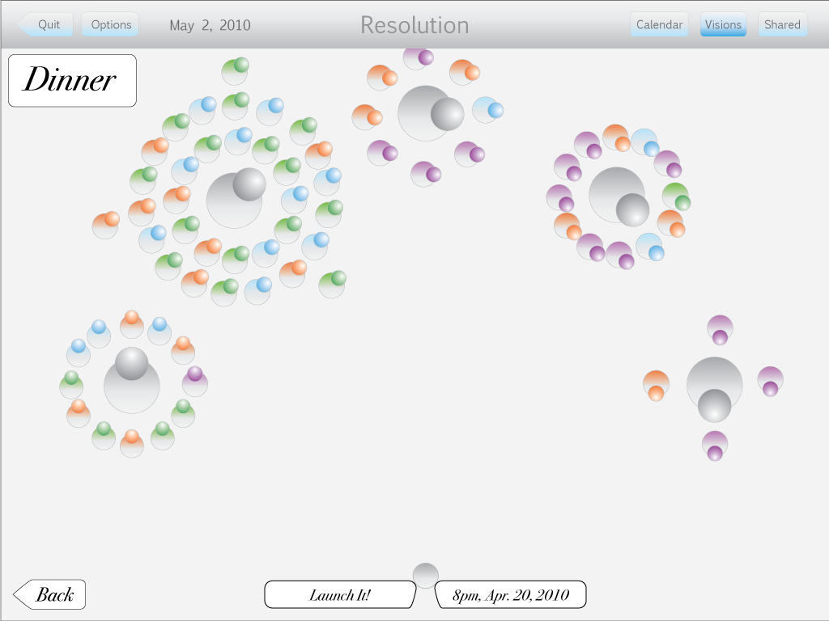
Figure 6
Figure 7

7- Remix

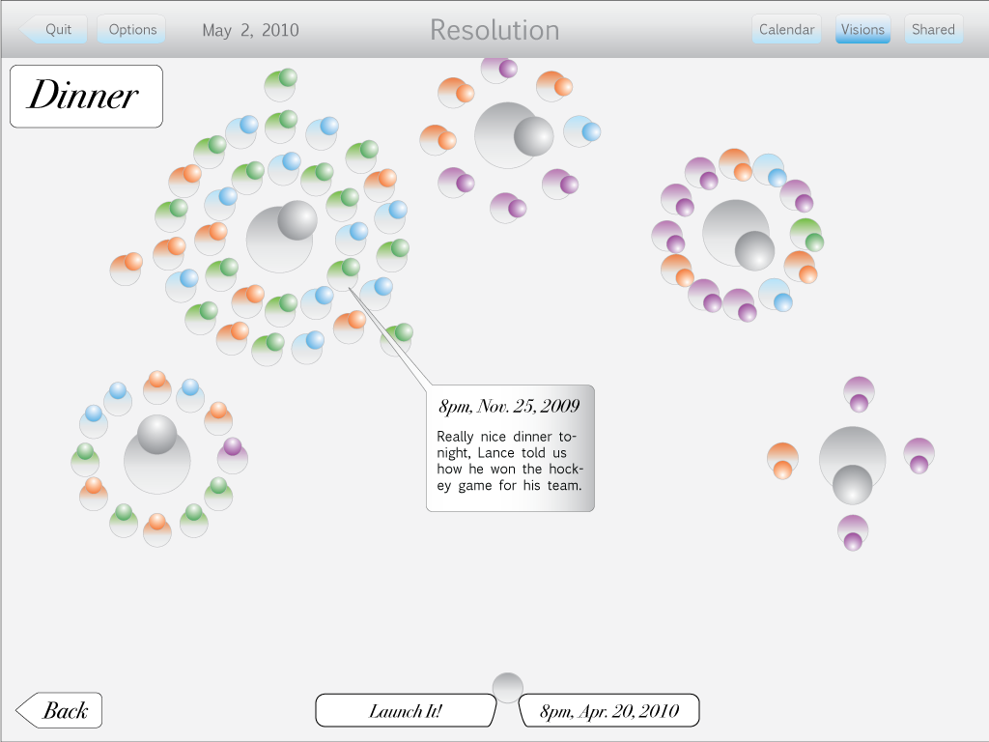
Remix is about taking the words of another family member (or you) from overall activity ratings, and combine them with your own voice. User chooses a family member to focus on (9), and a rating (10). The most used words (in the Why Was That? box) for that person and rating are then displayed (11). Pressing Mix It! (11) will scatter the words in another box (12). The user can then compose his/her own writing pieces (13). Clicking Share This Remix will present it for other family members to see.
Figure 8

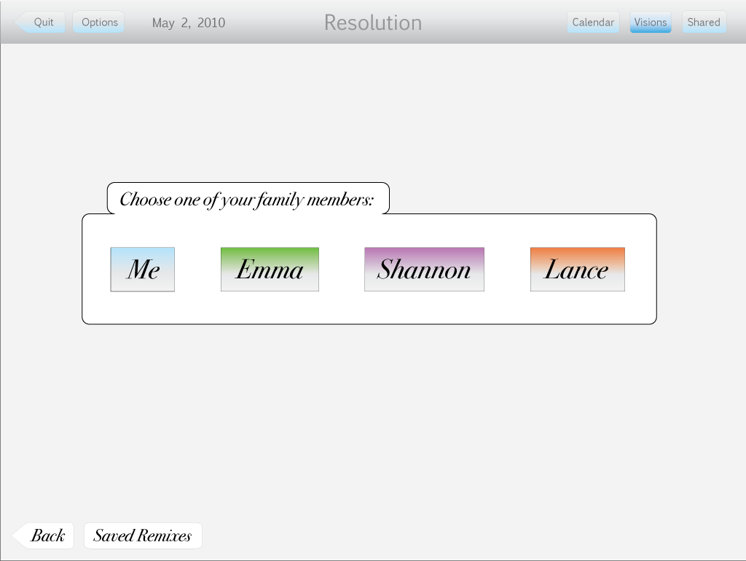
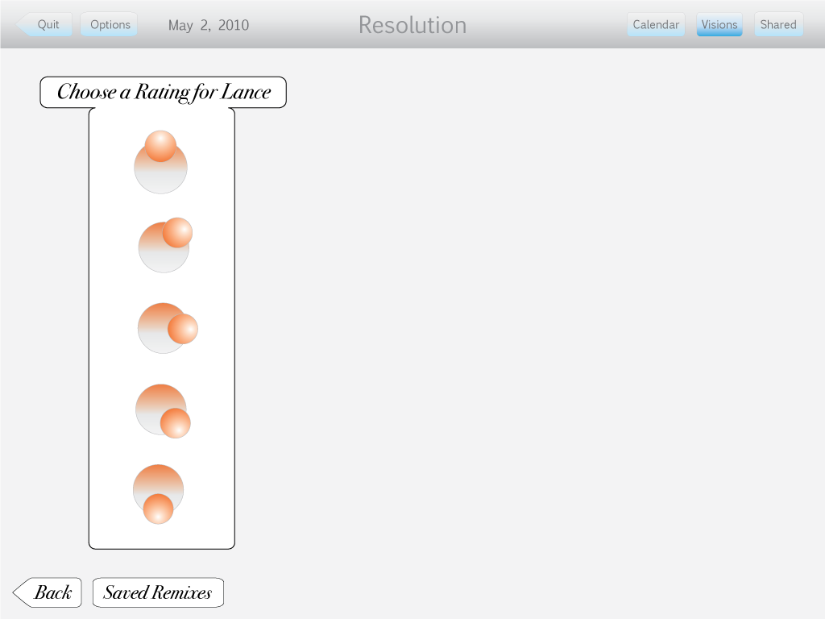
Figure 9
Figure 10

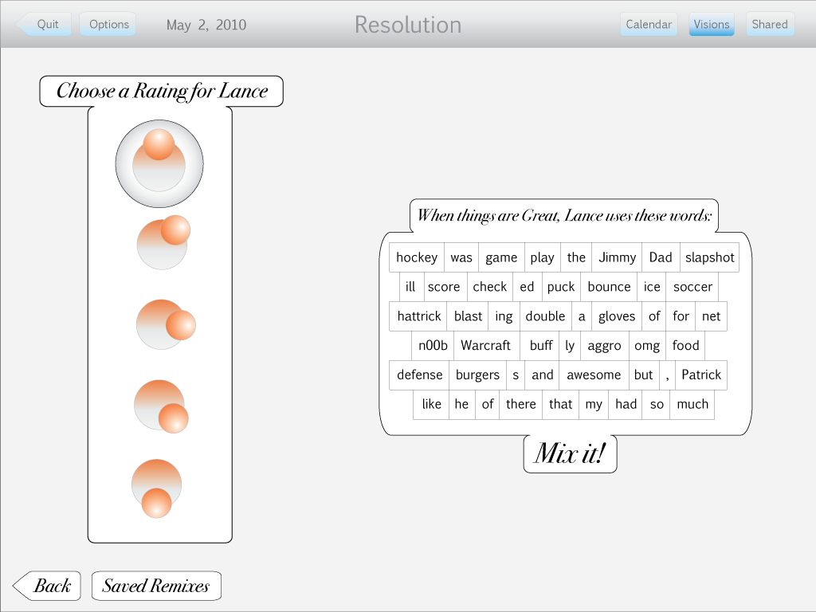
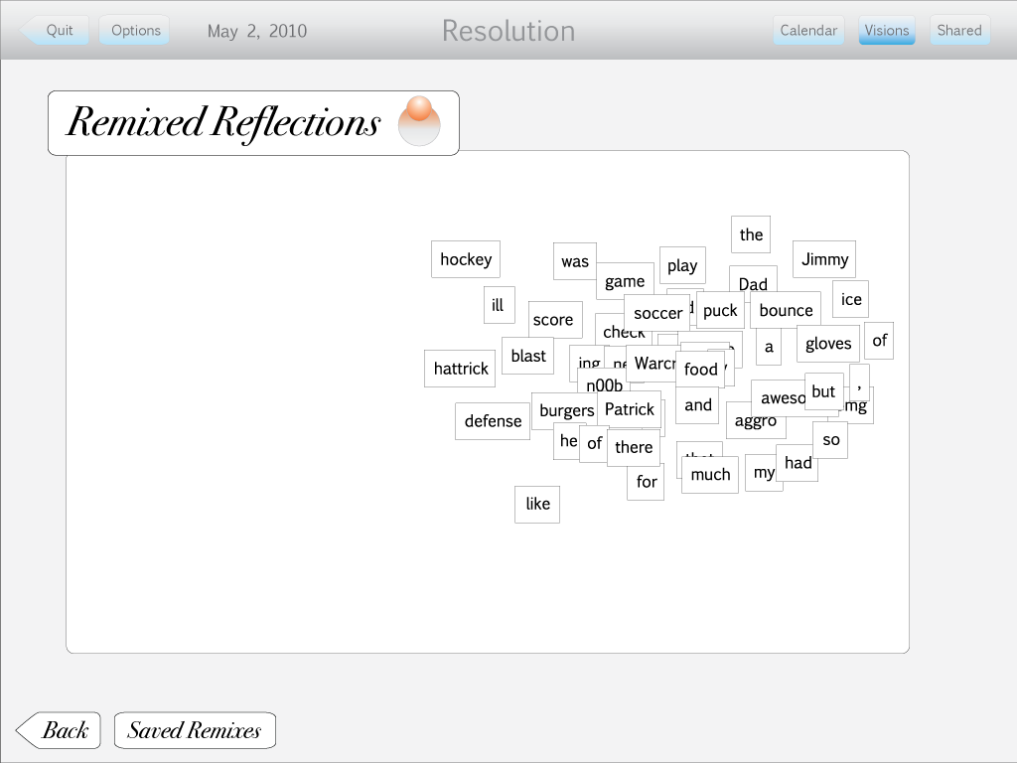
Figure 11
Figure 12

8 - Hunch

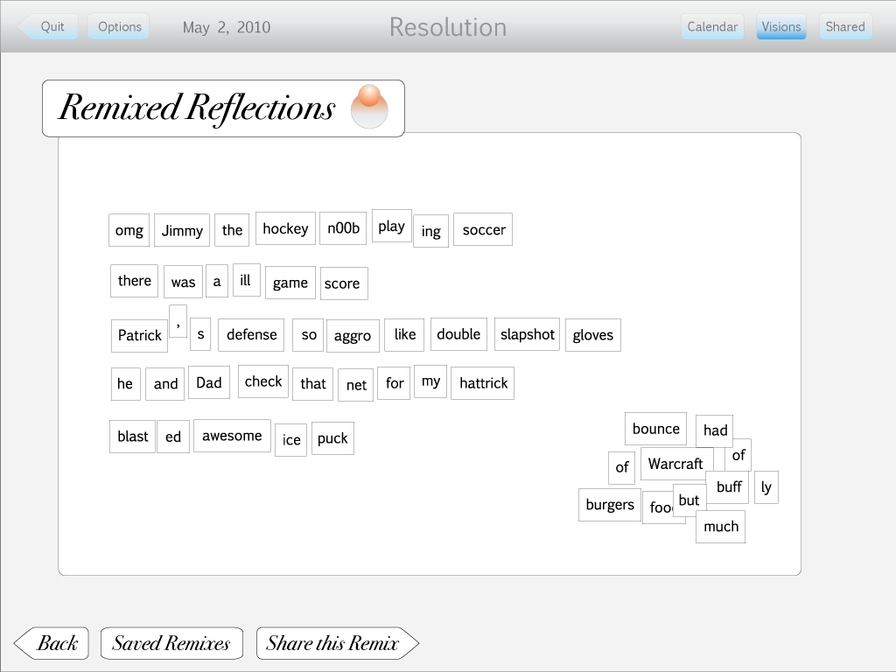
Hunch begins with the user spinning a rolling bar (14). The next screen shows the same roll bar displaying a random rating, or text from a random reflect box (15). The user must choose the right answer (16). If user gets it correct, (s)he gets a point. If the user chooses the wrong answer, the game is over (17). Pressing the High Scores button shows the High Score window (18).
Figure 13

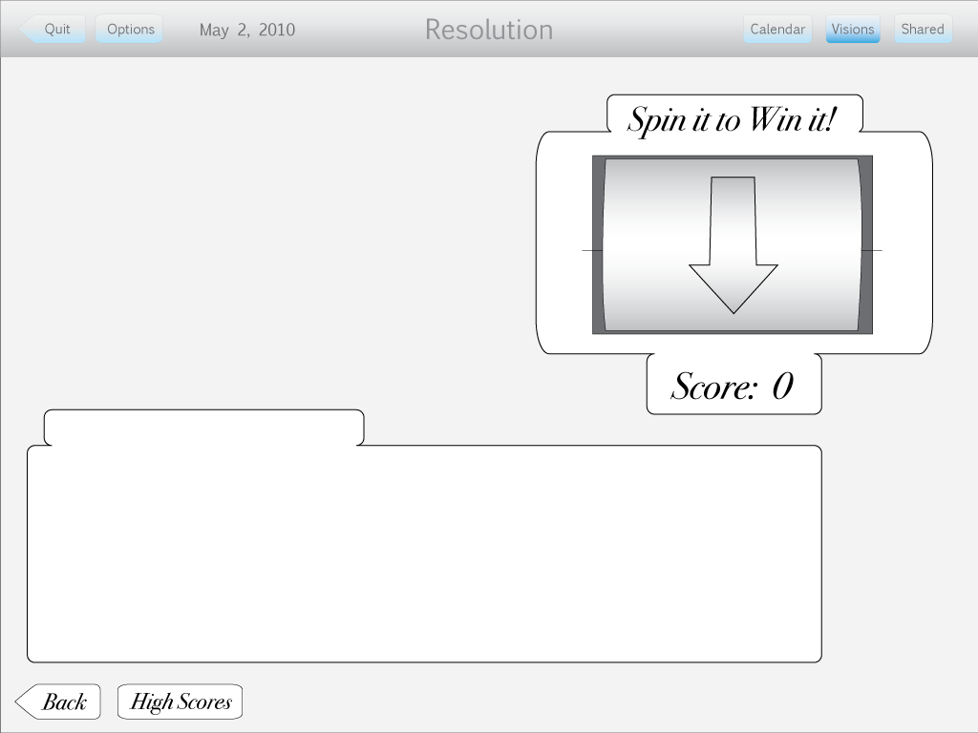
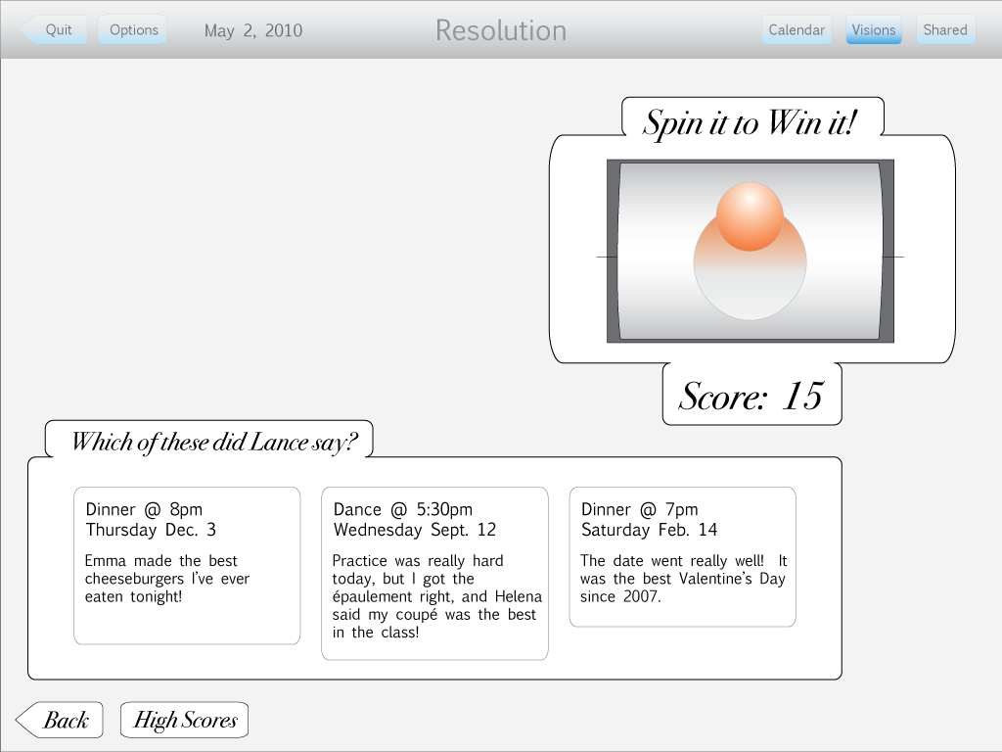
Figure 15
Figure 14

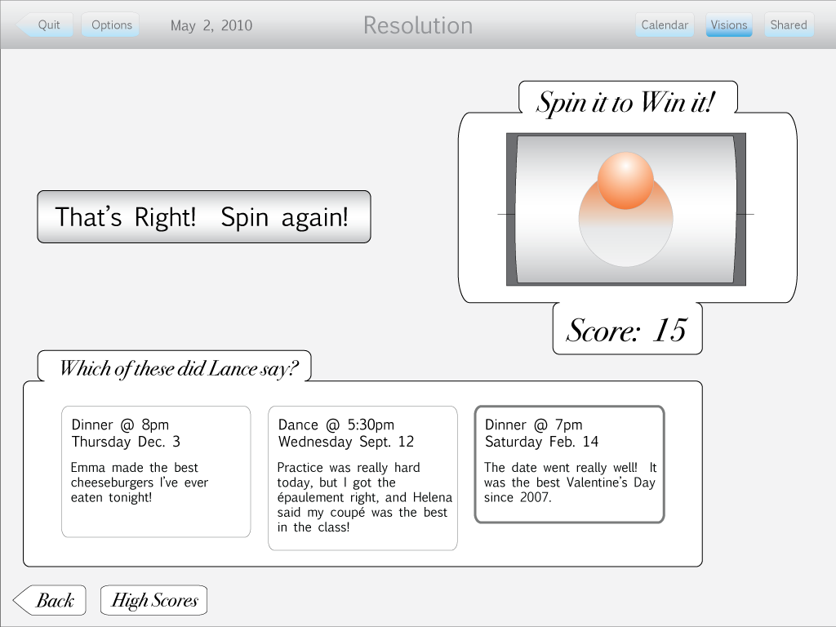
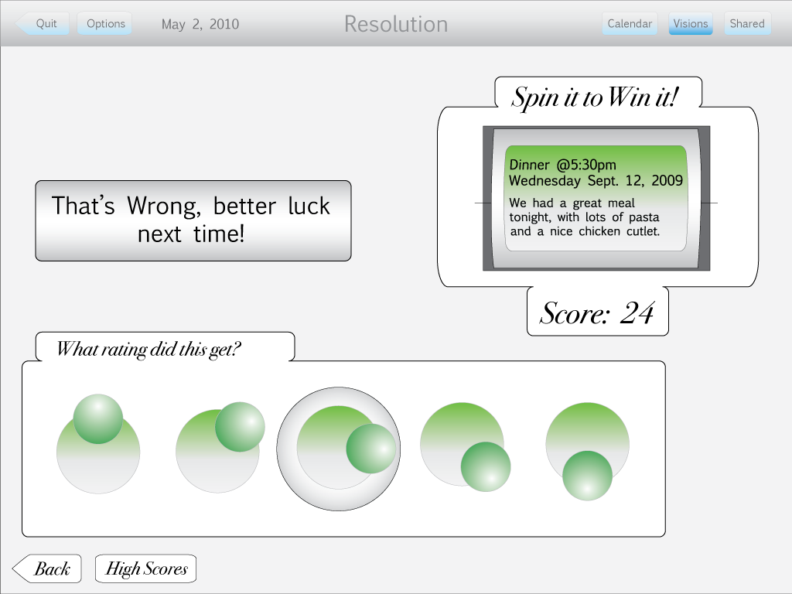
Figure 16
Figure 17

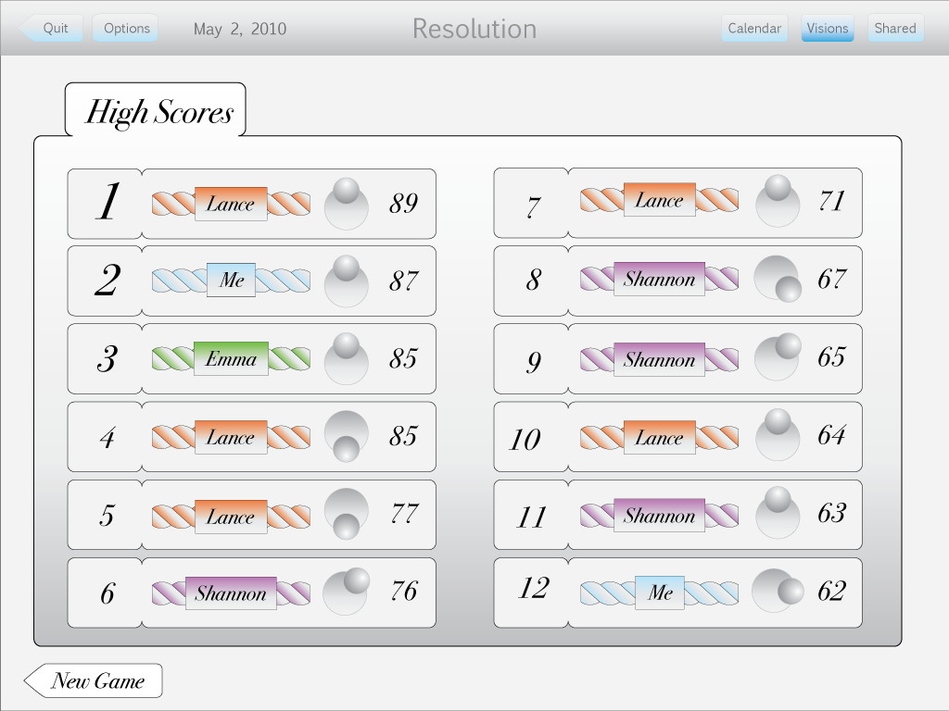
Figure 18

