Game 1 - Launch

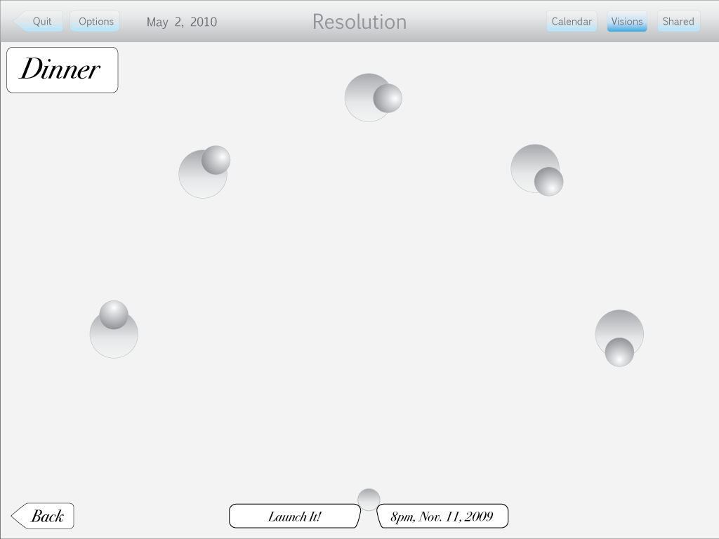
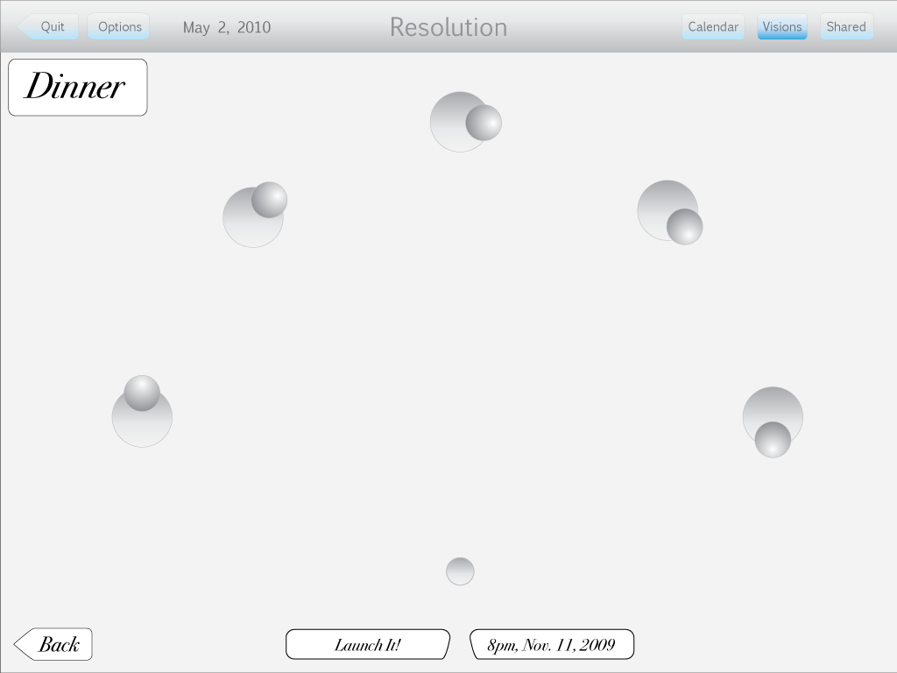
Screen 1 - grey ball at bottom of screen

Screen 2 - grey ball begins to rise

Screen 3 - ball keeps rising

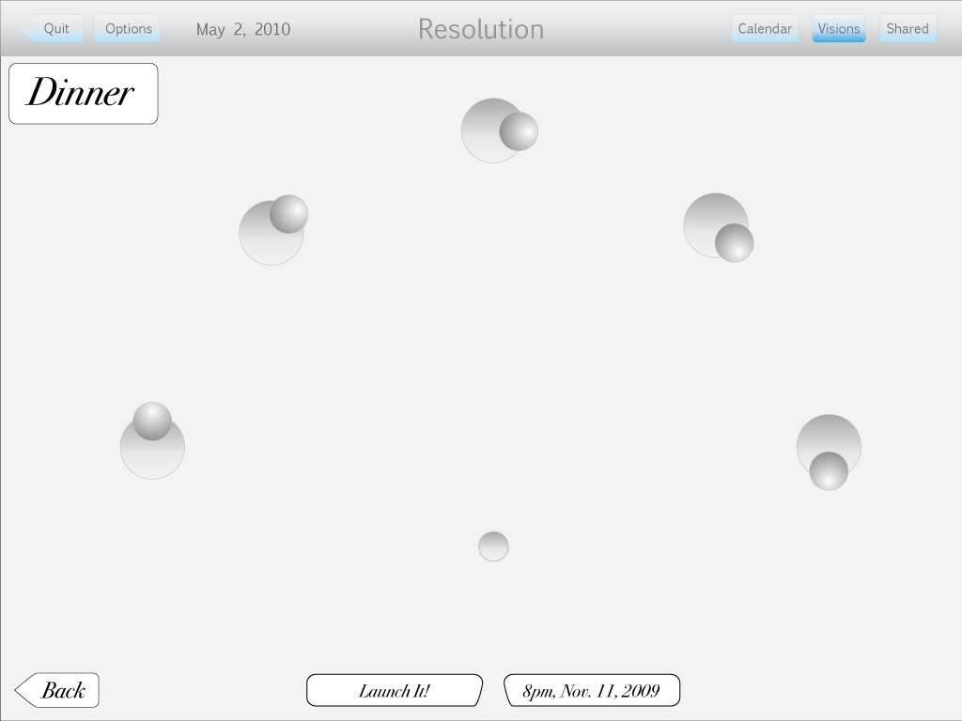
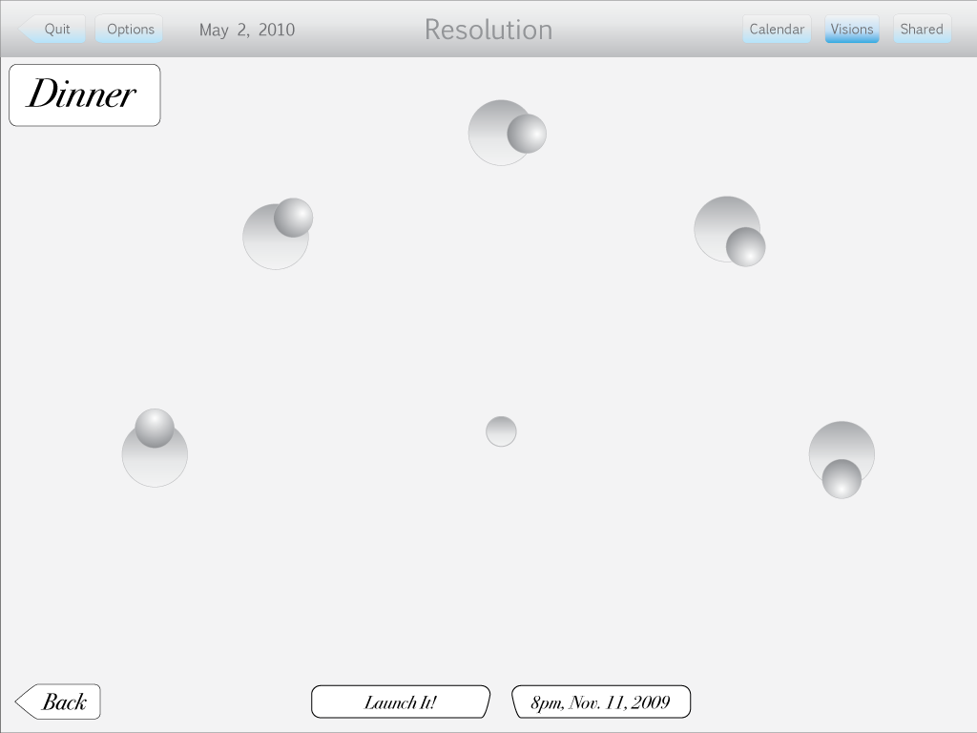
Screen 4 - At halfway point, ball transitions

Screen 5 - ball splits into four different colored balls

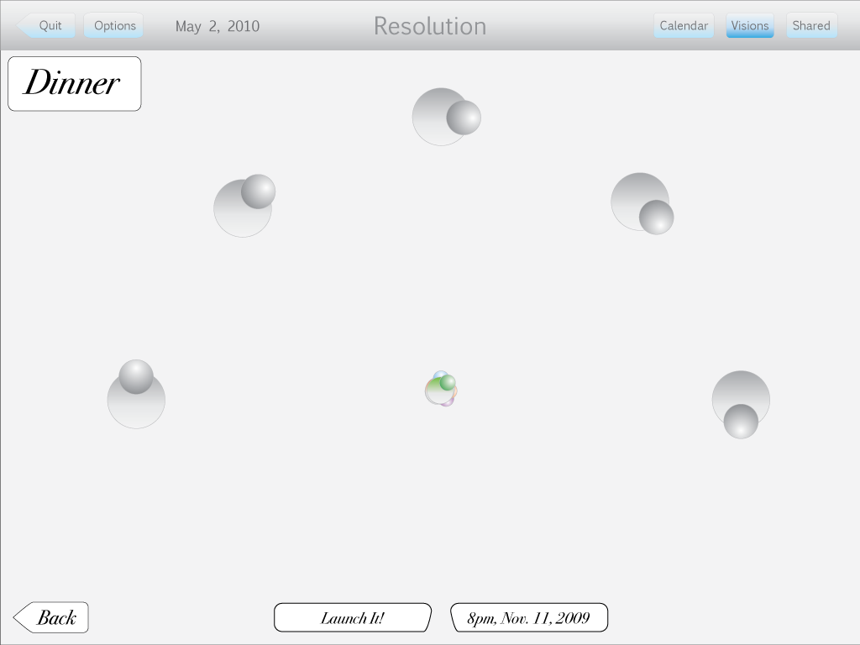
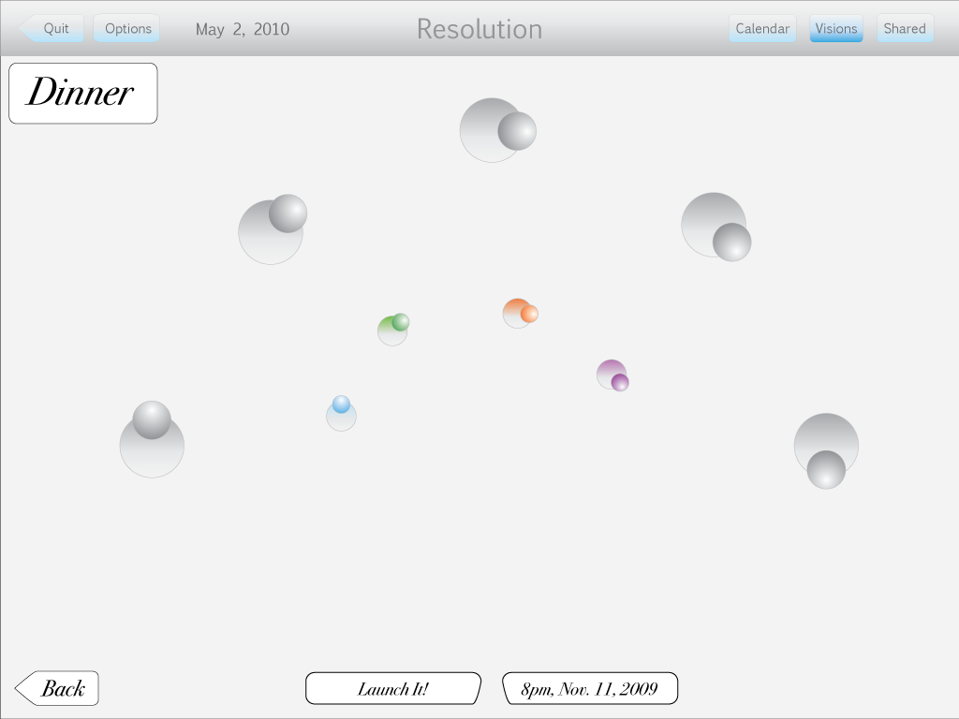
Screen 6 - Balls separate, and travel towards the five large grey balls. Each colored ball travels towards the grey ball with the same shape.

Screen 7 - Ball keeps moving

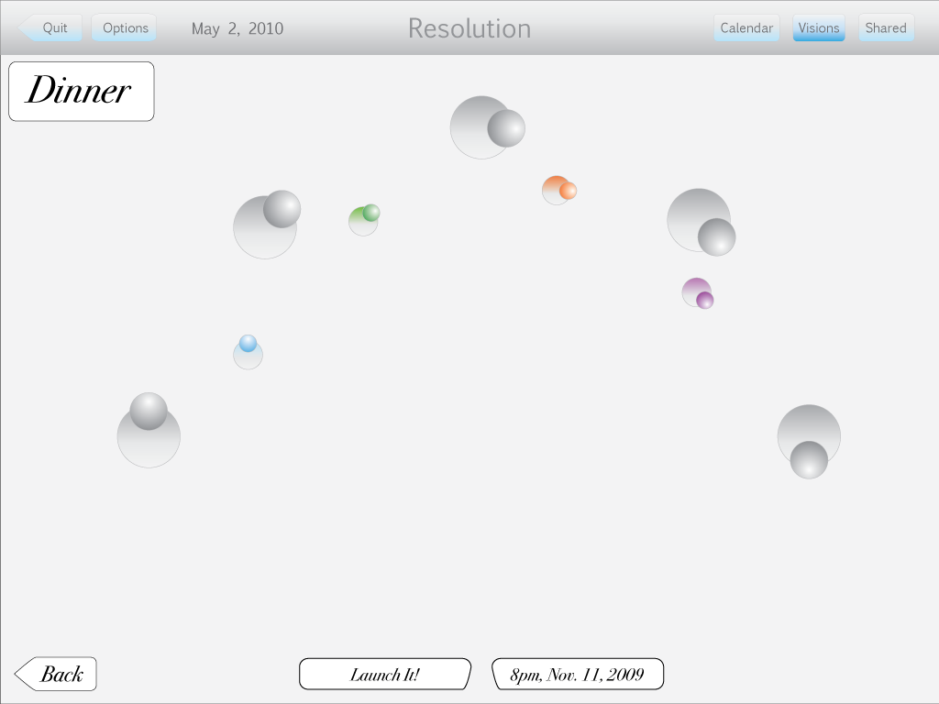
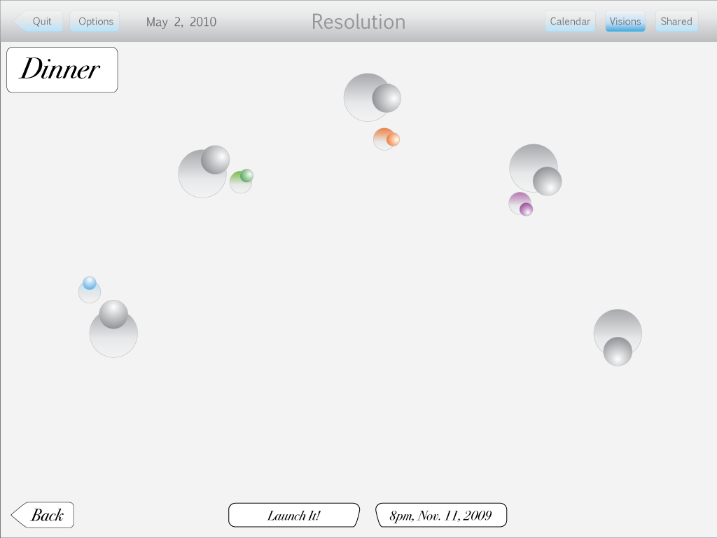
Screen 8 - colored balls go into “orbit” around grey balls. Time from screen 1 to screen 8 is 1.5 seconds.

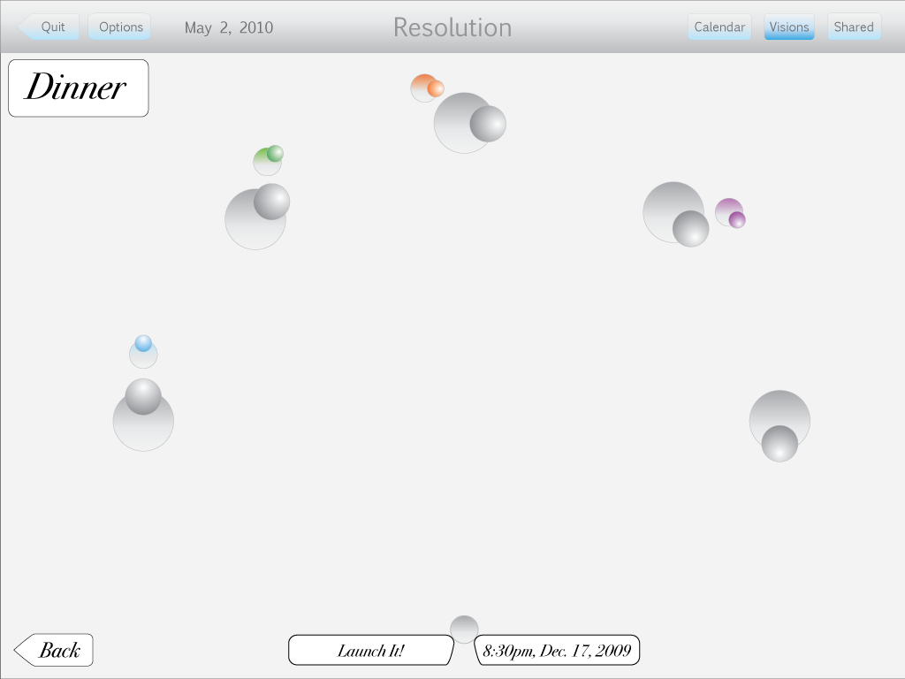
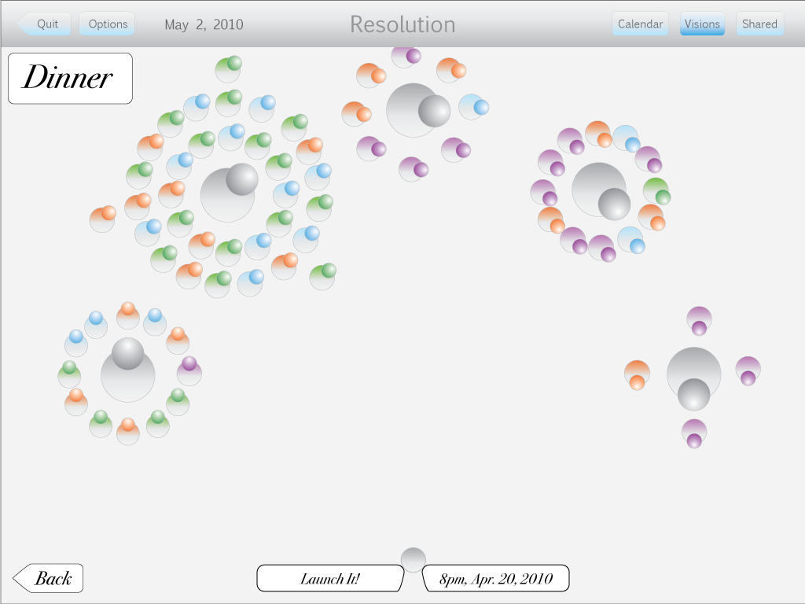
Screen 9 - colored balls orbiting slowly (one rotation around grey ball is two seconds). A new grey ball appears on the bottom of the screen. The white box on it’s right changes text from “8pm, Nov. 11, 2009” to “8:30pm, Dec.17, 2009.” Grey ball begins to rise, and then the screen transitions to screen ten. Screen 9 length of time is 1 second.

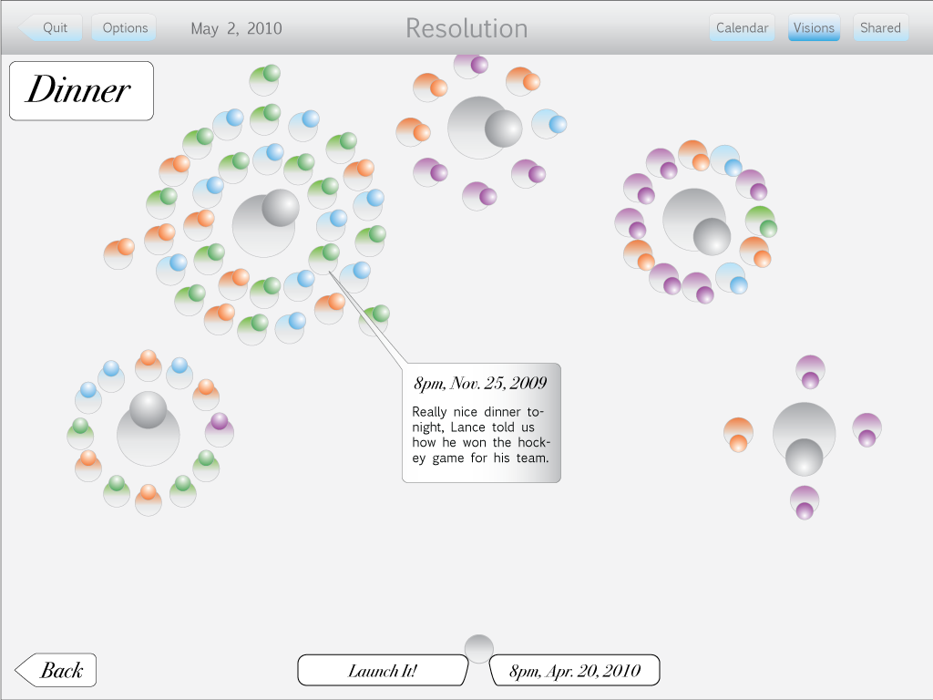
Screen 10 - Many colored balls now orbit the five grey balls. The inner circle of colored balls circling each of the five grey balls consists of up to 12 balls. The second ring consists of 18 colored balls. Length of time is five seconds.

Screen 11 - A window opens connected to a green colored ball. All orbiting stops, the screen is static. After five seconds the window closes, and orbiting resumes for five seonds.

End animation.

Game 2 - Remix

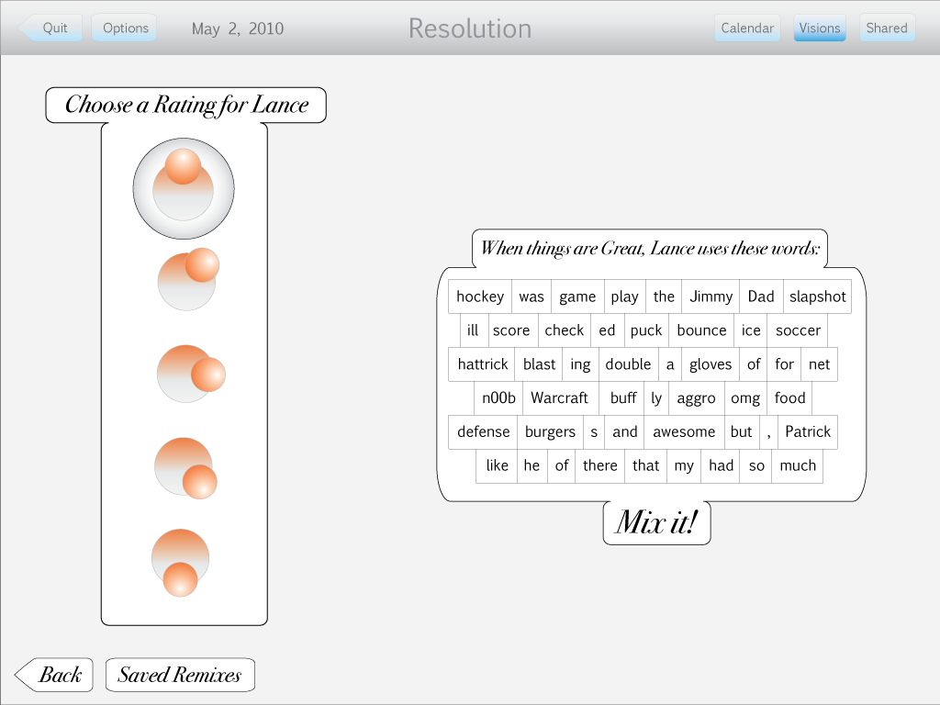
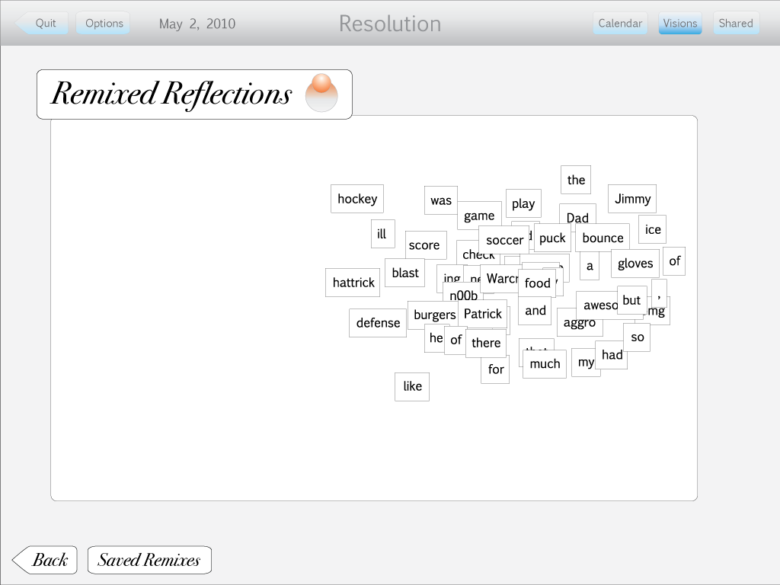
Screen 1 - Two white windows appear on the background screen. Screen is static for five seconds. Both windows disappear, and the individual words in boxes on the right window becomes disorganized (screen 2).

Screen 2 - Disorganized word boxes. Word boxes begin to move, creating sentences.

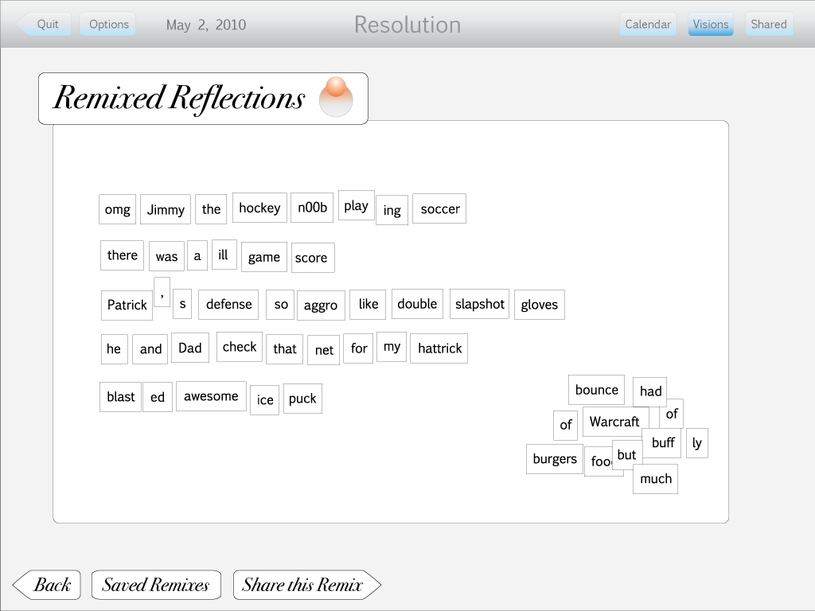
Screen 3 - Word boxes eventually end in this position. It takes 2 seconds for each sentence line to be constructed.

End animation

Game 3 - Spin

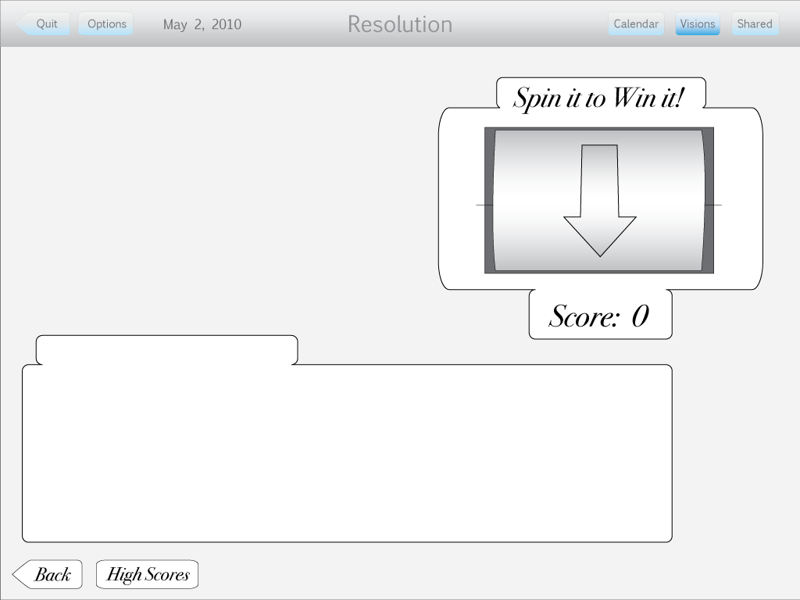
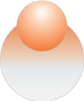
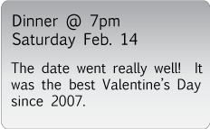



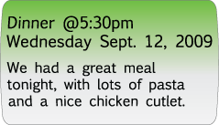
Screen 1 - A wheel on the upper right hand part of the screen is still for three seconds. Then the arrow begins to spin downwards quickly - 3 seconds.

Six images spin within the wheel.

Screen 2 - Wheel stops on orange ball. Three orange windows appear in the bottom white window. Seven seconds.

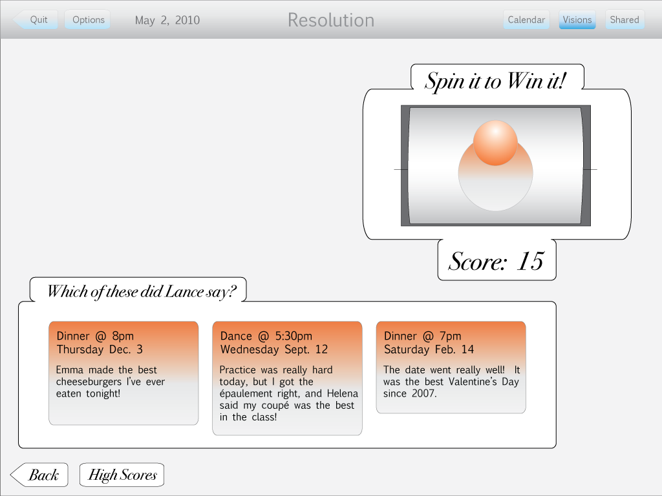
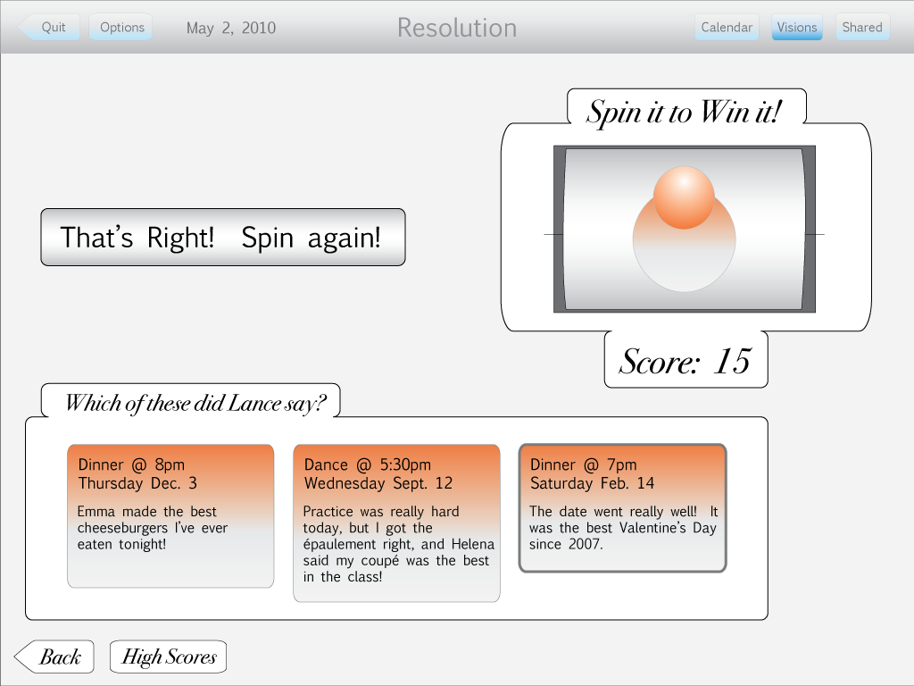
Screen 3 - Right orange window is highlighted. A grey window appears on upper left part of screen. Wheel begins to spin again. Two seconds.

Screen 4 - Wheel stops on green window, and a new window appears in lower white window. Seven seconds.

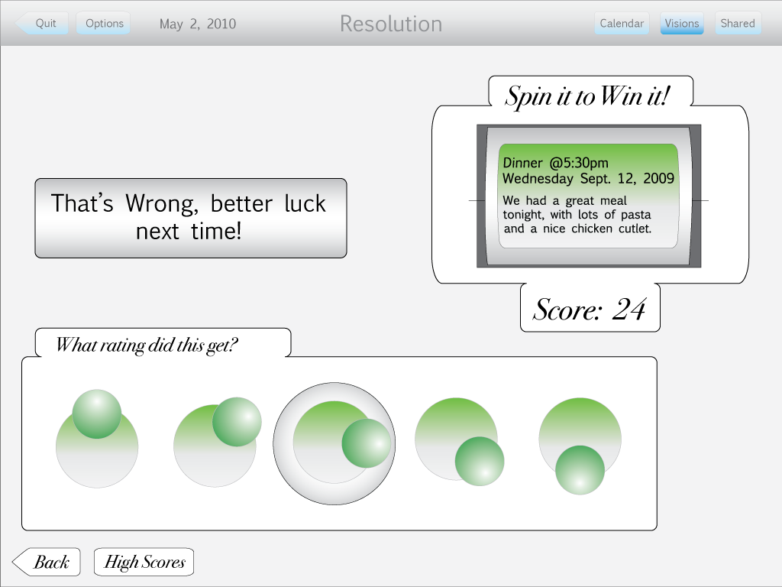
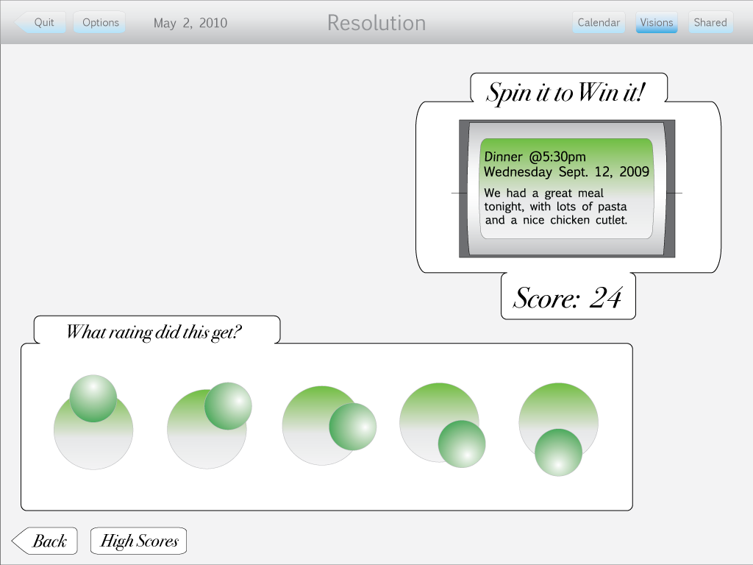

Screen 5 - Middle green ball is highlighted, new grey window appears on upper left hand side of screen. Two seconds.

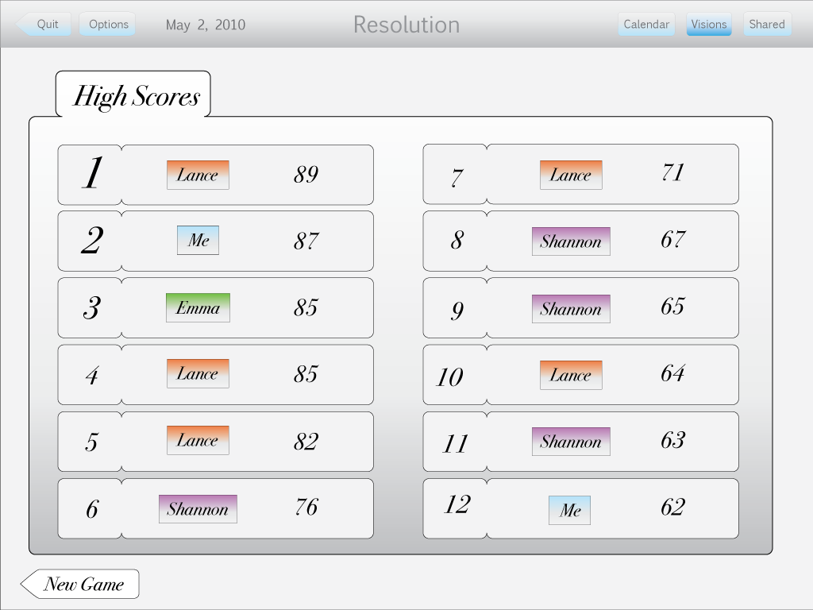
Screen 6 - New screen appears. Five seconds.

End animation

